SOC Investigation Report #2

Case Information
Field | Value
Case ID | SOC-002
Alert | Multiple Failed Login Attempts
Event ID | 4625
Host | windows
Data Source | Windows Security Log
Severity | Medium
Status | Closed - Benign Lab Activity

Executive Summary
Multiple Windows Security Event ID 4625 events were detected in Splunk. The account 'biru' generated repeated failed interactive logon attempts. The investigation confirmed these events were intentionally generated in the SOC lab by entering an incorrect password multiple times.

Investigation Objective
- Validate that failed logon events are forwarded to Splunk.
- Identify the affected account.
- Determine whether the activity represents a brute-force attack or expected user activity.

Evidence
Figure 1: Splunk search results for Windows Security Event ID 4625.
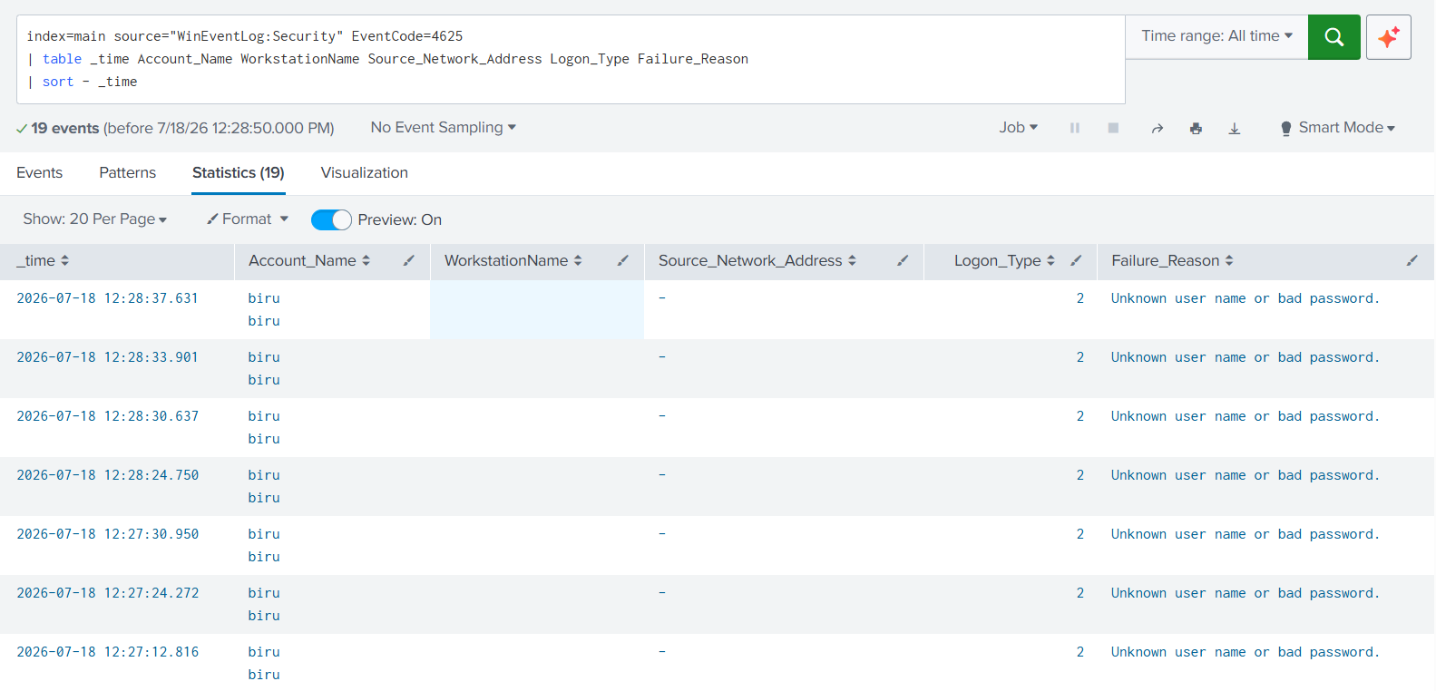

Observed Evidence
Field | Observation
Username | biru
Event ID | 4625
Logon Type | 2 (Interactive Logon)
Failure Reason | Unknown user name or bad password
Source Network Address | - (Local logon)
Result | Multiple failed login attempts

Splunk Detection Query
index=main source="WinEventLog:Security" EventCode=4625
| table _time Account_Name WorkstationName Source_Network_Address Logon_Type Failure_Reason
| sort - _time

MITRE ATT&CK Mapping
Technique | ID
Brute Force | T1110
Password Guessing | T1110.001

Analyst Findings
- The events were generated by repeated incorrect password entry.
- Logon Type 2 indicates a local interactive login.
- No successful compromise or privilege escalation was observed.
- Activity is consistent with expected SOC lab testing.

Severity Assessment
Medium. Repeated failed logins warrant investigation because they may indicate password guessing or brute-force attacks. In this case, the analyst verified the activity was intentional and benign.

Recommendations
- Monitor for repeated failed logins exceeding a threshold.
- Correlate Event ID 4625 with Event ID 4624.
- Review account lockout policies.
- Continue monitoring authentication activity.

Conclusion
The investigation confirmed successful collection of Windows Security Event ID 4625 in Splunk. The observed failed logons were intentionally generated for SOC lab validation. No malicious activity was identified.

