Xingyicheng (Shenzhen) Technology Co., Ltd.
Product Specifications
Product Name: 10.1-inch Self-service Price Checker
Contents
一、（Scope）--------------------------------------------------------- 4
二、（Product Views）------------------------------------------------ 4
三、（Features）------------------------------------------------------ 4
四、（Specifications）------------------------------------------------ 6
五、（Product Appearance）-------------------------------------9
- （Scope）
This product is suitable for shopping malls, supermarkets, convenience stores, and warehouses.
- （Product Views）
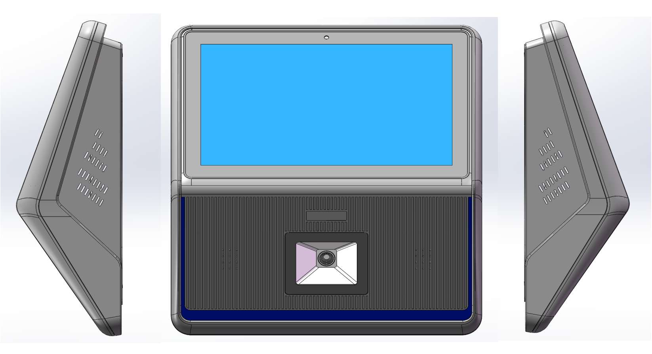
- （Features）
（一） Basic core functions (essential)
1.（Barcode scanning for price checks）
(Supports 1D/2D barcode scanning. Customers or store staff can scan a product's barcode, and the screen will display the product name, unit price, specifications, promotional price, and original price in real time, solving the problems of missing price tags and opaque promotional information.)
It is compatible with common barcode formats in supermarkets such as EAN-13 and QR Code, and some models support scanning and recognizing product batch numbers and production dates.
· 2.（Price and inventory move in tandem）
It integrates with supermarket ERP/POS systems to update product prices and inventory data in real time, avoiding disputes over "discrepancies between marked price and checkout price," while also displaying remaining inventory and inventory location (for easy restocking by store staff).
· 3.（Multi-language/Multi-currency switching）。
It supports multiple languages ​​such as Chinese and English, and some cross-border supermarket models can switch to multiple currencies for pricing, making it suitable for foreign customers or bonded store scenarios.
· 4.（Simplified operation design）
The device features both touchscreen and physical barcode scanning for dual operation. The interface is simple and streamlined, making it easy for seniors and children to use. It also supports voice-activated pricing (suitable for visually impaired users).
5.（Price and inventory move in tandem）
It integrates with supermarket ERP/POS systems to update product prices and inventory data in real time, avoiding disputes over "discrepancies between marked price and checkout price," while also displaying remaining inventory and inventory location (for easy restocking by store staff).
6.（Multi-language/Multi-currency switching）
It supports multiple languages ​​such as Chinese and English, and some cross-border supermarket models can switch to multiple currencies for pricing, making it suitable for foreign customers or bonded store scenarios.
7.（Simplified operation design）
It features dual operation with a touchscreen and physical barcode scanning button, a simple interface with no redundant steps, making it easy for the elderly and children to use; it also supports voice-announcement of prices (suitable for visually impaired people).

（二） Advanced extended functions (value-added)
1.（Promotions and Membership Services）
Displays product promotion rules (such as "buy two get one free" or "discount for purchases over a certain amount"), supports member login via QR code, and allows users to check member prices, points balance, and coupon information.
Some models can print promotional coupons to encourage repeat purchases.
2.（Product Information Display）
Leveraging the advantages of commercial display screens, product details (such as ingredient lists, usage instructions, and origin traceability) can be showcased, making it particularly suitable for categories that require detailed information, such as 3C digital products, cosmetics, and baby products.
3.（Data Statistics and Analysis）
The backend automatically compiles the top 10 most searched products and peak search times, helping merchants adjust price tag layouts and optimize promotional strategies.
4.Fault self-diagnosis and remote maintenance
It supports automatic reporting of device malfunctions (such as barcode scanning engine failure or network disconnection), allowing maintenance personnel to remotely repair the system and reduce offline maintenance costs.

（三） （Commercial display adaptation features）
1.（Wide viewing angle high-definition display）
It uses an IPS LCD panel to ensure accurate price display from different viewing angles, and the screen brightness can be automatically adjusted (to adapt to changes in supermarket lighting).
2.（Dustproof and waterproof protection）
With IP54-level protection, the machine is suitable for the humid environment of the fresh food section and the dusty environment of the snack section, extending the equipment's lifespan.
- （Specifications）
(Product Series) | Product Series）
(Product Series) | Model | XYC-CJ-D5
(Display) | LCD Size | 10.1 inch
(Display) | LCD Brand | LG / BOE / CSOT
(Display) | Backlight Type | D-LED
(Display) | Resolution | 1280 × 800 Pixels
(Display) | Brightness | 250~300 cd/m² (Typ.)
(Display) | Contrast Ratio | 900:1 (Typ.)
(Display) | Refresh Rate | 60Hz
(Display) | Viewing Angle | 85/85/85/85 (Typ.)
(Display) | Lifetime | 50,000 hrs (Min.)
(Display) | View Area (H×V) | 216(W) × 135(H) mm
(Motherboard Spec) | Chipset | A133
(Motherboard Spec) | CPU Architecture | ARM Cortex-A53
(Motherboard Spec) | CPU Frequency | 1.5GHz
(Motherboard Spec) | CPU Core | Quad-core
(Motherboard Spec) | GPU | IMG PowerVR GE8300
(Motherboard Spec) | RAM | 2GB
(Motherboard Spec) | ROM | 32GB
(Motherboard Spec) | Operating System | Android 10
(Motherboard Spec) | Wi-Fi | Wi-Fi ×1, 2.4G, 802.11b/g/n
(Motherboard Spec) | Bluetooth | 5.0
(Motherboard Spec) | LAN | RJ45, 10/100Mbps
(Motherboard Spec) | USB 2.0 | Type-A, Android
(Motherboard Spec) | USB 3.0 | Type-A, Public
（barcode scanner performance） | Image Sensor | 640 × 480 CMOS
（barcode scanner performance） | Illumination | White LED
（barcode scanner performance） | Code Recognition System  Reading Depth of Field | 2D: QR Code, Micro QR; 1D: Code 128, EAN-13, EAN-8, Code39, UPC-A, UPC-E, Codabar, Interleaved 2 of 5, ITF-6, ITF-14, ISBN, ISSN, Code 93, UCC/EAN-128, GS1 Databar, Matrix 2 of 5, Code 11, Industrial 2 of 5, Standard 2 of 5, AIM128, Plessey, MSI-Plessey
（barcode scanner performance） | Code Recognition System  Reading Depth of Field | EAN-13 (13mil): 25mm~110mm; Code39 (5mil): 15mm~50mm; QR Code (15mil): 15mm~85mm
（barcode scanner performance） | Symbol Contrast | ≥30%
（barcode scanner performance） | Barcode Sensitivity | Tilt 40°, Deflect 45°, Rotate 360°
（barcode scanner performance） | Perspective | Horizontal 64°, Vertical 49.8°
（barcode scanner performance） | Prompt Method | Buzzer Sound
（barcode scanner performance） | Touch Technology | Capacitive Touch
（barcode scanner performance） | Surface Protection | 2mm Tempered Glass
(Touch Screen Spec) | Infrared Touch | Android: 10 Points; Windows: 10 Points
(Touch Screen Spec) | Touch Accuracy | 90% Central Area: ±1mm
(Touch Screen Spec) | Touch Height | 2mm
(Touch Screen Spec) | Response Time | ≤5ms
(Touch Screen Spec) | Theory Clicks | Infinite
(Touch Screen Spec) | Minimum Touch Object | Single Point ≥3mm; Multi Point ≥5mm
(Touch Screen Spec) | Power Supply Method | DC 12V (Optional POE)
(Touch Screen Spec) | Maximum Power Consumption | 15W
(Electrical Spec) | Standby Power Consumption | <0.5W
(Electrical Spec) | Product Size (W×D×H) | 267 × 890 × 90mm
(Electrical Spec) | Packaging Size (W×D×H) | 325 × 325 × 135mm
(Structure) | Housing Material | Plastic
(Structure) | Housing Color | Black
(Structure) | Net Weight | 1.2kg
(Structure) | Gross Weight | 1.5kg
(Weight) | Operating Temperature | 0℃~40℃
(Weight) | Storage Temperature | -20℃~60℃
(Environmental Conditions) | Packaging Process | Cardboard Box
(Environmental Conditions) | Accessories | Adapter ×1; Certificate of Conformity & Warranty Card ×1; Wall Mount Bracket ×1
(Packing) | Model | XYC-CJ-D5
(Packing) | LCD Size | 10.1 inch

The following features are not included by default. If required, this must be clearly communicated with the business department before purchasing, as adding these features will increase costs.
Camera | It supports 1080P and 720P resolutions. | 720P  Default 720P
NFC/RFID
POE | PoE power supply | Default power supply for the adapter
（Chipset ）  （RAM）  （ROM） | The parameters described in the above document are factory standards. | It can be replaced, but different configurations will vary. Please confirm with the business team to clarify details such as: main chip, memory, storage, etc.
Standard color scheme | The default color scheme is yellow and blue. See the preview image. | 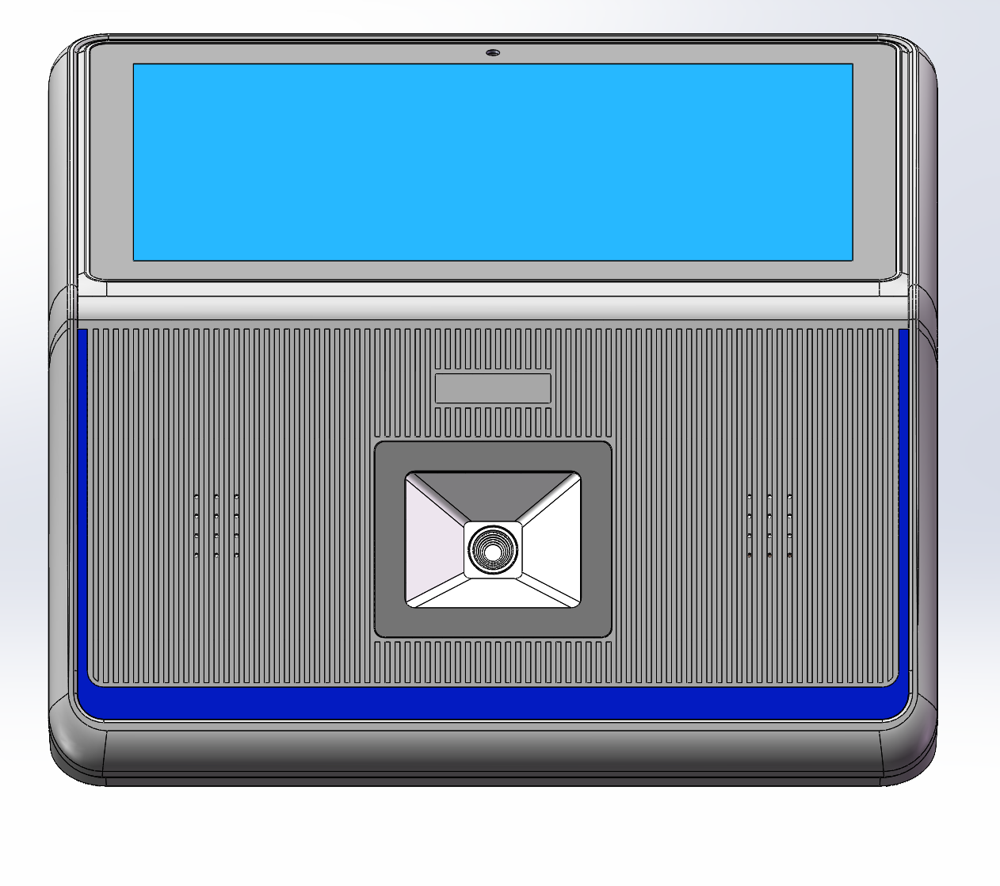
Standard color scheme |  | 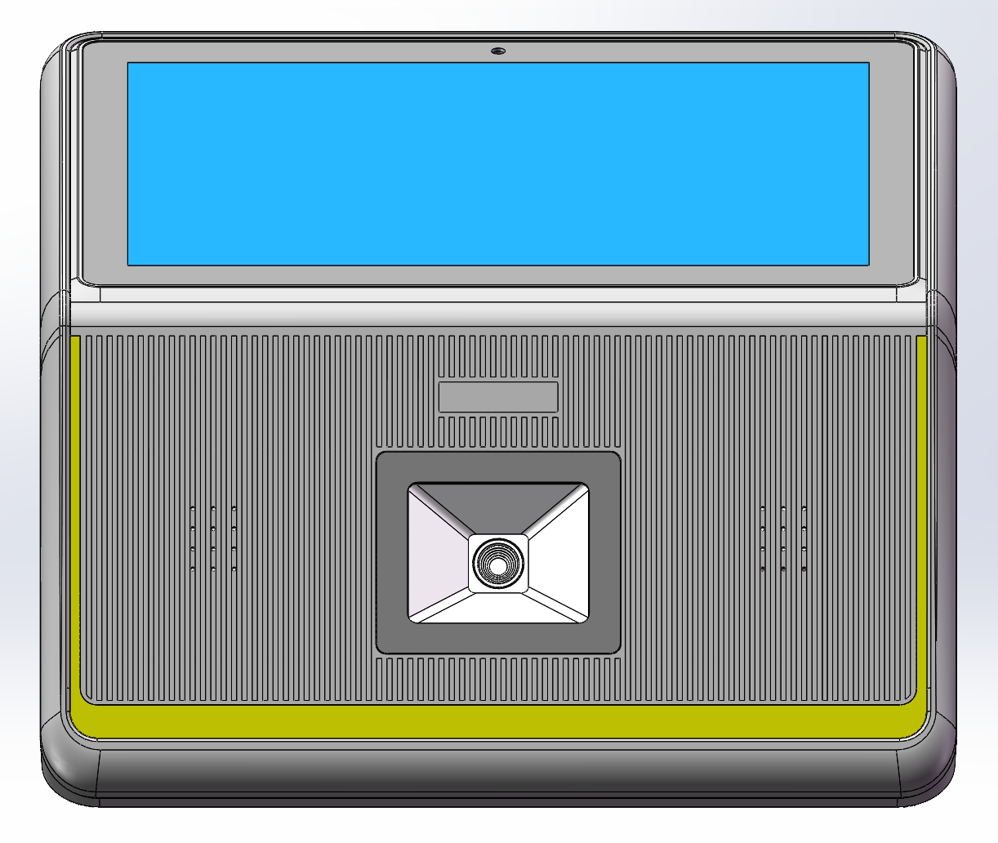

(Product Appearance)
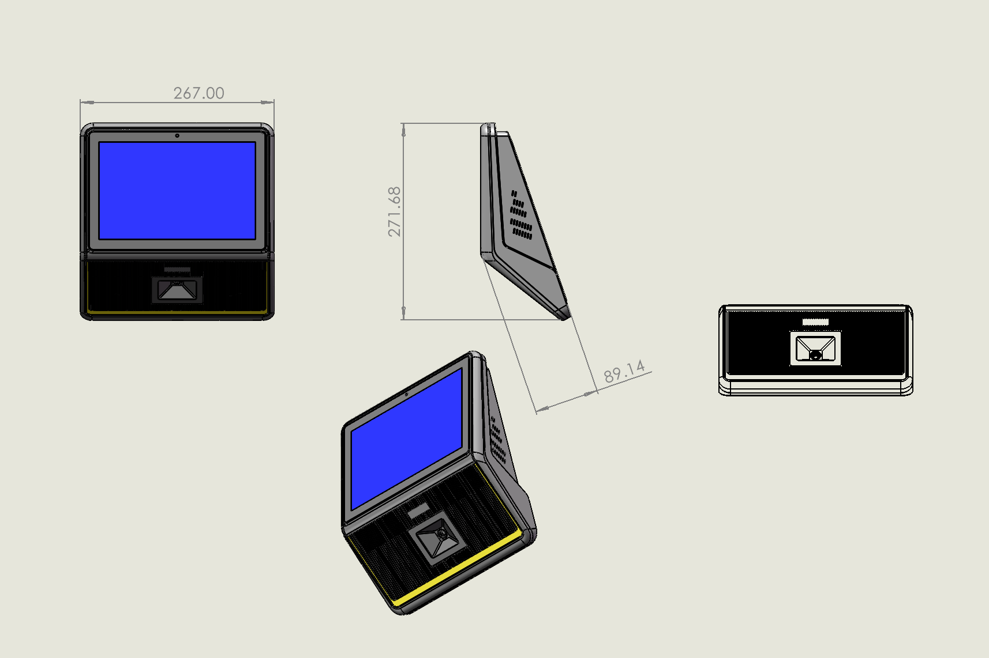
Wall-mounted mounting plate dimensions:
