<http://localhost/master/>



100



83



92



100



### Performance

Accessibility

### Best Practices

SEO

PWA

100

# Performance

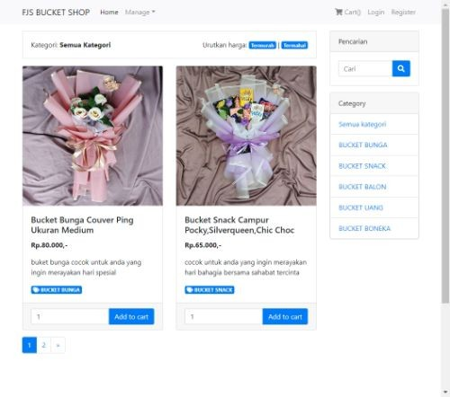

V[alues are estimated and may vary. The performance score is calculated directly from these metrics.](https://web.dev/performance-scoring/?utm_source=lighthouse&utm_medium=devtools) [See calculator.](https://googlechrome.github.io/lighthouse/scorecalc/#FCP%3D460%26TTI%3D460%26SI%3D460%26TBT%3D0%26LCP%3D500%26CLS%3D0%26FMP%3D460%26device%3Ddesktop%26version%3D9.6.6)

0–49 50–89 90–100

METRICS Expand view

First Contentful Paint

## 0.5 s

Time to Interactive

## 0.5 s

Speed Index

## 0.5 s

Total Blocking Time

## 0 ms

Largest Contentful Paint

## 0.5 s

Cumulative Layout Shift

## 0

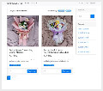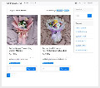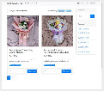

View Original Trace

View Treemap

Show audits relevant to: All FCP TBT LCP CLS

OPPORTUNITIES

Opportunity Estimated Savings

Eliminate render-blocking resources 0.27 s

These suggestions can help your page load faster. They don't [directly affect](https://web.dev/performance-scoring/?utm_source=lighthouse&utm_medium=devtools) the Performance score.

DIAGNOSTICS

Image elements do not have explicit width and height

Serve static assets with an efficient cache policy — 4 resources found

 Avoid chaining critical requests — 7 chains found

 Keep request counts low and transfer sizes small — 11 requests • 296 KiB

 Largest Contentful Paint element — 1 element found

 Avoid large layout shifts — 4 elements found

More information about the performance of your application. These numbers don't [directly affect](https://web.dev/performance-scoring/?utm_source=lighthouse&utm_medium=devtools) the Performance score.

PASSED AUDITS (33) Show

83

# Accessibility

These [checks highlight opportunities to improve the accessibility of your web app. Only a subset of accessibility issues can be automatically](https://web.dev/lighthouse-accessibility/?utm_source=lighthouse&utm_medium=devtools) detected so manual testing is also encouraged.

NAMES AND LABELS

Buttons do not have an accessible name

Form elements do not have associated labels

These are opportunities to improve the semantics of the controls in your application. This may enhance the experience for users of assistive technology, like a screen reader.

CONTRAST

Background and foreground colors do not have a sufficient contrast ratio.

These are opportunities to improve the legibility of your content.

ADDITIONAL ITEMS TO MANUALLY CHECK (10) Show

[These items address areas which an automated testing tool cannot cover. Learn more in our guide on conducting an accessibility review.](https://developers.google.com/web/fundamentals/accessibility/how-to-review?utm_source=lighthouse&utm_medium=devtools)

PASSED AUDITS (17) Show

NOT APPLICABLE (24) Show



92

# Best Practices

TRUST AND SAFETY

Includes front-end JavaScript libraries with known security vulnerabilities — 6 vulnerabilities detected

 Ensure CSP is effective against XSS attacks

GENERAL

 Detected JavaScript libraries

PASSED AUDITS (12) Show

NOT APPLICABLE (1) Show



100

# SEO

These checks ensure that your page is following basic search engine optimization advice. There are many additional factors Lighthouse does not score here that may affect your search ranking, including performance on [Core Web Vitals](https://web.dev/learn-web-vitals/?utm_source=lighthouse&utm_medium=devtools). [Learn more](https://support.google.com/webmasters/answer/35769).

ADDITIONAL ITEMS TO MANUALLY CHECK (1) Show

Run these additional validators on your site to check additional SEO best practices.

PASSED AUDITS (11) Show

NOT APPLICABLE (3) Show



# PWA

These checks validate the aspects of a Progressive Web App. [Learn more](https://developers.google.com/web/progressive-web-apps/checklist?utm_source=lighthouse&utm_medium=devtools).

INSTALLABLE

Web app manifest or service worker do not meet the installability requirements — 1 reason

PWA OPTIMIZED

Does not register a service worker that controls page and start_url

Is not configured for a custom splash screen Failures: No manifest was fetched.

Does not set a theme color for the address bar.

Failures: No manifest was fetched, No `<meta name="theme-color">` tag found.

 Content is sized correctly for the viewport

Has a <meta name="viewport"> tag with width or initial-scale

Does not provide a valid apple-touch-icon

Manifest doesn't have a maskable icon No manifest was fetched

ADDITIONAL ITEMS TO MANUALLY CHECK (3) Show

These checks are required by the baseline [PWA Checklist](https://developers.google.com/web/progressive-web-apps/checklist?utm_source=lighthouse&utm_medium=devtools) but are not automatically checked by Lighthouse. They do not affect your score but it's important that you verify them manually.

Captured at Dec 14, 2022,

8:50 PM GMT+7

Emulated Desktop with Lighthouse 9.6.6

Single page load

Initial page load Custom throttling Using Chromium 108.0.0.0 with devtools

Generated by **Lighthouse** 9.6.6 | [File an issue](https://github.com/GoogleChrome/Lighthouse/issues)

<http://localhost/master/login>



100

98

92

100



100



98



92



100



### Performance

Accessibility

### Best Practices

SEO

PWA



100

# Performance

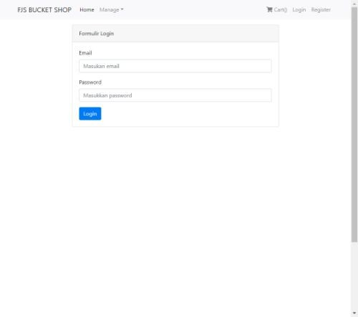

V[alues are estimated and may vary. The performance score is calculated directly from these metrics.](https://web.dev/performance-scoring/?utm_source=lighthouse&utm_medium=devtools) [See calculator.](https://googlechrome.github.io/lighthouse/scorecalc/#FCP%3D460%26TTI%3D460%26SI%3D460%26TBT%3D0%26LCP%3D460%26CLS%3D0%26FMP%3D460%26device%3Ddesktop%26version%3D9.6.6)

0–49 50–89 90–100

METRICS Expand view

First Contentful Paint

## 0.5 s

Time to Interactive

## 0.5 s

Speed Index

## 0.5 s

Total Blocking Time

## 0 ms

Largest Contentful Paint

## 0.5 s

Cumulative Layout Shift

## 0

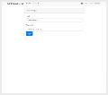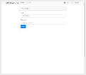

View Original Trace

View Treemap

Show audits relevant to: All FCP TBT LCP CLS

DIAGNOSTICS

Avoid chaining critical requests — 7 chains found

 Keep request counts low and transfer sizes small — 9 requests • 159 KiB

 Largest Contentful Paint element — 1 element found

 Avoid large layout shifts — 1 element found

More information about the performance of your application. These numbers don't [directly affect](https://web.dev/performance-scoring/?utm_source=lighthouse&utm_medium=devtools) the Performance score.

PASSED AUDITS (36) Show



98

# Accessibility

These [checks highlight opportunities to improve the accessibility of your web app. Only a subset of accessibility issues can be automatically](https://web.dev/lighthouse-accessibility/?utm_source=lighthouse&utm_medium=devtools) detected so manual testing is also encouraged.

CONTRAST

Background and foreground colors do not have a sufficient contrast ratio.

These are opportunities to improve the legibility of your content.

ADDITIONAL ITEMS TO MANUALLY CHECK (10) Show

[These items address areas which an automated testing tool cannot cover. Learn more in our guide on conducting an accessibility review.](https://developers.google.com/web/fundamentals/accessibility/how-to-review?utm_source=lighthouse&utm_medium=devtools)

PASSED AUDITS (17) Show

NOT APPLICABLE (26) Show



92

# Best Practices

TRUST AND SAFETY

Includes front-end JavaScript libraries with known security vulnerabilities — 6 vulnerabilities detected

 Ensure CSP is effective against XSS attacks

GENERAL

 Detected JavaScript libraries

PASSED AUDITS (12) Show

NOT APPLICABLE (1) Show



100

# SEO

These checks ensure that your page is following basic search engine optimization advice. There are many additional factors Lighthouse does not score here that may affect your search ranking, including performance on [Core Web Vitals](https://web.dev/learn-web-vitals/?utm_source=lighthouse&utm_medium=devtools). [Learn more](https://support.google.com/webmasters/answer/35769).

ADDITIONAL ITEMS TO MANUALLY CHECK (1) Show

Run these additional validators on your site to check additional SEO best practices.

PASSED AUDITS (10) Show

NOT APPLICABLE (4) Show



# PWA

These checks validate the aspects of a Progressive Web App. [Learn more](https://developers.google.com/web/progressive-web-apps/checklist?utm_source=lighthouse&utm_medium=devtools).

INSTALLABLE

Web app manifest or service worker do not meet the installability requirements — 1 reason

PWA OPTIMIZED

Does not register a service worker that controls page and start_url

Is not configured for a custom splash screen Failures: No manifest was fetched.

Does not set a theme color for the address bar.

Failures: No manifest was fetched, No `<meta name="theme-color">` tag found.

 Content is sized correctly for the viewport

Has a <meta name="viewport"> tag with width or initial-scale

Does not provide a valid apple-touch-icon

Manifest doesn't have a maskable icon No manifest was fetched

ADDITIONAL ITEMS TO MANUALLY CHECK (3) Show

These checks are required by the baseline [PWA Checklist](https://developers.google.com/web/progressive-web-apps/checklist?utm_source=lighthouse&utm_medium=devtools) but are not automatically checked by Lighthouse. They do not affect your score but it's important that you verify them manually.

Captured at Dec 14, 2022,

8:47 PM GMT+7

Emulated Desktop with Lighthouse 9.6.6

Single page load

Initial page load Custom throttling Using Chromium 108.0.0.0 with devtools

Generated by **Lighthouse** 9.6.6 | [File an issue](https://github.com/GoogleChrome/Lighthouse/issues)

<http://localhost/master/register>



100



90



92



100



### Performance

Accessibility

### Best Practices

SEO

PWA

100

# Performance

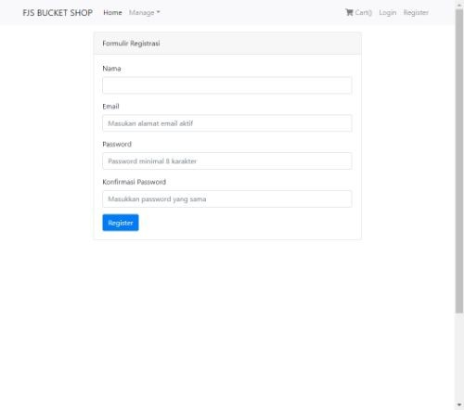

V[alues are estimated and may vary. The performance score is calculated directly from these metrics.](https://web.dev/performance-scoring/?utm_source=lighthouse&utm_medium=devtools) [See calculator.](https://googlechrome.github.io/lighthouse/scorecalc/#FCP%3D464%26TTI%3D464%26SI%3D464%26TBT%3D0%26LCP%3D464%26CLS%3D0%26FMP%3D464%26device%3Ddesktop%26version%3D9.6.6)

0–49 50–89 90–100

METRICS Expand view

First Contentful Paint

## 0.5 s

Time to Interactive

## 0.5 s

Speed Index

## 0.5 s

Total Blocking Time

## 0 ms

Largest Contentful Paint

## 0.5 s

Cumulative Layout Shift

## 0

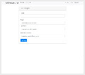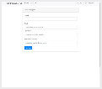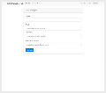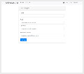

View Original Trace

View Treemap

Show audits relevant to: All FCP TBT LCP CLS

DIAGNOSTICS

 Avoid chaining critical requests — 7 chains found

 Keep request counts low and transfer sizes small — 9 requests • 160 KiB

 Largest Contentful Paint element — 1 element found

 Avoid large layout shifts — 1 element found

More information about the performance of your application. These numbers don't [directly affect](https://web.dev/performance-scoring/?utm_source=lighthouse&utm_medium=devtools) the Performance score.

PASSED AUDITS (36) Show

90

# Accessibility

These [checks highlight opportunities to improve the accessibility of your web app. Only a subset of accessibility issues can be automatically](https://web.dev/lighthouse-accessibility/?utm_source=lighthouse&utm_medium=devtools) detected so manual testing is also encouraged.

NAMES AND LABELS

Form elements do not have associated labels

These are opportunities to improve the semantics of the controls in your application. This may enhance the experience for users of assistive technology, like a screen reader.

CONTRAST

Background and foreground colors do not have a sufficient contrast ratio.

These are opportunities to improve the legibility of your content.

ADDITIONAL ITEMS TO MANUALLY CHECK (10) Show

[These items address areas which an automated testing tool cannot cover. Learn more in our guide on conducting an accessibility review.](https://developers.google.com/web/fundamentals/accessibility/how-to-review?utm_source=lighthouse&utm_medium=devtools)

PASSED AUDITS (16) Show

NOT APPLICABLE (26) Show



92

# Best Practices

TRUST AND SAFETY

Includes front-end JavaScript libraries with known security vulnerabilities — 6 vulnerabilities detected

 Ensure CSP is effective against XSS attacks

GENERAL

 Detected JavaScript libraries

PASSED AUDITS (12) Show

NOT APPLICABLE (1) Show



100

# SEO

These checks ensure that your page is following basic search engine optimization advice. There are many additional factors Lighthouse does not score here that may affect your search ranking, including performance on [Core Web Vitals](https://web.dev/learn-web-vitals/?utm_source=lighthouse&utm_medium=devtools). [Learn more](https://support.google.com/webmasters/answer/35769).

ADDITIONAL ITEMS TO MANUALLY CHECK (1) Show

Run these additional validators on your site to check additional SEO best practices.

PASSED AUDITS (10) Show

NOT APPLICABLE (4) Show



# PWA

These checks validate the aspects of a Progressive Web App. [Learn more](https://developers.google.com/web/progressive-web-apps/checklist?utm_source=lighthouse&utm_medium=devtools).

INSTALLABLE

Web app manifest or service worker do not meet the installability requirements — 1 reason

PWA OPTIMIZED

Does not register a service worker that controls page and start_url

Is not configured for a custom splash screen Failures: No manifest was fetched.

Does not set a theme color for the address bar.

Failures: No manifest was fetched, No `<meta name="theme-color">` tag found.

 Content is sized correctly for the viewport

Has a <meta name="viewport"> tag with width or initial-scale

Does not provide a valid apple-touch-icon

Manifest doesn't have a maskable icon No manifest was fetched

ADDITIONAL ITEMS TO MANUALLY CHECK (3) Show

These checks are required by the baseline [PWA Checklist](https://developers.google.com/web/progressive-web-apps/checklist?utm_source=lighthouse&utm_medium=devtools) but are not automatically checked by Lighthouse. They do not affect your score but it's important that you verify them manually.

Captured at Dec 14, 2022,

8:51 PM GMT+7

Emulated Desktop with Lighthouse 9.6.6

Single page load

Initial page load Custom throttling Using Chromium 108.0.0.0 with devtools

Generated by **Lighthouse** 9.6.6 | [File an issue](https://github.com/GoogleChrome/Lighthouse/issues)

Berikut adalah hasil dari testing aplikasi FJS-Bucket-Shop berdasarkan page home, login, dan register.

Menurut hasil diatas masing -masing page memiliki hasil rata-rata performa mencapai sekitar 100% dan accesbillity rata-rata 90% dengan kata lain aplikasi ini dapat diakses dan diggunakan dengan cepat .

Untuk kelemahan aplikasi ini kurangnya color background dan foreground masih black and white

Dan untuk akses aplikasi ini masih dilakukan secara local.