**Introduction**

Is process-oriented research declining in community ecology? Notably, some researchers, especially those conducting process-oriented research like ourselves, perceive such a “trend”. Ecosystems display intricate interactions among diverse components, which captivate community ecologists in their quest to unravel their complexities. To attain a comprehensive understanding of ecosystems, community ecologists have pursued both approaches: the pattern-oriented approach, which seeks recurring patterns across systems to develop general theories, and the process-oriented approach, which investigates the mechanisms underlying spatiotemporal variations within each system. This dichotomy, referred to as the "whole system" and "building blocks" approaches respectively (Schmitz 2010), reflects differing scales of analysis—broad patterns versus fine-scale processes—in understanding ecosystem dynamics.

Studies employing each process- and pattern-oriented approach have undoubtedly advanced community ecology and yielded several significant findings. Ecologists emphasize the distinction between static community traits (patterns) and dynamic mechanisms (processes) (Paine 1992), recognizing the role of each. Neither approach holds inherent superiority in revealing complexity (Schmitz 2010), and we acknowledge the difficulties of achieving generality, realism, and precision simultaneously in each type of research (Levins 1966). However, tension persists between the two approaches (Mittelbach and McGill 2019), with researchers often critiquing each other and engaging in unproductive debates. Process-oriented results may face scrutiny for their context-dependency, limiting general predictive capability. Criticisms, exemplified by Lawton's remarks, highlight perceived inadequacies in traditional process-oriented studies (Lawton 1999, 2000). Conversely, patterns, derived from aggregating data across studies, offer insights into average trends but lack causal inference (Schmitz 2010). Simberloff (2004) argues that general ecological laws may not always be applicable in specific management contexts, emphasizing the ongoing significance of advancing ecology at multiple scales, including traditional community ecology. Comparing this fruitless dispute to cookie baking, one perspective advocates for comparing finished cookies to discern patterns, while the other emphasizes focusing solely on the baking process itself. Despite the undeniable importance of both perspectives in making delicious cookies, they seem to engage in a state of mutual denial, each asserting the superiority of its approach over the other. Consequently, these two approaches appear to exist independently, evolving separately within the field (Box 1: History of Community Ecology in Ocean Ecosystems). In Japan, studies related to community ecology have oscillated between these two approaches, with pattern-oriented methodologies gaining prominence in recent years (Figure 1). This trend appears to be mirrored worldwide (Anderson 2021).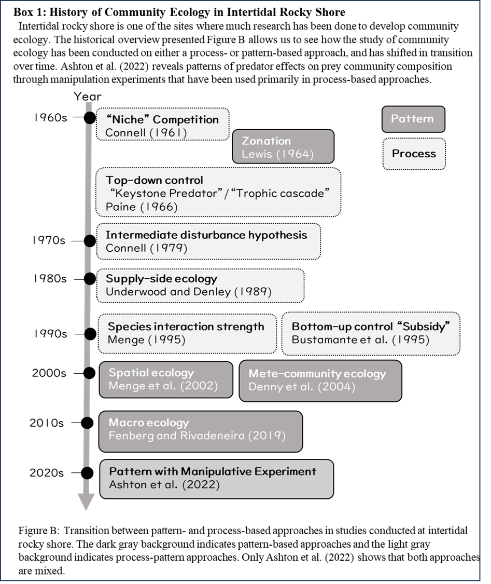

Vellend (2016) proposed using population genetics theory as a mean to alleviate this conflict structure. He divides processes into a hierarchy of lower-order and higher-order processes, arguing that clarifying higher-order processes improves the connection to patterns. However, no matter how many times we consider it, understanding the way of life and strategies of individual organisms requires clarification of lower-order processes, and it continues to fascinate us.

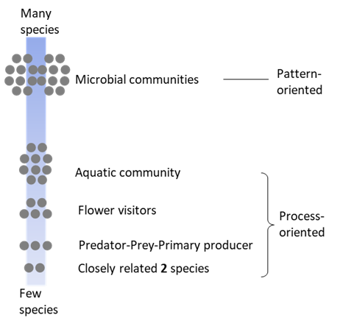 To begin with, there is no clear consensus on the distinction between pattern-oriented and process-oriented studies.Figure 2 is a conceptual diagram illustrating the number of species addressed by five authors interested in process-oriented studies, highlighting the hierarchy of studies. Among these authors, only the researcher focusing on microbial communities identifies their work as pattern-oriented, while the rest consider their studies to be process-oriented. Where would you position your own research in this hierarchy? Do you consider your research to be pattern- or process-oriented? The position in this hierarchy may be mostly determined by the “interests” of each researcher. When we, as ecologists, choose our research themes, individual “interests” often play a major role; we find certain topics or questions subjectively more interesting or attractive.

Figure 2

Additionally, various “methods” exist to address the challenge posed by each number of species under study. We consider whether we can tackle the theme or not; some “methods” are more feasible than others due to personal skills, budget, equipment availability, etc. These methods seem to have been determined to some extent by whether the research is pattern-oriented or process-oriented.

When actually starting research activities, there may be many occasions when researchers consider the “significance” of the research more than personal interest or methods. The significance of a study influences various aspects, including paper writing, securing research funding, and conference presentations.

In the development of ecological science, the roles of “interests”, “methods”, and “significance” are crucial. By considering these factors holistically, researchers would identify and pursue research questions that are not only scientifically valuable but also personally meaningful and feasible. These concepts may be able to be likened to Will, Can, and Must in the context of career development in the business sector in Japan (Figure 3a). First, individuals need to find jobs that they personally find interesting or attractive (personal Will). Second, they must identify tasks they are capable of performing (the things they Can do). Third, the job should meet a societal demand (the things that Must be done). This framework suggests that fulfilling these three factors leads to a good career. We draw a research version of this (Figure 3b). The intersection of these three factors may lead to a good theme or project. But what constitutes a good theme or project? Is it the kind of research that will address social demand and secure funding (McCallen et al. 2019)? To begin with, in community ecology, we feel that each factor tends to be dichotomized between pattern-oriented and process-oriented researchers from the outset. Furthermore, the size of the circle representing significance may also vary depending on who determines its significance and the criteria they use. For example, if the criterion for determining significance is whether a general law that appears to provide fundamental insights capable of addressing broad, impactful questions can be generated, then the scope of what may be considered significant in a community ecology study could be narrower. In this context, only pattern-oriented studies (e.g., species-area relationships, latitudinal diversity gradient (Rosenzweig 1995), and a general scaling law of predator and prey biomass (Hatton et al. 2015)) with the potential to establish general laws may fall within the realm of “significance” (Figure 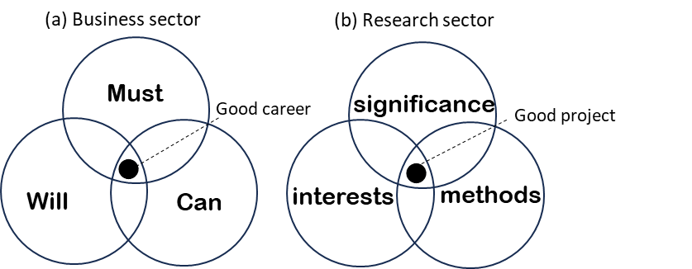3b).

Figure3

The purpose of this paper is to reconsider methods, interests, and significance as common ground for both pattern- and process-oriented research. Additionally, we will reexamine the connections among these factors. By doing so, we aim to reaffirm the futility of the controversy between these two approaches. Furthermore, we will discuss the future direction of research in this field. Thinking about the overlapping parts of the Venn diagram may provide some clues.

**Methods**

It seems that what studies ecologists recognize as pattern- or process-oriented largely depends on what “methods” those studies use. In this section, we explore the connections between pattern-oriented and process-oriented research and their relationship to "methods." Additionally, we examine how recent advancements in methodology may serve to bridge these research approaches. Methods used by community ecologists can be classified into two categories—observational and manipulative. The former methods observe natural communities, often consisting of many species, thereby describing the ‘spatial and temporal patterns’ of species diversity and functioning. The latter methods conduct manipulative experiments on a subset community consisting of a few species to test ‘causal processes’ between ecological variables.

Although these two lines of methods are not mutually exclusive, they both have their strength and shortage, which may have caused controversies in the relationships between community structures and biological processes such as species interactions. A notable example is a long-lasting debate on the importance of interspecific competition. In this debate, segregated spatial distribution between species based on purely observational studies was once thought of as the signal of interspecific competition. However, this naïve view was strongly criticized, as segregated distribution does not necessarily result from interspecific competition, nor does the lack of spatial segregation mean no competition. In other words, ecologists thought that purely observational studies cannot prove ‘causal processes’ between species nor between competition and observed community patterns. Shortly after these critiques, ecologists turned to focus on manipulative experiments, successfully revealing the presence or absence of interspecific competition between many pairs of species. More recently, however, accumulating such studies itself turned out to be insufficient to conclude the relevance of the community-structuring force of competition, as an emergent property of ecological communities, consisting of multispecies, is increasingly recognized.

Integrating knowledge from studies using observational and manipulative methods in community ecology is challenging. However, It is important to recognize that the methods chosen for a study do not always determine the specific questions or goals it seeks to answer. Therefore, we should not automatically assume that pattern-oriented studies are always observational or that process-oriented studies always involve manipulation. The apparent association between these approaches and methods may stem from the challenges of conducting manipulative studies, especially those involving many species. If a method could infer ecological processes in a multi-species system without manipulation, it could help bridge the gap between pattern- and process-oriented studies.

Recently, several promising methods have been developed to overcome this difficulty. There are broadly two different streams of the methodology development which are based on the spatial or temporal pattern of observational data: species distribution modeling (SDM) and nonlinear time series analysis (especially, empirical dynamic modeling (EDM)). SDM has originally been used to correlate the occurrence or abundance of a species with an abiotic environment, but there have been several attempts to correlate species occurrence/abundance with biotic interactions by using SDM. Among these, joint species distribution models (JSDMs), which extract the signal of biotic interactions represented by the residuals of co-occurrence models, are becoming increasingly popular. On the other hand, EDM is the method that extracts the underlying processes from time series data, under the assumption that the focal system is governed by deterministic processes. Specifically, EDM can (1) detect causality between species (i.e., demographic level interspecific interactions) and (2) quantify the sign and strength of interaction effects between species. As such, EDM can reconstruct species-interaction networks, i.e., processes, from purely observational, time series data of community dynamics. Of course, the interpretation of JSDM and EDM depends on a number of assumptions (for JSDM; missing abiotic variables, interdependence between environment and biotic interactions, and the direction of interactions (Blanchet et al. 2020), for EDM; deterministic processes, stationarity, and nonlinearity). Thus, careful diagnostics are needed to conclude that spatial and temporal pattern data reflect biotic interactions. Nevertheless, there has been an increasing number of studies that apply these new analytical methods to uncover the processes underlying community patterns.

An important strength of the SDM and EDM methods is that they can infer community processes (biotic interactions) from observational data. We consider that this strength expands the space of approaches that community ecology can apply. We illustrate this in Fig. 2. The conventional situation is represented by the association of two axes, i.e., pattern vs. process and many vs. few species. This is because manipulative studies are difficult with a system consisting of many species. In contrast, the recent development of new techniques such as JSDM and EDM loosened the association between the two axes and expanded the space of approaches we can use in community ecology. In other words, we may be able to conduct process-oriented studies with many species. This expansion of the possibilities within the realm of 'methods' has led us to realize that pattern-oriented research and process-oriented research occupy a shared space. This indicates a potential for the strengths and weaknesses of both approaches to complement each other using different methods.

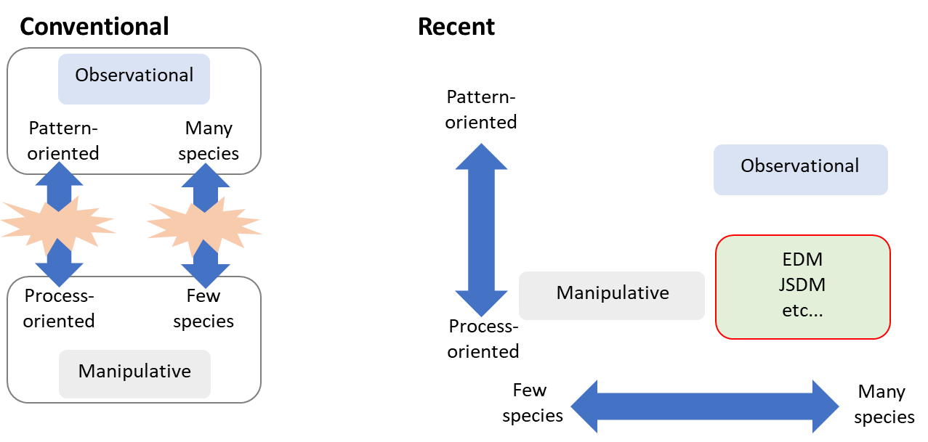

**Interests**

Roles of personal and subjective interests in advancing science are seldom discussed formally. This is understandable because personal and subjective interests do not appear consistent with the objectivity of science. However, it is also true that individual scientists are motivated by their subjective interests. In this section, we discuss why subjective interests matter in the science of ecology.

First, subjective interests drive individual ecologists. When conducting empirical studies, researchers typically focus on a small number of taxa in a particular ecosystem. The choice of which taxa to study is largely arbitrary. While ecologists may shift the taxa they study over their careers, the shifts between ecosystems (e.g., from terrestrial to marine) are less frequent, and the choice of ecosystems is also arbitrary. Some taxa are more suitable to certain experimental manipulations than others, and some taxa are commercially more important than others (e.g., crops and their pests), influencing researchers’ decisions. However, even in such cases, the underlying reason for conducting experiments or being concerned about agricultural production often stems from personal interests. We ecologists also know from experiences that sometimes study taxa or methods are chosen for reasons that are more obviously personal (e.g., preference for charismatic taxa or mathematics). Ultimately, why someone becomes an ecologist, rather than a physicist or lawyer, is (at least partly) a problem of personal interest. Thus, even choices with seemingly logical reasons are underlain by personal interests.

The arbitrariness of choice is especially relevant in ecology. Ecology (and evolutionary biology) is a science that deals with diversity. There are millions of species on Earth, and it is not practical to study all of them for individual ecologists. Furthermore, species is just one of the taxonomic scales. Populations can be different from each other, and the patterns and processes related to between-population differences (or similarities) are worth investigating (e.g., in butterflies and moths, populations at higher latitudes use larger numbers of host plant species; Lancaster 2020). Taxonomic scales above species can also exhibit patterns and processes. A subfamily of butterflies Pierinae, including the cabbage white, can detoxify glucosinolates produced by Brassicales, which is predominantly used as their larval diet (Wheat et al. 2007). Which taxa of which taxonomic scale a researcher is to study is inevitably arbitrary, as explained above. The hierarchy of biological organization (i.e., individuals, species, community, etc.) adds another dimension to the arbitrariness of the choice of study questions. Other components of choice include, though not exhaustive, theory (e.g., coexistence theory, metapopulation theory, etc.), hypotheses, methodology, and paradigms (Pickett et al. 2007).

Second, the diversity of personal interests is an important driver not only of individual scientists but also of the entire field of ecology. Because ecology is the science of diversity, studies on various taxa, scales of the biological hierarchy, etc., are necessary (i.e., the diversity of studies). The diversity of studies is guaranteed by the diversity of personal interests. Personal interests may sound too subjective for the discussion in science. However, science advances through “transformative interrogation” by a diverse community of scientists (Longino 1990). Thus, though personal interests per se are subjective, they collectively underlie the objectivity of science (Pickett et al. 2007).

We also note that arbitrarily chosen questions set the stage for an ecological phenomenon of interest to be interpreted either as a process or a pattern. Let us consider interspecific competition as an example. Experimental manipulation of conspecific and heterospecific densities is a classical approach to study interspecific competition (Connell 1983; Schoener 1983). One may think that interspecific competition quantified in this way is a process that generates patterns such as distributions and demographic dynamics. However, this approach is agnostic about the behavioral mechanisms of the competitive interaction. The presence of heterospecifics can reduce the performance of a population (e.g., population growth) through various mechanisms: e.g., consumption of shared resource (MacArthur and Levins 1967; Levins 1968; Tilman 1982), nonrandom spatial distribution (Pimm and Rosenzweig 1981; Shorrocks et al. 1984; Kuno 1988), or interspecific mating interactions (Kyogoku 2015). For researchers interested in behavioral mechanisms of competitive interactions, individual-level interactions are processes and the impact of heterospecifics on the performance is the resultant pattern. Whether a particular ecological phenomenon is a process or pattern is thus not an inherent characteristic of the phenomenon, but it is context-dependent, underlain by personal interests.

Considering pattern- and process-oriented research from the perspective of individual interests, it is clear that interest in both has developed community ecology itself. In addition to this, the boundaries between patterns and processes in ecology would have turned out to be very fuzzy because the ecological questions that ecologists consider, through the lens of personal interest, determine in a context-dependent manner whether a particular ecological phenomenon should be viewed as a pattern or a process.

**Significance**

In science, one criterion for evaluating the significance of a study is whether a general law could be derived. The skepticism about the maturity of ecology as science seems to have spread since around 1990 at the latest. Rosenzweig (1991) published in June highlighted this sentiment, stating, “*Yet some ecologists have formed a party of gloom, dwelling on our false starts and despairing that ecology will never achieve general principles*”. In September of the same year, Lawton referred to a criticism from a physicist, suggesting that ecologists never appear actually to solve crucial problems (Lawton 1991). Such views would be partly derived from critics of biology from philosophers of science (e.g., Beatty 1995). However, there should be no doubt that recent pessimistic views on generality in ecology, especially in community ecology, are largely influenced by Lawton’s famous opinion paper, “*Are There General Laws in Ecology*?” (Lawton 1999). This paper sparked a heated discussion about the significance of ecology as science, and about the existence of general laws in ecology (Murray 2000; Turchin 2002; Berryman 2003; Colyvan and Ginzburg 2003; Simberloff 2004; O’Hara 2005). Today, most textbooks on community ecology cite this influential paper (Vellend 2016; Leibold and Chase 2017; Mittelbach and Mcgill 2019).

Lawton (1999) argued that community ecology is “*the worst of all worlds*”, because ecological processes that structure local communities are too complicated and contingent, and thus cannot bring laws that work every system, like those of physics. In contrast, he suggested macroecology is superior because it can discover “*general patterns*” without being bothered by trivial events at the local scale (Lawton 1999). However, Lawton (1999) also clearly stated that these discovered patterns in macroecology are not be general laws as he considered laws to be a kind of principle that creates patterns we observe. As a result, the tone that emphasizes the superiority of macroecology gradually stalls as it moves from confident, and just concludes that contingencies in macroscales are manageable compared to intermediate scales (i.e., scales of traditional community ecology), even if it was not a panacea to find universal laws.

The shortcomings of Lawton's claims have been pointed out in many subsequent papers. Firstly, there is criticism regarding a biased understanding of scientific laws presented in Lowton’s paper. It is argued that a causal understanding of laws is not essential, and situational dependence exists in physical laws as well (Colyvan and Ginzburg 2003; Pickett et al. 2007). Additionally, the assertion that predictability is a requirement is challenged from a distant perspective on the purpose of science (Pickett et al. 2007). Furthermore, an alternative counterargument suggests that the presence or absence of a universal law is irrelevant to the significance of its existence in science (Simberloff 2004; O’Hara 2005); it is sufficient for individual events and theories to function cumulatively rather than having a single unified law. These cast doubt on the supremacy of physics within science, and most reached a reasonable conclusion that ecology, including community ecology, is sufficient to be considered a science. In this context, it becomes challenging to argue that pattern-oriented research is more important than process-oriented research.

Nevertheless, Lawton (1999) is much more cited than the subsequent ones, even considering the past years from publication (Table 1). The reason for this would be because the questions raised in Lawton (1999) are crucial, but from a skeptical point of view, it may be simply because extreme statements tend to leave a lasting impression. Arnqvist (2013) notes that the works that discuss their findings in a balanced manner, referring to many related studies, can be underestimated in terms of “novelty”. There is increasing awareness of how psychological bias influences our research evaluation, even in ecology; for example, opinion articles and special features on this theme were published in Nature Ecology and Evolution (Baum and Martin 2018) and The American Naturalist (Kamath et al. 2022). In addition, trends of the time should also influence our research evaluation. A culturomics analysis covering 80 years of trends in ecology and conservation showed boom-and-bust of many research themes (Anderson et al. 2021). For example, many studies around the 1940s focused on agricultural research, especially in grass systems, because the Dust Bowl drought in North America in the 1930s increased the necessity for such studies. It is important to realize that our evaluation of scientific significance can be influenced not only by truly universal values but also by something that is insubstantial atmosphere.

Table 1. The number of citations of Lawton 1999 and the representative articles against it. Citation numbers based on the results of “Google scholar” in May 2024.

|  |  |  |  |
| --- | --- | --- | --- |
| Author (s) | Publication year | Journal | Citation number |
| Lawton JH | 1999 | Oikos | 1874 |
| Murray BG | 2000 | Oikos | 72 |
| Colyvan M, Ginzburg LR | 2003 | Oikos | 132 |
| Simberloff D | 2004 | The American Naturalist | 379 |
| O’Hara RB | 2005 | Oikos | 74 |

**Discussion**

We have reviewed how methods, interests, and significance influence our selection of the research topics. These three aspects are not mutually exclusive but rather interdependent. Through this paper, we have become aware of how methods and interests can affect what is considered a "process" or a "pattern," highlighting the ambiguity of their boundaries. In the section on significance, we referred to how the significance of traditional community ecology, that is, process-oriented types, has been criticized, been protected again, and finally mentioned that we cannot deny that the judgment of scientific significance is affected by psychological biases, more or less.

If the significance of research is indeed ambiguous, should we simply pursue individual interests and explore research we are passionate about? The answer to this would be both yes and no. Even within the field of ecology, there are numerous specialized subfields, each developing independently and contributing to the diverse landscape of ecological research. Can we collectively work toward a common research goal? Rather, the question may start with, “Do we even have a common research goal?” Not only in ecology but in science itself, the methodology for achieving something as an organization is still quite immature, akin to constructing a castle without a blueprint. Although not widely recognized, Lawton (1991) made sharp observations on these issues. In this essay, he pointed out that each ecologist tends to focus on original materials and ecosystems, but should put more emphasis on common model materials and systems and prioritize reproducibility. Over 30 years have passed since the publication of the essay, we may have progressed a little; now we have some model systems, such as Brassicaceae and Solanaceae, and improved data sharing by data depository sites. However, research trends are still largely influenced by methodology, interests, and significance, and most researchers still focus on original systems. To change this situation, we may need a larger common goal. In this sense, efforts to resolve ongoing global environmental changes, such as climate changes and anthropogenic disturbance of biodiversity, may have the potential to propel ecology forward.

Alternatively, further clarification through greater specialization within the field could be a means of achieving organization. Lawton (1991) criticized the scattered approach of ecologists by using the analogy of disassembling different types of watches (spring-driven, electric, pendulum) in parallel to understand the concept of a clock. He argued that this scattered approach would never lead to a comprehensive understanding of the clock's mechanism. Instead, researchers studying spring mechanisms, for instance, could focus solely on springs and create catalogs, which might eventually be useful when assembling a spring-driven clock. Acknowledging this kind of flexibility could eliminate binary and fruitless debates (Pickett 2007) and contribute to the advancement of ecology. In such a scenario, the key lies in how the reorganization is carried out, ultimately requiring an overarching strategy. The higher-order processes proposed by Vellend (2016) and the Modern Coexistence Theory (MCT) formalized by Chesson (1994, 2000) could offer valuable insights for developing this overarching strategy.

In conclusion, we emphasize that both process- and pattern-oriented research are hierarchical and interconnected (Figure 4). Ecological processes that we identify often encompass both proximate (i.e., explanations based on characteristics of individual species) and ultimate (i.e., theoretical explanations) aspects, with focus varying based on personal interests. Therefore, it is essential to prioritize personal “interests” over mere subjectivity, recognizing their pivotal role in shaping research agendas. Embracing the diversity of research “methods” is also crucial, without confining them to specialized methods for either pattern- or process-oriented research. Recent advancements in modeling allow us to discern processes from observational data. Additionally, we must acknowledge the “significance” of various research approaches and fields, steering clear of narrow and arbitrary evaluations. The significance of a study transcends mere metrics like research funding or publication in high-impact factor journals. In the development of ecological science, the roles of methods, interests, and significance are crucial. By challenging conventional views and considering these factors holistically and by finding where they intersect (the red circle in Figure 4), researchers can identify and pursue research questions that are not only scientifically valuable but also personally meaningful and feasible. As process-oriented researchers, we take pride in our system-specific investigations. There are many important things that can only be discovered in that species and that system. However, we must acknowledge the importance of spreading our findings in a manner that can be extrapolated to other systems. For instance, while process-oriented studies offer valuable insights into the intricate interactions of organisms, they are sometimes overly focused on proximate aspects. On the other hand, simply categorizing phenomena into higher-order processes may fail to convey the interest and depth of individual systems and may lose the interest of process-oriented researchers. To explain how it is species-specific and yet not species-specific, one must maintain a firm interest without getting stuck in a rigid method and consider its importance at various levels of hierarchy. When the significance is balanced, neither too focused on patterns nor too focused on processes, a kind of general law may emerge that is just good enough. These “just good enough” general laws serve as bridges between intricate processes and overarching ecological patterns, enriching our understanding of ecological phenomena. Rather than conforming to singular, unified principles, they embrace the hierarchical interplay of individual processes and patterns, collectively enhancing our ecological insights.

