Credit Scoring Model Using Machine Learning
Project Report

Abstract
This project focuses on developing a Machine Learning-based Credit Scoring Model to predict whether a customer is creditworthy or risky based on financial and demographic information. The system uses data preprocessing, feature scaling, classification algorithms, and evaluation metrics to analyze customer credit behavior. Logistic Regression and Random Forest algorithms were implemented, and model performance was improved using the SMOTE balancing technique. The final model achieved balanced performance with improved risky-customer detection, making it useful for banking and financial risk analysis.

Chapter 1: Introduction
Credit scoring is an important process used by banks and financial institutions to determine whether a customer is eligible for loans or credit services. Traditional methods are time-consuming and less efficient for large datasets. Machine Learning provides automated and data-driven solutions for predicting customer creditworthiness.
This project develops a Machine Learning model that predicts whether a customer is financially reliable or risky using customer financial attributes such as age, loan amount, account information, housing status, and repayment-related details.
Objectives:
• Build a predictive credit scoring system
• Handle missing and categorical data
• Compare Machine Learning algorithms
• Improve performance using SMOTE
• Analyze feature importance and business insights

Chapter 2: Literature Review
Several Machine Learning techniques have been used in financial risk prediction systems. Logistic Regression is widely used due to its simplicity and interpretability. Decision Trees and Random Forest models provide improved prediction capabilities for nonlinear financial data. Ensemble learning methods such as Random Forest reduce overfitting and improve stability.
Recent research highlights that data preprocessing, feature engineering, and class balancing techniques significantly affect model performance. SMOTE has become a commonly used method for handling imbalanced financial datasets by generating synthetic minority-class samples.

Chapter 3: Dataset Description
The German Credit Dataset was used for this project. The dataset contains financial and demographic information about customers.
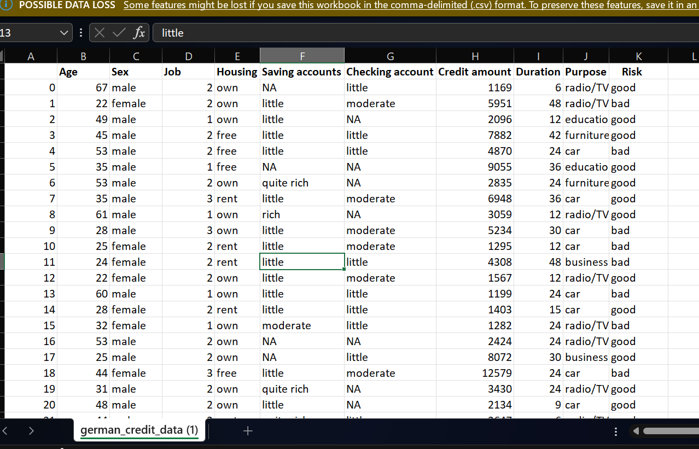
Dataset Features:
• Age
• Sex
• Job
• Housing
• Saving accounts
• Checking account
• Credit amount
• Duration
• Purpose
• Risk (Target Variable)
Target Classes:
• Good Credit Risk
• Bad Credit Risk
Dataset Size:
• Total Records: 1000
• Features Used: 9

Chapter 4: Methodology
Step 1: Data Collection
The German Credit Dataset was imported into Google Colab using Pandas.
Step 2: Data Preprocessing
• Removed unnecessary columns
• Handled missing values using 'unknown'
• Encoded categorical variables using Label Encoding
• Performed feature scaling using StandardScaler
Step 3: Train-Test Split
The dataset was divided into:
• 80% Training Data
• 20% Testing Data
Step 4: Model Training
The following algorithms were implemented:
• Logistic Regression
• Random Forest Classifier
Step 5: Handling Class Imbalance
SMOTE (Synthetic Minority Oversampling Technique) was applied to balance the training dataset.
Step 6: Model Evaluation
Performance was evaluated using:
• Accuracy
• Precision
• Recall
• F1-Score
• Confusion Matrix
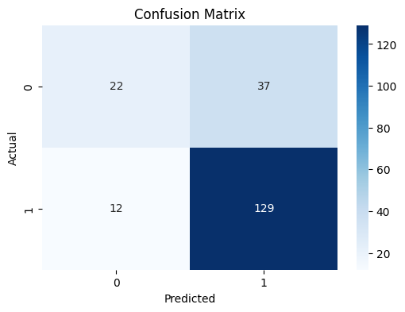
• ROC-AUC Curve
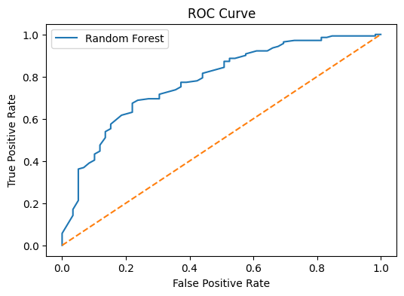

Chapter 5: Implementation
Libraries Used:
• Pandas
• NumPy
• Matplotlib
• Seaborn
• Scikit-learn
• imbalanced-learn
• Joblib
Main Implementation Steps:
1. Load Dataset
2. Handle Missing Values
3. Encode Categorical Features
4. Split Features and Target
5. Train-Test Split
6. Feature Scaling
7. Train Logistic Regression
8. Train Random Forest
9. Apply SMOTE
10. Evaluate Performance
11. Save Final Model

Chapter 6: Results and Discussion
Logistic Regression Results:
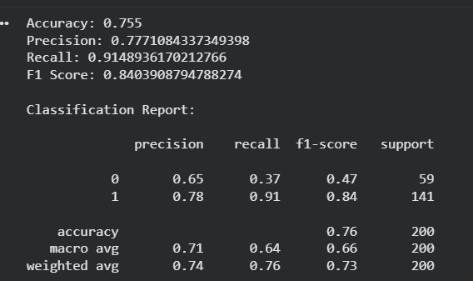
• Accuracy: 75.5%
• Precision: 77.7%
• Recall: 91.5%
• F1-Score: 84.0%
Random Forest Results:
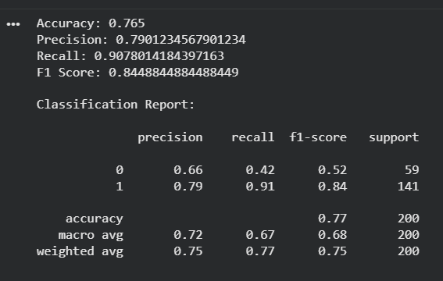
• Accuracy: 76.5%
• Precision: 79.0%
• Recall: 90.8%
• F1-Score: 84.5%

Random Forest with SMOTE Results:
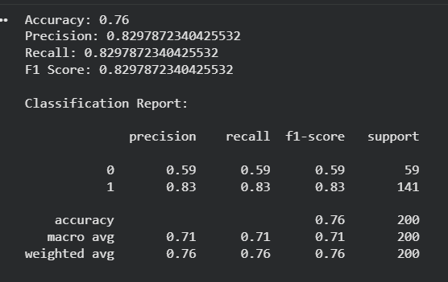

• Accuracy: 76.0%
• Precision: 82.9%
• Recall: 82.9%
• F1-Score: 82.9%
Observations:
• Random Forest performed better than Logistic Regression.
• SMOTE improved risky-customer detection significantly.
• Credit Amount, Age, and Duration were identified as the most important features.
• The model showed balanced performance with realistic financial prediction behavior.

Chapter 7: Feature Importance Analysis
Feature importance analysis showed that the following features had the highest influence on credit risk prediction:
1. Credit Amount
2. Age
3. Duration
4. Checking Account
5. Purpose
This indicates that financial behavior and loan-related factors have greater influence on customer risk compared to demographic variables.

Chapter 8: Advantages and Limitations
Advantages:
• Automated credit evaluation
• Faster financial decision-making
• Reduced human errors
• Improved risky-customer identification
• Efficient data analysis
Limitations:
• Dataset imbalance affected initial predictions
• Model performance depends on data quality
• Real-world banking datasets are larger and more complex
• Synthetic oversampling may introduce minor bias

Chapter 9: Conclusion and Future Scope
Conclusion:
The project successfully developed a Machine Learning-based Credit Scoring Model capable of predicting customer credit risk using financial and demographic data. Random Forest combined with SMOTE produced the most balanced performance. The project demonstrated the importance of preprocessing, class balancing, and evaluation metrics in financial prediction systems.
Future Scope:
• Implement advanced algorithms such as XGBoost
• Use larger real-world banking datasets
• Develop a Streamlit-based web application
• Deploy the model using cloud services
• Integrate real-time loan approval systems

References
1. Scikit-learn Documentation
2. Kaggle German Credit Dataset
3. Imbalanced-learn Documentation
4. Research Papers on Credit Risk Prediction
5. Machine Learning for Financial Risk Analysis

