

BUSINESS BROCHURE 2026

Measure & maximize
your AI return
on investment.

The vendor-neutral AI portfolio cockpit for CIO and CFO offices. AI spend, use-case ROI and workforce capability, on one screen.
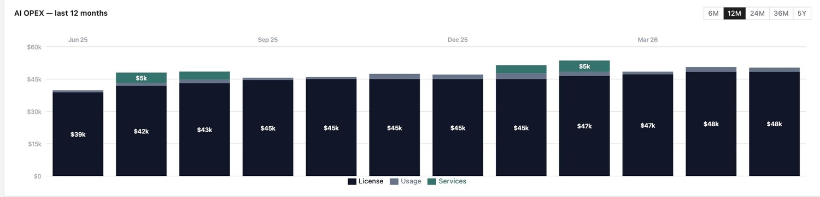

aixxen.com
sales@aixxen.com Pre-seed Live demo on request



INSIDE THIS BROCHURE
Contents

What AIXXEN does, the evidence behind it, how it works, and who it is built for. Every figure here reflects the live product or a named third-party source.
01 The Problem  02 The Evidence  03 What We Do  04 The Difference  05 Every Number That Matters  06 Tools & Vendors  07 Use Cases  08 The Five-Year Roadmap |  | 09 Reports & Capability  10 How It Works  11 Who It’s For  12 Inside the Cockpit  13 From the Founder  14 Questions & Answers  15 Why Now  16 Built on Trust



01 THE PROBLEM
Your AI is optimized.
Your employees aren’t.

AI tools are bought faster than any software category before them. Licenses land on departmental cards, pilots multiply, and the invoices stack up across a dozen vendors that no single person reconciles.
The benefit side stays unmeasured. Most AI budgets are still justified on projected savings. You know the line. “Five minutes per task across two hundred people.” Almost nobody checks it against the P&L afterward.
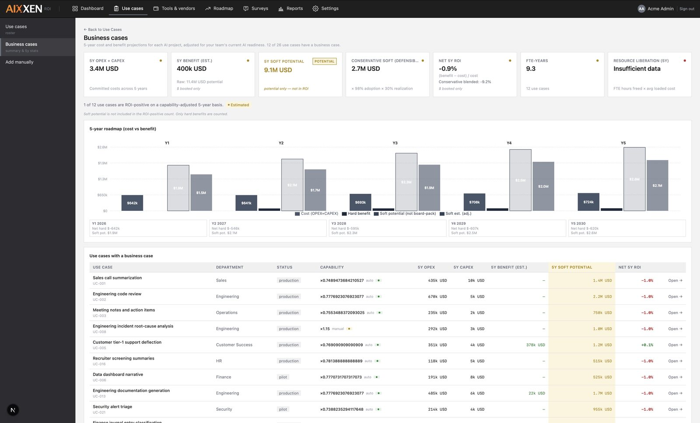
Business case analytics in AIXXEN. Projected potential is pulled back to realized value.
 | $307B  Enterprise AI spend in 2025  IDC, AI Spending Guide, 2025 | 30%+  of GenAI projects abandoned after proof of concept  Gartner, 2024 | 37%  of firms have a policy to manage shadow AI  IBM, Cost of a Data Breach, 2025
A gap has opened between what AI is
assumed to deliver, and what it has delivered.



02 THE EVIDENCE
Adoption raced ahead
of accountability.

95%  of enterprise generative-AI pilots show no measurable P&L impact.  MIT NANDA, The GenAI Divide, 2025  88%  use AI, yet only about 6% see meaningful EBIT impact.  McKinsey, The State of AI, 2025 |  | 5%  of companies capture AI value at scale. 60% see none at all.  BCG, The Widening AI Value Gap, 2025  1 in 5  organizations qualify as AI ROI Leaders that measure return.  Deloitte, AI ROI: The Paradox, 2025
Three independent methodologies, one finding. The constraint is not the technology. It is the absence of measurement, governance and a hard-versus-soft discipline. That gap is what AIXXEN closes.



03 WHAT WE DO
See your entire AI
portfolio on one screen.

Every dollar paid to every AI vendor. Use-case-by-use-case ROI. A five-year plan of record. One screen, one tab.
AIXXEN is a portfolio cockpit, not a compliance tool. Vendor-neutral by design, no compliance overhead. The job is narrow. Measure AI benefits, and show where the money works.
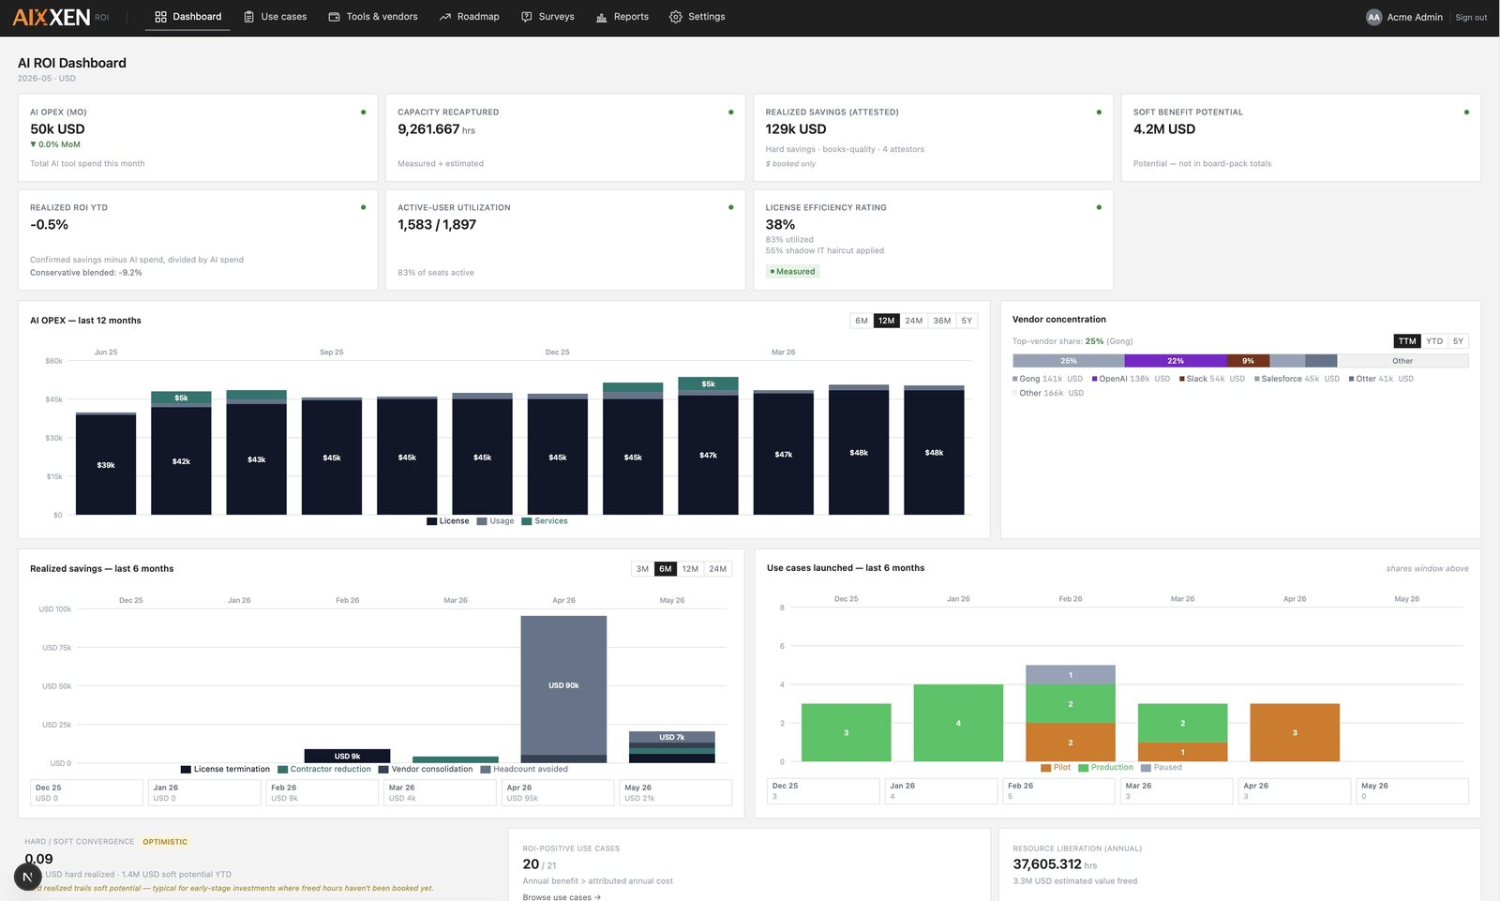
The AIXXEN portfolio dashboard. Total AI spend, realized ROI and capability score, in one glance.
 | Portfolio dashboard  Total AI spend, realized ROI, capability score and top use cases. Readable in under ten seconds. |  | Vendor spend tracking  Every AI vendor, every invoice, every renewal cliff. Sorted by lifetime spend, flagged before auto-renewal.
 | Use cases & business cases  Hard P&L savings and soft potential separated at the data model. |  | Capability measurement  A capability factor calibrated to your organization adjusts every soft projection.
Works with your stack. OpenAI, Microsoft Copilot, Google Gemini, Anthropic, Notion AI, Glean, Gamma and any other vendor.



04 THE AIXXEN DIFFERENCE
Hard savings. Soft potential.
Never blended.

The number your CFO sees is defensible because it earned its way there. It was never quietly mixed with a vendor’s optimistic projection. AIXXEN keeps the two apart at the data-model level.
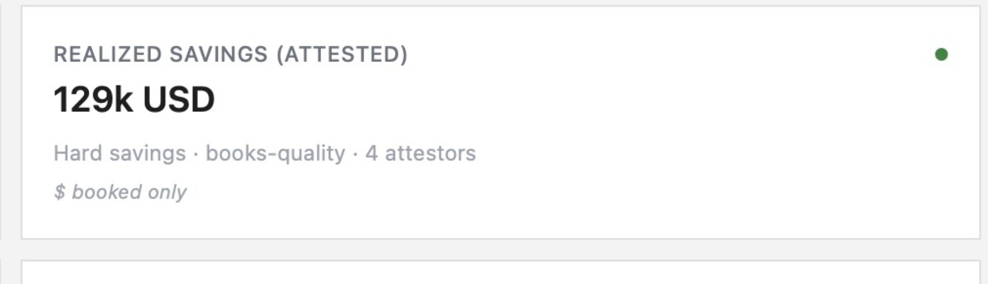
Hard savings. Booked, attested, and the only number that reaches the board-pack total.
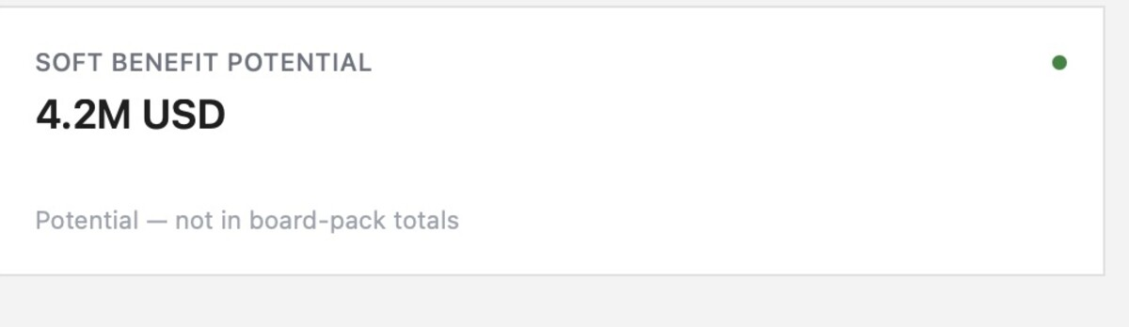
Soft potential. Capacity freed, reduced automatically by your capability factor. Tracked, never in the headline.



05 EVERY NUMBER THAT MATTERS
Six numbers.
One coherent answer.

Together these six answer the question every AI program reaches sooner or later. Is this worth it?
 | Vendor lifetime spend  Stacked spend over time, concentration risk flagged above 40%, a renewal Gantt and an invoice ledger. |  | Hard P&L savings  Attested savings that have moved through the P&L. Their own column, always.
 | Soft potential  Capacity freed, reduced by your capability factor. Not a vendor benchmark. |  | Five-year plan of record  Contracted costs, planned business cases and realized savings, sixty months forward.
 | Shadow AI signal  Spend you do not see yet, surfaced through spend-anomaly detection. |  | Board-pack reports  Any cross-source query as a table, bar, line, pie or KPI. CSV export.



06 PRODUCT SURFACE
Tools & Vendors

Every dollar paid to every AI vendor, on one page.
Stacked spend over time. Top-vendor concentration. A cost-versus-utilization quadrant that makes the tools wasting money visible at once. A renewal Gantt, an invoice ledger. No procurement workflow, no PO numbers. This is cost controlling, full stop.
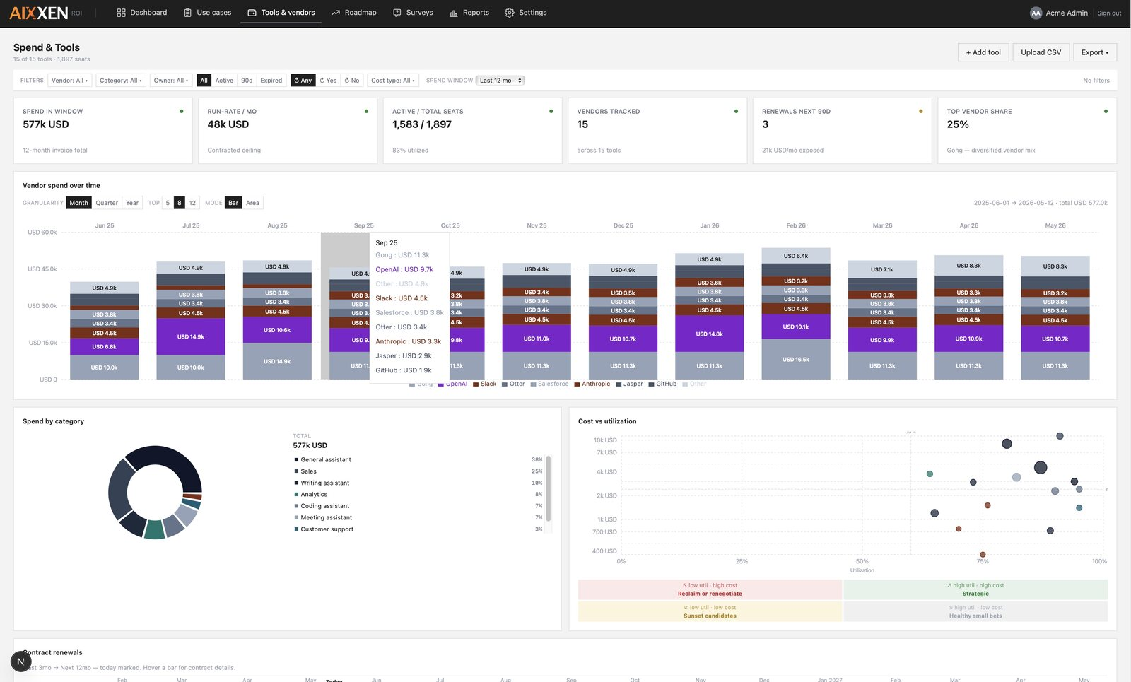
Vendor spend tracking. Lifetime spend, concentration and renewals on one view.
40%  Concentration risk threshold | 90 days  Renewal warning window | 1 click  To sort lifetime spend



07 PRODUCT SURFACE
Use Cases &
Business Cases

Hard and soft benefits, separated at the data model.
Every AI use case is tracked across its whole life. Idea, pilot, production, review. Each one carries a typed business case, and the capability factor is applied automatically. No vendor’s pitch number ever lands in your CFO’s spreadsheet untouched.
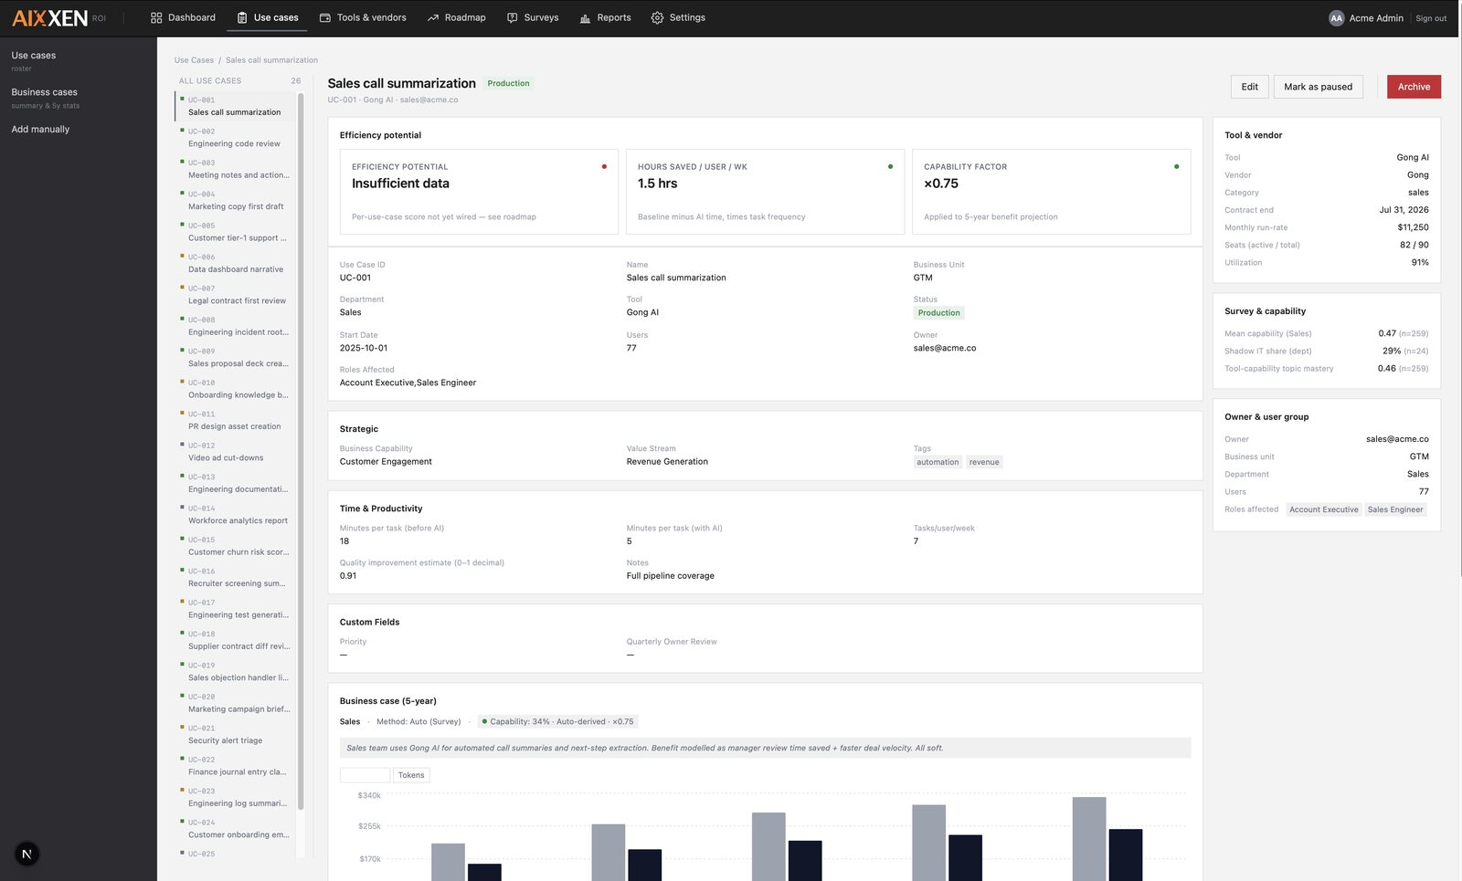
The use-case and business-case view. Hard and soft benefits, typed and separated.
 | Idea  01  Logged with an owner and a typed business case. |  | Pilot  02  Soft potential estimated, capability-adjusted. |  | Production  03  Hard savings attested as they hit the P&L. |  | Review  04  Projected versus realized, side by side.



08 PRODUCT SURFACE
The Five-Year
Roadmap

A plan of record across the next sixty months.
Contracted costs. Planned business cases. Realized savings, extending forward. Cluster filters by status, department, vendor, capability or value stream. It is not a forecast, not a Monte Carlo simulation, not built on AI uplift multipliers. It is what is already on the books.
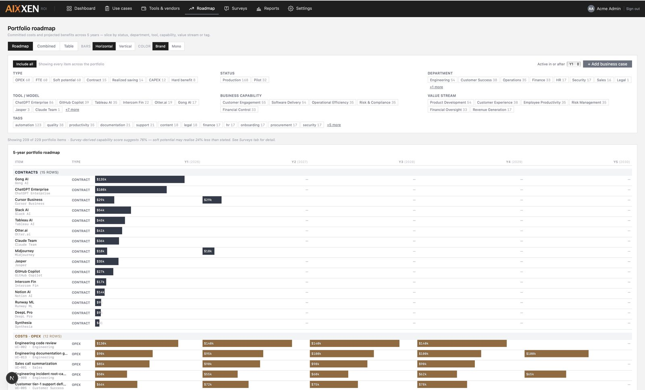
The five-year roadmap. Contracted costs, planned cases and realized savings on one timeline.



09 PRODUCT SURFACE
Reports & Capability

Custom reports. Capability scoreboards. Board-pack ready.
Build any cross-source query as a table, bar, line, pie or KPI. A capability score per department, adoption breadth and shadow-AI share sit alongside spend, never apart from it.
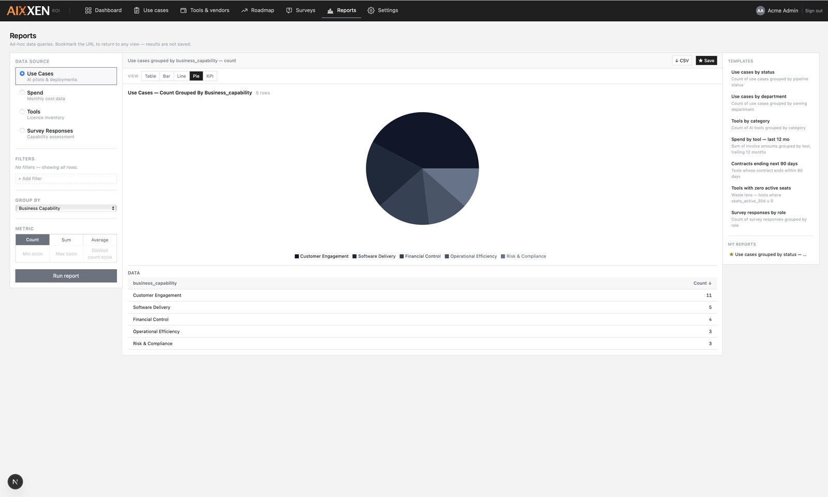
Custom reports and capability scoreboards. Board-pack ready, CSV-exportable.
The capability factor
Capability is calculated from real usage data. Adoption rates, active users, workflow integration. The result is calibrated to your organization rather than a vendor benchmark, so optimistic estimates fall back to the level your teams can really reach.



10 HOW IT WORKS
Three steps to a
working cockpit.

01
Setup
Bring four data sources. Tools, spend, user count and use cases. CSV or Excel works today, with direct API import on the roadmap. Most enterprises already export this from procurement and HR.
02
First capability snapshot
AIXXEN calculates your capability factor from real usage data. Adoption rates, active users, workflow integration. Calibrated to your organization, not a vendor benchmark.
03
Reporting
Vendor lifetime spend, hard versus soft realized savings, the roadmap and department readiness. All on screen, all exportable as CSV.



11 WHO IT’S FOR
Built for three jobs.
Worked around for none.

 | The CFO  A defensible number. Hard booked savings and soft potential live in different columns, and soft potential never reaches the board-pack total. |  | The CIO  Spend and readiness on one screen, so AI program decisions are informed by both at once. |  | The FinOps lead  The operator’s data layer. Utilization versus cost, shadow-AI share, soft-to-hard convergence, custom reports.
One surface, three vantage points. The CFO, the CIO and the FinOps lead read the same data model, each filtered to the view their job needs. A decision taken in the board room and a decision taken in the spreadsheet stay consistent.



12 INSIDE THE COCKPIT
The C-suite view,
in under ten seconds.

The portfolio dashboard is the first screen leadership sees. Total AI spend, realized ROI, capability score, top use cases, renewal exposure and shadow-AI share. If the portfolio cannot be read at a glance, it will not be read at all.
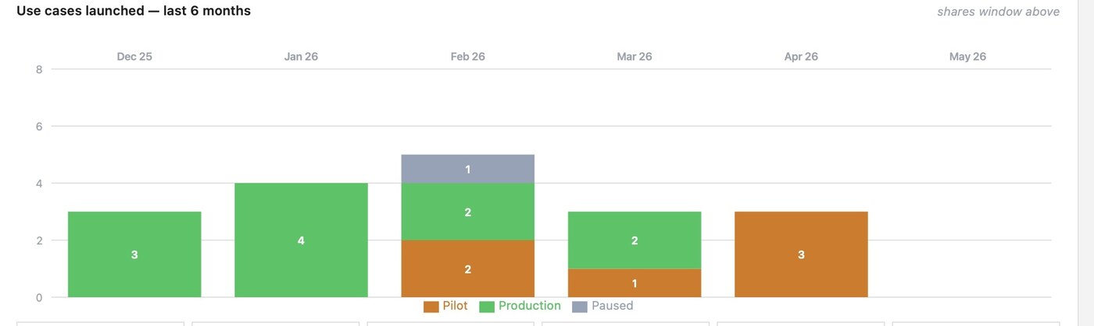
Use cases launched, pilot against production, over the trailing six months.
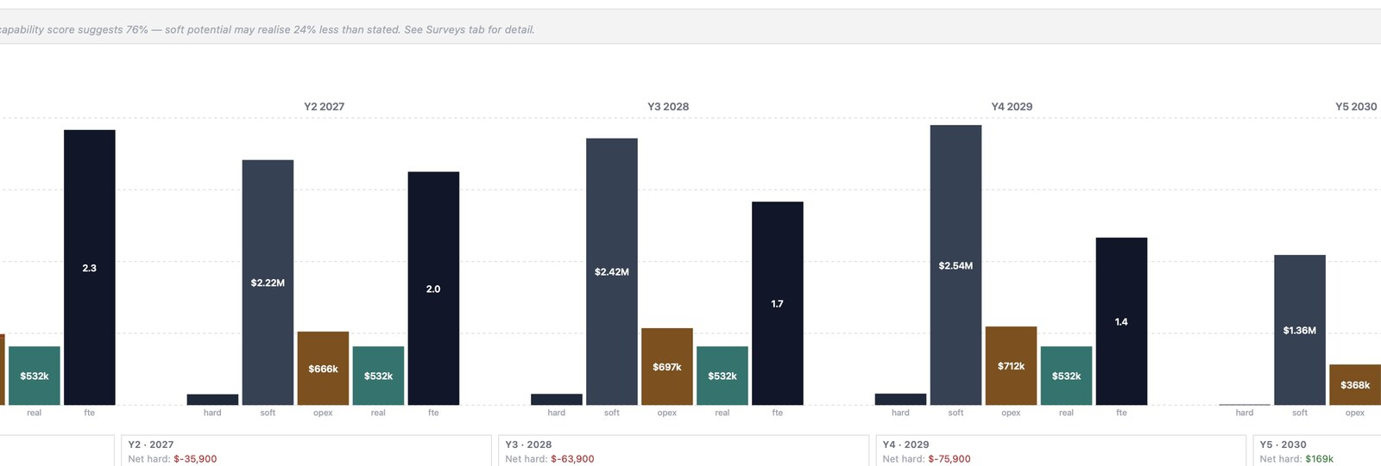
Stacked AI cost and realized savings across the portfolio horizon.



13 FROM THE FOUNDER
A company built around
one missing number.

 | 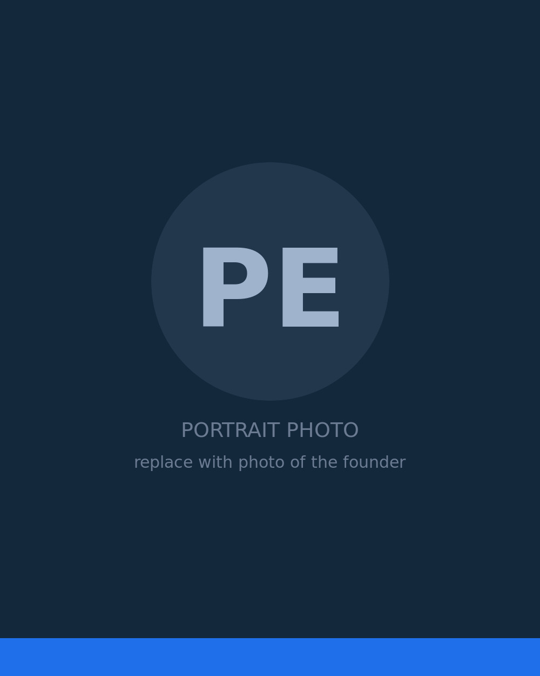  Philipp Eiselt  Founder, AIXXEN |  | AIXXEN started from a single observation. Enterprises can tell you to the cent what they spend on AI, and almost nothing about what it returns.  We build AIXXEN for the CIO and CFO offices carrying that gap. The product does one thing well. It turns scattered, unmeasured AI spend into a tracked portfolio, with use-case ROI, a hard-versus-soft savings split, and the governance view that AI programs now need.  Our vision is plain. AI accountability should be ordinary practice, the way SaaS cost control became ordinary a decade ago. Every AI dollar measured against the value it returns. No blended numbers, no vendor benchmarks standing in for evidence.  AIXXEN is early, and deliberately so. We would rather be the vendor-neutral system of record an AI portfolio is run on than another tool competing for a slice of the budget it is meant to measure.
THE VISION
“If you cannot measure it, you cannot defend it. AIXXEN exists so that every AI dollar an enterprise spends can be weighed against the value it returns.”



14 QUESTIONS & ANSWERS
Sharp questions,
sharp answers.

How do you calculate ROI on AI investments?
AI ROI is the realized financial benefit minus the total cost of ownership, divided by that cost. AIXXEN calculates it per use case, so you see which AI tools clear the bar and which do not.

What is AI governance, and how does AIXXEN support it?
It is the set of controls that keep AI usage visible, accountable and aligned with policy. AIXXEN provides the inventory behind it, every tool with its spend, owner and measured ROI on one screen.

How do you measure the benefits of AI correctly?
By separating projected potential from realized savings. AIXXEN tracks benefits against a baseline and counts only realized value.

Is AIXXEN vendor-locked?
No. AIXXEN is vendor-neutral by design. Every AI tool you pay for sits on the same page, regardless of vendor.

How quickly can we be live?
Onboarding is small and pragmatic. CSV and Excel import work today. Direct API import is on the roadmap.



15 WHY NOW
The audit gap
is closing fast.

What generic SaaS did over a decade, AI is doing in a few years. It spreads across departments, lands on cards, and compounds quietly into a serious line item.
Finance teams are catching up on the cost side. The discipline that took years to arrive for SaaS is arriving for AI much faster. The benefit side lags. Whether any of it returned the investment is still largely unmeasured.
Closing fast  The audit gap, knowing what AI costs. Procurement and finance are already moving on it. | Wide open  The ROI gap, knowing what AI returns. Still unmeasured in most organizations.

The organizations that measured SaaS ROI early spent the next decade with an advantage. AI is the same opportunity, on a shorter clock.



16 BUILT ON TRUST
Vendor-neutral.
No compliance overhead.

 | Vendor-neutral by design  Every AI tool you pay for sits on the same page, regardless of category or vendor. AIXXEN never steers you toward a preferred stack. |  | No compliance overhead  A portfolio cockpit, not a compliance regime. Visibility without adding process for your teams to carry.
 | Your data, your numbers  The capability factor is calibrated to your organization, not a vendor benchmark. The numbers you report are yours. |  | Import on your terms  CSV and Excel import work today. Direct API import is on the roadmap. You decide how your data reaches the cockpit.
Shadow AI, surfaced the right way
Unmanaged AI spend is real. It should not be hunted through network monitoring. AIXXEN surfaces shadow AI through spend-anomaly detection. A finance signal, not a surveillance one.



GET STARTED
Stop confusing soft
potential with
realized savings.

Book a 30-minute demo. Bring a sense of your AI tools, spend and use cases, and leave with a clear picture of what a portfolio cockpit would show you.
01 Book a demo
Email sales@aixxen.com to arrange a 30-minute walkthrough.
02 Talk through your data
We map your tools, spend, headcount and use cases to the four data sources.
03 See your cockpit
The screens populate and we agree a realistic onboarding timeline together.

sales@aixxen.com
aixxen.com Same-day response during EU and US business hours.



AI PORTFOLIO INTELLIGENCE

Evaluate, track and prove the return on every AI investment. On one screen.

aixxen.com sales@aixxen.com
© 2026 AIXXEN. AI benefits, tracked properly.

