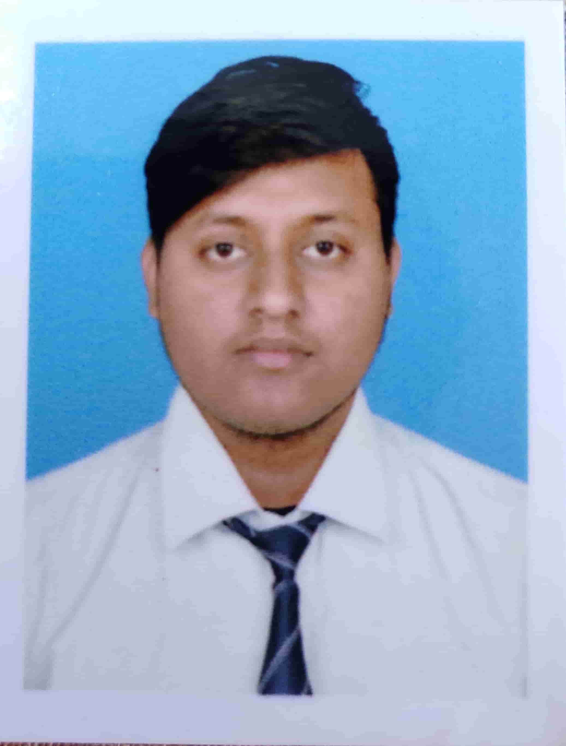HIRONMOY NANDI

Vill+po – Santiniketan

City – Bolpur

Dist – Birbhum

Pin - 731235

West Bengal

Mob: 7585950384

Email: hiron1997@gmail.com

**Career Objectives:**

* Secure a responsible career opportunity to fully utilized my training and skills, while making a significant contribution to the success of the company.

**Skill sets:**

* **HTML5,CSS, BOOTSTRAP, ANGULAR JS**
* Good communication skill

**Education Qualification :**

|  |  |  |  |  |
| --- | --- | --- | --- | --- |
| **EDUCATION** | **INSTITUTION** | **UNIVERSITY/**  **BOARD** | **YEAR OF PASSING** | **MARKS/DGPA** |
| **BCA** | **BENGAL COLLEGE OF ENGINEERING AND TECHNOLOGY** | **MAKAUT** | **2020** | **7.06** |
| **12** | **BOLPUR HIGH SCHOOL** | **WBCHSE** | **2017** | **56.4%** |
| **10** | **BOLPUR HIGH SCHOOL** | **WBBSE** | **2015** | **48.85%** |

**WORK EXPERIENCE:**

**1 year at WEBSKITTERS TECHNOLOGY SOLUTION PVT LTD**

**As a Web designer in html css and angular js with figma design.**

**PROJECT:**

* **Student management system in java.**

**TRAINING:**

* + **CORE JAVA IN ARDENT COMPUTECH PVT LTD.**

**HOBBIES:**

* **Singing**
* **Watching movie**

**PERSONAL PROFILE:**

**Date of birth** : 23/11/1999

**Language** : Bengali , Hindi, English