www.vbripress.com/eamc, DOI: [10.5185/eamc.2017](http://dx.doi.org/10.5185/eamc.2017) Published online by the VBRI Press in 2017

**Participatory Architectural Design and Fabrication with Natural Materials in Native Forms**

Photograph of Presenting author

**Hironori Yoshida1*, Maria Larsson1 ,Takeo Igarashi1**

*1the University of Tokyo, Tokyo, 113-0033, Japan*

*Corresponding author. Tel: (+81) 3-5841-4109 ; Fax: (+81) 3-5841-4105; E-mail: hyoshida@hy-ma.com

**Table of contents**

1. Introduction
2. Related Work
3. Workflow
   1. Digital Model Acquisition
   2. Digital Fabrication
4. BranchConnect: The Game
   1. The Game System
   2. Score Calculation
5. Case Study
   1. User Experiences
   2. Results
6. Conclusion
7. References

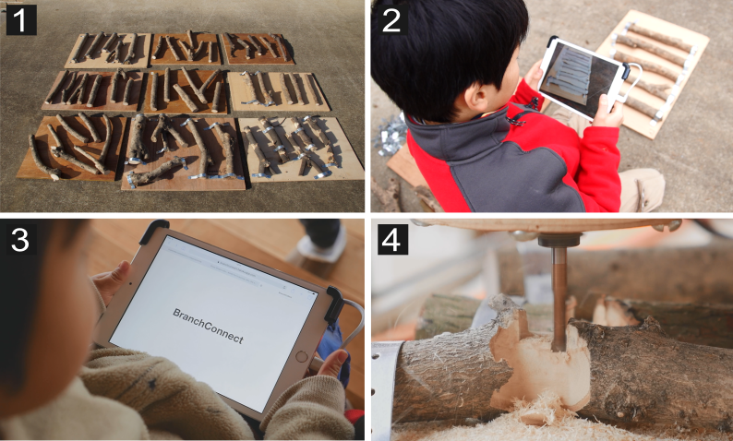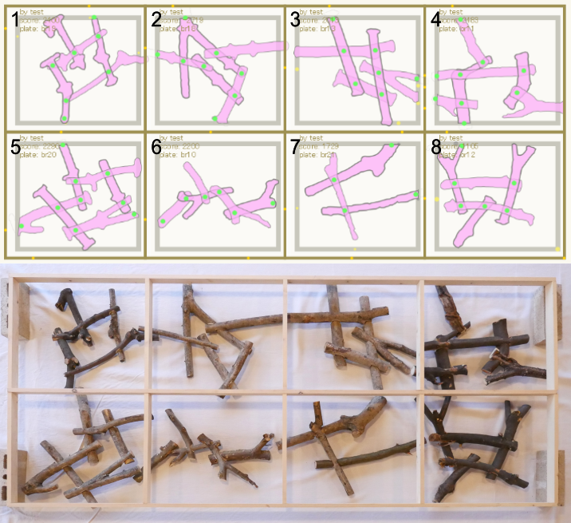

Left: an overview of the workflow: 1. fix branches on plates. 2. scan the plates and upload the model. 3. play the game with

scanned branches. 4. fabricate joineries by a CNC (Computer Numerical Control) router. Right top: branch layouts designed using the game. 6 and 7 were designed and fabricated by participants in the case study. Right bottom: the fabricated 2D fence (2000 mm × 900 mm). Each pair of branches is connected with rigid lapped joint.

**Abstract**

Diverse natural materials such as stones and woods have been used as architectural elements preserving their native forms since primitive shelters. Today, such a direct use can not compete with highly standardized materials and construction system, however, the uniqueness of native forms is a valuable quality which is lacking in standardized materials. As the material is locally obtained, building and living get much closer, thus people using the building can easily commit design and fabrication, fostering the sense of belonging to the community. This paper aims to make the above-mentioned qualities of materials in native forms more accessible for end users by leveraging digital technologies. We use locally obtained branches which can be found almost everywhere, and design and fabricate an architectural element through playing an online game “BranchConnect”. The game enables end users to design layouts of branches two-dimensionally and fabricate designs by a CNC router. Taking irregular forms of branches, each connection has a customized unique lap-joint. The scoring system of the game guides users to design feasible solutions with given branches and fabrication constraints, such as movable axis limitations with ordinal 3-axis CNC routers. Not only playing the game, but users can also upload branches to our online platform by collecting and scanning branches found in their environment at hand and scan them by mobile devices. For validating our process, we conducted a workshop with children and their parents from a local community. They collected branches in a nearby forest and contributed to design and fabricate a 2D fence with our system.

**Keywords:** Participatory Architectural Design; Digital Fabrication; Human Computation. (Include 3-5 Keywords)

**Acknowledgements**

Please acknowledge the funding authorities and other research supports.

**Reference** (Not more than 5, please follow the below reference style if any).

1. S CHINDLER , C., T AMKE , M., T ABATABAI , A., B EREUTER , M., AND Y OSHIDA , H. 2014. Processing branches: Reactivating the performativity of natural wooden form with contemporary information technology. International Journal of Architectural Computing 12, 2, 101–115.
2. IMERMAN , B. 2000. Participatory design in architecture: can computers help? In PDC, 40–48
3. UELLER , S., L OPES , P., AND B AUDISCH , P. 2012. Interactive construction: interactive fabrication of functional mechanical devices. In Proceedings of the 25th annual ACM symposium on User interface software and technology, ACM, New York, NY, USA, UIST ’12, 599–606
4. L AFRENIERE , B., G ROSSMAN , T., A NDERSON , F., M ATEJKA , J., K ERRICK , H., N AGY , D., V ASEY , L., A THERTON , E., B EIRNE , N., C OELHO , M. H., ET AL . 2016. Crowdsourced fabrication. In Proceedings of the 29th Annual Symposium on User Interface Software and Technology, ACM, 15–28.
5. MPAECHER , A., F ELTMAN , N., T REUILLE , A., AND C OHEN , M. 2013. Real-time drawing assistance through crowdsourcing. ACM Transactions on Graphics (TOG) 32, 4, 54.