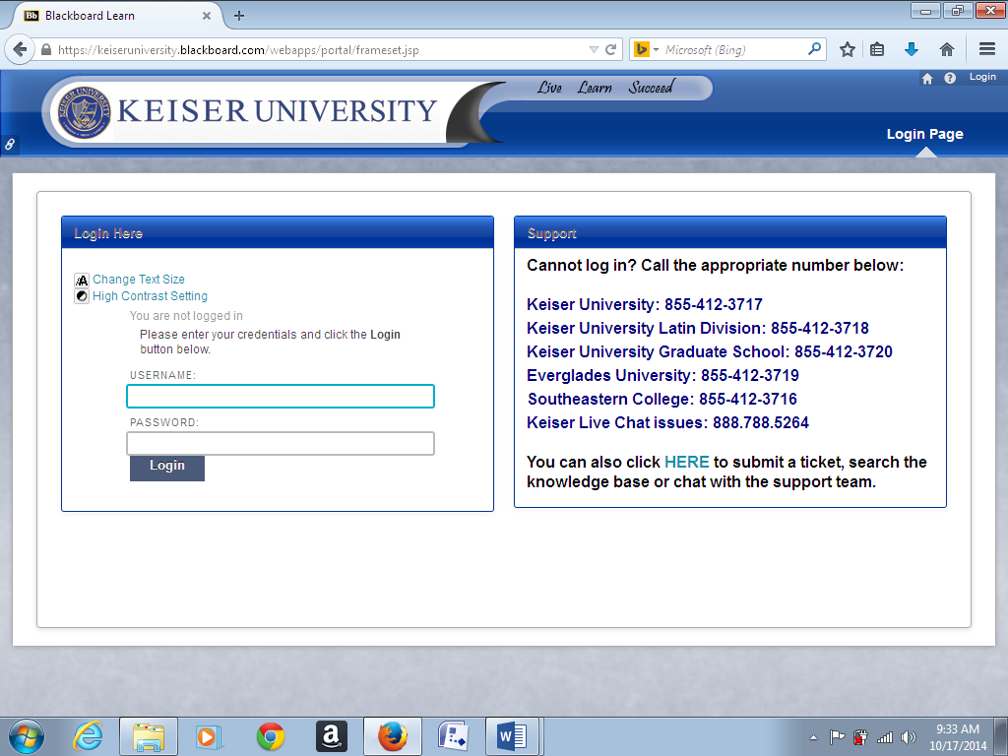

TRAINING MANUAL

**FOR KU TAX TEAM**

**Prepared By:** SHELIA WILLIAMS

**Prepared For:** TAX SERVICES STAFF

**Date:** 10/17/2014

**ABOUT MANUAL**

This manual is prepared to help new and existing staff to train employees on the new tax database. This manual contains screen shots of the actual database and instructions. This manual can be used as system documentation for the owner.

**Log-in Screen** – Requires that the Employee enter a valid user-id and password. Passwords will expire every ninety days, and the user will be prompted to change their password.

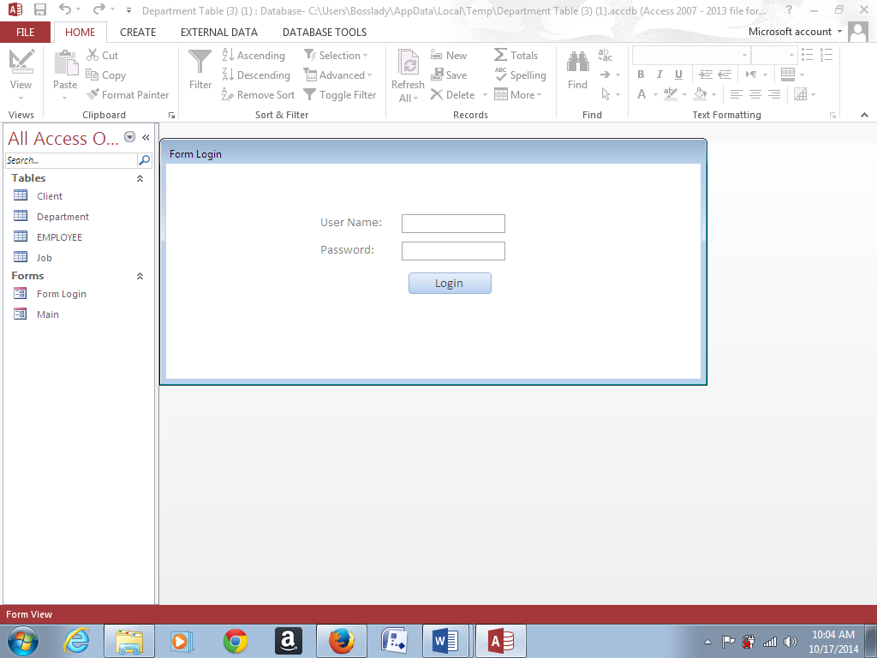

The **EMPLOYEE table** consists of employee personal data. If the employee’s name is not in this table, they will not be able to access the system.

**Note: The example below does not contain actual employees’ data, this is only an example.**

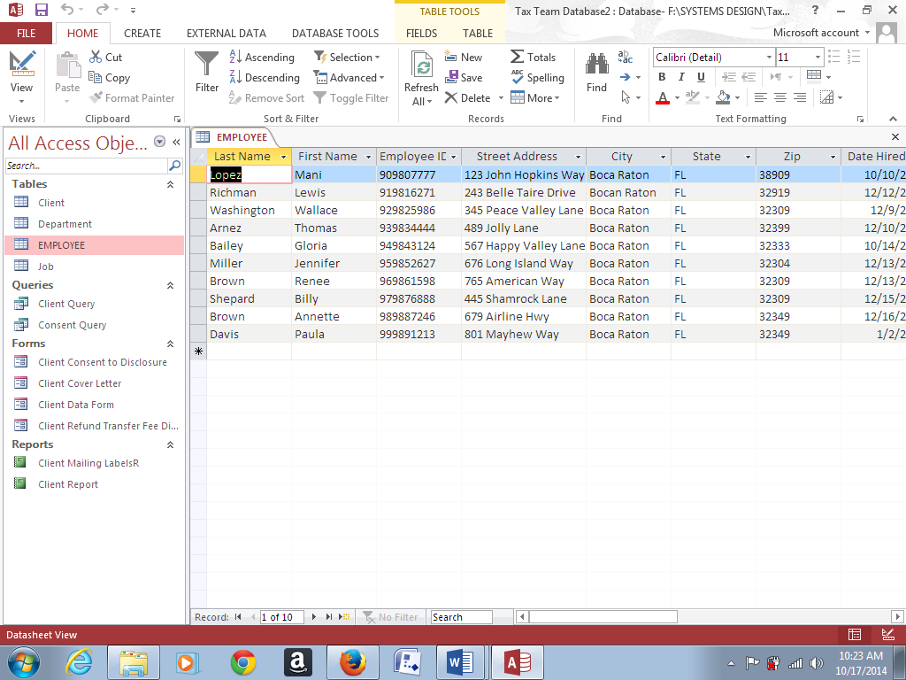

The **CLIENT table** contains secure client information. The data in this table includes the client’s tax refund and tax payment information which is used as input for the **Refund Transfer Fee Disclosure** form. This information is also reported to the IRS.

The data in this table is only viewable by the employee who is assigned to a particular client, otherwise the data is not viewable.

**Note: The example below does not contain actual client data, this is only an example.**

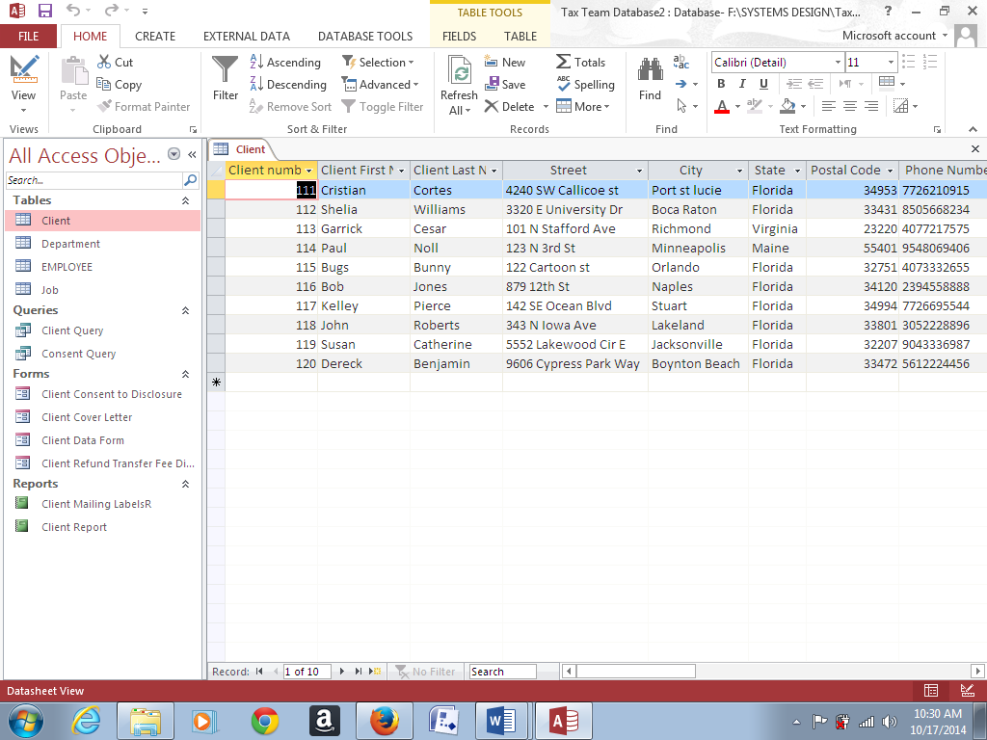

The **Department table** includes information about the different departments within the Tax Services organization, and is only updateable by the systems administrator.

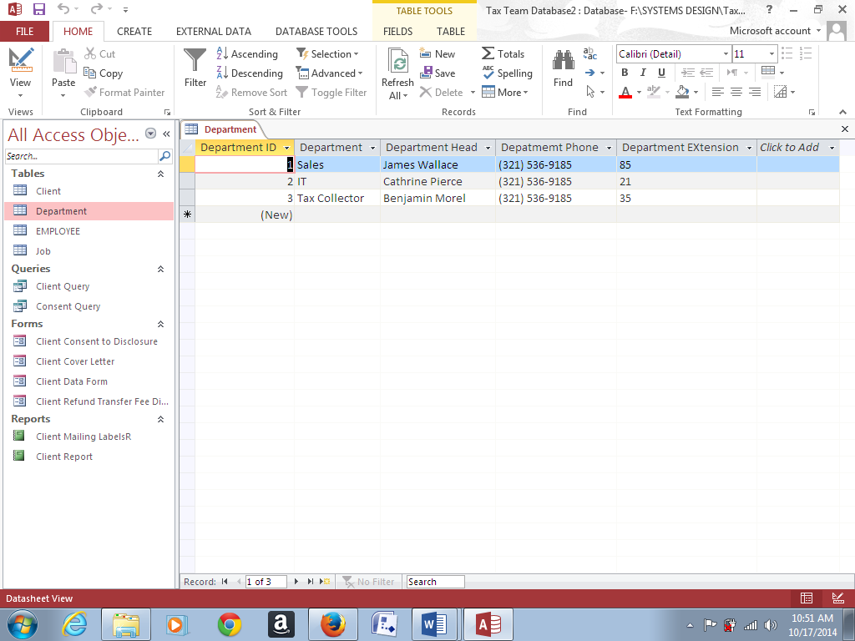

The **JOB table**

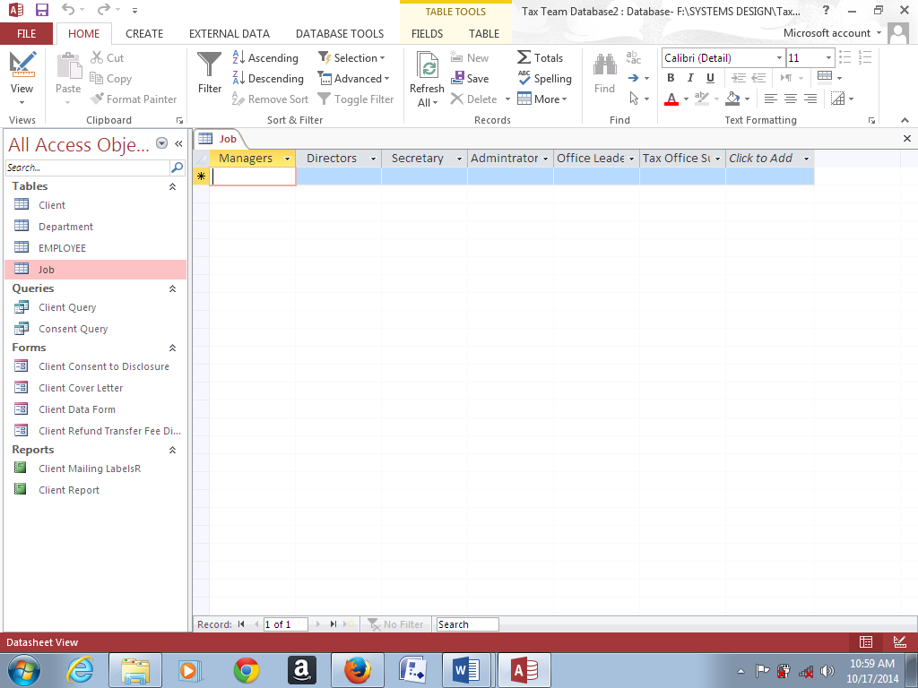

The **Client Cover Letter** is an instructional letter advising the client on the options that they chose in filing their income tax return.

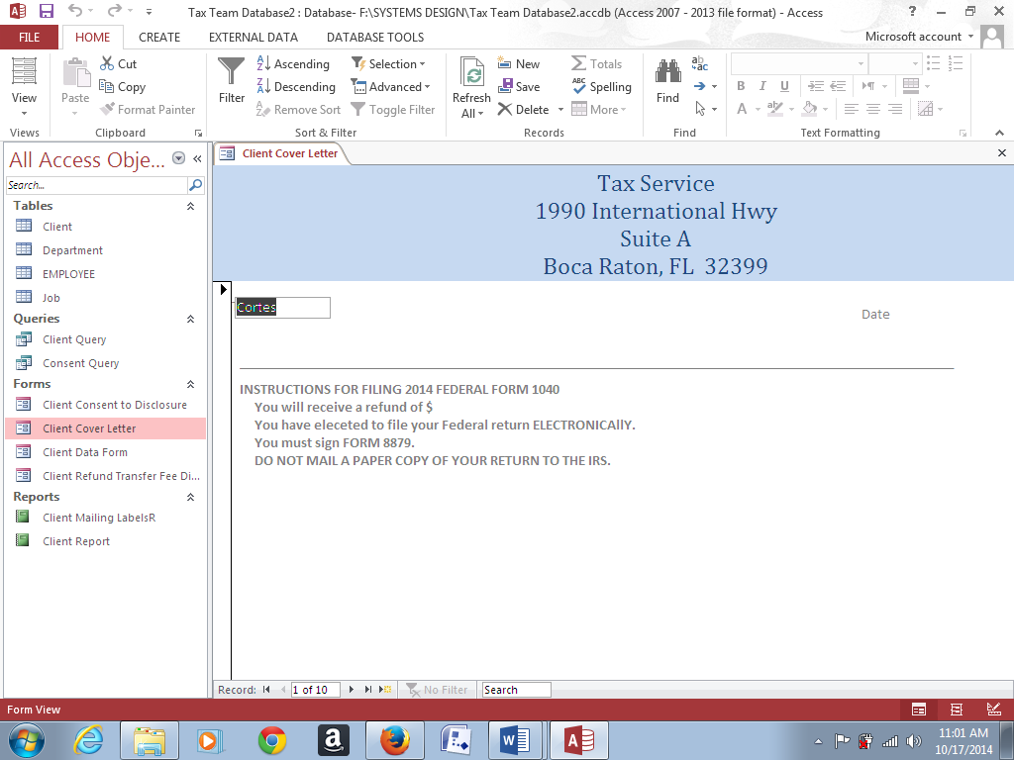

The **Consent to Disclosure form** is provided to the client to advise the client that we (Tax Service) is not allowed to disclose their information to a third party without the clients’ consent.

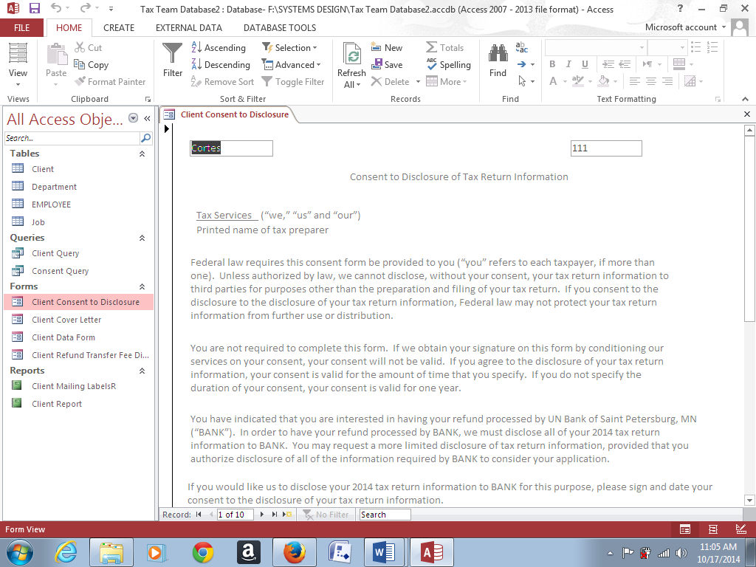

The **Refund Transfer Fee Disclosure** letter is to provide the client with information on the amount of their refund as well as inform the client on how their refund is distributed to the tax preparer, transmitter and to the Bank that processed the refund.

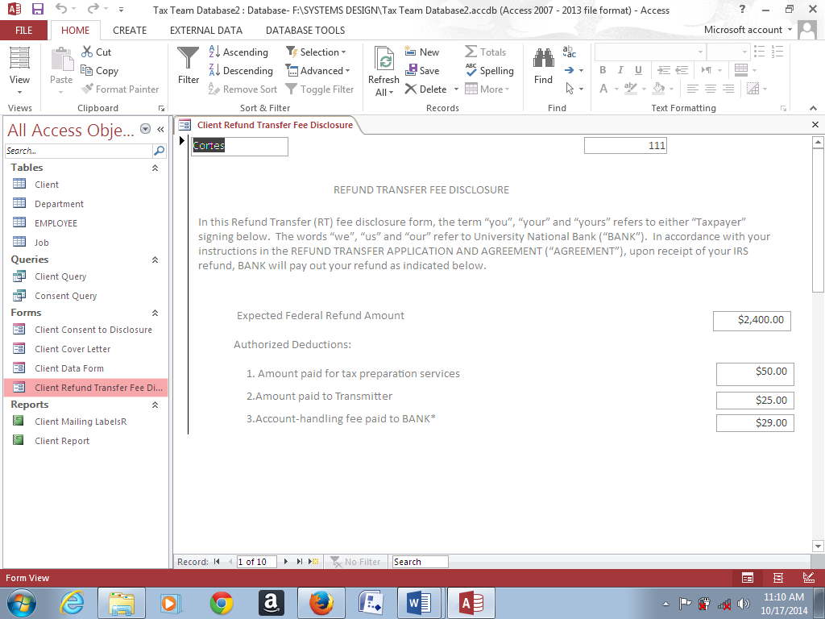

**Mailing labels**

