Spend Data
Integration Design Document

Date: March 2026
Status: Design confirmed (some prerequisites pending verification)

Executive Summary
This document defines the design policy for integrating Spend Data scattered across multiple systems and making it trustworthy. The current confidence level is approximately 50% (intuition-based), and this document identifies the root causes and the approach to resolving them.

Current Problems
Three compounding issues are creating the 50% confidence problem
Issue 1: Data preparation is ad-hoc and manual with no reproducibility
Issue 2: No formal rules defining which system to use for which vendor — decisions are undefined
Issue 3: No mechanism to verify data accuracy — correctness cannot be proven

Key Design Decisions
Three business decisions have been confirmed to resolve these issues.

Decision | Content | Rationale
Spend = Payment basis | PO amounts (contract totals) are excluded. Only records where payment has been executed are counted. | PO amounts represent pre-payment commitments and diverge from actual spend
SAP Concur takes precedence on conflict | When the same vendor has amounts in both Purchasing System and Concur, SAP Concur is adopted as the authoritative source | This project defines Spend on a payment basis, and Concur records actual payments
GL as external validation benchmark | GL cannot be used as vendor-level detail, but reconciling the integrated Spend total against GL account totals allows verification of omissions and double-counting | With three exclusive systems, there is no way to validate the whole without an external reference

Immediate Actions Required
The following four items must be verified against real data before implementation can proceed (Q1 and Q2 require design changes if they fail)
Q1: Confirm no erroneous Concur records exist for vendors already paid via the Purchasing System
Q2: Confirm no PO-amount records are mixed into the Purchasing System payment table
Q3: Confirm no duplicate overseas vendor records exist across the AP System and Purchasing System
Q4: Confirm GL Data alignment on period, currency, account codes, and accrual vs. cash basis

Once confirmed, the short-term goal (~1 month) is to complete vendor ID matching and codify cleansing rules. The mid-term goal (~3 months) is to automate the pipeline. Monthly GL reconciliation as a quantitative confidence check will be established as ongoing steady-state operations.

1. Current Situation and Issues

1.1 Why Is Spend Data Unreliable?
The current Spend Data is sourced from three different systems, but no rules exist defining how to integrate them. The preparation process depends on individual judgment, and there is no validation mechanism. These three factors combine to leave confidence at an intuition-based 50%.

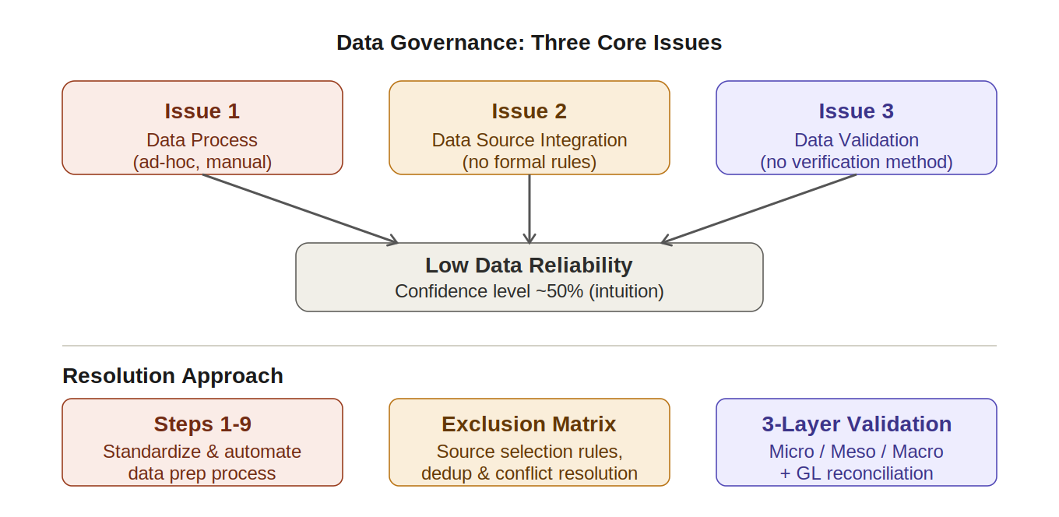

1.2 The Reality of the Three Data Sources
Spend Data comes from the following three systems. Critically, each system covers different vendors and transaction types — they are principally exclusive to one another. This is not a problem of "the same data duplicated in three places" but rather "no rules exist defining who takes what from where."

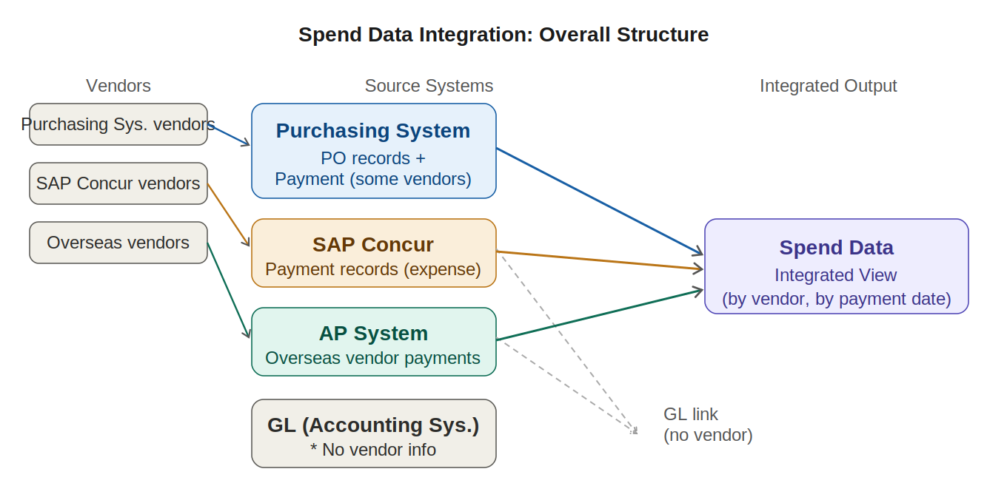

System | Transactions Covered | Data Used
Purchasing System | Domestic vendor orders and some payments | Payment table only (PO table excluded)
SAP Concur | Payments to vendors not paid via Purchasing System | Payment records
AP System | Overseas vendor payments | Payment records
GL Data (Accounting) | Company-wide journal entries (no vendor info) | Validation use only — cannot use as detail

1.3 Dependencies Between the Three Issues
The three issues are not independent. The integration rules (Issue 2) must be defined before cleansing (Issue 1) can be designed, and Issues 1 and 2 must be complete before validation (Issue 3) can function. They must be resolved in the following order.

Resolution order: Issue 2 (confirm integration rules) -> Issue 1 (standardize data prep) -> Issue 3 (operationalize validation)
Ignoring this dependency and "fixing the prep process first" means rework when integration rules change.

2. Key Design Decisions
This chapter records the principal decisions confirmed for the Spend Data integration design. These are business agreements and form the prerequisites for technical implementation.

2.1 Spend Definition: Payment Basis
The Purchasing System contains two table types: a PO table (contract totals) and a payment table (actual payment records). This project uses the payment table only.

Example: 2-year contract with annual payments
PO table: 1 record (2-year total amount) -> Not used
Payment table: 2 records (Year 1 and Year 2 payment amounts) -> Used

2.2 Conflict Resolution: SAP Concur Takes Precedence
For vendors where a PO exists in the Purchasing System and a payment record exists in SAP Concur, the SAP Concur payment record is adopted as authoritative.

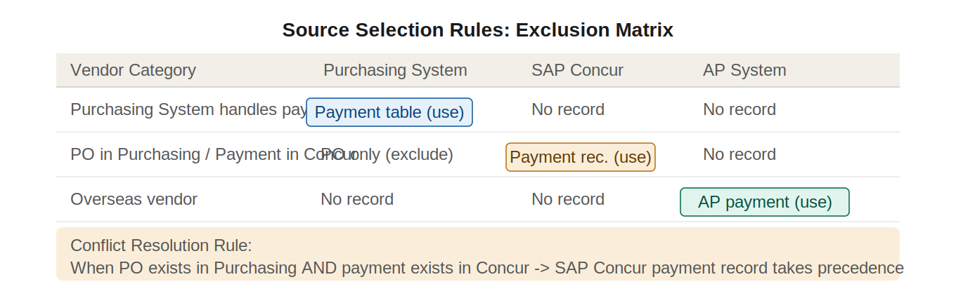

2.3 Vendor ID Matching: Three-Phase Process
The same vendor may hold different IDs across systems. A matching table must be created prior to integration to map all records to a unified vendor ID. Matching cannot be completed by technology alone — the question "are these two vendor IDs the same entity?" always requires human judgment from procurement and finance teams.

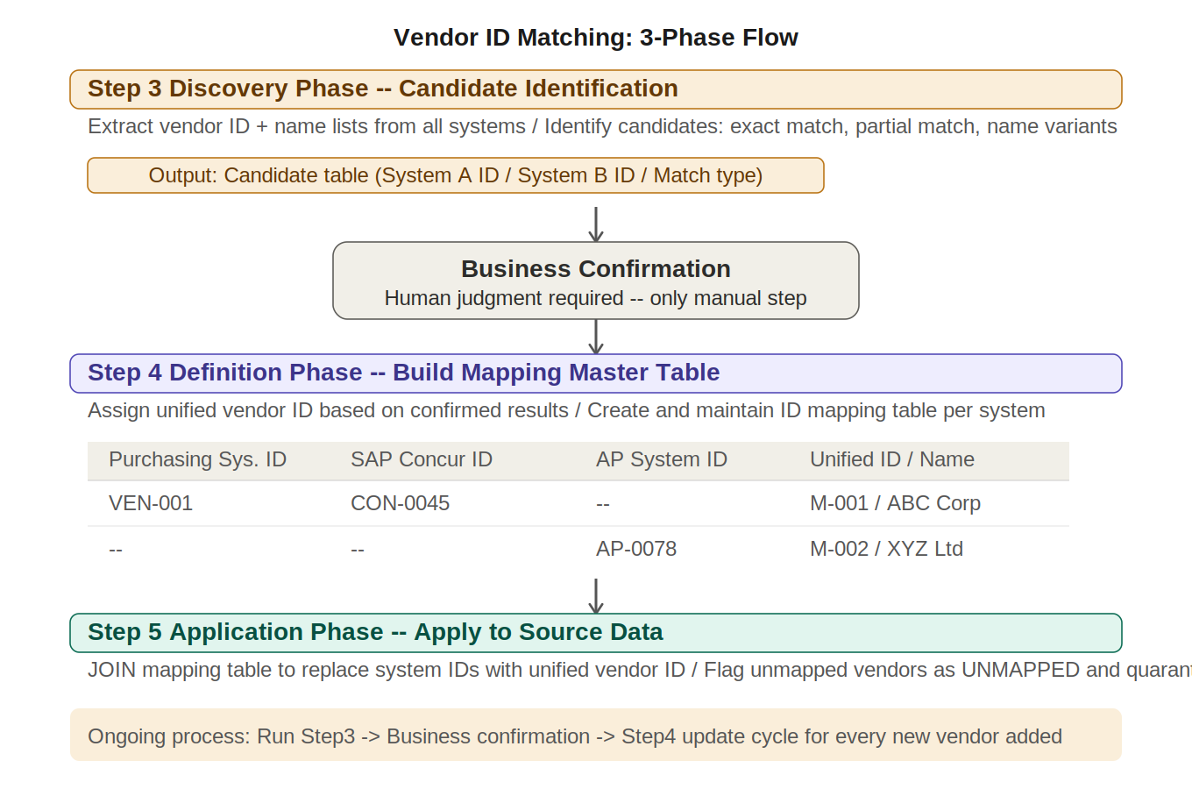

2.4 GL Data: External Validation Benchmark
GL Data cannot be used as vendor-level detail because it lacks vendor information. However, by reconciling "integrated Spend total = GL account total," it serves as the only external benchmark capable of simultaneously verifying omissions and double-counting.
The following must be confirmed via Q4 before GL can be used as a benchmark (see Next Actions)
Period close dates are consistent between the three systems and GL
FX conversion rates and conversion timing are consistent
Target GL accounts fully correspond to Spend categories with no gaps or overlaps
How to handle accrual basis (GL) vs. cash basis (Spend) differences

3. Implementation Approach
The concrete implementation approach for resolving Issues 1, 2, and 3 is described below in dependency order.

3.1 Data Preparation Process Standardization (Issue 1)
Replace the current ad-hoc process with the standard Steps 1-9 flow. Steps 3 and 4 receive project-specific extended definitions.

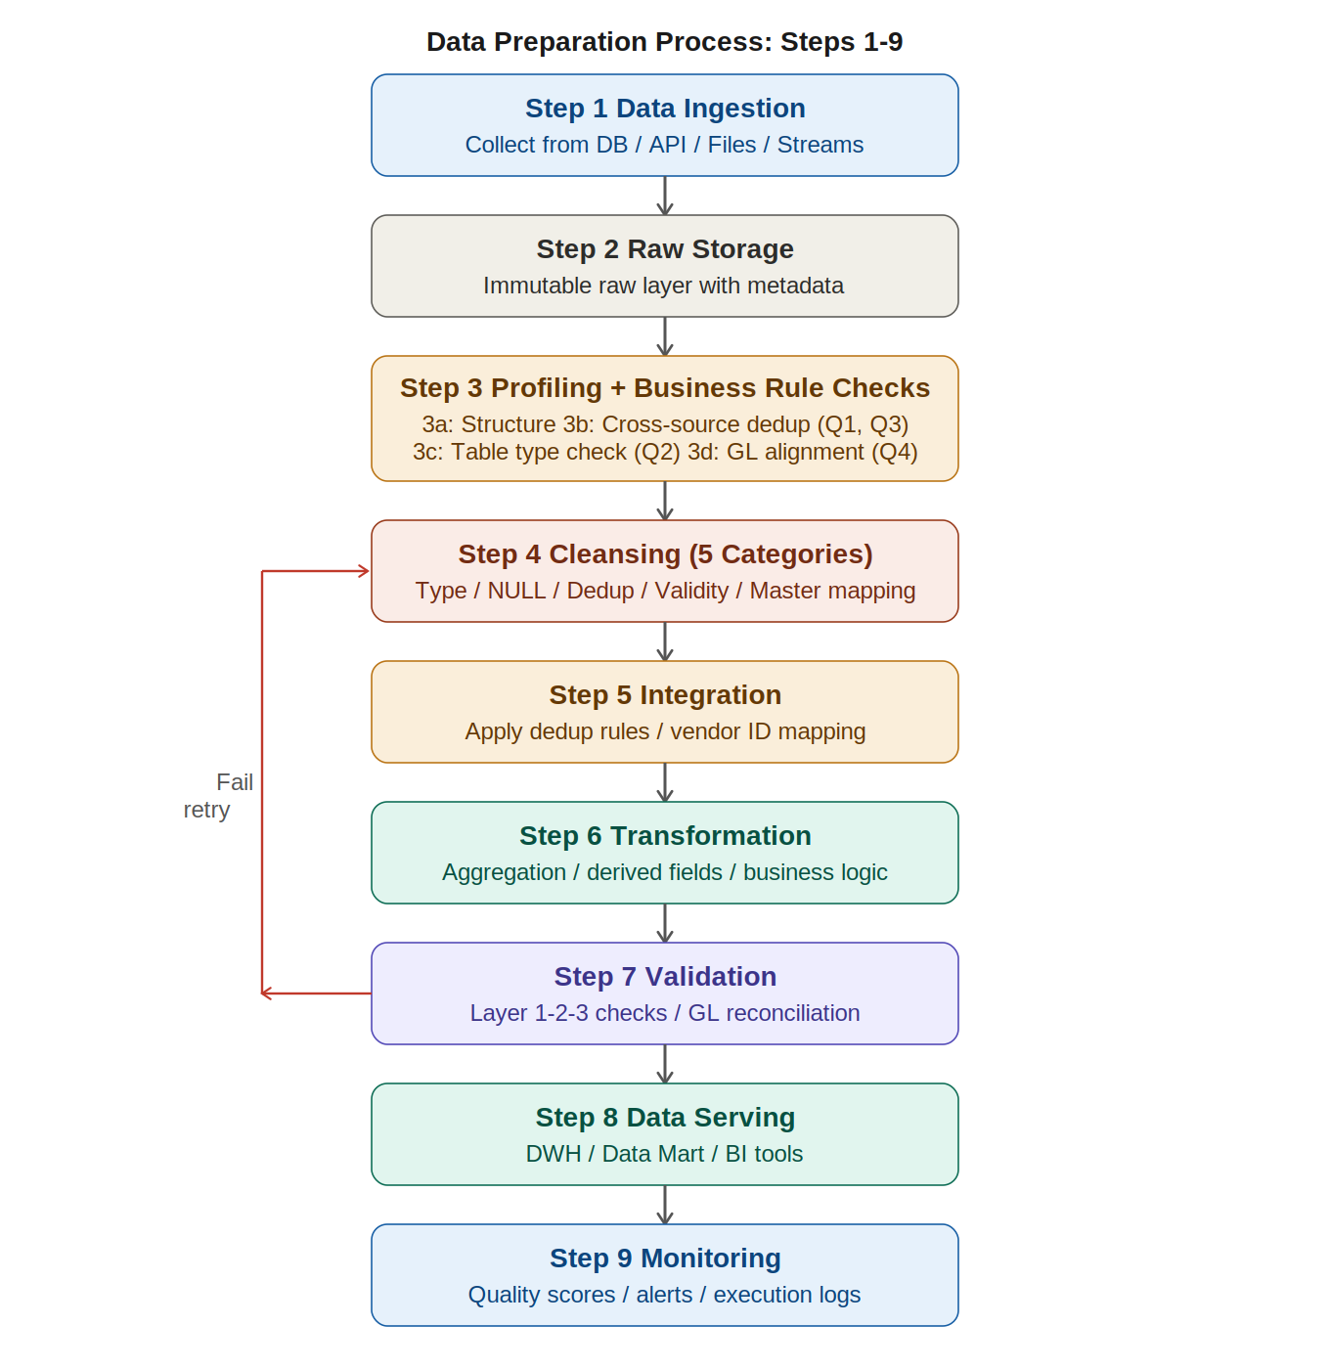

Step 3 Extension: Add Business Rule Verification
In addition to standard profiling (NULL rates, types, distributions), the following four sub-steps specific to Spend Data integration are required. The execution order must be: vendor matching creation -> Q1 -> Q2 -> Q3 -> Q4.

Sub-step | Activity | Related Q
3a Structure profiling | NULL rate, types, row counts, distributions (standard profiling) | --
3b Cross-source dedup scan | Confirm the same vendor does not appear in multiple systems | Q1, Q3
3c Table type check | Confirm no PO-amount records are mixed into payment data | Q2
3d GL alignment check | Confirm GL alignment on period, currency, and account codes | Q4

Step 4 Cleansing Rules: Standardized Across 5 Categories
Explicitly define all cleansing rules as code to eliminate ad-hoc manual judgment. Category 5 (code mapping) is the core of this integration and the highest priority.

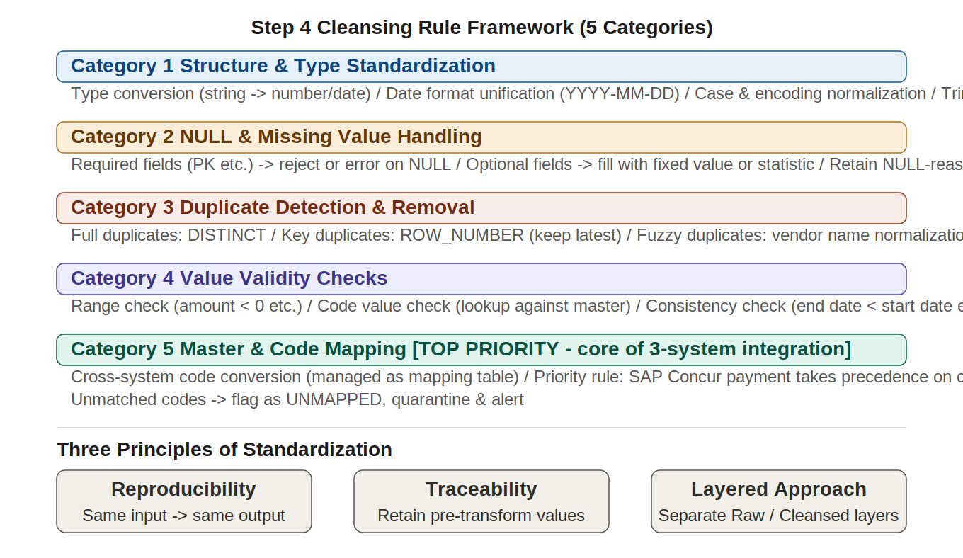

3.2 Integration Processing Flow (Issue 2)
The three sources are integrated following the per-vendor source selection rules in the order below.

- Extract from Purchasing System payment table only (PO table excluded)
- Extract SAP Concur payment records (exclude vendors already paid via Purchasing System)
- Extract AP System overseas vendor payments
- Deduplication check and removal: reconcile by vendor x payment date x amount
- Reconcile integrated total against GL Data
- Output as Spend Data integrated view by vendor, payment date, and source

3.3 Three-Layer Validation Structure (Issue 3)
Because the three systems cover exclusively different vendors and transaction types, direct cross-system reconciliation cannot detect omissions or double-counting. Validation is therefore structured in three layers.

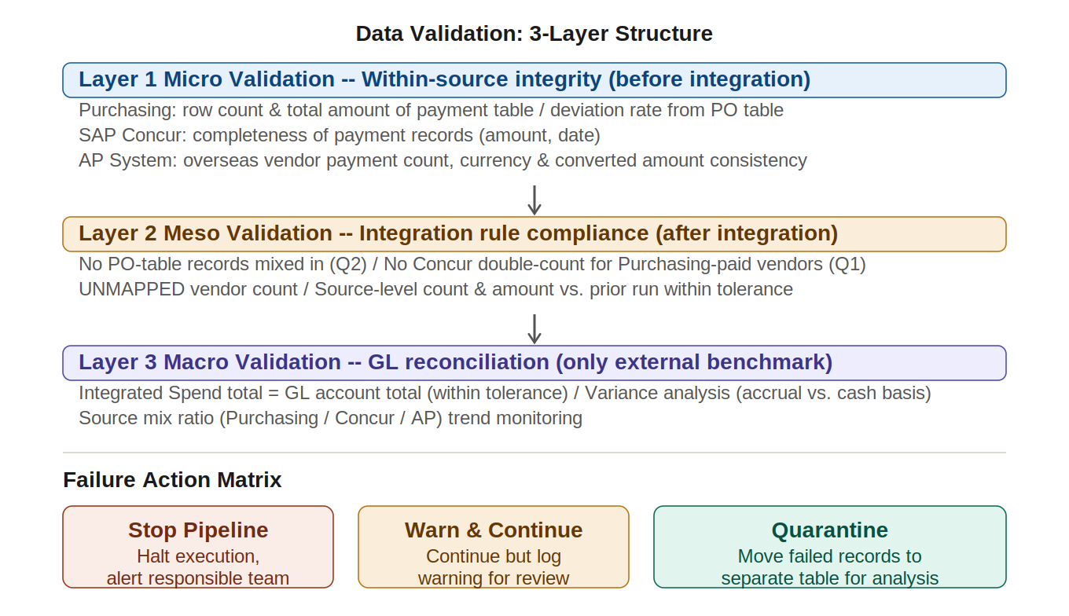

Layer | Timing | Key Checks | What It Ensures
Layer 1 Micro validation | Before integration | Per-system row count, total amount, and completeness checks | Source data quality
Layer 2 Meso validation | After integration | No PO-amount contamination, no double-counting, UNMAPPED count | Integration rule accuracy
Layer 3 Macro validation | Monthly steady-state | Integrated Spend total = GL total (within tolerance) | Absence of omissions and double-counting

3.4 Automation Policy
Because the current process is largely manual, insufficient time remains for validation. The following approach will reduce "execution" work and allow focus on "judgment."

- Codify all cleansing rules so that results are reproducible regardless of who runs the process
- Run Step 7 validation automatically; humans focus on investigating failures and deciding responses
- Automate vendor matching candidate extraction to minimize manual confirmation effort

4. Next Actions and Confirmation Items
This chapter is an action list defining who does what by when. Q1 and Q2 require design changes if they fail — both must be completed before implementation begins.

4.1 Real Data Verification (Q1-Q4)
Q1 and Q2 are blockers: failures require revision of the integration rules in Chapter 2

Item | Check Content | Expected Result | If Fails | Owner | Status
Q1 | Any erroneous Concur records for vendors already paid via Purchasing System?Join key: Vendor ID x payment date x amount | Matching records = 0 | Quarantine matching records; confirm authoritative system with business side; define exclusion rule in Step 4 | -- | Not started
Q2 | Any PO-amount records mixed into Purchasing System payment table?Also check for NULL or future-dated payment dates | Payment flag only; all payment dates are real past dates | Identify contaminated records; define exclusion condition in Step 4 cleansing rules (Category 4) | -- | Not started
Q3 | Any duplicate overseas vendor records across AP System and Purchasing System?Also check for name-matching duplicates across different IDs | Duplicate vendors = 0; name-match candidates = 0 | Define authoritative source rule for duplicate vendors; update matching table; rerun check | -- | Not started
Q4 | Are GL alignment conditions consistent?Period, currency, account codes, accrual vs. cash basis | All conditions aligned; tolerance range defined | Define correction rules per misaligned item, or limit GL reconciliation scope accordingly | -- | Not started

4.2 Business Confirmations for Vendor Matching Table
After Step 3b (matching candidate extraction) is complete, the following must be confirmed with procurement and finance teams. This is the only step in the process that cannot be replaced by technology — human judgment is required.

- Approval of the candidate list of presumed same-entity vendors
- ID assignment convention for unified vendor IDs where system IDs differ
- Agreement on canonical vendor name when name variants are identified

4.3 Phase-by-Phase Implementation Roadmap
Progress from the current intuition-based "~50% confidence" to a state where reliability is expressed as a concrete number — in stages.

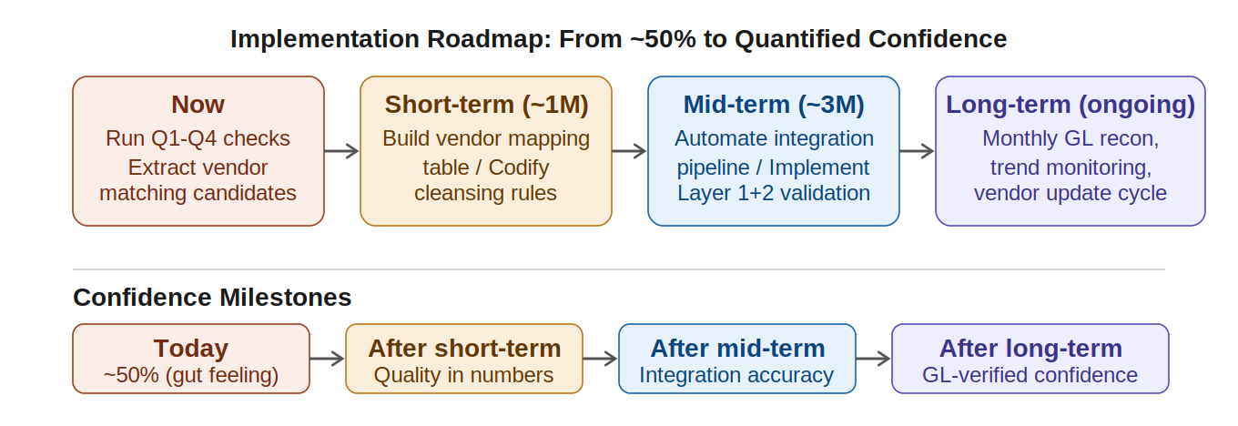

Phase | Timeline | Key Activities | Target State
Now | Immediate | Run Q1-Q4 check queries; extract vendor matching candidates | Prerequisites for integration confirmed
Short-term | ~1 month | Build vendor matching table (incl. business confirmation); codify cleansing rules | Source quality measurable in numbers
Mid-term | ~3 months | Automate integration pipeline; implement Layer 1 and 2 validation | Integration rule accuracy verifiable
Long-term (ongoing) | Steady-state | Monthly GL reconciliation; trend monitoring; vendor matching update cycle | GL reconciliation quantitatively confirms omissions and double-counting

4.4 Ongoing Operational Cycle
The following three activities form the continuous data governance cycle. Building the pipeline once is not the end — the cycle must keep running with every new vendor addition or system change.

Cycle | Frequency | Content | Owner
Vendor matching updates | On new vendor addition | Step 3 candidate extraction -> business confirmation -> matching table update | --
GL reconciliation | Monthly | Reconcile integrated Spend total against GL total; alert if variance exceeds tolerance | --
Delta monitoring | Each pipeline run | Log period-on-period row count and amount changes; auto-detect anomalies | --

Appendix: Technical Reference
This chapter is a reference for technical staff. Managers should consult as needed.

A. Q1-Q4 Check Query Requirements
The following are the requirements for the business rule verification checks carried out as part of Step 3 (profiling). Actual SQL is implemented based on these requirements.
Prerequisite: Q1 and Q3 require a vendor matching table to exist before execution. Without it, the same vendor under different IDs will be missed.
Common note 1: All queries must include the target period as a filter condition. Without it, historical clean data contaminates the results.
Common note 2: Q1-Q4 results (row counts and amounts) must be saved as Step 3 output logs. They will be reused as GL reconciliation baseline values in Step 7.

Q1 Erroneous Registration in SAP Concur
Confirm that vendors whose payments are fully handled by the Purchasing System are not also registered in SAP Concur. If such cases exist, the same payment will be double-counted from both systems during integration.

Item | Detail
Purpose | Confirm that vendors paid via the Purchasing System do not also have payment records in SAP Concur
Join key | Vendor ID (unified ID via matching table) x payment date x payment amount
Verification steps | 1. Retrieve the list of vendor IDs present in the Purchasing System payment table2. Check whether those vendor IDs appear in SAP Concur payment records3. If found, check whether records with matching payment date and amount exist
Expected result | Matching records = 0
If fails | Quarantine matching records to a Quarantine table. Confirm which system is authoritative with the business side and define an exclusion rule in Step 4

Q2 PO Amount Contamination in Purchasing Payment Table
Confirm that the Purchasing System payment table does not contain PO-amount records (contract totals) mixed in alongside actual payment records. Contamination causes the payment-basis aggregation to be significantly overstated.

Item | Detail
Purpose | Confirm that no PO-amount records are mixed into the payment table
Identification key | Record-type flag (PO / Payment) or equivalent column value
Verification steps | 1. Check the distribution of record-type flag values in the payment table2. Check for records with a NULL or future-dated payment date3. Check whether the sum of payment records for a given PO ID matches the PO amount in the PO table (a match suggests the PO amount itself may have been inserted as a payment record)
Expected result | Record-type flag = "Payment" only; all payment dates are real past dates
If fails | Identify the contaminated records and define their exclusion condition explicitly in Step 4 cleansing rules (Category 4: Validity Checks)

Q3 Overseas Vendor Overlap: AP System x Purchasing System
Confirm that the same overseas vendor is not registered in both the AP System and the Purchasing System with payment records in each.

Item | Detail
Purpose | Confirm that payments to the same overseas vendor are not duplicated across both systems
Join key | Vendor ID (unified ID via matching table) x payment date x payment amountNote: also check cases where IDs differ but names are the same (matching table gaps)
Verification steps | 1. Retrieve the list of overseas vendor IDs in the Purchasing System payment table2. Check whether those IDs appear in the AP System vendor master or payment records3. If found, check whether records with matching payment date and amount exist in both systems4. Run name-matching to detect vendors with similar names under different IDs (matching table gap detection)
Expected result | Duplicate vendors = 0; name-match candidates = 0
If fails | Define the authoritative source for duplicate vendors as a rule; add the exclusion filter to Step 4. If name-match candidates are found, update the matching table and rerun the check

Q4 GL Data Alignment Confirmation
Confirm that the aggregation conditions of the three source systems and GL are aligned before using GL Data as the Layer 3 macro validation benchmark in Step 7. Running reconciliation without this confirmation risks misclassifying condition-based variance as "data errors."

Check Item | Check Content | If Misaligned
1. Period | Confirm that monthly close dates are the same across the three systems and GL | Define a correction rule establishing which timing is the reference standard
2. Currency / FX | Confirm that FX conversion rates and conversion timing (transaction-date rate, month-end rate, etc.) are consistent | Define the conversion variance as part of the tolerance range, or unify the conversion method
3. Account codes | Identify the GL account codes corresponding to Spend categories and create a mapping table. Check for any gaps or overlaps in coverage | Limit GL reconciliation to the specific confirmed account codes
4. Accrual vs. cash | If GL records on an accrual basis (expense recognition date), confirm how the difference from cash-basis Spend (payment execution date) is handled | Define accrual-to-cash differences (accrued liabilities, etc.) as part of the tolerance range, or agree with finance on a cash-basis GL extraction condition

Q4 expected result: All four items above are aligned AND a GL reconciliation tolerance range (e.g., within +/-1%) is defined
Even if not all conditions align, GL can still be used as a validation benchmark as long as correction rules or scope limitations are agreed upon for each misaligned item

B. Step 7 Validation Checklist (All Items)
Validation checklist with implementation timing targets by priority.
Priority | Target | Check Item | Validation Logic
Required | This week | Total row count | Pre/post-processing row counts match
Required | This week | Abnormal row count drop | Alert if variance vs. prior run exceeds threshold
Required | This week | Per-source row count reconciliation | Record and compare each source's row count
Required | This week | NULL count ceiling | NULL rate in required fields below threshold
Required | This week | Total amount reconciliation | Aggregated amount matches source
Required | This week | Cross-source reconciliation | Record count of value mismatches across systems
Required | 2-3 weeks | Foreign key reference check | No codes absent from master table
Recommended | 1 month | Aggregation granularity | Line-item total = header total
Recommended | 1 month | Outlier detection | Values beyond mean +/-3 sigma flagged for review
Recommended | 1 month | Period-on-period amount variance | Total amount within tolerance vs. prior run
Maturity | Continuous | New / deleted key detection | Alert on keys added or removed vs. prior run
Maturity | Continuous | Time-series anomaly detection | Deviation from weekly/monthly trend patterns

C. Failure Action Matrix
Defining failure responses in advance prevents ad-hoc judgment and reintroduces the human-dependency problem the process redesign is meant to eliminate.
Failure Type | Action | Example Trigger | Decision Criteria
Stop pipeline | Halt execution; alert responsible team | Large total amount deviation; mass NULL in required keys | Variance exceeds 2x tolerance, or NULL rate > threshold
Warn and continue | Continue processing; log warning for review | Minor row count variance; small number of outliers | Within tolerance but statistically significant vs. prior run
Quarantine | Move failed records to separate table for later analysis | UNMAPPED vendors; unrecognized code values | Record-level quality issue that can be specifically identified

This document is the agreed design specification for the design phase and will be updated to reflect actual implementation outcomes upon completion.

