MATRIX CALCULATOR
A MINI PROJECT REPORT

Submitted by

K.S.T.ARUN (113216104019)
D.HIRRANGANDHI (113216104049)
A.SUDARSHAN (113216104139)
M.SURYA PRABHAHARAN (113216104146)

DEPARTMENT OF COMPUTER SCIENCE AND ENGINEERING



VELAMMAL ENGINEERING COLLEGE,AMBATTUR,
CHENNAI -66

BONAFIDE CERTIFICATE

Certified that this mini project report on Matrix Calculator, is the bonafide work of K.S.T.Arun, D.Hirrangandhi, A.Sudarshan and M.Surya Prabhaharan of Second Semester B.E., Computer Science and Engineering, who carried out the MINI PROJECT work under my supervision during the academic year 2016-2017.

HOD SIGNATURE GUIDE SIGNATURE
Dr. S.Shahil Kirupavathy M.Sc., M.Phil.,Ph.D Mr.A.Arockia Abins,M.E.,
Professor & Head I Year CSE,CIVIL &IT Assistant Professor-II
Velammal Engineering College, Velammal Engineering College,
Chennai-600 066 Chennai-600 066

ABSTRACT

In this project, We are included many matrix operations.

We can find the types of matrix, verify the properties of matrix ,do various matrix calculations.

We are included challenge by which one can test his capability on matrix calculations.

.

INDEX

- Introduction
  - Existing System & its Demerits
  - Proposed System & its Merits
  - Modules & Description
  - Architecture
- Hardware and software Specifications
- Implementation & Result
3.1 User interface design
3.2 Snapshots
- Sample code

INTRODUCTION:
A matrix is a rectangular array of numbers or other mathematical objects for which operations such as addition and multiplication are defined. Most commonly, a matrix over a field F is a rectangular array of scalars each of which is a member of F. Most of this article focuses on real and complex matrices, that is, matrices whose elements are real numbers or complex numbers, respectively. The numbers, symbols or expressions in the matrix are called its entries or its elements. The horizontal and vertical lines of entries in a matrix are called rows and columns, respectively.
  - EXISTING SYSTEMS & DEMERITS:
In The Existing Systems,
We cannot find the type and verify the properties of matrix.
We are also unable to reduce the equation from quadratic form to canonical form.
This challenge is not done by anyone.

  - PROPOSED SYSTEM & MERITS:
In the proposed system, we can find the type of a matrix and verify the properties of matrix and do various matrix calculations.
This challenge concept is used to test the person’s capability in matrix.

  - MODULES & DESCRIPTION:
This project can split into
- MATRIX TYPES :
Here, We are using ten types of matrix, when the user enters the matrix the compiler says the type of the matrix.

- MATRIX CALCULATION :
Here, We are using seven types of calculation which the user wants to do.

- PROPERTIES OF MATRIX :

Here,We are using ten types of matrix, when the user enters the matrix the compiler says the type of the matrix.
- CHALLENGE :
Here, We are introducing a new concept when the user chosen this option the output window will show the random matrix and the user want to do the matrix calculation finally the window shows the correct answer and the time taken to complete the challenge.

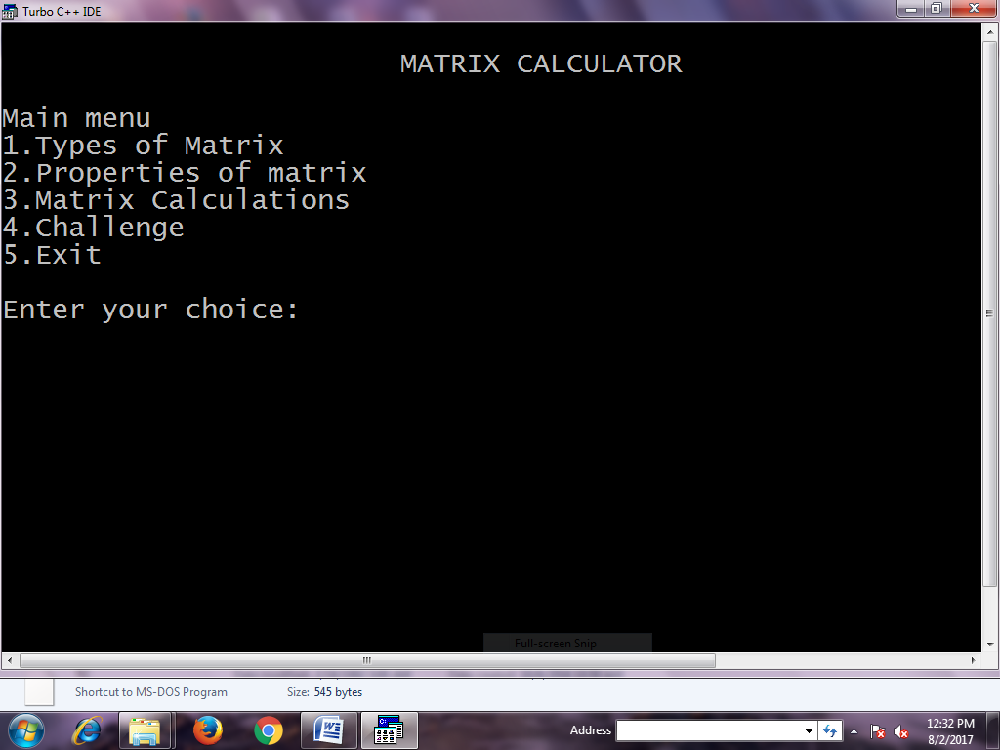
  - Architecture

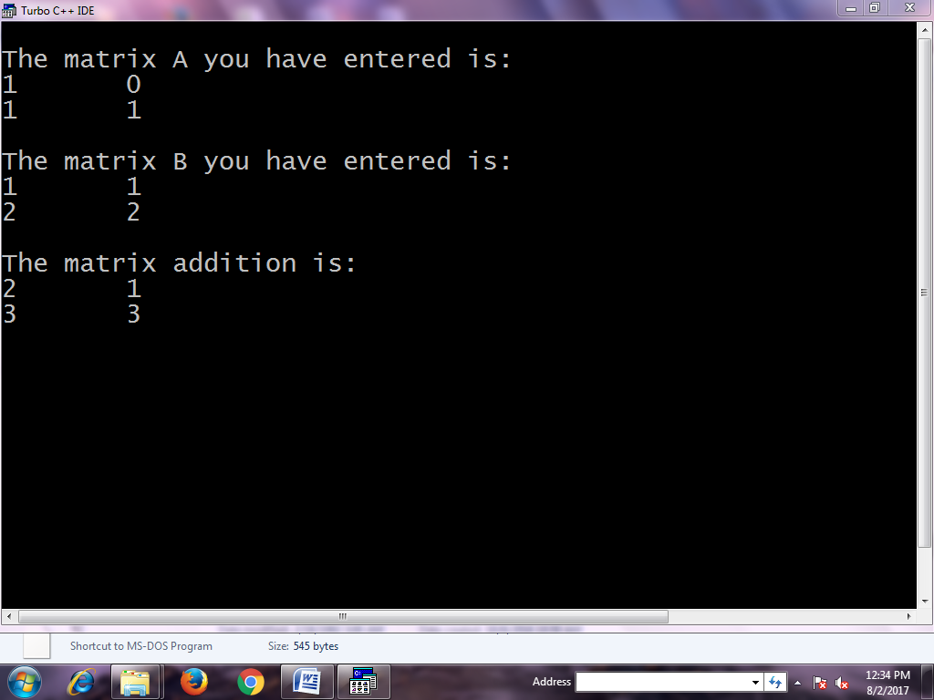

  - HARDWARE AND SOFTWARE Requirements:
- Turbo C++ or ANSI C
- Language : C

3.IMPLEMENTATION AND RESULT:

3.1 Sample of user interface design :

Select what do you want to do
1.Types of matrix
2. Properties of matrix
3. Matrix calculations
4. Challenge
If 1 was chosen,
- Enter the matrix.
- The type of the matrix will be displayed as output.

If 2 was chosen,
- List of properties of matrix will be displayed, Select a property.
- Enter the matrix based on the property you chosen.
- Output will be displayed as whether the property is verified or not

If 3 was chosen,
- List of matrix calculations will be displayed, Select one.
- Enter the matrix based on the requirements.
- The result will be displayed.

If 4 was chosen,
- List of matrix calculations will be displayed, Select one.
- The random matrix will be shown.
- User should find the answer and press any key.
- Finally the answer and the time taken will be displayed.

4.3 SNAPSHOTS:

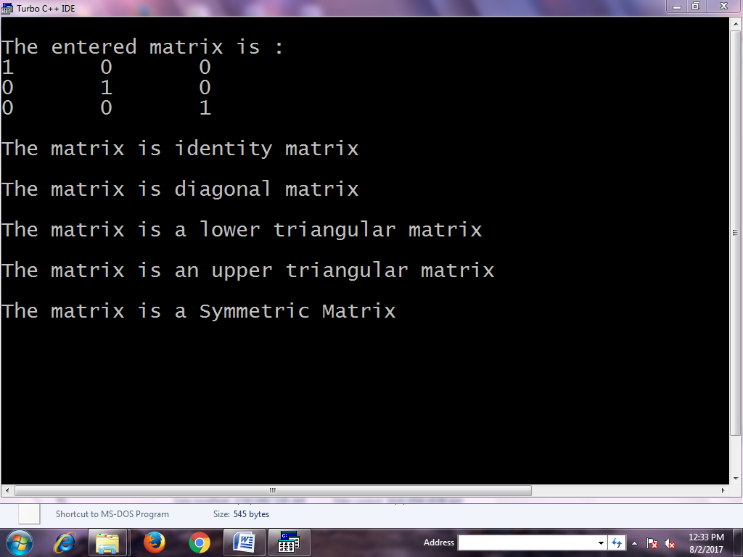

4.Sample Code:

Main Program:

#include<stdio.h>
#include<conio.h>
#include<stdlib.h>
#include<math.h>
#include"TYPES11.c"
#include"ADDASS.C"
#include"ADDCOM.C"
#include"ADDID.C"
#include"ADDINV.C"
#include"CALADD.C"
#include"CALSUB.C"
#include"CALMUL.C"
#include"CALTRANS.C"
#include"TRANS1.C"
#include"TRANS2.C"
#include"TRANS3.C"
#include"MUL1.C"
#include"MUL2.C"
#include"MUL3.C"
#include"MUL4.C"
#include"INV2.C"

void main()
{
int ch,ch1,ch2,ch3,ch4,ch5,
printf("\n\t\t\tMATRIX CALCULATOR\N");
printf("\nMain menu\n1.Types of Matrix \n2.Properties of matrix \n 3.Matrix Calculations \n4.Challenge \n5.Exit");
printf("\n\nEnter your choice:\t");
scanf("%d",&ch);
switch(ch)
{
case 1:
types();
break;
case 2:
printf("\n\tProperties of matrix\n");
printf("\n1.Properties based on ADDITION \n2.Properties based on MULTIPLICATION \n3.Properties based on TRANSPOSE \n4.Exit");
printf("\nEnter your choice:\t");
scanf("%d",&ch1);
switch(ch1)
{
case 1:
printf("\nProperties based on ADDITION\n");
printf("\n1.Commutative A+B=B+A \n2.Associative (A+B)+C=A+(B+C) \n3.Additive identity A+0=A \n4.Additive inverse A+B=0");
printf("\nEnter your choice:\t");
scanf("%d",&ch2);
switch(ch2)
{
case 1:
addcom();
break;
case 2:
addass();
break;
case 3:
addid();
break;
case 4:
addinv();
break;
default:
printf("\nInvalid choice");
}
break;
case 2:
printf("\nProperties based on MULTIPLICATION\n);
printf("\n1.Associative A(BC)=(AB)C \n2.Distributive A(B+C)=AB+AC \n3.Distributive (A+B)C=AC+BC \n4.Multiplicative identity IA=AI=A\n");
printf("\nEnter your choice:\t");
scanf("%d",&ch3);
switch(ch3)
{
case 1:
mul1();
break;
case 2:
mul2();
break;
case 3:
mul3();
break;
case 4:
mul4();
break;
default:
printf("\nInvalid choice");
}
break;
case 3:
printf("\nProperties based on TRANSPOSE\n);
printf("\n1.(A^T)^T = A \n2.(A+B)^T = A^T+B^T \n3.(AB)^T = B^T A^T \n");
printf("\nEnter your choice:\t");
scanf("%d",&ch4);
switch(ch4)
{
case 1:
trans1();
break;
case 2:

trans2();
break;
case 3:
trans3();
break;

default:
printf("\nInvalid choice");
}
break;
case 4:
exit(0);
break;
default:
printf("\nInvalid choice\n");
break;
}
case 3:
printf("\n\t Matrix calculations\n");
printf("\n1.Addition \n2.Subtraction \n3.Multiplication \n4.Transpose of a matrix\n5.Determinant of a matrix \n6.Inverse of a matrix\n7.Exit\n");
printf("\nEnter your choice:\t");
scanf("%d",&ch5);
switch(ch5)
{
case 1:
caladd();
break;
case 2:
calsub();
break;
case3:
calmul();
break;
case 4:
caltrans();
break;
case 5:
determinant();
break;
case 6:
inverse();
break;
case 7:
exit();
break;
default:
printf("\nEnter valid choice\n");
}
break;
default:
printf("\nInvalid choice");
}
}
getch();
}

Types Program:

#include<stdio.h>
#include<conio.h>
#include<stdlib.h>
#include<math.h>
#include"TYPES11.c"
#include"ADDASS.C"
#include"ADDCOM.C"
#include"ADDID.C"
#include"ADDINV.C"
#include"CALADD.C"
#include"CALSUB.C"
#include"CALMUL.C"
#include"CALTRANS.C"
#include"TRANS1.C"
#include"TRANS2.C"
#include"TRANS3.C"
#include"MUL1.C"
#include"MUL2.C"
#include"MUL3.C"
#include"MUL4.C"
#include"INV2.C"

void main()
{
int ch,ch1,ch2,ch3,ch4,ch5,
printf("\n\t\t\tMATRIX CALCULATOR\N");
printf("\nMain menu\n1.Types of Matrix \n2.Properties of matrix \n 3.Matrix Calculations \n4.Challenge \n5.Exit");
printf("\n\nEnter your choice:\t");
scanf("%d",&ch);
switch(ch)
{
case 1:
types();
break;
case 2:
printf("\n\tProperties of matrix\n");
printf("\n1.Properties based on ADDITION \n2.Properties based on MULTIPLICATION \n3.Properties based on TRANSPOSE \n4.Exit");
printf("\nEnter your choice:\t");
scanf("%d",&ch1);
switch(ch1)
{
case 1:
printf("\nProperties based on ADDITION\n");
printf("\n1.Commutative A+B=B+A \n2.Associative (A+B)+C=A+(B+C) \n3.Additive identity A+0=A \n4.Additive inverse A+B=0");
printf("\nEnter your choice:\t");
scanf("%d",&ch2);
switch(ch2)
{
case 1:
addcom();
break;
case 2:
addass();
break;
case 3:
addid();
break;
case 4:
addinv();
break;
default:
printf("\nInvalid choice");
}
break;
case 2:
printf("\nProperties based on MULTIPLICATION\n);
printf("\n1.Associative A(BC)=(AB)C \n2.Distributive A(B+C)=AB+AC \n3.Distributive (A+B)C=AC+BC \n4.Multiplicative identity IA=AI=A\n");
printf("\nEnter your choice:\t");
scanf("%d",&ch3);
switch(ch3)
{
case 1:
mul1();
break;
case 2:
mul2();
break;
case 3:
mul3();
break;
case 4:
mul4();
break;
default:
printf("\nInvalid choice");
}
break;
case 3:
printf("\nProperties based on TRANSPOSE\n);
printf("\n1.(A^T)^T = A \n2.(A+B)^T = A^T+B^T \n3.(AB)^T = B^T A^T \n");
printf("\nEnter your choice:\t");
scanf("%d",&ch4);
switch(ch4)
{
case 1:
trans1();
break;
case 2:

trans2();
break;
case 3:
trans3();
break;

default:
printf("\nInvalid choice");
}
break;
case 4:
exit(0);
break;
default:
printf("\nInvalid choice\n");
break;
}
case 3:
printf("\n\t Matrix calculations\n");
printf("\n1.Addition \n2.Subtraction \n3.Multiplication \n4.Transpose of a matrix\n5.Determinant of a matrix \n6.Inverse of a matrix\n7.Exit\n");
printf("\nEnter your choice:\t");
scanf("%d",&ch5);
switch(ch5)
{
case 1:
caladd();
break;
case 2:
calsub();
break;
case3:
calmul();
break;
case 4:
caltrans();
break;
case 5:
determinant();
break;
case 6:
inverse();
break;
case 7:
exit();
break;
default:
printf("\nEnter valid choice\n");
}
break;
default:
printf("\nInvalid choice");
}
}
getch();
}

Challenge Program:

void challenge()
{
printf("\nWELCOME TO CHALLENGE\nin challeng,the computer will randomly generate two matrices to perform matrix operations like addition,subtraction,multiplication of your own choice.\nThen you have to take a paper and pen and do the calculation you have selected for the generated matrices and enter the answer you have got in the system);
printf("Enter to continue");
scanf("%d",&ze);
if(ze==0)
{
clrscr();
break;
}
else
{
printf("Enter correct choice")
continue;
}
printf("\nSelect your choice\n");
printf("\n1.Addition,2.Subtraction,3.Multiplication\n");
scanf("%d",&choice);
t=time(NULL);
local=localtime(&t);
printf("You have the started the calculation on %d/%d/%d at %d:%d:%d",local->tm_year+1900,local->tm_mon+1,local->tm_mday,local->tm_hour,local->tm_min,local->tm_sec);
start=time(NULL);
switch(choice)
{
case 1:

srand(time(NULL));
printf("\nYou are going to perform the matrix calculations with the following matrices");
printf("\nThe first matrix is\n");
for(i=0;i<3;i++)
{
for(j=0;j<3;j++)
{
printf("%d\t",a[i][j]=rand()%10);
}
printf("\n");
}
printf("The second matrix is");
for(i=0;i<3;i++)
{
for(j=0;j<3;j++)
{
printf("%d\t",b[i][j]=rand()%10);
}
printf("\n");
}
for(i=0;i<3;i++)
{
for(j=0;j<3;j++)
{
c[i][j]=a[i][j]+b[i][j];
}
}
break;

case 2:

srand(time(NULL));
printf("\nYou are going to perform the matrix calculations with the following matrices");
printf("\nThe first matrix is\n");
for(i=0;i<3;i++)
{
for(j=0;j<3;j++)
{
printf("%d\t",a[i][j]=rand()%10);
}
printf("\n");
}
printf("The second matrix is");
for(i=0;i<3;i++)
{
for(j=0;j<3;j++)
{
printf("%d\t",b[i][j]=rand()%10);
}
printf("\n");
}
for(i=0;i<3;i++)
{
for(j=0;j<3;j++)
{
c[i][j]=a[i][j]-b[i][j];
}
}
break;

case 3:

srand(time(NULL));
printf("\nYou are going to perform the matrix calculations with the following matrices");
printf("\nThe first matrix is\n");
for(i=0;i<3;i++)
{
for(j=0;j<3;j++)
{
printf("%d\t",a[i][j]=rand()%10);
}
printf("\n");
}
printf("The second matrix is");
for(i=0;i<3;i++)
{
for(j=0;j<3;j++)
{
printf("%d\t",b[i][j]=rand()%10);
}
printf("\n");
}
for(i=0;i<3;i++)
{
for(j=0;j<3;j++)
{
c[i][j]=0;
for(k=0;k<3;k++)
{
c[i][j]=c[i][j]+a[i][k]*b[k][j];
}
}
}
break;

default:
printf("Enter correct choice");
break;
}

//Program to calculate time
#include,stdio.h>
#include<conio.h>
#include<time.h>
#include<stdlib.h>
int main(void)
{
int sec;
struct tm *local,*local;
time_t t,t1,end,start;
t=time(NULL);
local=localtime(&t);
printf("You have the started the calculation on %d/%d/%d at %d:%d:%d",local->tm_year+1900,local->tm_mon+1,local->tm_mday,local->tm_hour,local->tm_min,local->tm_sec);
start=time(NULL);
//call rand fuction
//call the corresponding calculation
end=time(NULL);
sec=difftime(end,start);
if(sec>60)
{
printf("Minutes you took was %d",sec/60);
}
elseif(sec>3600)
{
printf("Hours you took was %d",sec/3600);
}
else
{
printf("Second you took was %d",sec);
}
t1=time(NULL);
local1=localtime(&t1);
printf("You have the completed the calculation on %d/%d/%d at %d:%d:%d",local1->tm_year+1900,local1->tm_mon+1,local1->tm_mday,local1->tm_hour,local1->tm_min,local1->tm_sec);
getch();
return 0;
}

CONCLUSION

This project will be really helpful for amateur in matrix, as it will be easy to do all the calculations im the matrix, perform challenges and to do various matrix operations.

