A
PROJECT REPORT
ON

“SQLite EDITOR AND PARSER”

Submitted in partial fulfillment for the completion of
SUMMER TRAINING
(12th June to 24th July, 2015)

Submitted By:
PIYUSH BHATT

B.Tech (3rd Year)
Computer Science and Engineering
Govind Ballabh Pant Engineering College
Pauri Garhwal

At
Instruments Research & Development Establishment
Dehradun

Declaration

I, PIYUSH BHATT, pursuing B-Tech (3rd year) in Computer Science & Engineering at, Dehradun Institute Of Technology, Dehradun, hereby declare that the project work entitled “SQLite EDITOR AND PARSER” is an authenticated work carried out by me at INSTRUMENTS RESEARCH AND DEVELOPMENT ESTABLISHMENT, DEHRADUN, under the guidance of Mr. DINESH SINGH KUTIYAL, Scientist ‘E’ for the partial fulfillment of the award of the degree of B-Tech.

Date:
Place:

TABLE OF CONTENTS

S. No. | CONTENT | PAGES
 | Acknowledgement | 5
 | Certificate | 6
1. | ORGANIZATIONAL PROFILE
1.1 | About IRDE | 8-9
1.2 | Areas of Work | 10
1.3 | Present Scenario | 10-11
1.4 | Ballistic Computers | 11
2. | INTRODUCTION TO STRUCTURED QUERY LANGUAGE(SQL)
2.1 | Introduction | 13
2.2 | History | 14
2.3 | Design | 14
2.4 | SQL features and Benefits | 15
2.4.1 | Java Integration (JDBC) | 15
2.4.2 | High-Level, English-Like Structure | 15
2.4.3 | Portability across Computer Systems | 16
2.4.4 | Relational Foundation | 16
2.4.5 | Extensibility and Object Technology | 16
2.5 | Syntax
2.5.1 | Language Elements | 17
2.5.2 | Types of SQL Statements | 17
2.5.3 | Operators | 18
2.5.4 | Data types | 18
2.6 | SQL Standards
2.6.1 | The ANSI/ISO Standards | 19
2.6.2 | Other SQL Standards | 19
3. | INTRODUCTION TO SQLite
3.1 | Introduction | 21
3.2 | Design | 22
3.3 | History | 23
3.4 | Features | 23
3.5 | Well-Known Users Of SQLite | 23-25
3.6 | SQL As Understood By SQLite | 26
3.6.1 | SQL Keywords | 26
3.6.2 | Omitted SQL Features | 27
4. | INTRODUCTION TO JAVA
4.1 | Introduction | 29
4.2 | Running A Java Program | 30
4.3 | Java: An Object Oriented Programming Language | 31
4.3.1 | Encapsulation | 31-32
4.3.2 | Abstraction | 32-33
4.3.3 | Inheritance | 33-34
4.3.4 | Polymorphism | 35-37
5. | INTRODUCTION TO SQLite JDBC DRIVER (XERIAL)
5.1 | Introduction | 39
5.2 | JDBC Architecture | 40
5.3 | Common JDBC Components | 41
5.4 | The JDBC 4.0 Packages | 41
5.5 | The Xerial JDBC-Driver | 42
6. | INTRODUCTION TO ANTLR 4
6.1 | Introduction | 44
6.2 | Features Of ANTLR 4 | 45
6.3 | ANTLRWorks 2 | 46
7. | PROJECT WORK  SQLite EDITOR & PARSER
7.1 | Abstract | 48
7.2 | Purpose | 49
8. | REQUIREMENT SPECIFICATION
8.1 | Problem Definition | 51
8.2 | Hardware and Software Requirements | 51-52
9. | DESIGN AND CODING
9.1 | Design: GUI | 54-55
9.2 | Coding | 56
9.2.1 | List Of Classes And Their Description | 56
9.2.2 | List Of Functions And Their Use | 56-57
9.2.3 | Pseudo code | 58-59
10. | TESTING
10.1 | Testing: Phase-I | 59-66
10.2 | Testing: Phase-II | 67-70
11. | REFRENCES | 71

ACKNOWLEDGEMENT

In a closely knit, complex, interwoven & intricate social system such as ours it’s obvious that nothing of significance can ever be accomplished without the act of assistance, words of encouragement and gestured of helpfulness for the other members of the society.

I am deeply indebted to Instruments Research & Development Establishment for having faith in me and letting me work on the project.

First of all, I would like to thank Training & Placement Cell GBPEC, for providing me the opportunity to undergo training at Instruments Research & Development Establishment, Dehradun. I also express my sincere gratitude to, to Dr. S. S. Negi, Director, I.R.D.E. Dehradun, Mr. Anil Kumar, Associate Director, Group Director of Ballistic Computer Division, for providing me the opportunity to undertake this project at IRDE.

I would also like to pay my gratitude to Mr. Dinesh Singh Kutiyal, Scientist ‘E’ for his guidance, support, showing all the patience and abundant encouragement throughout the project duration.

I would also like to thank my parents and my family members for their support and guidance.

CERTIFICATE

This is to certify that PIYUSH BHATT, B.TECH, Computer Science And Engineering (3rd Year) at Govind Ballabh Pant Engineering College, Pauri Garhwal has undergone Practical Training at Instruments Research & Development Establishment, Defense Research & Development Organization (DRDO), Ministry of Defense, Raipur, Dehradun, India from 12th June 2015 to 24th July 2015 in the BALLISTIC COMPUTER (BC) DIVISION under my guidance and supervision.
He was assigned the project on “SQLite Editor and Parser”.
I am impressed by his hard work, sincerity and devotion to the assigned task.
I wish him all success for his future.
Date: 20th August 2015

Mr. M S Rawat Mr. Dinesh Singh Kutiyal
(Scientist ‘E’) (Scientist ‘E’)
IRDE,Ddun IRDE,Ddun

INTRODUCTION
TO ORGANIZATIONAL PROFILE

  - ABOUT IRDE :

Brief Historical Background
The origin of INSTRUMENTS RESEARCH AND DEVELOPMENT ESTABLISHMENT (IRDE) dates back to the establishment of Inspectorate of Scientific Stores in 1939 at Rawalpindi (Now in Pakistan) with the responsibility to inspect Telecommunication equipment used by the Army. This had the role of Authority for Holding Seal Particulars (AHSP). This ASHP underwent many organizational changes until it took a shape of Technical Development Establishment (Instruments and Electronics) covering both R&D and AHSP functions in fields of instruments during the subsequent years, shed some of its R&D and AHSP responsibilities and came into existence in its present form in February 1960.

Instruments Research & Development Establishment (IRDE), Dehradun is a pioneering institution devoted to research, design, development and technology transfer in the fields of sophisticated optical and electro-optical Instruments of vital interest to the Defense. Situated on the foothills of the great Himalayas, it houses some of country’s best talents.

Its primary role is to design, develop and provide guideline for indigenous manufacturing of modern and sophisticated equipment with the sole objective of modernizing all three wings of Defense Services.



DEFENCE RESEARCH & DEVELOPMENT ORGANIZATION (DRDO)
INSTRUMENTS RESEARCH & DEVELOPMENT ESTABLISHMENT
(IRDE, Dehra Dun)

1.2 AREAS OF WORK
- Research, design and development in the fields of optical, electro-optical and opsonic instrumentation of surveillance, reconnaissance, piloting, navigation guidance, target identification and acquisition, weapon aiming, designation, ranging and counter measures under all weather conditions during day and night.
- Design and development of complete fire control systems and devices.
- Applied and background research and development in applied optics.
- Creation and maintenance of facilities for parametric measurement performance and environment evaluators of optical and electro optical components/systems.
- Transfer of technology to public to private sectors, Consultancy of optical and electro-optical instruments, components and materials.

1.3 PRESENT SCENARIO
This establishment is at present devoted towards the design and development of equipment in the following areas.
1. Optical instrument
2. Night vision devices
3. Laser based instruments
4. Stabilization of systems
5. Thermal imaging system
6. Integrated fire control system
7. Fiber optics
8. Micro controller, Microprocessor and FPGA based systems.
I.R.D.E has also developed a large number of Opto-Medical instruments. Specialized groups have been created in the organization that are devoted towards Research and Development of instruments belonging to different areas like Fiber optics, Imaging, Ranging, Fire control application and Tracking etc.
Apart from the usual R&D work, the organization has also under taken the investigation of major defects existing instruments, suggest solutions and carry out major modification if needed. The establishment has also been assisting the Armed Forces in the evolution of foreign equipments.
At the international level it maintains liaison with bodies like Optical Society of America, International Society for Optical Engineering, and Institute of Electrical and Electronics Engineers (IEEE).
IRDE has also acquired the ISO 9001:2000 certification.

1.4 BALLISTIC COMPUTER DIVISION

Ballistic Computer Division in I.R.D.E. is hub of all computer related activities and it has huge infrastructure of software development from client-server computing to Sun technology, Oracle technology and Microsoft technology to develop general-purpose application software.
One of the important tasks of this division is development of ballistic algorithms. This division has been named BC (Ballistic Computer) because ballistic solutions have been provided by the division in fire control systems for projects. Different projects related software development is also carried out for various systems as and when required. Responsibility of maintenance and modernization of fire control of MBT (Main Battle Tank) also lies with Ballistic Computer division.
Intranet and Internet facilities are provided and managed by this division. Publishing information on intranet and maintaining websites are also offered to I.R.D.E.’s users for creating efficient working environment.

INTRODUCTION
TO
STRUCTURED QUERY LANGUAGE
(SQL)

2.1 INTRODUCTION
SQL (pronounced "ess-que-el") stands for Structured Query Language. Structured Query Language) is a special-purpose programming language designed for managing data held in a relational database management system (RDBMS), or for stream processing in a relational data stream management system (RDSMS).
SQL is used to communicate with a database. According to ANSI (American National Standards Institute), it is the standard language for relational database management systems. SQL statements are used to perform tasks such as update data on a database, or retrieve data from a database. Some common relational database management systems that use SQL are: Oracle, MySQL, SQLite, Microsoft SQL Server, Access, Ingres, etc. Although most database systems use SQL, most of them also have their own additional proprietary extensions that are usually only used on their system. However, the standard SQL commands such as "Select", "Insert", "Update", "Delete", "Create", and "Drop" can be used to accomplish almost everything that one needs to do with a database.
Originally based upon relational algebra and tuple relational calculus, SQL consists of a data definition language, data manipulation language, and a data control language. The scope of SQL includes data insert, query, update and delete, schema creation and modification, and data access control. Although SQL is often described as, and to a great extent is, a declarative language (4GL), it also includes procedural elements.

SQL became a standard of the American National Standards Institute (ANSI) in 1986, and of the International Organization for Standardization (ISO) in 1987. Since then, the standard has been revised to include a larger set of features. Despite the existence of such standards, though, most SQL code is not completely portable among different database systems without adjustments.

2.2 HISTROY
SQL was initially developed at IBM by Donald D. Chamberlin and Raymond F. Boyce in the early 1970s. This version, initially called SEQUEL (Structured English Query Language), was designed to manipulate and retrieve data stored in IBM's original quasi-relational database management system, System R, which a group at IBM San Jose Research Laboratory had developed during the 1970s. The acronym SEQUEL was later changed to SQL because "SEQUEL" was a trademark of the UK-based Hawker Siddeley aircraft company.
In the late 1970s, Relational Software, Inc. (now Oracle Corporation) saw the potential of the concepts described by Codd, Chamberlin, and Boyce, and developed their own SQL-based RDBMS with aspirations of selling it to the U.S. Navy, Central Intelligence Agency, and other U.S. government agencies. In June 1979, Relational Software, Inc. introduced the first commercially available implementation of SQL, Oracle V2 (Version2) for VAX computers.
After testing SQL at customer test sites to determine the usefulness and practicality of the system, IBM began developing commercial products based on their System R prototype including System/38, SQL/DS, and DB2, which were commercially available in 1979, 1981, and 1983, respectively.

2.3 DESIGN
SQL deviates in several ways from its theoretical foundation, the relational model and its tuple calculus. In that model, a table is a set of tuples, while in SQL, tables and query results are lists of rows: the same row may occur multiple times, and the order of rows can be employed in queries (e.g. in the LIMIT clause). Whether this is a practical concern is a subject of debate. Furthermore, additional features (such as NULL and views) were introduced without founding them directly on the relational model, which makes them more difficult to interpret.
Critics argue that SQL should be replaced with a language that strictly returns to the original foundation: for example, see The Third Manifesto. Other critics suggest that Datalog has two advantages over SQL: it has cleaner semantics, which facilitates program understanding and maintenance, and it is more expressive, in particular for recursive queries.
2.4 SQL features and Benefits
SQL is both an easy-to-understand language and a comprehensive tool for managing data. Here are some of the major features of SQL and the market forces that have made it successful:
- Vendor independence
- Portability across computer systems
- SQL standards
- IBM endorsement (DB2)
- Microsoft commitment (ODBC and ADO)
- Relational foundation
- High-level, English-like structure
- Interactive, ad hoc queries
- Programmatic database access
- Multiple views of data
- Complete database language
- Dynamic data definition
- Client/server architecture
- Extensibility and object technology
- Internet database access
- Java integration (JDBC)

2.4.1 Java Integration (JDBC)
One of the major new areas of SQL development is the integration of SQL with Java. Seeing the need to link the Java language to existing relational databases, SunMicrosystems (the creator of Java) introduced Java Data Base Connectivity (JDBC), a standard API that allows Java programs to use SQL for database access. Many of the leading database vendors have also announced or implemented Java support within their database systems, allowing Java to be used as a language for stored procedures and business logic within the database itself. This trend toward integration between Java and SQL will insure the continued importance of SQL in the new era of Java-based programming.

2.4.2 High-Level, English-Like Structure
SQL statements look like simple English sentences, making SQL easy to learn and understand. This is in part because SQL statements describe the data to be retrieved, rather than specifying how to find the data. Tables and columns in a SQL database can have long, descriptive names. As a result, most SQL statements "say what they mean" and can be read as clear, natural sentences.
2.4.3 Portability across Computer Systems
SQL-based database products run on computer systems ranging from mainframes and midrange systems to personal computers, workstations, and even handheld devices. They operate on stand-alone computer systems, in departmental local area networks, and in enterprise-wide or Internet-wide networks. SQL-based applications that begin on single-user systems can be moved to larger server systems as they grow. Data from corporate SQL-based databases can be extracted and downloaded into departmental or personal databases. Finally, economical personal computers can be used to prototype a SQL-based database application before moving it to an expensive multi-user system.

2.4.4 Relational Foundation
SQL is a language for relational databases, and it has become popular along with the relational database model. The tabular, row/column structure of a relational database is intuitive to users, keeping the SQL language simple and easy to understand. The relational model also has a strong theoretical foundation that has guided the evolution and implementation of relational databases. Riding a wave of acceptance brought about by the success of the relational model, SQL has become the database language for relational databases.

2.4.5 Extensibility and Object Technology
The major challenge to SQL's continued dominance as a database standard has come from the emergence of object-based programming, and the introduction of object-based databases as an extension of the broad market trend toward object-based technology. SQL-based database vendors have responded to this challenge by slowly expanding and enhancing SQL to include object features. These "object/relational" databases, which continue to be based on SQL, have emerged as a more popular alternative to "pure object" databases and may insure SQL's continuing dominance for the next decade.

2.5 SYNTAX

2.5.1 Language Elements
The SQL language is subdivided into several language elements, including:
- Clauses, which are constituent components of statements and queries. (In some cases, these are optional.)
- Expressions, which can produce either scalar values, or tables consisting of columns and rows of data
- Predicates, which specify conditions that can be evaluated to SQL three-valued logic (3VL) (true/false/unknown) or Boolean truth values and are used to limit the effects of statements and queries, or to change program flow.
- Queries, which retrieve the data based on specific criteria. This is an important element of SQL.
- Statements, which may have a persistent effect on schemata and data, or may control transactions, program flow, connections, sessions, or diagnostics. SQL statements also include the semicolon (";") statement terminator. Though not required on every platform, it is defined as a standard part of the SQL grammar.
- Insignificant whitespace is generally ignored in SQL statements and queries, making it easier to format SQL code for readability.
2.5.2 Types of SQL Statements
- Data Manipulation Language (DML) statements are used for managing data within schema objects.
- Data Definition Language (DDL) statements are used to define the database structure or schema.
- Data Control Language (DCL) statements grants or withdraws access privileges.
- Transaction Control (TCL) statements are used to manage the changes made by DML statements. It allows statements to be grouped together into logical transactions.

2.5.3 Operators

Operator | Description | Example
= | Equal to | Author = 'Alcott'
<> | Not equal to (many DBMSs accept != in addition to <>) | Dept <> 'Sales'
> | Greater than | Hire_Date > '2012-01-31'
< | Less than | Bonus < 50000.00
>= | Greater than or equal | Dependents >= 2
<= | Less than or equal | Rate <= 0.05
BETWEEN | Between an inclusive range | Cost BETWEEN 100.00 AND 500.00
LIKE | Match a character pattern | First_Name LIKE 'Will%'
IN | Equal to one of multiple possible values | DeptCode IN (101, 103, 209)
IS or IS NOT | Compare to null (missing data) | Address IS NOT NULL
IS NOT DISTINCT FROM | Is equal to value or both are nulls (missing data) | Debt IS NOT DISTINCT FROM - Receivables
AS | Used to change a field name when viewing results | SELECT employee AS 'department1'

2.5.4 Data types
Each column in an SQL table declares the type(s) that column may contain. ANSI SQL includes the following data types:
- Character String
- Bit Strings
- Numbers
- Date and Time
2.6 SQL STANDARDS

One of the most important developments in the market acceptance of SQL is the emergence of SQL standards. References to "the SQL standard" usually mean the official standard adopted by the American National Standards Institute (ANSI) and the International Standards Organization (ISO). However, there are other important SQL standards, including the de facto standard SQL defined by IBM's DB2 product family.

2.6.1 The ANSI/ISO Standards
Work on the official SQL standard began in 1982, when ANSI charged its X3H2 committee with defining a standard relational database language. At first the committee debated the merits of various proposed database languages. However, as IBM's commitment to SQL increased and SQL emerged as a de facto standard in the market, the committee selected SQL as their relational database language and turned their attention to standardizing it.
The resulting ANSI standard for SQL is largely based on DB2 SQL, although it contains some major differences from DB2. After several revisions, the standard was officially adopted as ANSI standard X3.135 in 1986, and as an ISO standard in 1987. The ANSI/ISO standard has since been adopted as a Federal Information Processing Standard (FIPS) by the U.S. government. This standard, slightly revised and expanded in 1989, is usually called the "SQL-89" or "SQL1" standard.
The "real" SQL standard, of course, is the SQL implemented in products that are broadly accepted by the marketplace. For the most part, programmers and users tend to stick with those parts of the language that are fairly similar across a broad range of products. The innovation of the database vendors continues to drive the invention of new SQL capabilities; some products remain years later only for backward compatibility, and some find commercial success and move into the mainstream.

2.6.2 Other SQL Standards
Although it is the most widely recognized, the ANSI/ISO standard is not the only standard for SQL. X/OPEN, a European vendor group, has also adopted SQL as part of its suite of standards for a "portable application environment" based on UNIX. The X/OPEN standards play a major role in the European computer market, where portability among computer systems from different vendors is a key concern.

INTRODUCTION
TO
SQLite

3.1 INTRODUCTION

SQLite is a relational database management system contained in a C programming library. In contrast to many other database management systems, SQLite is not a client–server database engine. Rather, it is embedded into the end program.
SQLite is ACID-compliant and implements most of the SQL standard, using a dynamically and weakly typed SQL syntax that does not guarantee the domain integrity.
SQLite is a popular choice as embedded database software for local/client storage in application software such as web browsers. It is arguably the most widely deployed database engine, as it is used today by several widespread browsers, operating systems, and embedded systems, among others. SQLite has bindings to many programming languages. The source code for SQLite is in the public domain.

SQLite is an in-process library that implements a self-contained, server less, zero-configuration, transactional SQL database engine. The code for SQLite is in the public domain and is thus free for use for any purpose, commercial or private. SQLite is the most widely deployed database in the world with more applications than we can count, including several high-profile projects.

SQLite is an embedded SQL database engine. Unlike most other SQL databases, SQLite does not have a separate server process. SQLite reads and writes directly to ordinary disk files. A complete SQL database with multiple tables, indices, triggers, and views, is contained in a single disk file. The database file format is cross-platform - you can freely copy a database between 32-bit and 64-bit systems or between big-endian and little-endian architectures. These features make SQLite a popular choice as an Application File Format. Think of SQLite not as a replacement for Oracle but as a replacement for fopen().

SQLite is a compact library. With all features enabled, the library size can be less than 500KiB, depending on the target platform and compiler optimization settings. If optional features are omitted, the size of the SQLite library can be reduced below 300KiB. SQLite can also be made to run in minimal stack space (4KiB) and very little heap (100KiB), making SQLite a popular database engine choice on memory constrained gadgets such as cellphones, PDAs, and MP3 players.
3.2 DESIGN
Unlike client–server database management systems, the SQLite engine has no standalone processes with which the application program communicates. Instead, the SQLite library is linked in and thus becomes an integral part of the application program. The library can also be called dynamically. The application program uses SQLite's functionality through simple function calls, which reduce latency in database access: function calls within a single process are more efficient than inter-process communication. SQLite stores the entire database (definitions, tables, indices, and the data itself) as a single cross-platform file on a host machine. It implements this simple design by locking the entire database file during writing. SQLite read operations can be multitasked, though writes can only be performed sequentially.

Due to the server-less design, SQLite applications require less configuration than client-server databases. SQLite is called zero-conf because it does not require service management (such as startup scripts) or access control based on GRANT and passwords. Access control is handled by means of File system permissions given to the database file itself. Databases in client-server systems use file system permissions which give access to the database files only to the daemon process.

Another implication of the server-less design is that several processes may need to be able to write to the database file. In server-based databases, several writers will all connect to the same daemon, which is able handle its locks internally. SQLite on the other hand has to rely on file-system locks. It has less knowledge of the other processes that are accessing the database at the same time. Therefore SQLite is not the preferred choice for write-intensive deployments. However for simple queries with little concurrency, SQLite performance profits from avoiding the overhead of passing its data to another process.

SQLite uses PostgreSQL as a reference platform. “What would PostgreSQL do” is used to make sense of the SQL standard. One major deviation is that, with the exception of primary keys, SQLite does not enforce type checking; the type of a value is dynamic and not strictly constrained by the schema (although the schema will trigger a conversion when storing, if such a conversion is potentially reversible).

3.3 HISTORY
D. Richard Hipp designed SQLite in the spring of 2000 while working for General Dynamics on contract with the United States Navy. Hipp was designing software used aboard guided missile destroyers, which were originally based on HP-UX with an IBM Informix database back-end. The design goals of SQLite were to allow the program to be operated without installing a database management system or requiring a database administrator. Hipp based the syntax and semantics on PostgreSQL 6.5 documentation. In August 2000, version 1.0 of SQLite was released, with storage based on gdbm (GNU Database Manager). SQLite 2.0 replaced gdbm with a custom B-tree implementation, adding transaction capability. SQLite 3.0, partially funded by America Online, added internationalization, manifest typing, and other major improvements.

3.4 FEATURES
- Transactions are atomic, consistent, isolated, and durable (ACID) even after system crashes and power failures.
- Zero-configuration - no setup or administration needed.
- Full SQL implementation with advanced features like partial indexes and common table expressions. (Omitted features)
- A complete database is stored in a single cross-platform disk file. Great for use as an application file format.
- Supports terabyte-sized databases and gigabyte-sized strings and blobs. (See limits.html.)
- Small code footprint: less than 500KiB fully configured or much less with optional features omitted.
- Simple, easy to use API.
- Written in ANSI-C. TCL bindings included. Bindings for dozens of other languages available separately.
- Well-commented source code with 100% branch test coverage.
- Available as a single ANSI-C source-code file that is easy to compile and hence is easy to add into a larger project.
- Self-contained: no external dependencies.
- Cross-platform: Android, *BSD, iOS, Linux, Mac, Solaris, VxWorks, and Windows (Win32, WinCE, WinRT) are supported out of the box. Easy to port to other systems.
- Comes with a standalone command-line interface (CLI) client that can be used to administer SQLite databases.
3.5 WELL-KNOWN USERS OF SQLite
 | Adobe uses SQLite as the application file format for their Photoshop Lightroom product. SQLite is also a standard part of the Adobe Integrated Runtime (AIR). It is reported that Acrobat Reader also uses SQLite.
 | Airbus confirms that SQLite is being used in the flight software for the A350 XWB family of aircraft.
 | Apple uses SQLite for many functions within Mac OS X, including Apple Mail, Safari, and in Aperture. Apple uses SQLite in the iPhone and in the iPod touch and in iTunes software.
 | Bosch uses SQLite in the multimedia systems install on GM, Nissan, and Suzuki automobiles. (link)
 | The increasingly popular Dropbox file archiving and synchronization service is reported to use SQLite as the primary data store on the client side.
 | SQLite is the primary meta-data storage format for the Firefox Web Browser and the Thunderbird Email Reader from Mozilla.
 | Flame is a malware spy program that is reported to make heavy use of SQLite.
 | We believe that General Electric uses SQLite in some product or another because they twice wrote to the SQLite developers requesting the US Export Control Number for SQLite. So presumably GE is using SQLite in something that they are exporting. But nobody (outside of GE) seems to know what that might be.
 | It is known that Google uses SQLite in their Desktop for Mac, in Google Gears, in the Android cell-phone operating system, and in the Chrome Web Browser. People are suspicious that Google uses SQLite for lots of other things that we do not know about yet. Engineers at Google have made extensive contributions to the full-text search subsystem within SQLite.
 | McAfee uses SQLite in its antivirus programs. Mentioned here and implied here.
 | Microsoft is known to use SQLite in Windows 10, and there are unconfirmed reports that SQLite is used in products like Excel for iPad.
 | The popular PHP programming language comes with both SQLite2 and SQLite3 built in.
 | SQLite comes bundled with the Python programming language since Python 2.5.
 | A representative of Toshiba wrote to the SQLite developers and requested the US Export Control Number for SQLite. We infer from this that Toshiba is exporting something from the US that uses SQLite, but we do not know what that something is.

3.6 SQL AS UNDERSTOOD BY SQLite

SQLite understands most of the standard SQL language. But it does omit some features while at the same time adding a few features of its own. This document attempts to describe precisely what parts of the SQL language SQLite does and does not support.

3.6.1 SQL Keywords
ABORT  ACTION  ADD  AFTER  ALL  ALTER  ANALYZE  AND  AS  ASC  ATTACH  AUTOINCREMENT  BEFORE  BEGIN  BETWEEN  BY  CASCADE  CASE  CAST  CHECK  COLLATE  COLUMN  COMMIT  CONFLICT  CONSTRAINT  CREATE  CROSS  CURRENT_DATE  CURRENT_TIME  CURRENT_TIMESTAMP  DATABASE  DEFAULT  DEFERRABLE  DEFERRED  DELETE | DESC  DETACH  DISTINCT  DROP  EACH  ELSE  END  ESCAPE  EXCEPT  EXCLUSIVE  EXISTS  EXPLAIN  FAIL  FOR  FOREIGN  FROM  FULL  GLOB  GROUP  HAVING  IF  IGNORE  IMMEDIATE  IN  INDEX  INDEXED  INITIALLY  INNER  INSERT  INSTEAD  INTERSECT  INTO  IS  ISNULL  JOIN | KEY  LEFT  LIKE  LIMIT  MATCH  NATURAL  NO  NOT  NOTNULL  NULL  OF  OFFSET  ON  OR  ORDER  OUTER  PLAN  PRAGMA  PRIMARY  QUERY  RAISE  RECURSIVE  REFERENCES  REGEXP  REINDEX  RELEASE  RENAME  REPLACE  RESTRICT  RIGHT  ROLLBACK  ROW  SAVEPOINT  SELECT  SET | TABLE  TEMP  TEMPORARY  THEN  TO  TRANSACTION  TRIGGER  UNION  UNIQUE  UPDATE  USING  VACUUM  VALUES  VIEW  VIRTUAL  WHEN  WHERE  WITH  WITHOUT
3.6.2 OMITTED SQL FEATURES
SQLite implements most of the common features of SQL. Rather than try to list all the features of SQL that SQLite does support, it is much easier to list those that it does not. Unsupported features of SQL are shown below.

RIGHT and FULL OUTER JOIN | LEFT OUTER JOIN is implemented, but not RIGHT OUTER JOIN or FULL OUTER JOIN.
Complete ALTER TABLE support | Only the RENAME TABLE and ADD COLUMN variants of the ALTER TABLE command are supported. Other kinds of ALTER TABLE operations such as DROP COLUMN, ALTER COLUMN, ADD CONSTRAINT, and so forth are omitted.
Complete trigger support | FOR EACH ROW triggers are supported but not FOR EACH STATEMENT triggers.
Writing to VIEWs | VIEWs in SQLite are read-only. You may not execute a DELETE, INSERT, or UPDATE statement on a view. But you can create a trigger that fires on an attempt to DELETE, INSERT, or UPDATE a view and do what you need in the body of the trigger.
GRANT and REVOKE | Since SQLite reads and writes an ordinary disk file, the only access permissions that can be applied are the normal file access permissions of the underlying operating system. The GRANT and REVOKE commands commonly found on client/server RDBMSes are not implemented because they would be meaningless for an embedded database engine.

INTRODUCTION

TO

JAVA

4.1 INTRODUCTION

Java is a general-purpose computer programming language that is concurrent, class-based, object-oriented, and specifically designed to have as few implementation dependencies as possible.

Java is intended to let application developers "write once, run anywhere" (WORA), meaning that compiled Java code can run on all platforms that support Java without the need for recompilation. Java applications are typically compiled to bytecode that can run on any Java virtual machine (JVM) regardless of computer architecture. As of 2015, Java is one of the most popular programming languages in use, particularly for client-server web applications, with a reported 9 million developers.[citation needed] Java was originally developed by James Gosling at Sun Microsystems (which has since been acquired by Oracle Corporation) and released in 1995 as a core component of Sun Microsystems' Java platform. The language derives much of its syntax from C and C++, but it has fewer low-level facilities than either of them.

The original and reference implementation Java compilers, virtual machines, and class libraries were originally released by Sun under proprietary licences. As of May 2007, in compliance with the specifications of the Java Community Process, Sun relicensed most of its Java technologies under the GNU General Public License. Others have also developed alternative implementations of these Sun technologies, such as the GNU Compiler for Java (bytecode compiler), GNU Classpath (standard libraries), and IcedTea-Web (browser plugin for applets).

4.2 RUNNING A JAVA PROGRAM

The “Hello, World” program is traditionally used to introduce a programming language. Here it is in Java:

import java.lang.*;
class Hello
{
public static void main(String args[])
{
System.out.println("Hello, World");
}
}

COMPILING

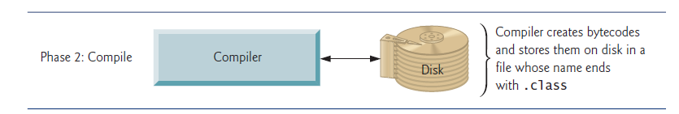

To compile a java program the system must have JDK (Java Development Kit) installed in the system.
Java source files typically have the file extension .java. Assuming that the “Hello, World” program is stored in the file hello.java, the program can be compiled with the Java compiler using the command line
javac hello.java
Which produces a class file named Hello.class

The output produced by this can be seen from command line using
java Hello
Output: Hello, World

4.3 JAVA: AN OBJECT ORIENTED PROGRAMMING LANGUAGE

OOP is a design philosophy. It stands for Object Oriented Programming. Object Oriented Programming (OOP) uses a different set of programming languages than old procedural programming languages (C, Pascal, etc.). Everything in OOP is grouped as self-sustainable "objects". Hence, you gain re-usability by means of four main object-oriented programming concepts.

OBJECT: An object can be considered a "thing" that can perform a set of related activities. The set of activities that the object performs defines the object's behavior.

CLASS: A class is simply a representation of a type of object. It is the blueprint/ plan/ template that describe the details of an object.

4.3.1 ENCAPSULATION
The encapsulation is the inclusion within a program object of all the resources need for the object to function - basically, the methods and the data. In OOP the encapsulation is mainly achieved by creating classes, the classes expose public methods and properties. The class is kind of a container or capsule or a cell, which encapsulate the set of methods, attribute and properties to provide its indented functionalities to other classes. In that sense, encapsulation also allows a class to change its internal implementation without hurting the overall functioning of the system. That idea of encapsulation is to hide how a class does it but to allow requesting what to do. In order to modularize/ define the functionality of a one class, that class can uses functions/ properties exposed by another class in many different ways. According to Object Oriented Programming there are several techniques, classes can use to link with each other and they are named association, aggregation, and composition. There are several other ways that an encapsulation can be used, as an example we can take the usage of an interface. The interface can be used to hide the information of an implemented class.

Example for encapsulation is class. A class can contain data structures and methods.
Consider the following class:
public class Aperture
{
public Aperture () { }
protected double height;
protected double width;
protected double thickness;
public double getVolume()
{
double volume=height * width * thickness;
if (volume<0)
return 0;
return volume;
}
}
In this example we encapsulate some data such as height, width, thickness and method getVolume(). Other methods or objects can interact with this object through methods that have public access modifier.

4.3.2 ABSTRACTION
Abstraction is a process of hiding the implementation details and displaying the essential features. In Java we use access specifiers to achieve abstraction.
Java has three access specifiers
Public -- Accessible outside the class through object reference.
Private -- Accessible inside the class only through member functions.
Protected -- Just like private but Accessible in derived classes also through member functions.

Example:

public class Class1
{
private int i;
public int j;
protected int k;
}

public static void main(String args[])
{
Class1 ob=new Class1();
ob.i= 10; // Error can’t access private data through object
ob .j=10;
ob.m=10;
}

4.3.3 INHERITANCE
Inheritance is a process of deriving the new class from already existing class. Java is a complete object oriented programming language. Inheritance is one of the primary concepts of object- oriented programming. It allows you to reuse existing code. Through effective use of inheritance, you can save lot of time in your programming and also reduce errors, which in turn will increase the quality of work and productivity.
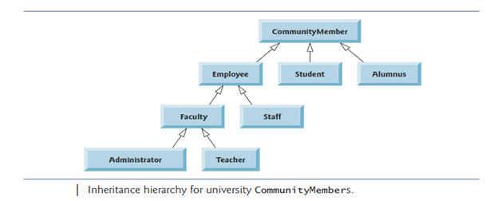

A simple example to understand inheritance in Java:
public class BaseClass
{
public baseClass ()
{
System.out.println("Base Class Constructor executed");
}
public void write ()
{
System.out.println("Write method in Base Class executed");
}
}

public class childClass extends baseClass
{
public childClass ()
{
System.out.println("Child Class Constructor executed");
}
public static void main (String args[])
{
childClass cc = new childClass ();
cc.write ();
}
}
In the Main () method in childClass we create an instance of childClass. Then we call the write () method. If you observe the childClass does not have a write() method in it. This write () method has been inherited from the parent baseClass.

Output:
Base Class Constructor executed
Child Class Constructor executed
Write method in Base Class executed
This output proves that when we create an instance of a child class, the base class constructor will automatically be called before the child class constructor. So in general Base classes are automatically instantiated before derived classes.
4.3.4 POLYMORPHISM
Polymorphism enables you to “program in the general” rather than “program in the specific.” In particular, polymorphism enables you to write programs that process objects that share the same superclass (either directly or indirectly) as if they’re all objects of the superclass; this can simplify programming.

Consider the following example of polymorphism. Suppose we create a program that simulates the movement of several types of animals for a biological study. Classes Fish, Frog and Bird represent the types of animals under investigation. Imagine that each class extends superclass Animal, which contains a method move and maintains an animal’s current location as x-y coordinates. Each subclass implements method move. Our program maintains an Animal array containing references to objects of the various Animal subclasses. To simulate the animals’ movements, the program sends each object the same message once per second—namely, move. Each specific type of Animal responds to a move message in its own way—a Fish might swim three feet, a Frog might jump five feet and a Bird might fly ten feet. Each object knows how to modify its x-y coordinates appropriately for its specific type of movement. Relying on each object to know how to “do the right thing” (i.e., do what is appropriate for that type of object) in response to the same method call is the key concept of polymorphism. The same message (in this case, move) sent to a variety of objects has “many forms” of results—hence the term polymorphism.

Example:

/* File name : Employee.java */
public class Employee
{
private String name;
private String address;
private int number;
public Employee(String name, String address, int number)
{
System.out.println("Constructing an Employee");
this.name = name;
this.address = address;
this.number = number;
}
public void mailCheck()
{
System.out.println("Mailing a check to " + this.name
+ " " + this.address);
}
public String toString()
{
return name + " " + address + " " + number;
}
public String getName()
{
return name;
}
public String getAddress()
{
return address;
}
public void setAddress(String newAddress)
{
address = newAddress;
}
public int getNumber()
{
return number;
}
}

Now suppose we extend Employee class as follows:
/* File name : Salary.java */
public class Salary extends Employee
{
private double salary; //Annual salary
public Salary(String name, String address, int number, double
salary)
{
super(name, address, number);
setSalary(salary);
}
public void mailCheck()
{
System.out.println("Within mailCheck of Salary class ");
System.out.println("Mailing check to " + getName()
+ " with salary " + salary);
}
public double getSalary()
{
return salary;
}
public void setSalary(double newSalary)
{
if(newSalary >= 0.0)
{
salary = newSalary;
}
}
public double computePay()
{
System.out.println("Computing salary pay for " + getName());
return salary/52;
}
}

Now, run the following program:
/* File name : VirtualDemo.java */
public class VirtualDemo
{
public static void main(String [] args)
{
Salary s = new Salary("Mohd Mohtashim", "Ambehta, UP", 3, 3600.00);
Employee e = new Salary("John Adams", "Boston, MA", 2, 2400.00);
System.out.println("Call mailCheck using Salary reference --");
s.mailCheck();
System.out.println("\n Call mailCheck using Employee reference--");
e.mailCheck();
}
}

This would produce the following result:
Constructing an Employee
Constructing an Employee
Call mailCheck using Salary reference --
Within mailCheck of Salary class
Mailing check to Mohd Mohtashim with salary 3600.0

Call mailCheck using Employee reference--
Within mailCheck of Salary class
Mailing check to John Adams with salary 2400.0
WHAT HAPPENED?
Here, we instantiate two Salary objects. One using a Salary reference s, and the other using an Employee reference e.
While invoking s.mailCheck() the compiler sees mailCheck() in the Salary class at compile time, and the JVM invokes mailCheck() in the Salary class at run time.
Invoking mailCheck() one is quite different because e is an Employee reference. When the compiler sees e.mailCheck(), the compiler sees the mailCheck() method in the Employee class.
Here, at compile time, the compiler used mailCheck() in Employee to validate this statement. At run time, however, the JVM invokes mailCheck() in the Salary class.
This behaviour is referred to as virtual method invocation, and the methods are referred to as virtual methods. All methods in Java behave in this manner, whereby an overridden method is invoked at run time, no matter what data type the reference is that was used in the source code at compile time.

INTRODUCTION

TO

SQLite JDBC DRIVER

(XERIAL)

5.1 INTRODUCTION
JDBC stands for Java Database Connectivity, which is a standard Java API for database-independent connectivity between the Java programming language and a wide range of databases.
The JDBC library includes APIs for each of the tasks mentioned below that are commonly associated with database usage.
- Making a connection to a database.
- Creating SQL or MySQL statements.
- Executing SQL or MySQL queries in the database.
- Viewing & Modifying the resulting records.
Fundamentally, JDBC is a specification that provides a complete set of interfaces that allows for portable access to an underlying database. Java can be used to write different types of executable, such as −
- Java Applications
- Java Applets
- Java Servlets
- Java ServerPages (JSPs)
- Enterprise JavaBeans (EJBs).
All of these different executable are able to use a JDBC driver to access a database, and take advantage of the stored data.
JDBC provides the same capabilities as ODBC, allowing Java programs to contain database-independent code.

5.2 JDBC ARCHITECTURE
The JDBC API supports both two-tier and three-tier processing models for database access but in general, JDBC Architecture consists of two layers −
- JDBC API: This provides the application-to-JDBC Manager connection.
- JDBC Driver API: This supports the JDBC Manager-to-Driver Connection.
The JDBC API uses a driver manager and database-specific drivers to provide transparent connectivity to heterogeneous databases.
The JDBC driver manager ensures that the correct driver is used to access each data source. The driver manager is capable of supporting multiple concurrent drivers connected to multiple heterogeneous databases.

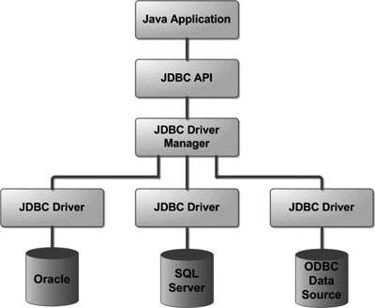

The architectural diagram showing the location of the driver manager with respect to the JDBC drivers and the Java application.

5.3 COMMON JDBC COMPONENTS
The JDBC API provides the following interfaces and classes −
DriverManager: This class manages a list of database drivers. Matches connection requests from the java application with the proper database driver using communication sub protocol. The first driver that recognizes a certain sub protocol under JDBC will be used to establish a database Connection.
Driver: This interface handles the communications with the database server. You will interact directly with Driver objects very rarely. Instead, you use DriverManager objects, which manages objects of this type. It also abstracts the details associated with working with Driver objects.
Connection: This interface with all methods for contacting a database. The connection object represents communication context, i.e., all communication with database is through connection object only.
Statement: You use objects created from this interface to submit the SQL statements to the database. Some derived interfaces accept parameters in addition to executing stored procedures.
ResultSet: These objects hold data retrieved from a database after you execute an SQL query using Statement objects. It acts as an iterator to allow you to move through its data.
SQLException: This class handles any errors that occur in a database application.
5.4 THE JDBC 4.0 PACKAGES
The new features in these packages include changes in the following areas −
- Automatic database driver loading and Annotations.
- Exception handling improvements.
- Enhanced BLOB/CLOB functionality.
- Connection and statement interface enhancements.
- National character set support.
- SQL ROWID access.
- SQL 2003 XML data type support.
5.5 THE XERIAL JDBC-DRIVER

SQLite JDBC, developed by Taro L. Saito, is a library for accessing and creating SQLite database files in Java.

Xerial SQLiteJDBC library requires no configuration since native libraries for major OSs, including Windows, Mac OS X, Linux etc., are assembled into a single JAR (Java Archive) file. The usage is quite simple; download our sqlite-jdbc library, then append the library (JAR file) to your class path.

The Xerial sqlite-jdbc implementation is forked from Zentus' SQLite JDBC driver. We have improved it in two ways:
- Support major operating systems by embedding native libraries of SQLite, compiled for each of them.
- Remove manual configurations

In the original version, in order to use the native version of sqlite-jdbc, users had to set a path to the native codes (dll, jnilib, so files, etc.) through the command-line arguments, e.g., -Djava.library.path=(path to the dll, jnilib, etc.), or -Dorg.sqlite.lib.path, etc. This process was error-prone and bothersome to tell every user to set these variables. Our SQLiteJDBC library completely does away these inconveniences.

EXAMPLE:
Here is an example to select a file C:\dtbs.db (in Windows)
Connection con;
con = DriverManager.getConnection("jdbc:sqlite:C:/dtbs.db");

INTRODUCTION

TO

ANTLR 4

6.1 INTRODUCTION

ANTLR is a powerful parser generator that you can use to read, process, execute, or translate structured text or binary files. It’s widely used in academia and industry to build all sorts of languages, tools, and frameworks. Twitter search uses ANTLR for query parsing, with over 2 billion queries a day. The languages for Hive and Pig, the data warehouse and analysis systems for Hadoop, both use ANTLR. Lex Machina uses ANTLR for information extraction from legal texts. Oracle uses ANTLR within SQL Developer IDE and their migration tools. NetBeans IDE parses C++ with ANTLR. The HQL language in the Hibernate object-relational mapping framework is built with ANTLR.

Terence Parr is the man behind ANTLR and has been working on it since 1989.

Aside from these big-name, high-profile projects, you can build all sorts of useful tools like configuration file readers, legacy code converters, wiki markup renderers, and JSON parsers. I’ve built little tools for object-relational database mappings, describing 3D visualizations, injecting profiling code into Java source code, and have even done a simple DNA pattern matching example for a lecture.

From a formal language description called a grammar, ANTLR generates a parser for that language that can automatically build parse trees, which are data structures representing how a grammar matches the input. ANTLR also automatically generates tree walkers that you can use to visit the nodes of those trees to execute application-specific code.

There are thousands of ANTLR downloads a month and it is included on all Linux and OS X distributions. ANTLR is widely used because it's easy to understand, powerful, flexible, generates human-readable output, comes with complete source under the BSD license, and is actively supported.

ANTLR has contributed to the theory and practice of parsing including:

- linear approximate look ahead
- semantic and syntactic predicates
- ANTLRWorks
- tree parsing
- LL(*)
- Adaptive LL(*) in ANTLR v4

6.2 FEATURES OF ANTLR 4

The v4 release of ANTLR has some important new capabilities that reduce the learning curve and make developing grammars and language applications much easier.
Here are the key features:
- There are no grammar conflict or ambiguity warnings as ANTLR translates your grammar to executable, Human–readable parsing code.

- ANTLR parsers use a brand-new parsing technology called Adaptive LL(*) or ALL(*) (“all star”)

- ANTLR v4 dramatically simplifies the grammar rules used to match syntactic structures like programming language expressions.

- ANTLRgenerated parsers automatically build convenient representations of the input called parse trees that an application can walk to trigger code snippets as it encounters constructs of interest.

- Because ANTLR automatically generates parse trees and tree walkers, there’s no need for you to build tree grammars in v4.

- The biggest change is that v4 deemphasizes embedding actions (code) in the grammar, favoring listeners and visitors instead. Those mechanisms decouple grammars from application code, nicely encapsulating an application instead of fracturing it and dispersing the pieces across a grammar.

6.3 ANTLRWorks 2
ANTLRWorks 2 is an ANTLR Grammar Development Environment.
ANTLRWorks 2 is available both as a standalone application and as a plugin to NetBeans 7.3 or later.

Features of ANTLRWorks 2:
- Highly Responsive Code Completion: ANTLRWorks 2 is the first development environment to incorporate Tunnel Vision Labs' recent advances in highly responsive code completion — code completion features respond instantly as you type in a grammar. In the past, languages with dynamic typing and/or type inference posed significant limitations on IDEs to produce usable code completion behavior. ANTLRWorks 2 highlights the ability of our algorithms to overcome these limitations.

- Navigation Features: ANTLRWorks 2 provides several standard navigation features in NetBeans. In addition to the Navigator window, ANTLRWorks 2 highlights references to the element under the caret (the "Mark Occurrences" feature) and allows the user to Ctrl+Click elements to jump to a declaration.

- Unique Features: The performance and consistency of Tunnel Vision Labs' source analysis algorithms allows us to provide several additional features to help users understand large amounts of code with less effort. ANTLRWorks 2 allows users to hover over an element in a grammar to see a tooltip with information about the referenced rule.

- Source Code Diagrams: While editing ANTLR grammar files, the Syntax Diagram window shows a visual representation of the current rule. This feature offers a natural representation of elements of a grammar, and is an example of providing custom features to augment characteristics of a particular language. As an added bonus, double clicking on an element in the source code diagram will immediately jump to the relevant source code.

- Editor Hints: ANTLRWorks 2 provides editor hints to alert a developer to potential bugs or performance issues in a grammar which the grammar compiler does not currently detect. Since this type of static analysis is unique to each language, we work with both language creators and users to provide analysis features most likely to detect problematic code early in the development cycle. Current analysis features for grammars in ANTLRWorks include the following.

PROJECT WORK
SQLite EDITOR
&
PARSER

7.1 ABSTRACT

This software is a SQLite Editor and Parser. As its name suggests, it provides a user friendly environment for executing SQLite commands over a database. Additionally it parses the SQLite commands before executing on the database and thus assisting with the process of debugging.

SQLite Editor and Parser provides a very rich editing environment with full text highlighting and a lot more features to ease the Database management. Due to the attractive GUI of the software it is more comfortable to work on the database as compared to working on the SQLite command line interface.

Some distinguishing features of the SQLite Editor and Parser are:

- Syntax Highlighting: The SQL statements written inside the editor are properly highlighted to provide the rich editing environment.
- Easy Debugging: All the SQL statements before being executed on the database are first parsed for any syntax errors and thus a lot of errors are caught in a much safer and in earlier steps.
- Lightweight: The software is extremely lightweight and can run on any machine having JRE (Java Runtime Environment).
- Simple to use: The software is designed in a way so as to cater to the user’s ease. Its functionality is simple and easy to use as compared to SQLite’s command line.
- Uses SQLite: This software used SQLite, which is arguably the most widely used SQL RDBMS.
- Atomic Transactions: It provides a very easy “Click-and-go” functionality for performing atomic transaction.
- Syntax Hint: There are hints available for the mismatched string type of syntax errors.
- GUI: This provides a GUI for managing the database rather than a command line interface as provided by SQLite.

7.2 PURPOSE
Purpose of the software is to provide a user friendly environment for the management of a database system. Thus providing a better alternative to the default SQLite command line interface for the management of a database in SQLite without compromising with the rich features of the SQLite.
It also focusses on providing better detection of the errors and thus better debugging features. Thus providing a more comfortable and rich environment for efficient users of the database.
The software has also been designed keeping in mind the most basic users of the database management system who can simply click and go towards learning the SQL statements and commands without having to deal with any sort of complicated back-end installation and knowledge of the command line processing. Thus serving the new students to learn RDBMS in a more efficient and fast manner.

REQUIREMENT
SPECIFICATION

8.1 PROBLEM DEFINITION
Development of a SQLite Editor and Parser using the Java, ANTLR4 and Xerial JDBC SQLite driver which can be used to manage the database stored on a computer using the standard SQLite(SQL) statements.

8.2 HARDWARE & SOFTWARE REQUIREMENT

Operating System: Microsoft Windows Vista and later.
Hard Disk : 100 GB and higher
Ram : 1 GB and higher
IDE : NetBeans 7.4
NetBeans IDE is FREE, open source, and has a worldwide community of users and developers. It can be used to quickly and easily develop desktop, mobile and web applications with Java, HTML5, PHP, C/C++ and more. NetBeans IDE and NetBeans Platform are based on software from netbeans.org, which has been dual licensed under the Common Development and Distribution License (CDDL) and the GNU General Public License version 2 with Classpath exception.

Language : Java (JDK 1.7.0_51)

Java is a general-purpose computer programming language that is concurrent, class-based, object-oriented, and specifically designed to have as few implementation dependencies as possible. Java is intended to let application developers "write once, run anywhere" (WORA), meaning that compiled Java code can run on all platforms that support Java without the need for recompilation.

Extra Libraries : ANTLR4, ANTLRWorks 2 and JSyntaxPane.
Packages
and Plugins ANTLR4, ANTLRWorks 2
This ANTLR4 package and ANTLRWorks 2 plugin together are used to generate the parser for the SQL statements being run on the software based on the SQLite grammar provided in the documentation of SQLite 3. ANTLRWorks 2 plugin version used is v2.2.2

JSyntaxPane
A very simple package to use and extends JEditorKit that supports few languages. The main goal is to make it easy to have nice looking Java Swing Editors with support for Syntax Highlighting. Requires at least Java 1.6.

DESIGN
AND
CODING

9.1 DESIGN: Graphical User Interface

The Graphical User Interface of the software is fairly simple and user friendly. It consists of the basic functionalities for the management of a database provided along with the software once installed.

Figure: GUI of SQLite Editor and Parser

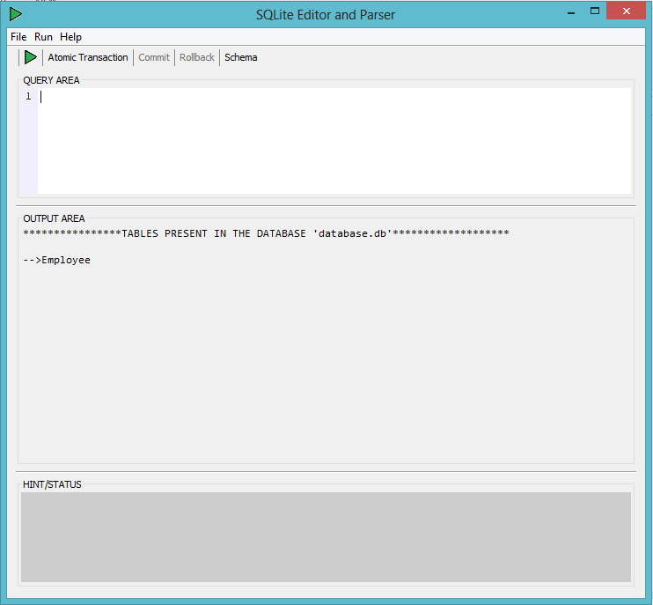

The description of the components of the player are given below:

- QUERY AREA: It is the editing space for the SQL statements.

- Play Button: This is used to execute the statement written in ‘QUERY AREA’ on the database and thus show user the respective output and hint/status.

- Atomic Transactions Button: This button is used to start the transaction and thus activates the ‘Commit’ and ‘Rollback’ buttons for the successful execution of Atomic Transaction. It is deactivated after the transaction has begun to keep the transaction atomic and isolate.

- Commit Button: This button is used to commit the changes made to the database during the transaction. It gets activated only after the transaction has begun and is deactivated after transaction ends.

- Rollback Button: This button is used to roll back the changes made to the database during the transaction. It gets activated only after the transaction has begun and is deactivated after transaction ends.

- OUTPUT AREA: This space is used to display the output and errors received from the database or parser.

- HINT/STATUS: This area is one of the special features of the software. It provides extra hint in case of errors and exceptions for easy debugging of the problem.

- File Menu Bar: It contains the menu item which launches the default browser in the system and opens the SQLite syntax page. Thus providing an easy way for users to look for syntax in case of confusion.

  - CODING

9.2.1 LIST OF CLASSES AND THEIR DESCRIPTION

CLASS | DESCRIPTION
SqlEditor | It is the class extending javax.swing.JFrame class and implementing ActionListener thus building the foundation for the GUI of the software. It also controls the main functionality of the software. Main function is present in this class only.
CheckSyntax | This class makes use of the ANTLR generated grammar for checking the syntax of the statement being executed. It contains the function to send the statement to the parser and retrieve the response of the parser.

9.2.2 LIST OF FUNCTIONS AND THEIR USE
fUNCTION | RETURN TYPE | ACCESS SPECIFIER | ARGUMENTS | USE
initComponents() | void | private | - | Used to initialize components used in frame.
actionPerformed() | void | public | ActionEvent e | Used to perform action based on the button pressed. ‘e’ gives he information about which button was pressed.
fUNCTION | RETURN TYPE | ACCESS SPECIFIER | ARGUMENTS | USE
output() | void | public | String s | Used to populate the output from the server to the output area.
updateTerminal() | void | public | int i  String s | Called from the output() in case when the server returns only number of rows modified. It displays the appropriate message inside output area.
show() | void | public | ResultSet rs | Called from the output() in case when the server returns table data. It displays the data in tabular form inside output area.
errorShow() | void | public | String s | This is used to show the syntax error as returned by the parser and also display the hint for debugging if available.
atomicMessage() | void | public | String s | Displays final output in case of transaction.

9.2.3 PSEUDOCODE

class SqlEditor

SqlEditor() //constructor
establish connection with the database;
initComponents();

actionPerformed()
if execute button clicked
output();
else if atomic transaction button clicked
start atomic transaction;
else if commit button clicked
commit the operations;
atomicMessage(MESSAGE);
else if rollback button clicked
roll back the changes on database
atomicMessage(MESSAGE);
else if schema button clicked
display the schema of database;

updateTerminal()
display the number of rows modified on the database due to the statement executed by the user. It is called in case of the statements which do not return table data on being executed on the database;

show(data)
display the data inside output area;

errorShow()
display the appropriate message to help make the user understand the error and help him/her appropriately debug it;

atomicMessage(MESSAGE)
Displays the statements executed on the database in case of commit and the statements which were rolled back in case of roll back procedure. The argument is used to display appropriate message to the user;

output()
checkSyntax();
if(no syntax error)
execute statement on datanbase;
if(exception occured)
errorShow();
else if(data returned from database)
show(data);
else if(database returned number of rows)
updateTerminal(no. of rows,MESSAGE);
if(syntax error occured)
errorShow();

//Class SqlEditor Ends

TESTING

  - TESTING: PHASE-I
In this phase we will test the basic functionality of the software to be able to execute the statements on the database and we also test how much responsive the buttons are?

STEP 1: Write the query in the QUERY AREA
In this example query is “SELECT * FROM Employee”
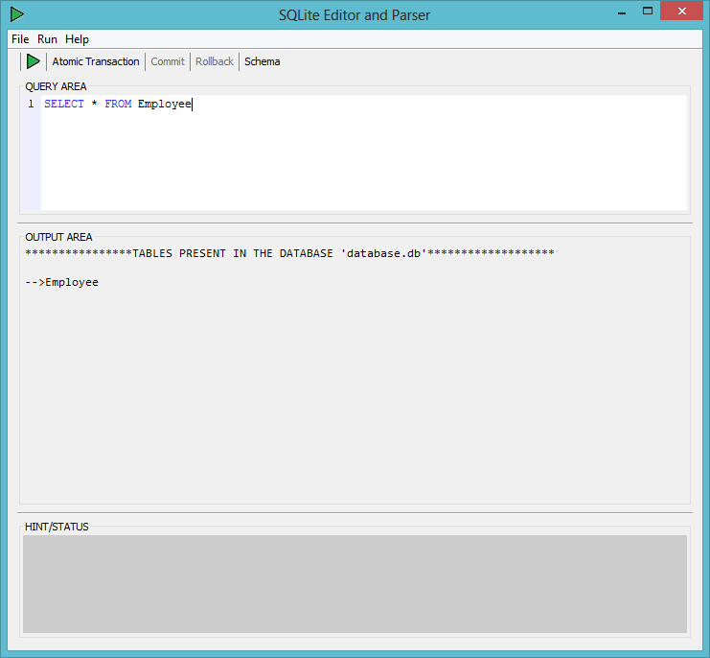

Result : The query can easily be written inside QUERY AREA and syntax highlighting feature is functioning.

STEP 2: Execute the command using play button, Menu item from run or through shortcut Ctrl+1.

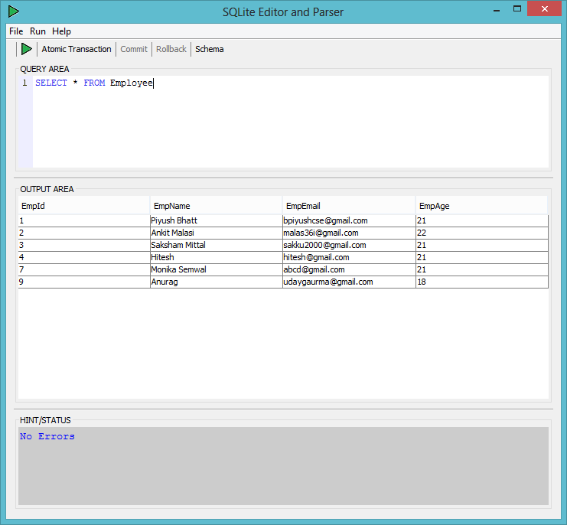

Result: Command executed successfully on the database and result is shown in the OUTPUT AREA.

STEP 3: Start Atomic transaction. Commit and Rollback buttons must turn active for performing the transaction.

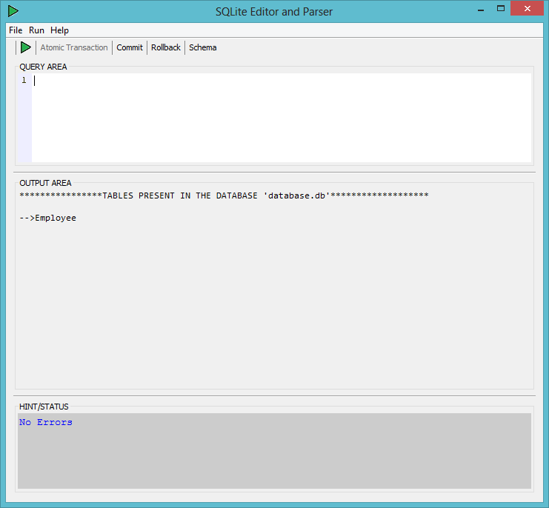

Result: Commit and Rollback buttons successfully turned active on starting the transaction along with deactivating the transaction button. This proves that the transaction button is working properly.

STEP 4: Write two statements and execute them on the database waiting to commit.

Execute first statement: “INSERT INTO Employee VALUES('15','Atul Jugran','atul.jugran@yahoo.com',21)”

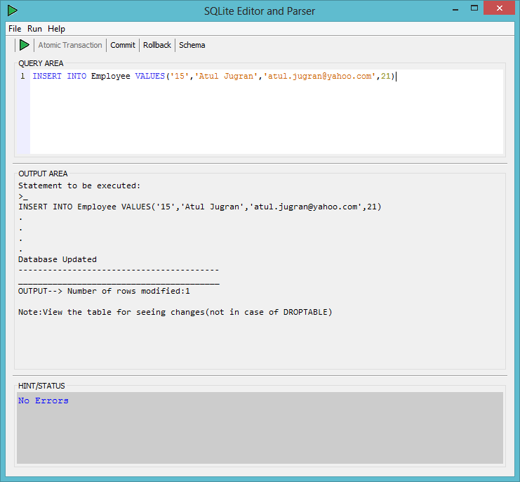

Execute second statement: “INSERT INTO Employee VALUES('16','Akhil Dobhal','akhil.dobhal@rediff.com',22)” similarly.

STEP 5: Commit the operations on the database.

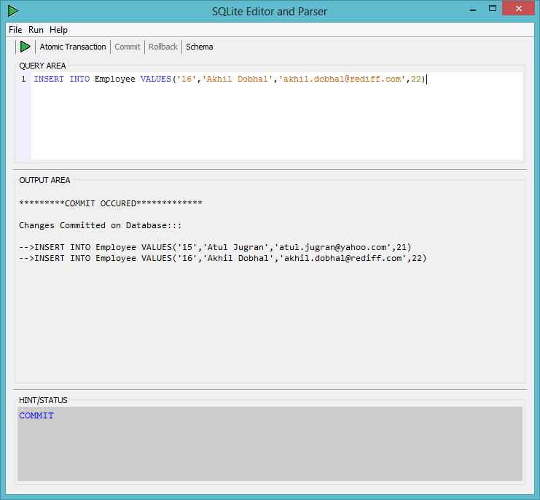

RESULT: Changes committed successfully on the database and a suitable result is shown in the OUTPUT AREA. It also deactivates the commit and rollback buttons along with activating the transaction button.

This further confirms the non-faulty functionality of the Execute, Atomic Transaction and Commit buttons.

STEP 6: Perform the step 4 again with different primary key and this time Rollback the operations on the database.

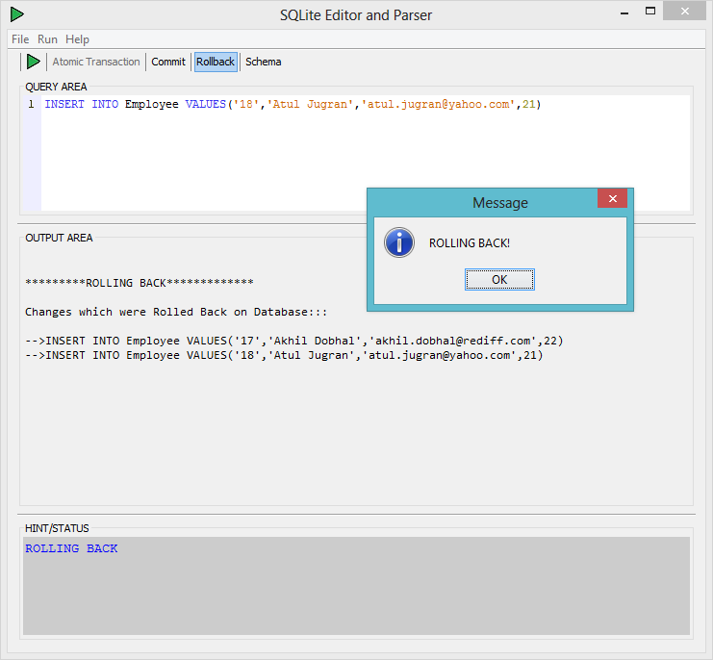

RESULT: Changes rolled back successfully on the database and a suitable result is shown in the OUTPUT AREA. It also deactivates the commit and rollback buttons along with activating the transaction button.

This further confirms the non-faulty functionality of the Execute, Atomic Transaction and Rollback buttons.

10.2 TESTING: PHASE-II
In this phase we will test the software for how it responds in case of different kinds of errors in various situations.

STEP 1: Write and execute the query with syntax error in the QUERY AREA

In this example query is “SELEC * FROM Employee”
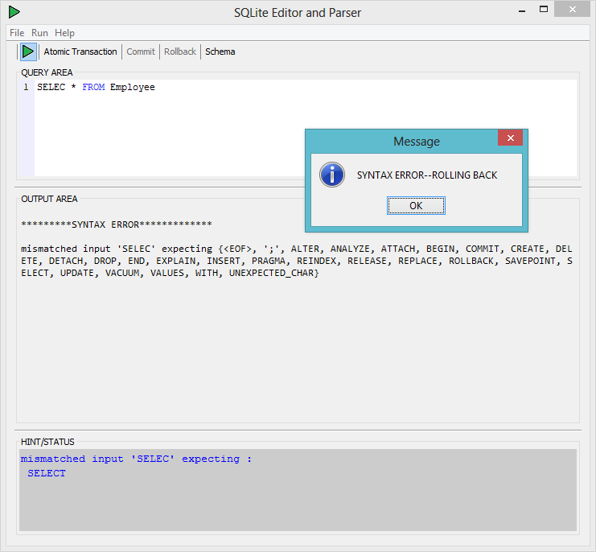

RESULT: Error message from the parser is shown in the OUTPUT AREA.
Suitable hint is shown in case of syntax error.
Further confirmation of proper functioning of execute button.
STEP 2: Write and execute the query with runtime error in the QUERY AREA

In this example query is “SELECT * FROM Student”
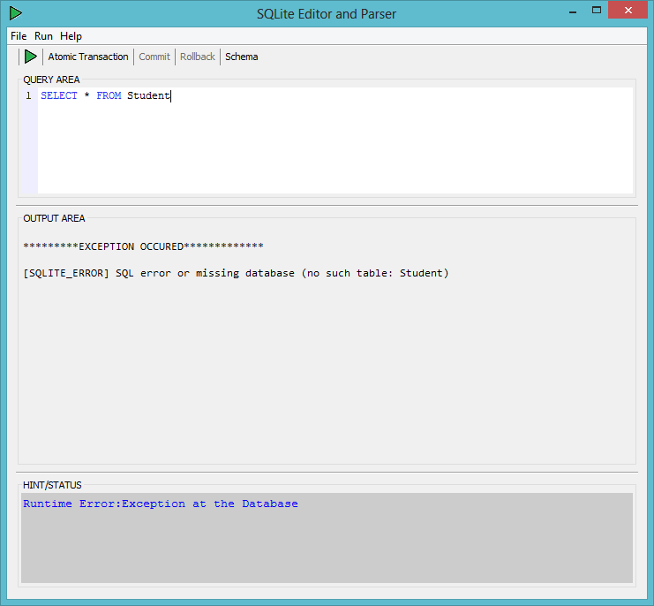

RESULT: Error message from the database is shown in the OUTPUT AREA.
Suitable status is shown in case of exception.
Further confirmation of proper functioning of execute button.
Thus confirms the non-faulty handling of exceptions by the software.

STEP 3: Start Atomic Transaction and execute two query with the second one containing runtime error.

In this example the queries are :
“DELETE FROM Employee WHERE EmpId = 9”
“DELETE FROM mployee WHERE EmpId = 1”
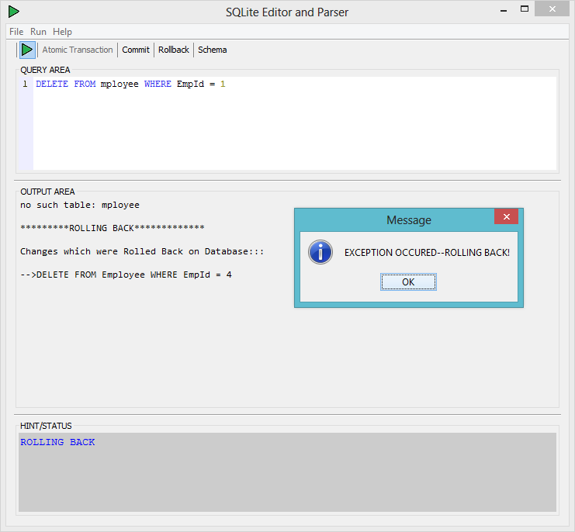

RESULT: Error message from the database is shown in the OUTPUT AREA.
Database is successfully rolled back to the last save point.
Suitable status is shown in case of rolling back.
Further confirmation of proper functioning of atomic transactions.
STEP 4: Start Atomic Transaction and execute two query with the second one containing syntax error.

In this example the queries are :
“DELETE FROM Employee WHERE EmpId = 4”
“ELETE FROM Employee WHERE EmpId = 1”
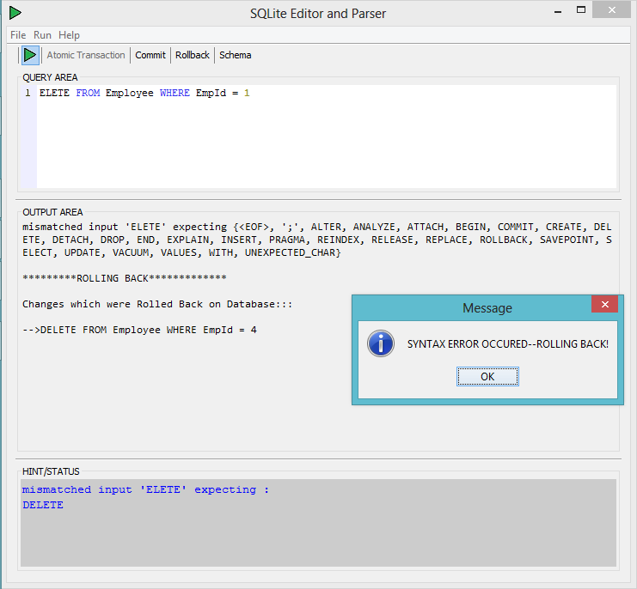

RESULT: Error message from the parser is shown in the OUTPUT AREA.
Database is successfully rolled back to the last save point.
Suitable hint is shown in case of rolling back.
Further confirmation of proper functioning of atomic transactions.
REFERENCES:
- Encyclopedia Britannica. "SQL". Retrieved 2013-04-02.
- IBM. "SQL Guide".
- Microsoft. "Structured Query Language (SQL)".
- Codd, Edgar F (June 1970). "A Relational Model of Data for Large Shared Data Banks". Communications of the ACM (Association for Computing Machinery) 13 (6): 377–87.
- Chapple, Mike. "SQL Fundamentals". Databases. About.com. Retrieved 2009-01-28.
- "Structured Query Language (SQL)". International Business Machines. October 27, 2006.
- "ISO/IEC 9075-1:2008: Information technology – Database languages – SQL – Part 1: Framework (SQL/Framework)"
- Chamberlin, Donald D; Boyce, Raymond F (1974). "SEQUEL: A Structured English Query Language". Proceedings of the 1974 ACM SIGFIDET Workshop on Data Description, Access and Control (Association for Computing Machinery): 249–64.
- Oppel, Andy (February 27, 2004). Databases Demystified. San Francisco,
CA: McGraw-Hill Osborne Media. pp. 90–1. ISBN 0-07-146960-5
- "History of IBM, 1978". IBM Archives. IBM.
- "Information Technology: Database Language SQL". CMU.
- ANSI/ISO/IEC International Standard (IS). Database Language SQL—
Part 2: Foundation (SQL/Foundation). 1999.
- Allen, Grant; Owens, Mike (November 5, 2010). The Definitive Guide to SQLite (2nd ed.). Apress. p. 368. ISBN 1-4302-3225-0.
- Kreibich, Jay A. (August 17, 2010). Using SQLite (1st ed.). O'Reilly Media. p. 528. ISBN 0-596-52118-9.
- van der Lans, Rick F. (September 7, 2009). The SQL Guide to SQLite (1st ed.) p. 542. ISBN 0-557-07676-5.
- Newman, Chris (November 9, 2004). SQLite (Developer's Library) (1st ed.). Sams. p. 336. ISBN 0-672-32685-X.
- ANTLRWorks 2 release notes
- Gosling, James; Joy, Bill; Steele, Guy; Bracha, Gilad; Buckley, Alex (2014). The Java® Language Specification (Java SE 8 ed.).
- Gosling, James; Joy, Bill; Steele, Guy L., Jr.; Bracha, Gilad (2005). The Java Language Specification (3rd ed.). Addison-Wesley. ISBN 0-321-24678-0.
- Lindholm, Tim; Yellin, Frank (1999). The Java Virtual Machine Specification (2nd ed.). Addison-Wesley. ISBN 0-201-43294-3.

