

**Progress Report 2：**

**User Interface Design**

**Team Number: UCL Engineering Video Guidelines**

*Author hiru.ranasinghe.17@ucl.ac.uk*

**Team leader name** hiru.ranasinghe.17@ucl.ac.uk

**Second member name** ali.soomro.17@ucl.ac.uk

**COMP103P Applied Software Development**

**February 9, 2018**

Department of Computer Science

University College London

Existing solution (UCL MEDIACENTRAL)

Main features:

* Web-based application
* Allows users to view, upload, rate, share and download videos with download options
* Front page of featured videos
* Allows users to search for content using a simplistic search bar
* Uses a tag system to search for related content and to produce video suggestions
* Sorts videos by contributor
* Integration with current UCL login credentials (ID and password) (OAuth)
* Allows users to save their own playlists/favourites
* Creates an automatic playlist of latest and most viewed videos
* Supports digital media live streaming

Limitations:

* Lack of a home page which explains purpose and gives a tour of the website
* Lack of video categorisation by discipline or subject; categories are extremely general
* Lack of advanced filters in search options
* Related video suggestions do not seem to be tied closely to the current video from testing
* Lack of video quality options while viewing
* Lack of mobile application

Inspiration and Potential Improvements:

* Website should have a clean layout with a main page of recent videos
* There should be a FAQ or tutorial option within the website
* Integration with UCL Login system should be implemented using OAuth
* Videos filters should include contributor(s) as well as categories
* Categories must be created and used efficiently and effectively for videos to be easily accessible
* Feedback on videos (comments and rating) should be available to logged in members
* Flexible download options will improve recyclability of videos

# Mock Up and Sitemap

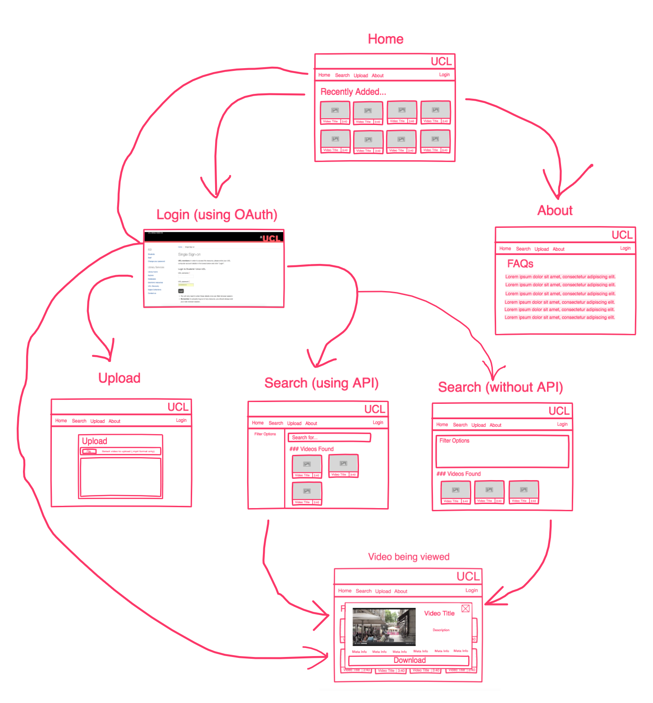

When opening the website, the user should be presented with the home page which will display recently added videos. The user can only view the about page, which is intended to be used as a tutorial guide for the website and maybe have a brief description of what the website does, without logging in. However, if they wish to view, search or upload a video they must go through the UCL sign in process to verify whether the user has the rights to view this content. After signing in, they can use the extra features as they wish.

The reason why there are two search screens are because if we find a good API to use to search the database, we can implement a more sophisticated results page where the result can also be filtered down. However, should we run into difficulties finding such an API, the user will be forced to search the video catalogue using drop down lists and checkboxes. The end result will remain the same; both pages will be used to find the video clip needed by the user