

**Progress Report 4:**

**First Prototype**

**Team 57: UCL Engineering Video Guidelines**

*Author hiru.ranasinghe.17@ucl.ac.uk*

**Hiru Ranasinghe** hiru.ranasinghe.17@ucl.ac.uk

**Ali Soomro** ali.soomro.17@ucl.ac.uk

**COMP103P Applied Software Development**

**March 9, 2018**

Department of Computer Science

University College London

# System Architecture

As this is a web application there will be a client side and a server side. For this project we will be using the architecture of a standard web app, where the frontend resides on the client machine when loading the webpage. The server will send the resources (HTML, CSS, JS) required to view the website on the client browser using HTTP protocols through port 80.

The server side contains the storage solution as well as the webserver. We will be using node.js to run the server, as it is better at handling DB requests than PHP in my opinion. The webserver will deal with all requests through the client and will act as a connection to the SQL storage, ensuring the database is protected from the outside world. The database query language that we will be using will be PostgreSQL because it integrates well with node.js, as well as coming preinstalled with it.

# Frontend Technologies

* HTML
* CSS
* JavaScript

# Backend Technologies

* Node.js
* npm
* express

# Data Storage

* PostgreSQL

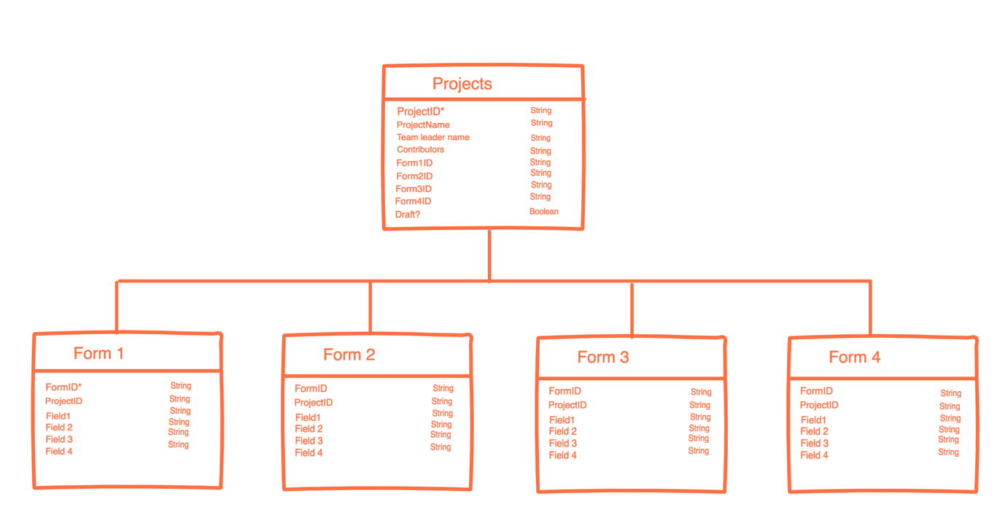

This is the current schema that we will be using. Since the DB has not yet been implemented, I expect the format and the field types to change.

Note: For contributors we will be using a parser, as it would be easier to store a list of other contributors rather than making another table for them.

# MoSCoW Progress

|  |  |
| --- | --- |
| MoSCoW Requirement | Done? |
| Set up a local environment for node.js server | ✓ |
| Created a basic front end | ✓ |
| Set up AWS for temporary deployment | ✓ |
| Temporary storage on server js file | ✓ |
| Set up storage space | X |
| Resolve issue with client server space for permanent deployment | X |
| Add UCL branding | X |
| Add all guideline content | X |
| Include UCL single sign on and extract data from login | X |
| Display username in top right corner | X |
| Create new instances in storage when a new project is opened | X |
| Delete projects | X |
| Add ‘verified’ page to display to users when video is approved/ or a similar disapproved video | X |
| Add help page | X |

# Current Look of the Frontend

