Screenshots or program listings must be copied into appropriate cells in the following table.
Save this evidence document as evidence_ followed by your centre number_ candidate number, for example, evidence_ zz999_9999 and insert your name, centre number and candidate number into the header above.
Examiners must be able to read the contents including any screenshots without the use of a magnifying glass. Answers that are not readable or are missing will not be awarded any marks.
Save this evidence document at regular intervals, for example every 10 minutes.
Question 1
Part 1(a)
Animals = ['']*10

Part 1(b)
Animals[0] = "horse"
Animals[1] = "lion"
Animals[2] = "rabbit"
Animals[3] = "mouse"
Animals[4] = "bird"
Animals[5] = "deer"
Animals[6] = "whale"
Animals[7] = "elephant"
Animals[8] = "kangaroo"
Animals[9] = "tiger"

Part 1(c)
def SortDescending():
"""bubble sort in descending order for Animals list"""
global Animals
n = len(Animals)
for i in range(n):
for j in range(0, n-i-1):
if Animals[j][0] > Animals[j+1][0]:
Animals[j], Animals[j+1] = Animals[j+1], Animals[j]

Part 1(d)(i)
def main():
global Animals
SortDescending()
for animal in Animals:
print(animal, end="\n")

if __name__ == "__main__":
main()

Part 1(d)(ii)
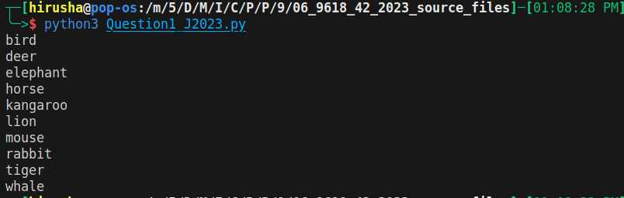

Question 2
Part 2(a)
class SaleData:
def __init__(self, id_="", quantity=-1):
self.id_ = id_
self.quantity = quantity

def __repr__(self):
return f"<SaleData id='{self.id_}' quantity={self.quantity}>"

Part 2(b)
CircularQueue = [SaleData()]*5 # of 5 items to store the sale records
Head = 0
Tail = 0
NumberOfItems = 0

Part 2(c)
def Enqueue(RecordToAdd):
global CircularQueue, Head, Tail, NumberOfItems
if(NumberOfItems == 5):
return -1
else:
CircularQueue[Tail] = RecordToAdd
if(Tail == 4):
Tail = 0
else:
Tail +=1
NumberOfItems +=1
return 1

​# I GOT THIS WRONG. LEARN MORE LATER! PLEASE. THIS ANSWER IS FROM THE M/S

Part 2(d)
def Dequeue():
global CircularQueue, Head, Tail, NumberOfItems

if NumberOfItems == 0:
return SaleData()

record = CircularQueue[Head]

# PLEASE REMEMBER THIS
Head = (Head + 1) % len(CircularQueue) # Circular increment
NumberOfItems -= 1

return record

Part 2(e)
def EnterRecord():
id_ = input("Enter ID: ")
quantity = input("Enter Quantity: ")
r = Enqueue(SaleData(id_=id_, quantity=quantity))
if r == -1:
print("Full")
else:
print("Stored")

Part 2(f)(i)
def main():
for _ in range(0, 6):
EnterRecord()
dequeued_record = Dequeue()
if dequeued_record.id_ == "":
print("No items")
else:
print(f"De-Queued element: {dequeued_record}")
EnterRecord()
for i in CircularQueue:
print(i)

if __name__ == "__main__":
main()

Part 2(f)(ii)
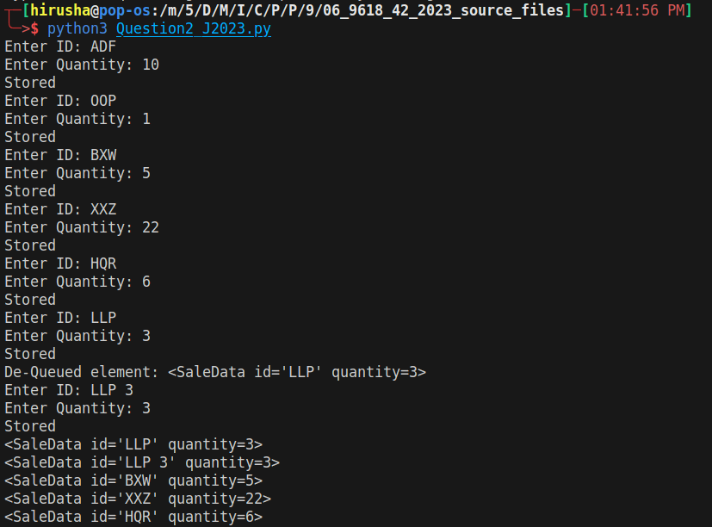

Question 3
Part 3(a)(i)
class Employee:
def __init__(self, HourlyPay, EmployeeNumber, JobTitle):
self.__HourlyPay: float = HourlyPay
self.__EmployeeNumber: str = EmployeeNumber
self.__JobTitle: str = JobTitle
self.__PayYear2022: str[float] = [0.00]*52 # 52 elements from index 0 to 51

Part 3(a)(ii)
def GetEmployeeNumber(self):
return self.__EmployeeNumber

Part 3(a)(iii)
def SetPay(self, WeekNumber, NoOfHours):
if (WeekNumber < 0) or (WeekNumber > 52):
raise ValueError("Invalid `WeekNumber`. Week Number is out of range. It should be between 0-52")
# PLEASE remember to sub 1 from the index. human to index conversion thing
self.__PayYear2022[WeekNumber-1] = self.__HourlyPay * NoOfHours

Part 3(a)(iv)
def GetTotalPay(self):
total = 0
for week in self.__PayYear2022:
total += week
return total

Part 3(b)(i)
class Manager(Employee):
# self.__BonusValue is a float
def __init__(self, HourlyPay, EmployeeNumber, JobTitle, BonusValue):
super().__init__(HourlyPay, EmployeeNumber, JobTitle)
self.__BonusValue = BonusValue

Part 3(b)(ii)
def SetPay(self, WeekNumber, NoOfHours):
NoOfHours = NoOfHours * (1 + (self.__BonusValue/100)) # from IGCSE Maths
return super().SetPay(WeekNumber, NoOfHours)

Part 3(c)
# EmployeeArray is array/list of Employee or Manager
EmployeeArray: list[Employee | Manager] = []*8 # from index 0 to 7
try:
with open("Employees.txt", "r", encoding="utf-8") as _file:
for i in range(0,8): # EmployeeArray
hp = float(_file.readline())
en = _file.readline().strip() # THIS DOESNT WORK WHEN float(). I DONT KNOW WHY
tmp = _file.readline()
try:
bs = float(tmp)
tl = _file.readline()
EmployeeArray.append(Manager(HourlyPay=hp,EmployeeNumber=en,JobTitle=tl,BonusValue=bs))
except ValueError:
EmployeeArray.append(Employee(HourlyPay=hp, EmployeeNumber=en, JobTitle=tmp))
except (FileNotFoundError, IOError):
print("File: Employee.txt not found!")

Part 3(d)
def EnterHours():
try:
with open("HoursWeek1.txt", "r", encoding="utf-8") as f:
for _ in range(0,8): # EmployeeArray
en = f.readline()
hrs = f.readline()
for element in EmployeeArray:
if element.GetEmployeeNumber() == en:
element.SetPay(1, float(hrs)) # week 1, no. of hours per week 1
except (FileNotFoundError, IOError):
print("File: Employee.txt not found!")

Part 3(e)(i)
EnterHours()
for element in EmployeeArray:
print(f"{element.GetEmployeeNumber()} - {element.GetTotalPay()}")

Part 3(e)(ii)
