Screenshots or program listings must be copied into appropriate cells in the following table.
Save this evidence document as evidence_ followed by your centre number_ candidate number, for example, evidence_ zz999_9999 and insert your name, candidate number and centre number into the header above.
Examiners must be able to read the contents including any screenshots without the use of a magnifying glass. Answers that are not readable or are missing will not be awarded any marks.
Save this evidence document at regular intervals, for example every 10 minutes.
Question 1
Part 1(a)(i)
def IterativeVowels(Value):
# Value string
# IterateVowels() returns integer
Total = 0
for x in range(0, len(Value)):
FirstCharacter = Value[0]
if FirstCharacter in ["a", "e", "i", "o", "u"]:
Total += 1
Value = Value[1:len(Value)]
return Total

Part 1(a)(ii)
print(IterativeVowels("house"))

Part 1(a)(iii)

Part 1(b)(i)
def RecursiveVowels(Value):
if len(Value) == 0:
return 0
else:
fch = Value[0]
if fch in ["a", "e", "i", "o", "u"]:
return 1 + RecursiveVowels(Value[1:len(Value)])
else:
return RecursiveVowels(Value[1:len(Value)])

Part 1(b)(ii)
print(RecursiveVowels("imagine"))

Part 1(b)(iii)
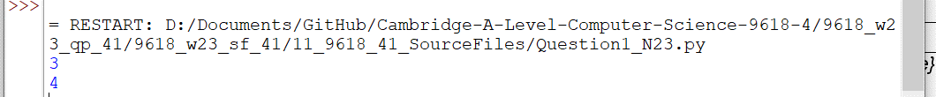

Question 2
Part 2(a)(i)
{Copy and paste program code listing for Question 2(a)(i) here}

Part 2(a)(ii)
{Copy and paste program code listing for Question 2(a)(ii) here}

Part 2(a)(iii)
{Copy and paste program code listing for Question 2(a)(iii) here}

Part 2(b)
{Copy and paste program code listing for Question 2(b) here}

Part 2(c)(i)
{Copy and paste program code listing for Question 2(c)(i) here}

Part 2(c)(ii)
{Copy and paste program code listing for Question 2(c)(ii) here}

Part 2(c)(iii)
{Copy and paste program code listing for Question 2(c)(iii) here}

Part 2(d)
{Copy and paste program code listing for Question 2(d) here}

Part 2(e)(i)
{Copy and paste program code listing for Question 2(e)(i) here}

Part 2(e)(ii)
{Copy and paste screenshot for Question 2(e)(ii) here}

Question 3
Part 3(a)(i)
{Copy and paste program code listing for Question 3(a)(i) here}

Part 3(a)(ii)
{Copy and paste program code listing for Question 3(a)(ii) here}

Part 3(a)(iii)
Copy and paste program code listing for Question 3(a)(iii) here}

Part 3(a)(iv)
{Copy and paste program code listing for Question 3(a)(iv) here}

Part 3(b)
{Copy and paste program code listing for Question 3(b) here}

Part 3(c)(i)
Copy and paste program code listing for Question 3(c)(i) here}

Part 3(c)(ii)
{Copy and paste program code listing for Question 3(c)(ii) here}

Part 3(d)
{Copy and paste program code listing for Question 3(d) here}

Part 3(e)(i)
{Copy and paste program code listing for Question 3(e)(i) here}

Part 3(e)(ii)
{Copy and paste screenshot for Question 3(e)(ii) here}

