Task 4.4D
Following the task instructions, I created a three column web page layout with a header, navigation menu, the main contents section (with three columns) followed by a footer at the very end. Since I’m more familiar with Tailwind CSS and it’s utility classes oriented approach, I quickly drafted this UI/layout with it to understand the structure, spacing and the responsive behavior. After getting the layout correct, I manually wrote vanilla CSS to replicate an identical layout.
During this conversion, I created my own CSS classes like .container, .box, .content-one, .main-content, and .content-two. The .box class is used for reusable visual styling for the boxes/containers.
For the layout, I stuck with using CSS grids. By default, the page uses `grid-template-columns: 1fr;` which creates one full width column area. Here, fr basically means a fraction of the available space. So, 1fr means one fraction, or all available space if there is only one column. This makes the mobile layout stack vertically.
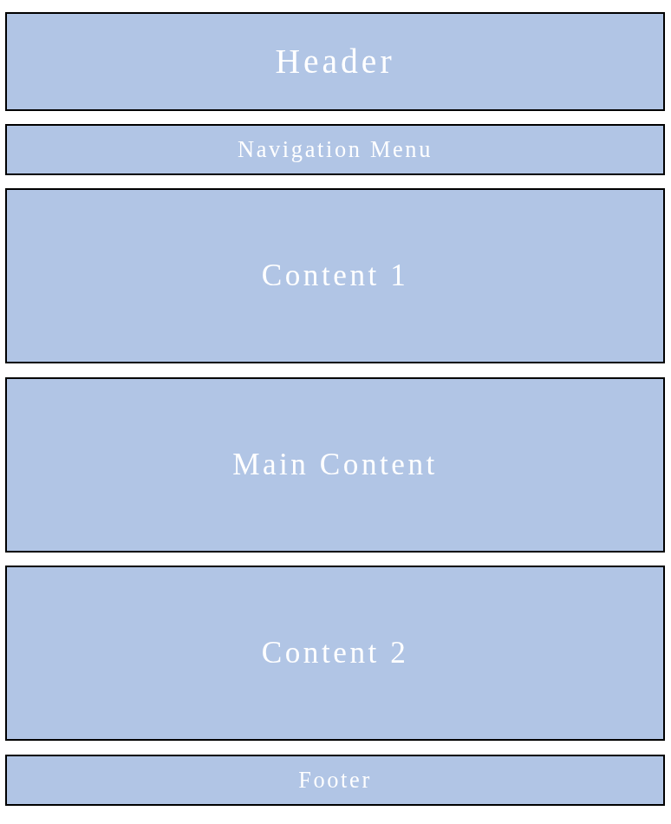
I then used the `@media screen and (min-width: 768px)` rule to change the layout for larger screens. 768px is like the conventional value. When the screen is at least 768px wide, the main section will change to `grid-template-columns: 1fr 3fr 1fr;`. This will create three columns, where the left and right sections take one fraction of the space while the middle main content section takes three fractions, making it wider.
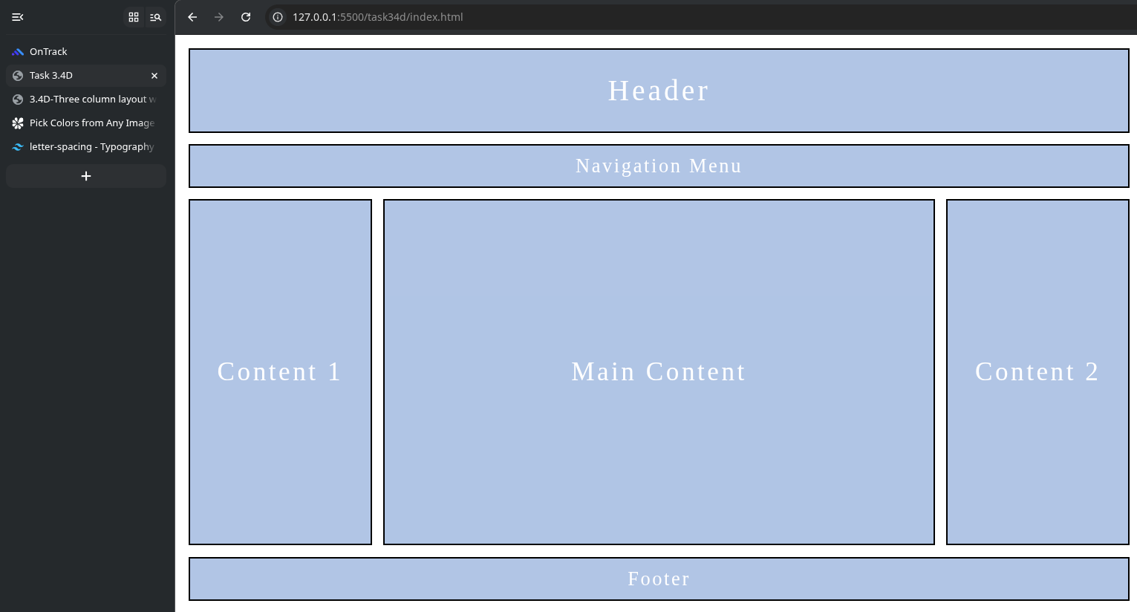
This is mobile first front end development.

Redo
Feedback I received:
Hi Hirusha. This task is not just about replicating the wireframe as per the task sheet, it needs to be filled with real content as per the topic of your choice. As it is a disticntion task, I would liek to see proper content in this submission other than a simple wireframe implementation.
Response:
Hi, thanks for the feedback. I’m now resubmitting with real content this time. This page is built based on the content from one of my blog posts about hardening linux, with actual article text, a table of contents and an info sidebar, rather than the bare wireframe.
Mobile View:

