QUIC – Research Report

What is QUIC?
QUIC is a transport protocol that works over UDP and basically takes over the jobs that would normally have been handled by TCP and TLS seperately. It was originally developed by Google at around 20212, and was later standardized by the IETF as RFC 9000 in 2021^{[1]}.
There a few things that makes QUIC different from normal TCP based connections.
- It runs in the application rather than the operating system. For example, QUIC can be implemented directly within apps like Chrome. This also means that it can be updated much easily and faster without depending on the operating system to update.
- Encryption is built in. QUIC uses TLS1.3 as a part of the protocol itself instead of having TLS added later on as another layer on top like with TCP^{[2]}.
- Connections use a Connection ID. Instead of identifying a connection only using IP addresses and port numbers, QUIC uses a Connection ID. Therefore, as a result of this, connections can survive things like switching over from WiFi to mobile data without needing to reconnect from the very beginning.
We could tabulate the primary changes as follows:
Traditional HTTP/2 stack | HTTP/3 with QUIC
HTTP/2 | HTTP/3
TLS | Built into QUIC
TCP | QUIC
IP | UDP —> IP

So, QUIC is not really just “TCP over UDP” – it uses UDP as the base, but implements its own connection management, reliability, security and other transport features on top of it.`

Why do we need QUIC?

Slow connection setup
QUIC was mainly created because TCP has a few problems that are very hard to fix without basically replacing it. TCP first needs a 3 way handshake which takes 1 RTT. If TLS is being used, there is then another handshake before the actual application data can start moving. So, traditionally, you can spend around 2 round trips just setting up the connection.
QUIC combines the transport and TLS setup together, so a new connection can normally start in 1 RTT. If the client has already connected to the server before, QUIC can also use 0 RTT allowing application data to be send immediately.

Head of line blocking
HTTP/2 allows multiple requests to share a single TCP connection but TCP still treats everything as one ordered by stream. This means that if one TCP packet is lost, later data cannot be delivered to the application until that that missing packet is retransmitted, even if the later packets have already arrived.
QUIC handles this differently by having multiple independent streams. Each stream has its own ordering, so, packet loss affecting one stream doesn’t necessarily stop the others.

Connections break when the IP address changes
TCP connections are identified using the src/dst IP addresses and port numbers. Because of this, changing networks can break the connection. For example, switching form WiFi to mobile data – which normally changes your IP address – will result in the existing TCP connections to be created again.
QUIC uses a Connection ID to identify the connection. This allows the same connection to continue even when the client’s IP address or the network changes.

TCP is difficult to evolve
Another issue is that TCP has existed for so long that firewalls, NATs and other middleboxes often inspect the TCP headers and expects TCP to behave in a specific way. This has caused the loss of flexibility, extensibility and evolvability of network protocols – also called “protocol ossification”. So, adding or changing TCP features becomes difficult because some middleboxes may block or incorrectly handle anything they do not recognize.
QUIC avoids a lot of this by running over UDP and encrypting or protecting most of its transport information. This makes it much harder for middleboxes to take assumptions about the internal behavior of the protocol.

Does it actually make a difference?
Yes! It does! In google’s early deployment of QUIC, they reported around an 8% reduction in Google Search latency on desktop and around an 18% reduction in YouTube rebuffering^{[3]}. So, QUIC is mainly trying to keep the reliability of TCP while fixing some of the performance and flexibility problems that have built up around TCP over time.

Functionality and frame formats
QUIC mainly uses two different header types depending on what stage the connection is in. They are the long header and the short header.

Long header
The long header is mostly used while the connection is being set up. At this point, both sides are still working out things like Connection IDs and the QUIC version being used. So, it contains things such as:
Header Form (1 = long) | Packet Type | Version | Destination Connection ID | Source Connection ID | Payload
There are four long header packet types:
Type | Purpose
Initial | Carries the first TLS handshake messages, like ClientHello and ServerHello
0-RTT | Carries early data when reconnecting to a server
Handshake | Carries the rest of the TLS handshake
Retry | Used when the server wants the client to prove that its address is actually valid

Short header
Once the handshake has finished, QUIC switches to use the much smaller short header. This is used for most normal traffic after the connection has been established. It basically contains a flags byte, the Connection ID, the packet number and the payload.

A lot of this information is encrypted or protected, so things like the version source Connection ID and packet length are no longer just sitting there in plain text. Because of this, after setup, QUIC traffic is fairly difficult for something in the middle of the network to inspect in detail.

Packets and frames
This is probably one of the more important parts of how QUIC works. A UDP datagram can contain one or more QUIC packets, and inside the encrypted payload of each QUIC packet there can be one or more frames.
TCP normally puts a lot its control related information directly into the header using things like SYN, ACK, FIN, RST, etc.. flags. However, QUIC does this differently. Most of it’s control information is carried as frames inside the encrypted payload itself.
Some of the main frame types are:
Frame | What it does
CRYPTO | Carries TLS handshake data
STREAM | Carries application data
ACK | Acknowledges packets that have been received
PADDING | Adds padding to increase the packet size when needed
MAX_DATA / MAX_STREAM_DATA | Used for flow control
NEW_CONNECTION_ID | Gives the other endpoint extra Connection IDs that can be used during migration
PATH_CHALLENGE / PATH_RESPONSE | Checks whether a new network path is working
CONNECTION_CLOSE | Closes the connection
HANDSHAKE_DONE | Lets the client know that the server considers the handshake finished

Together, these frames handle most of the actual data transfer, acknowledgements, flow control, connection management and path changes inside QUIC.

Handshake
A simplified QUIC handshake looks something like this:

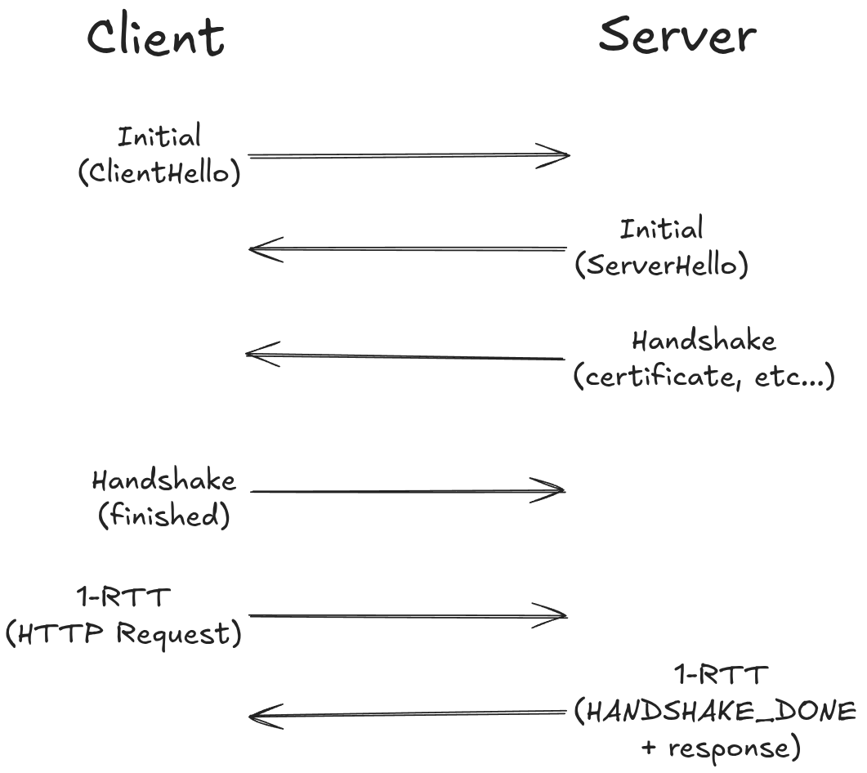
The client starts by sending an Initial packet containing the TLS ClientHello. This includes the information information needed to start negotiating this secure connection, like the supported TLS options and cryptographic parameters.
The server then replies with its own Initial packet containing the ServerHello. After that, it sends Hanshake packets containing the rest of the TLS handshake information, including things such as its certificate and the information needed to establish the encryption keys. Once the client has verified the server and both sides have worked out the required keys, the client sends its final handshake data back to the server.
Once the client has checked the server and both sides have the keys they need, the client sends the last part of its handshake data. After this, it can start sending normal 1-RTT packets, including actual application data such as an HTTP/3 request. The server can then send its own 1-RTT packets back, and it may also send a HANDSHAKE_DONE frame to basically tell the client that the handshake is fully finished.
The main difference compared to TCP with TLS is that QUIC doesn’t first establish a transport connection and then start the TLS handshake seperately afterwards – instead, both of them happen together, thus removing an extra round trip and lets encrypted data to start moving much sooner between the two hosts.

Advantages and disadvantages
QUIC fixes a few problems that come with the traditional TCP+TLS+HTTP/2 setup, but it also comes with it’s own tradeoffs.

Compared to TCP + TLS + HTTP/2
 | TCP + TLS + HTTP/2 | QUIC + HTTP/3
New connection | 2 RTT | 1 RTT
Repeat connection | 1 RTT | 0 RTT
Head-of-line blocking | Yes | No between independent streams
Headers visible to the network | Mostly visible | Very little visible
Survives an IP/network change | No | Yes
Usually runs in | Kernel | Application
CPU cost | Lower | Higher

The main advantage here is the speed and its flexibility.
QUIC can setup a secure connection in about 1 RTT, and repeat connections might use 0 RTT to send data immediately. It also avoids TCPs head of line blocking by using separate streams – so, packet loss from one stream doesn’t stop the others. QUIC’s Connection ID also lets connections survive network changes like mentioned above. More transport information will also be hidden from the network – making it harder for middleboxes to interfere with or make assumptions about how this protocol should behave.

Compared to plain UDP
Plain UDP is very basic. It doesn’t provide reliability, guaranteed ordering, congestion control or any built in security. If you needed any of those things, the application protocol would have to implement them itself.
QUIC however adds reliable ordered delivery, congestion control, flow control, TLS1.3, connection management, retransmission and loss recovery mechanisms on top of UDP. So, we still get all these useful features that we’d normally expect from TCP while actually still using UDP under the hood.

Disadvantages
QUIC is not always good. It comes with it’s own set of disadvantages.

High CPU usage
QUIC usually needs more processing power than TCP because most of it’s work is done in the user space and encryption is built directly into the protocol itself. Google’s earlier experiments revealed that QUIC is roughly as twice as expensive per byte as TCP+TLS^{[3]}. Implementations have improved a lot since then but QUIC can still have a higher CPU cost comparatively.

Some networks block UDP port 443
Not every network lets QUIC traffic through. Some networks have been reported to deliberately block 443/udp, sometimes because they want HTTPS traffic to fall back to TCP as its easier for existing network equipment to inspect and deal with^{[4]}. Because of this, browsers still need to support falling back to HTTP/2 over TCP.

Less visibility for network operators
Encryption is good for privacy but it might prevent firewalls, IPS/IDS systems and/or any other network monitoring tools from inspecting QUIC traffic in the same way they can inspect TCP headers. From the networks point of view, this is basically just encrypted UDP traffic.

No clearly visible connection ending
With TCP, a firewall can see FIN and RST flags and can therefore get a fairly clear idea of when a connection has ended. However, QUIC’s CONNECTION_CLOSE frame is encrypted and middleboxes can’t see it directly – thus making it really hard for them to determine whether the connection has finished or not. To do this, they normally reply on inactivity timers instead^{[4]}.

Adoption numbers can be misleading
QUIC and HTTP/3 are already very widely supported but the exact adoption rate mainly depends on whats being measured. Around 39% of actual websites advertise to support HTTP/3, but in reality, the actual HTTP/3 requests at are much more closer to 20%^{[5]}. This is because a website supporting HTTP/3 doesn’t mean that every connection to that website will actually use it.
Overall, QUIC provides a better connection setup, helps avoid transport level head of line blocking and handles changes network changes way easily. The main tradeoff is that its very resource intensive comparatively and it makes life harder for other networks that rely heavily on inspecting transport layer information.

Applications that use QUIC
QUIC was originally built for web traffic but its now used by quite a few other applications as well.
Application | Why QUIC is used
HTTP/3^{[6]} | Faster connection setup and no head of line blocking between streams
DNS over QUIC (RFC 9250)^{[7]} | Keeps DNS encrypted while still being fast, and helps protect against spoofing
SMB over QUIC (Microsoft) | Lets users access Windows file shares over the internet without needing a traditional VPN
WebTransport | Gives browsers a modern transport option for low-latency, bidirectional communication
MASQUE | Used for VPN style tunnelling, including services such as Apple iCloud Private Relay and Cloudflare WARP
YouTube, Instagram and Facebook | Helps with video delivery and can reduce stalls when packets are lost

Also, one major thing to note is that QUIC doesn’t always mean HTTP/3. It was initially designed around the needs of web but it has become a more general purpose transport protocol over time and it can carry other types of application traffic as well^{[4]}.

How QUIC improves security over TCP/TLS
QUIC improves the security by encrypting and authenticating more parts of the connection compared to a regular TCP + TLS setup.

More transport information is protected
TCP acknowledgements are a part of the normal TCP header and they aren’t cryptographically authenticated. In QUIC, ACK frames are also carried inside authenticated packets. This makes it much more harder for someone on the network to forge acknowledgment packets or interfere with loss recovery.

Encryption is mandatory
QUIC is encrypted – there’s no unencrypted version. QUIC always uses TLS1.3, allowing for more advanced security features like forward secrecy and many others to be built in right into the connection. If someone captures any encrypted QUIC traffic now and later gets access to the servers long terms private key, that alone should not let them decrypt the old traffic.

Connection settings are protected
QUIC also protects its transport parameters during the TLS handshake. Since this too is encrypted, this will protect us against downgrade attacks.

The trade off
This obviously provides better privacy and security between two endpoints but it also means that other network devices (even legitimate security related ones) might not be able to inspect that data and function as intended. This makes traditional network monitoring and filtering more difficult.

Key cryptographic mechanisms
QUIC uses LTS1.3, which is directly integrated to the transport protocol instead of running it seperately on top.
Goal | How QUIC does it
Key exchange | Uses the TLS 1.3 handshake, carried inside CRYPTO frames instead of normal TLS records
Authentication | The server presents an X.509 certificate, similar to normal HTTPS
Confidentiality | Packets are encrypted using AEAD algorithms such as AES GCM or ChaCha20 Poly1305
Integrity | Each encrypted packet includes an authentication tag, so changes to the packet can be detected
Header protection | A separate protection step hides information such as the packet number from anyone observing the traffic
Forward secrecy | Uses ephemeral session keys, with support for updating keys during a connection

Security threats and mitigations
Even though QUIC improves the security overall in a lot of areas, it still has its own attacks and problems that should be dealt with.
Threat | What happens | Mitigation
0 RTT replay | 0 RTT data can be captured and replayed by an attacker | Only allow safe and repeatable requests to use 0 RTT^{[2]}.
Amplification attack | An attacker spoofs a victim’s IP address, causing the server to send larger replies to the victim | Before the client's address is verified, the server cannot send more than 3× the amount of data it has received. Initial packets also have to be at least 1200 bytes^{[1]}.
Handshake flooding | An attacker sends a large number of connection requests, forcing the server to repeatedly perform expensive cryptographic work. It is similar to a SYN flood, but can cost the server more CPU | Retry tokens can verify the client's address before the server does the expensive work, along with rate limiting new connections.  Research has shown QUIC servers can use several times more CPU than TCP during this type of attack^{[8]}.
UDP flooding | Large amounts of traffic are sent to UDP port 443 to overwhelm the server or network | Use DDoS protection and scrubbing services that understand QUIC traffic^{[9]}.
User tracking | If the same Connection ID is kept when moving between networks, an observer may be able to link the old and new IP addresses to the same user | Change to a fresh Connection ID when migrating between networks. NEW_CONNECTION_ID frames should be able to do this.
Reduced defender visibility | Malicious traffic can be harder for network security tools to inspect because most QUIC traffic is encrypted | Inspect traffic at the endpoint instead, or block UDP/443 and force applications to fall back to TCP where required^{[4]}.
Implementation bugs | The QUIC protocol itself can be secure while a particular implementation still contains vulnerabilities. Researchers fuzz-tested six production QUIC servers and found exploitable bugs in several of them^{[10]}. | Keep QUIC libraries patched and regularly perform interoperability and security testing.

Scalability
QUIC scales pretty well but it might put more pressure on the server compared to TCP.

Peer Connections
One single QUIC connection can carry multiple streams of data at the same time without one stream completely blocking the others. Flow control mainly works at two levels.
- Per stream: which limits how much data one stream send
- Per connection: which limits how much data can be in flight across the whole connection
This helps to stop one busy stream from taking over the entire connection. Compared to this, HTTP/1.1 often needed multiple seperate TCP streams to the same site, just so it could download resources in parallel.

Per Server
This is one of QUICs main weaker areas. Every QUIC packet is encrypted and processed individually. And most of the work happens at the application level rather than directly inside the kernel. Therefore, this tends to have a higher CPU usage compared to using TCP. Servers reduce this overhead by processing packets in batches and using features like UDP Segmentation Offload (USO). Cloudflare reported increasing throughput from around 640 Mbps to 1.6 Gbps after using these kinds of optimizations^{[11]}.

Across Infrastructure
Load balancing also works a little differently with QUIC. With TCP, a load balancer can normally use the client’s IP and port to keep traffic going to the same backend server. QUIC can’t fully rely on this because the client’s IP or port can change when it moves between networks.
Instead, servers can include routing information inside the Connection ID they give to the client^{[4]}. The load balancer can then use that IDF to keep sending packets to the correct backend. This can actually work better for connection migration, because the routing can continue even if the client switches from something like WiFi to mobile data.
Another advantage is that QUIC runs mainly in the application. Therefore, any updates/improvements/fixes can be done easily without having to wait for the operating systems networking stacks to be updated.

Wireshark
Following this YouTube tutorial: https://www.youtube.com/watch?v=QRRHA_5hS2c, I was able to complete this task quite easily.
First, I set the SSLKEYLOGFILE environment variable so that it could be used by both Chromium and Wireshark.
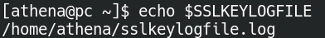

I then launched the Chromium browser and started capturing traffic in Wireshark.
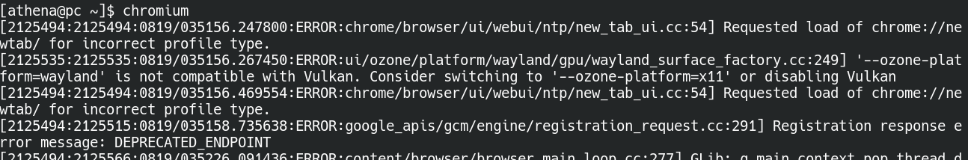
After capturing some traffic, I went to: Edit —> Preferences —> Protocols —> TLS —> and updated the TLS settings as follows:
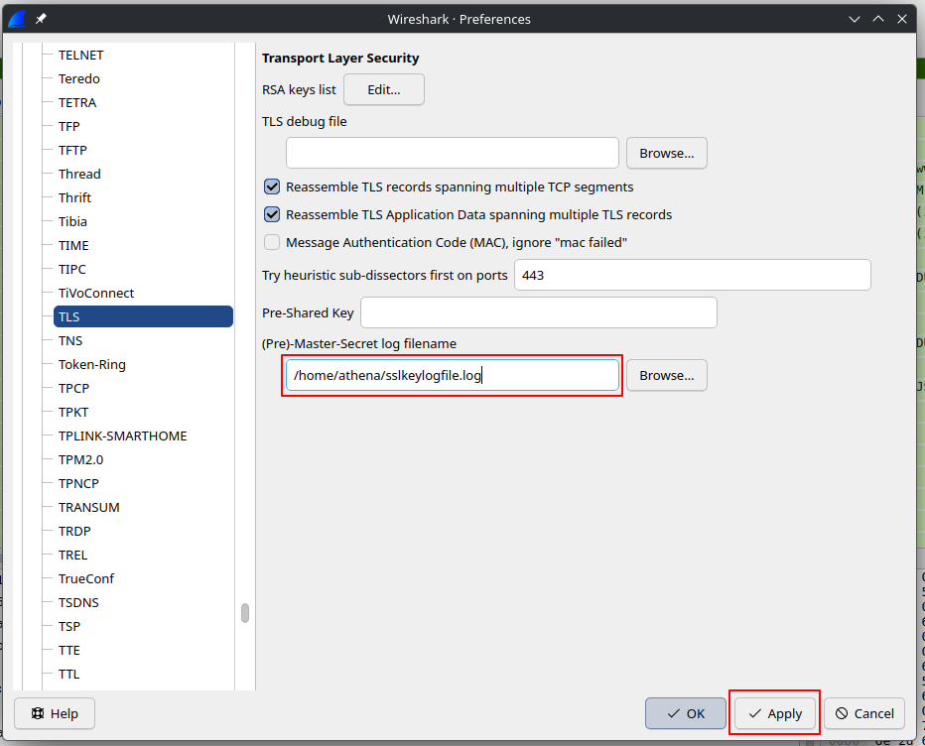
Just out of curiosity, the contents of the sslkeylog file looked something like this:
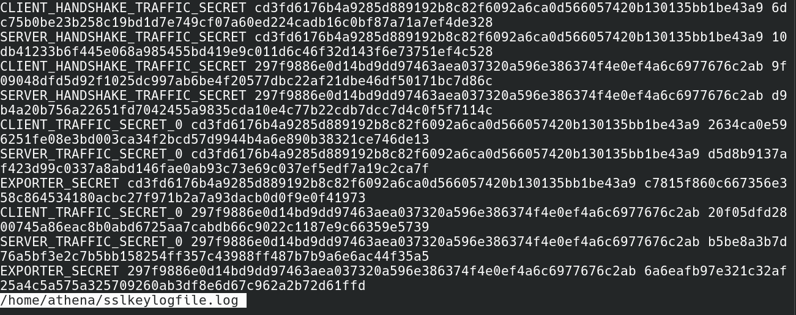

Once the key log file was configured properly in Wireshark, I filtered the capture for HTTP/3 traffic. At this point, Wireshark was able to decrypt the QUIC traffic, meaning the HTTP/3 data could now be viewed in a readable form instead of only seeing encrypted QUIC packets.
