SIT120 – Task 1.1P Website Planning & Design Template
Part 1: Project Concept & Scope
1.1 — Project Brief
Write 150–200 words describing your website: what it does, who it's for, and why responsive design matters.
LabelLens is a responsive website made for health conscious individuals who want to understand what food ingredients/additives they put into their body from the products they buy, without having to manually look up unfamiliar chemical names or INS numbers.
Users are able to either search for multiple additives from a searchable multi select dropdown menu (inspired by react-select), or point their phone camera at the ingredients section of a product. The website will use OCR — fully on the client side, without data ever leaving your device – to extract possible additive names, and compared them against the database, and display the closest matches ranked by the confidence, followed by the alphabetical order. The user can confirm or correct the detected additives before (or while) viewing the results.
Each additive will also have it’s own page, containing all of it’s information, including but not limited to sensitivity concerns, regulatory details, and the reliability and source of the available evidence. Instead of simply labeling additives as “good” or “bad”, the website will provide a lot of details to the users to help them make their own informed decisions.
The main target audience is health conscious adults aged 18-55 of any gender. More specifically, we are aiming for regular grocery shoppers, parents and people with food sensitivities. They may use the website in grocery stores while comparing packaged products / food items, or at home, while planning what to purchase when they get to researching ingredients. The response design allows users to scan and check labels quickly on a smartphone while shopping, while still giving them the ability to both check details about it on the spot quickly as well and go through them in depth.

1.2 — Site Aim
State the website's primary business goal in one clear sentence. Avoid using “to promote” — identify the real outcome.
To help health conscious individuals make informed decisions about what they put in their body when choosing packages food by providing trustworthy food additive details, clear explanations, also with simple comparisons for ease of use.

1.3 — User Goals (UX / Design Goals)
List 5 specific user outcomes your site should enable. Focus on what users need to accomplish, not features.
1. Identify food additives/ingredients simply by scanning the label or looking up the INS number manually without having to work out unfamiliar scientific names and abbreviations.
2. Review and correct the matches detected by the camera after scanning before displaying and reading through the results.
3. Understand why each ingredient is used, along with sensitivity related information, side effects and all the information, with links for further reading on trusted external websites.
4. Compare multiple additives from the same product in one easy to read and review way.
5. Make a quick, confident and an informed decision while shopping with a phone along with the ability to read more about each additive/ingredient as needed.
Part 2: User Research & User Stories
2.1 — Target Audience Personas
Define 2 distinct user personas. For each, include: name, age, tech literacy level, primary device, and key needs/pain points.
Persona 1: Raj Patel

Age: 25
Tech literacy: High (comfortable with camera permissions, filters, and other general stuff)
Primary device: Smartphone, Desktop
Context: compares packaged snacks and other packaged food and he often checks the labels using on hand while holding a basket.
Key needs: A fast scan, clear match confidence, easy and quick correction of OCR inaccuracies, and short and sweet summaries.
Pain points: tiny curved labels, exaggerated online claims, and website that needs long searches before showing any useful information.
Picture: https://www.dreamstime.com/photos-images/checking-phone-grocery.html
Persona 2: Madison Taylor
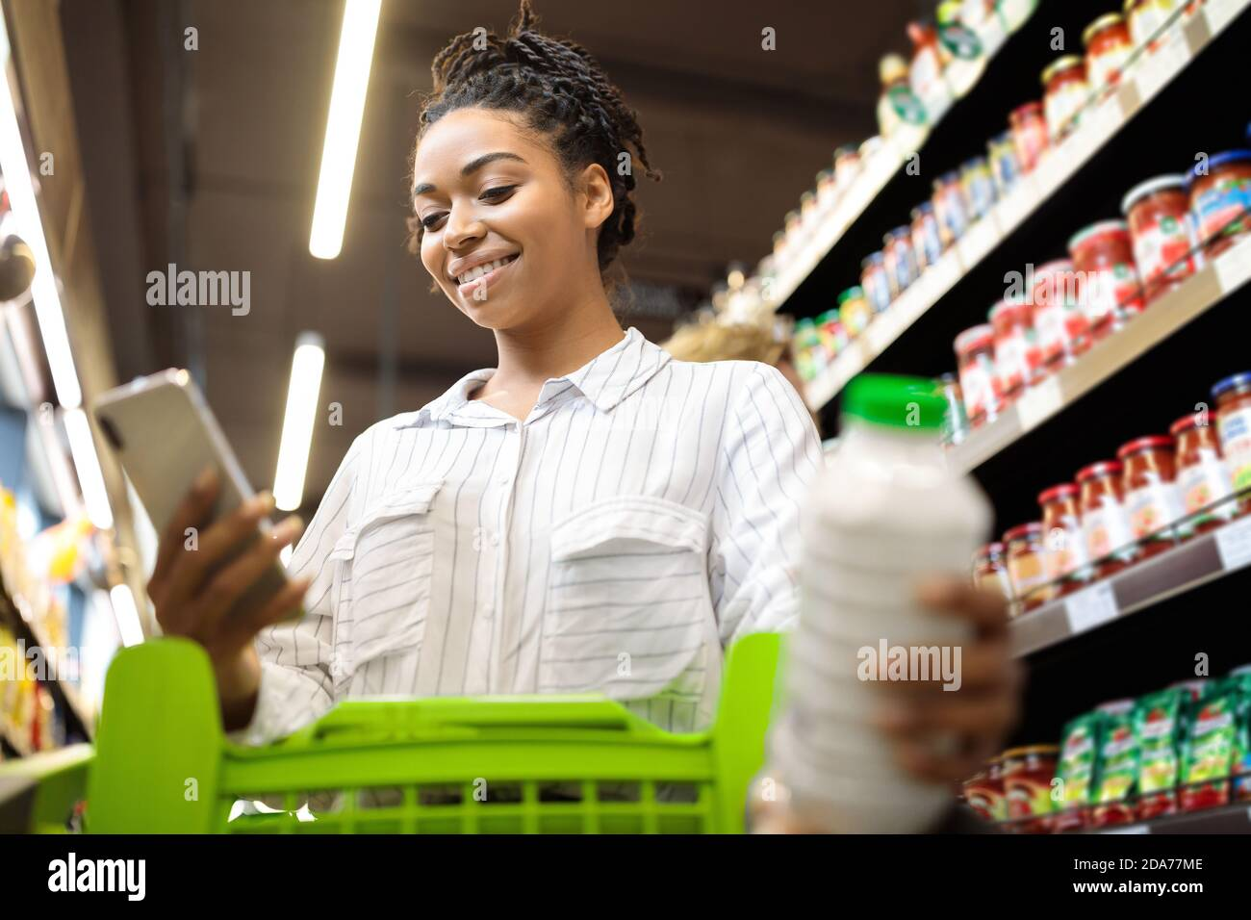
Age: 45
Tech literacy: Moderate (confident with websites but avoids complex settings and dense UIs)
Primary device: Smartphone, occasionally a laptop.
Context: Plans family groceries in advance and researches everything after checking the product labels.
Key needs: Readable text with a good contrast ratio, understandable and categorized data for easier reading, ability to re-visit the information later.
Pain points: Small unreadable text, unexplained technical terms.
Picture: https://www.alamy.com/lady-using-cellphone-with-grocery-shopping-application-in-supermarket-image384934382.html
Note: To facilitate the need of people like Madison Taylor, I will have to add a feature to upload product images along with the camera access feature.
2.2 — User Stories
Write 4 user stories in the format: As a [user], I want to [action], so that [outcome]. At least 2 must describe mobile or on-the-move usage scenarios.
1. As a supermarket shopper using my phone, I want to scan ingredient labels of food products so that I can understand the additives before buying the product.
2. As a shopper comparing products on the move, I want to quickly correct OCR text extraction matches so that I can make an accurate choice.
2. As a parent planning groceries at home, I want to compare several additives, so that I can choose good products for my family.
4. As a first time user, I want to see match confidence before viewing the in-depth results so that I can avoid being overwhelmed with information about additives and to avoid receiving information about the wrong additive.
Continue to Next Page

Part 3: Visual Style Guide
3.1 — Colour, Typography & Visual Style
Colour Palette
Include 3 colours: primary, secondary, and accent. Show each as a swatch and provide the hex code.
Colour Role | Hex Code | Swatch
Primary | #155E63 | 
Secondary | #F6F3EA | 
Accent | #B64900 | 

Colour Rationale:
The deep teal style gives trust and clarity without making the website seem too clinical. The warm cream creates a calm background while the burnt orange can be used to highlight important actions like scanning, confirming and comparing additives.
Typography
Heading Font (should be distinctive and work at larger sizes)
Font Name: Roboto Slab
Font Link: https://fonts.google.com/specimen/Roboto+Slab
Sample (apply your heading font): "The quick brown fox jumps over the lazy dog."
The quick brown fox jumps over the lazy dog.

Body Font (should be easy to read at smaller sizes and work well on all devices)
Font Name: Inter
Font Link: https://fonts.google.com/specimen/Inter
Sample (apply your body font): "The quick brown fox jumps over the lazy dog."
The quick brown fox jumps over the lazy dog.

Visual Style
Write 2–3 sentences explaining the overall tone (for example: professional, playful, modern) and how it aligns with your users and site aim.
This website will be using a modern and a calm visual style with clear contrasty colors for easier readability. Confidence indicators and confirmation controls will help users trust the results, while the layout will stack on mobile and expand for comparison on larger screens. The theme and the styling will look professional. I might stick with an already existing UI styling guideline/framework like Material UI when designing the frontend to ensure users feel comfortable in it.
Images / Graphics
Include or reference 2 images, icons, or graphics. Note the source and license for each.
Image / Graphic 1

• Description: The main icon
• Source / Reference: https://www.flaticon.com/free-icon/barcode-scan_2722003
• License / Attribution: Flaticon License (Free for personal and commercial purpose with attribution.)

Image / Graphic 2
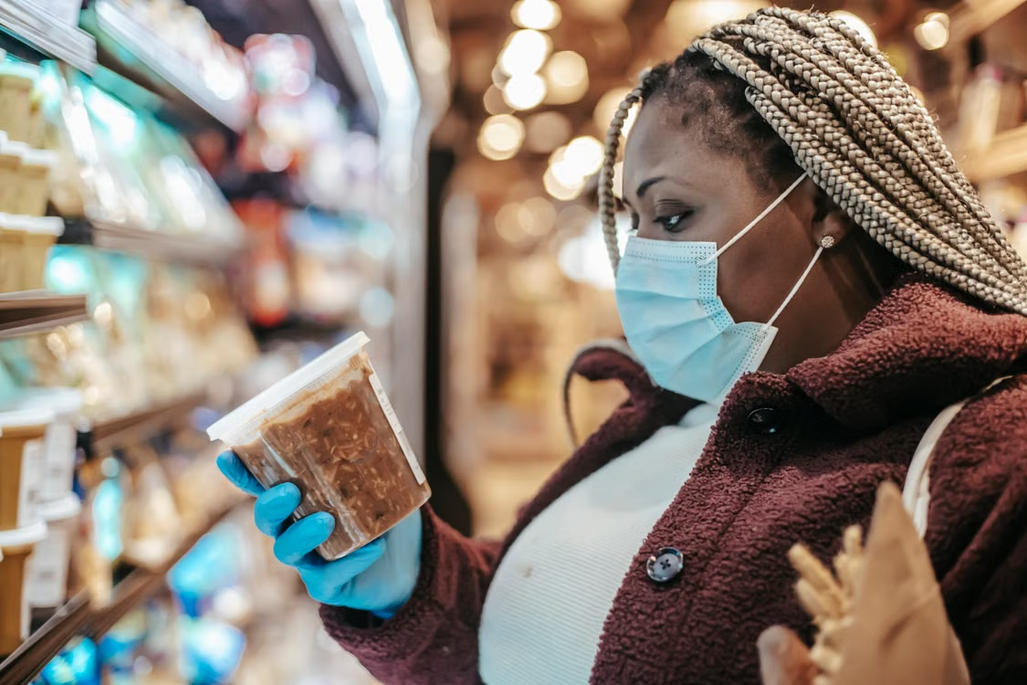
• Description: A good image for promotional material.
• Source / Reference: https://www.pexels.com/legal-pages/license/
• License / Attribution: Pexels License (free for personal use).
Part 4: Wireframing
Create low-fidelity wireframes for 3 key pages (for example: homepage, content page, contact/about).
Each wireframe should include:
- Header, content areas, images, calls-to-action, and footer.
- Clear labels
- Brief annotations explaining key design decisions.
- Evidence of thinking about user flow and usability.
Page 1: Home Page (Desktop) – scan and search are the main actions.
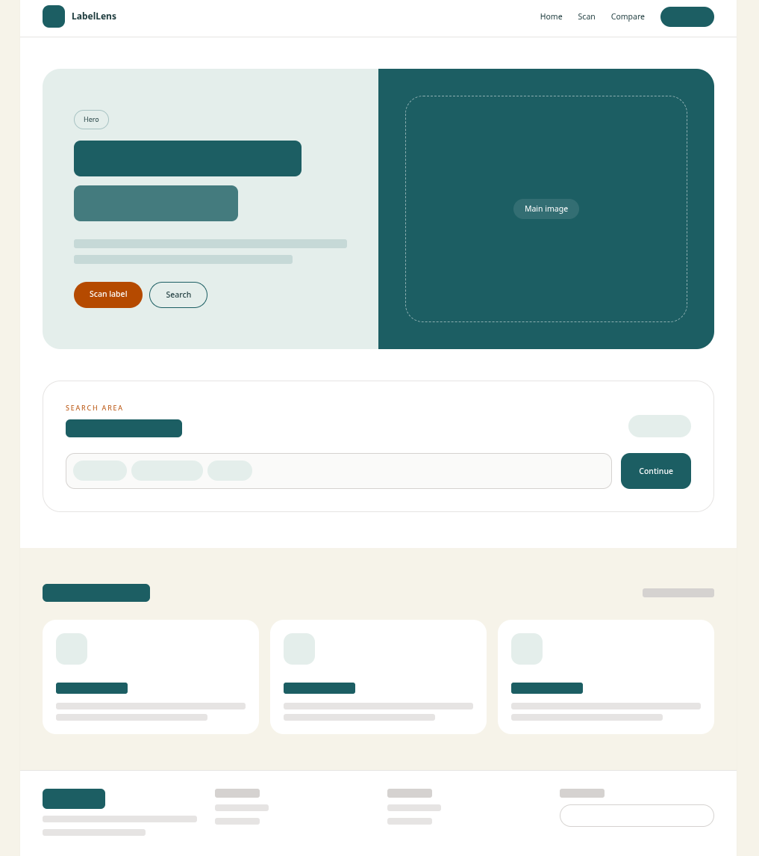

Page 1: Home Page (Mobile) - Cards stack on mobile.
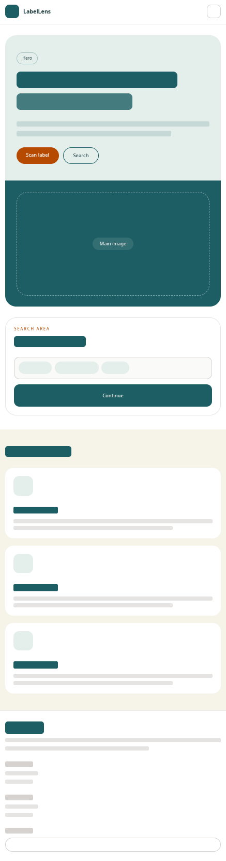
Page 2: Scan Results (Desktop) - camera preview first, detected matches second, confirmation last.
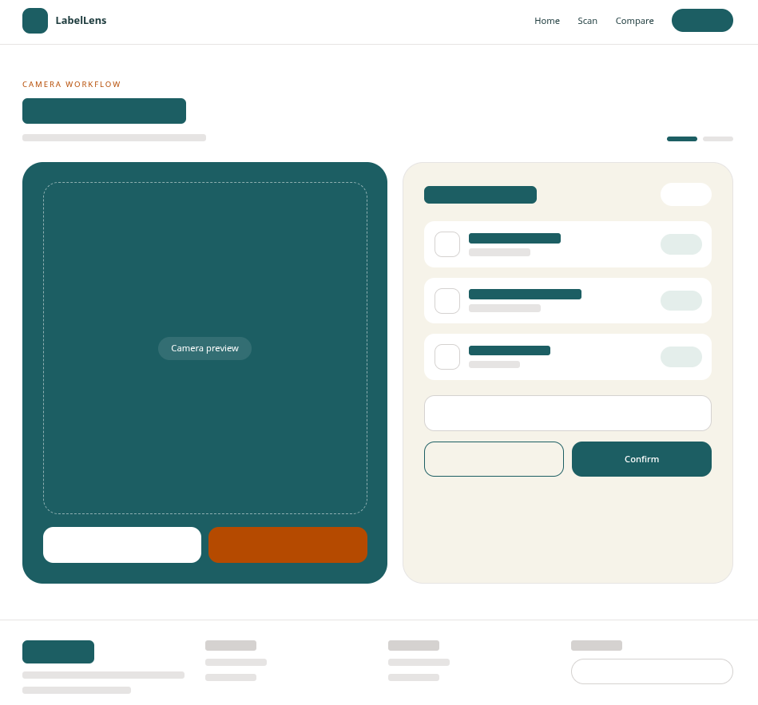

Page 2: Scan Results (Mobile)
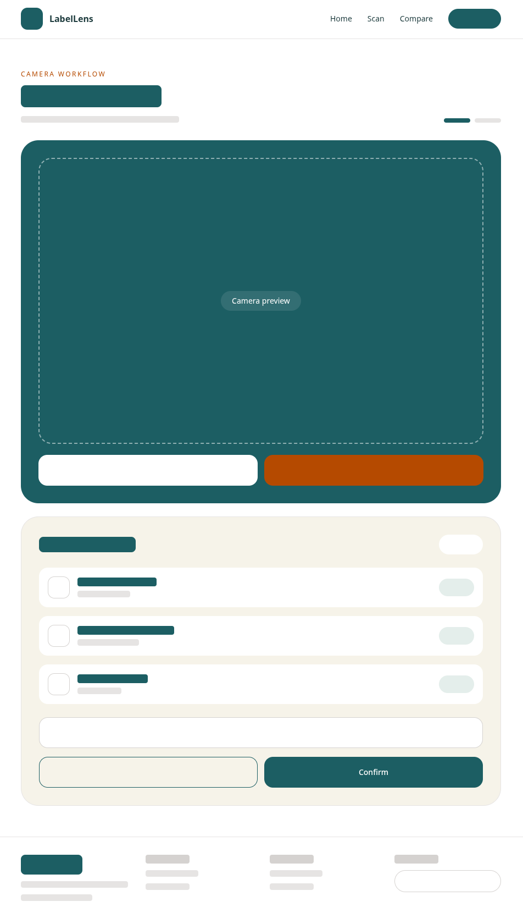

Page 3: Compare Results (Desktop) - repeated cards allow easy comparison and stack vertically on smaller screens.
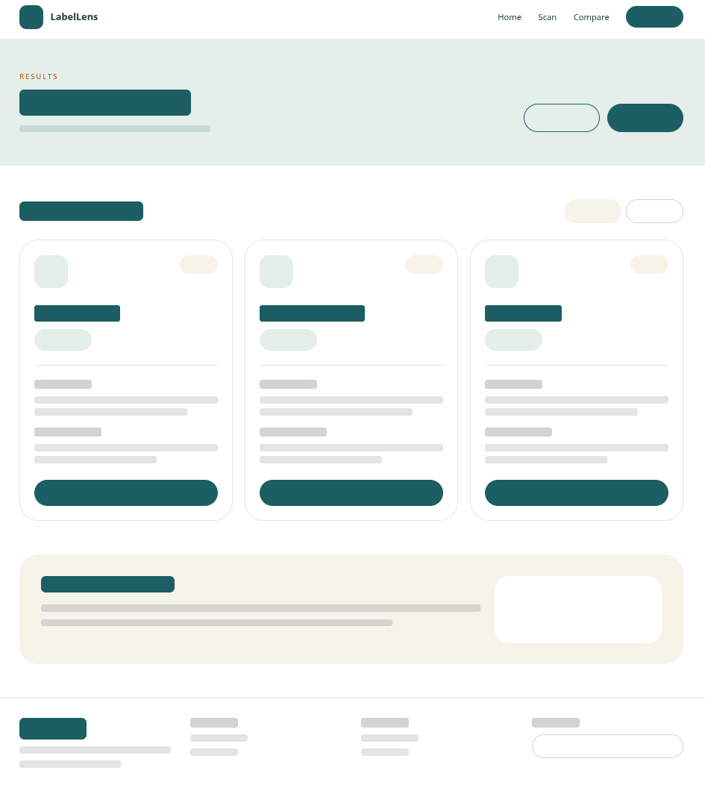

Page 3: Home Page (Mobile)
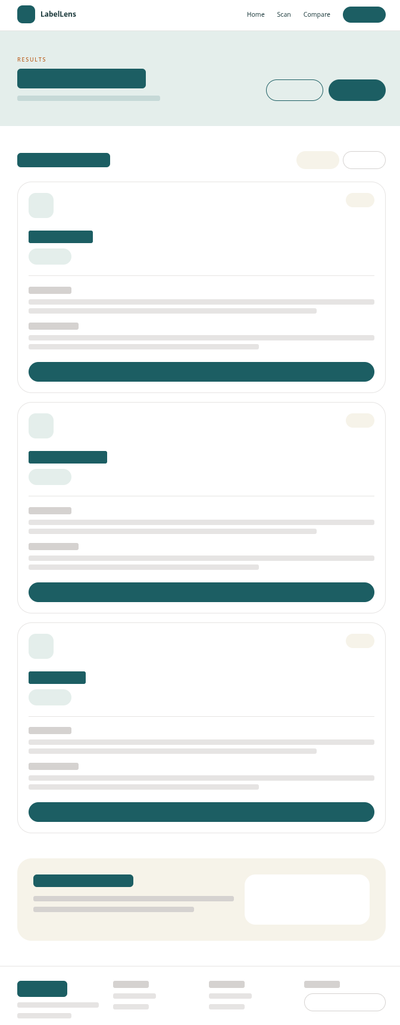
User Journey, Site Flow, and Layout Notes
Briefly describe how users move through your 3 pages. Include a simple diagram using arrows and arrowheads to show how each page links to the others, and provide a written explanation.
Diagram:
Home page —> Scan & Confirm page —> Results and Comparison page
Users begin on the home page where they can either scan an ingredients section or search of ingredients/additives manually. After scanning, they move to the confirmation page to review and correct the additives detected by OCR. Once confirmed, the results page displays the selected additives in an easy to read comparison view. Users can return to the confirmation page to make changes or go back to the home page to start a new search. This allows for a smooth user experience and flow among the pages. The header at the top helps this even further.

Submission
One PDF document, all sections completed, wireframes included.
NOTE: The wireframes were made with HTML using divs and basic layout related classes from TailwindCSS which was hooked up via the CDN.
— End —

