Task 4.3D

Tests

Valid Tests
I first tested these values as a valid baseline. It works as expected.
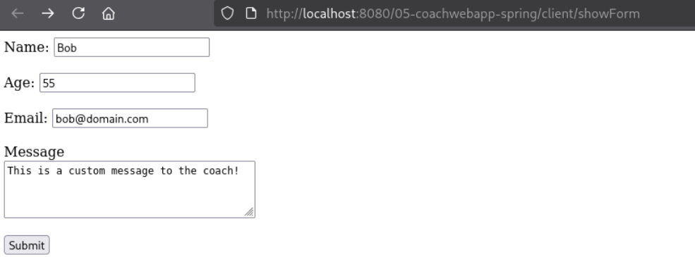
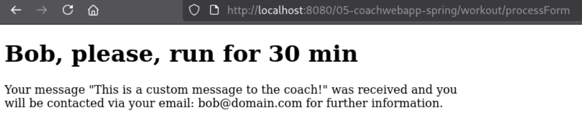
To ensure that the message allows special characters like !@#*,. The tested message contains these special characters with some common punctuation, keeping the other fields valid. It worked as expected and the submission was accepted. This confirms that the regex whitelist permits !@#* along side letters, digits and basic punctuation.
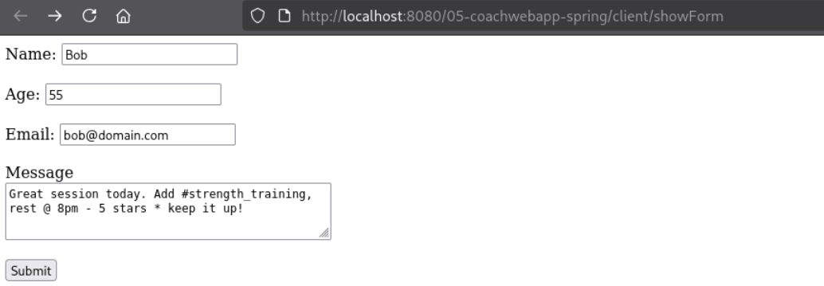
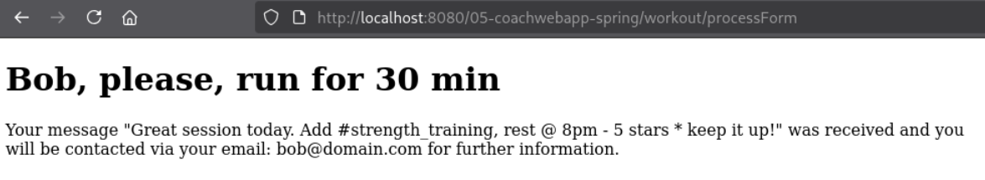

Invalid Names
To test that the name field rejects empty input, I tested with Name not set to anything/blank. It didn’t work and the server returned the form again with a validation error, because @NotNull rejects the missing value.
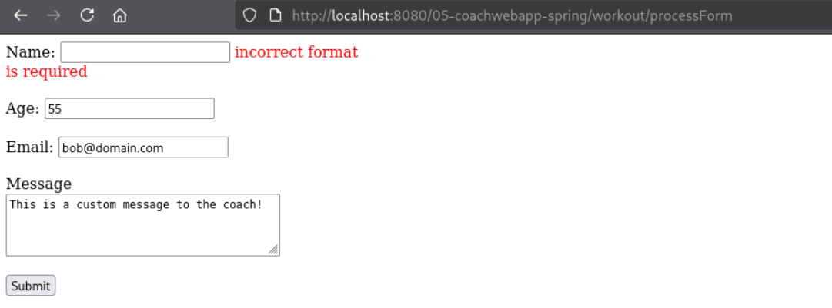
To test that the name field restricts the submissions to a minimum length, I tested with Name set to Bo. The server rejected it because @Size(min = 3) requires at least 3 characters and it shows a meaningful error message.
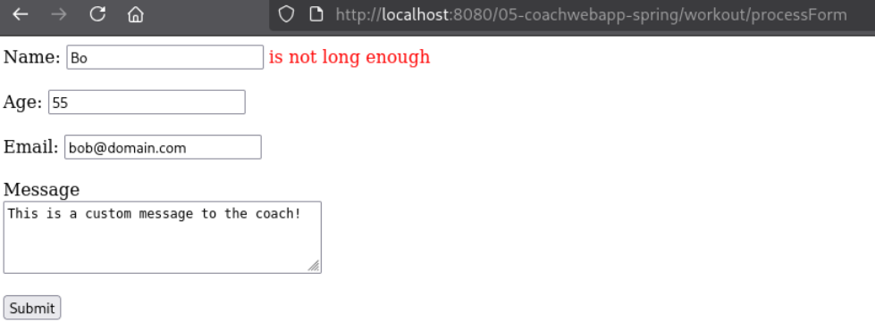
To test that the name field rejects non alphabetical characters, I tested with Name set to Bob2. The server rejected it because the @Pattern regex [a-zA-Z]+ only permits letters and it showed a meaningful error message suggesting it has something to do with the format.
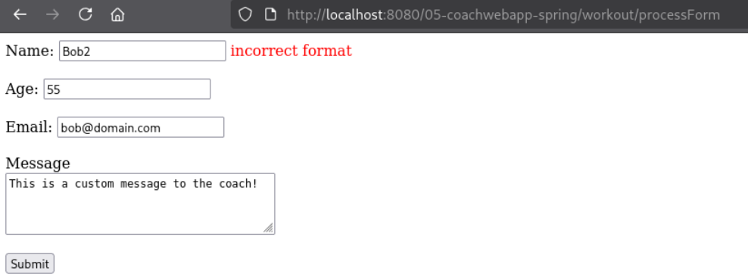
Similarly, characters like < and > was also rejected because they all fall outside of [a-zA-Z]+.
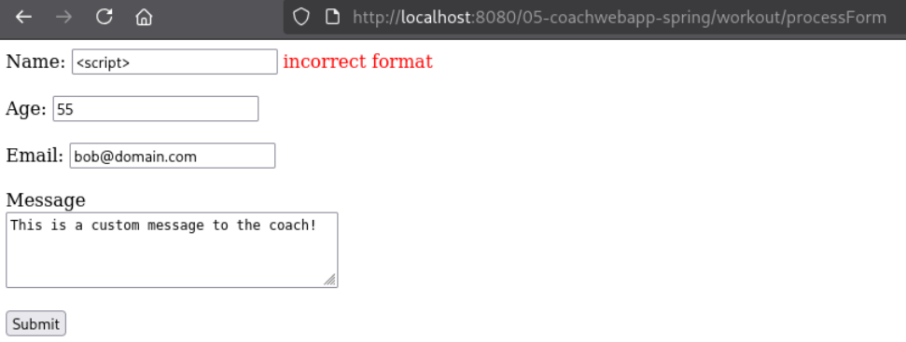

I attempted using some URL encoding for < and >. As it has characters that falls outside the whitelist regex, this gets rejected too.
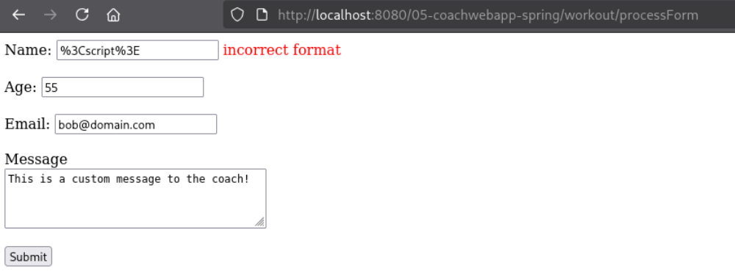

Invalid Emails
To test that the email field enforces a .com domain, I tested with Email set to bob@domain.org. The server rejected it because the regex ^[a-zA-Z0-9._]+@[a-zA-Z0-9-]+\.com$ only accepts a .com suffix.
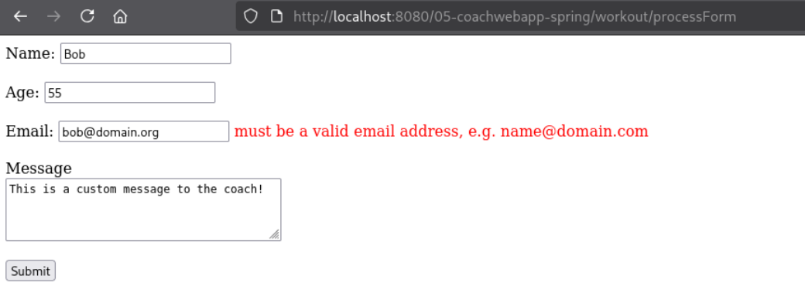
However, using regular expressions to validate emails is considered bad practice^{[1][2]}. Proper standard compliant email regexes are much more complicated than it seems.
A simple regex like mine can reject valid emails or accept invalid ones, while the fully RFC822 compliant regex is just massive and difficult to maintain. It’s recommended to use email parsers that are already provided by a language or a framework.
A much more efficient regex is the RTC5322 compliant version^{[3]}. Below is that regex with it’s railroad diagram.
(?:[a-z0-9!#$%&'*+/=?^_`{|}~-]+(?:\.[a-z0-9!#$%&'*+/=?^_`{|}~-]+)*|"(?:[\x01-\x08\x0b\x0c\x0e-\x1f\x21\x23-\x5b\x5d-\x7f]|\\[\x01-\x09\x0b\x0c\x0e-\x7f])*")@(?:(?:[a-z0-9](?:[a-z0-9-]*[a-z0-9])?\.)+[a-z0-9](?:[a-z0-9-]*[a-z0-9])?|\[(?:(?:25[0-5]|2[0-4][0-9]|[01]?[0-9][0-9]?)\.){3}(?:25[0-5]|2[0-4][0-9]|[01]?[0-9][0-9]?|[a-z0-9-]*[a-z0-9]:(?:[\x01-\x08\x0b\x0c\x0e-\x1f\x21-\x5a\x53-\x7f]|\\[\x01-\x09\x0b\x0c\x0e-\x7f])+)\])
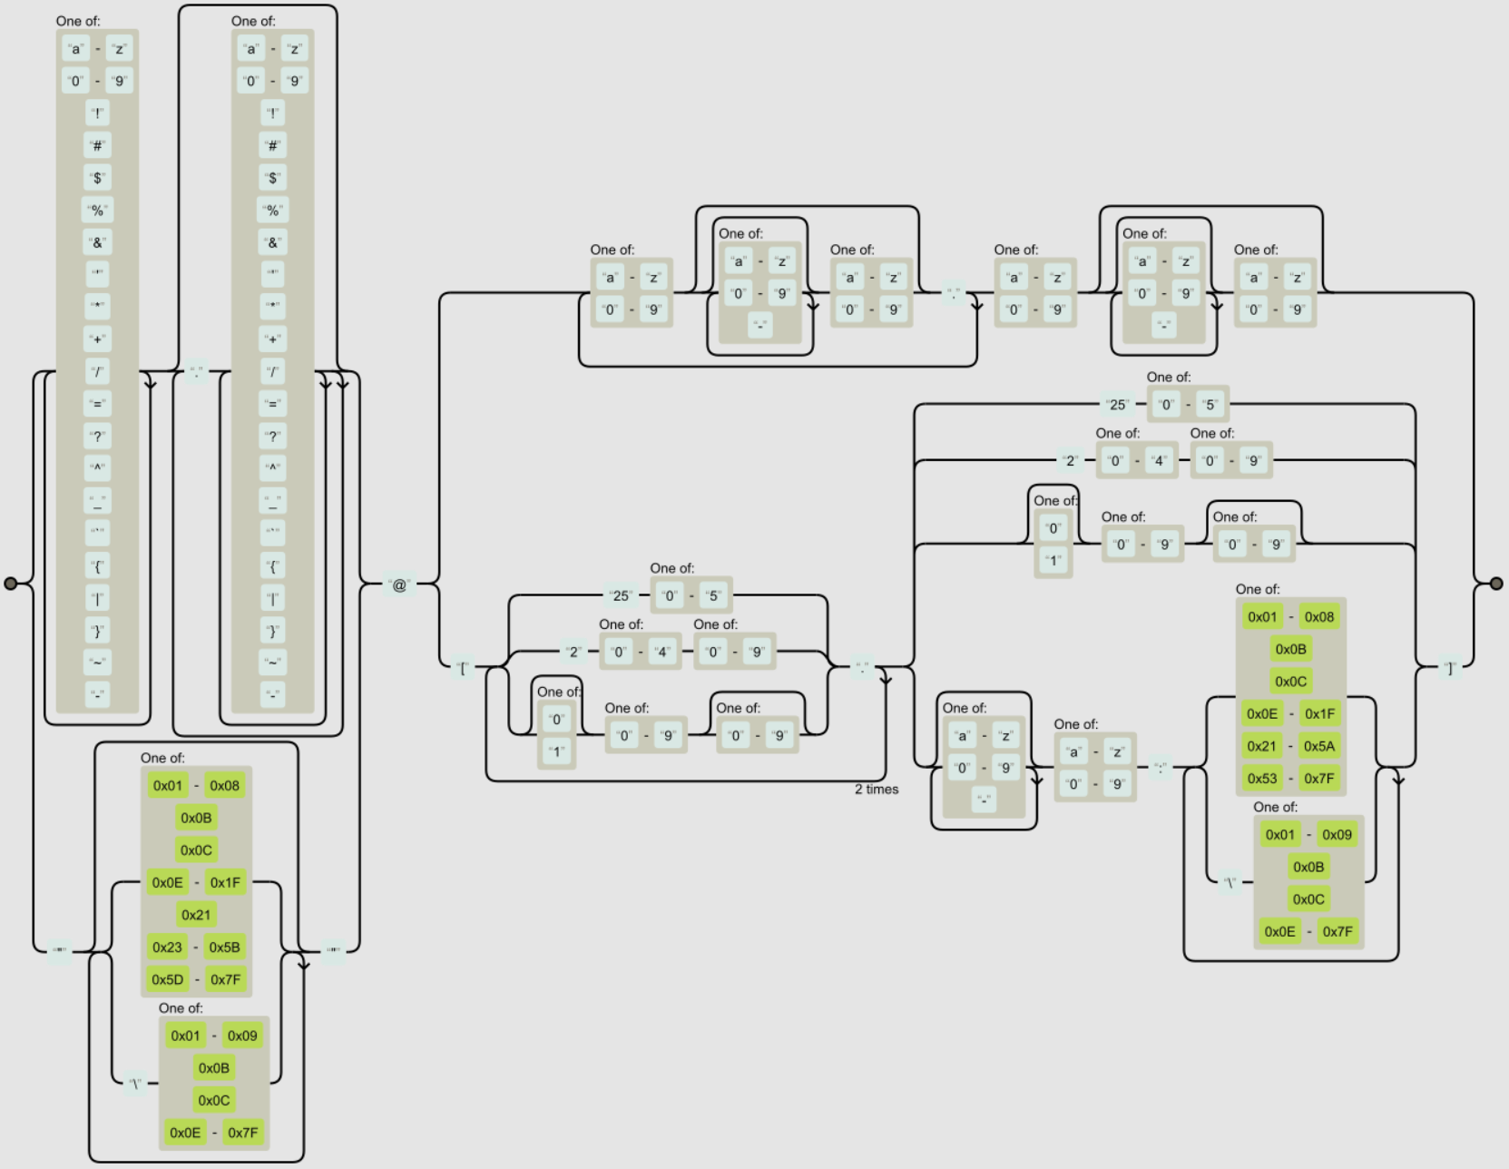
The web servers code can be updated by simply replacing my regex with this value. However, for the rest of this task, I will be using my own regex. But I thought it would be great to mention the correct way of doing things too.
To test whether the email field requires an @ symbol, I used bobdomain.com as the email address. The frontend initially blocked the submission because `type="email"` detected it as invalid. Because of this, I later sent the request using curl, which confirmed that the server also rejected it because the regex requires an @ between the local part and domain.
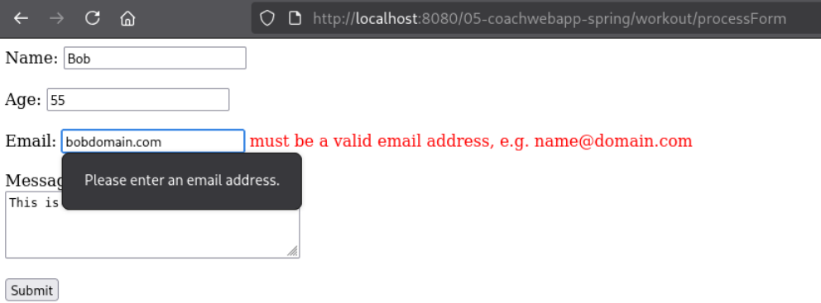
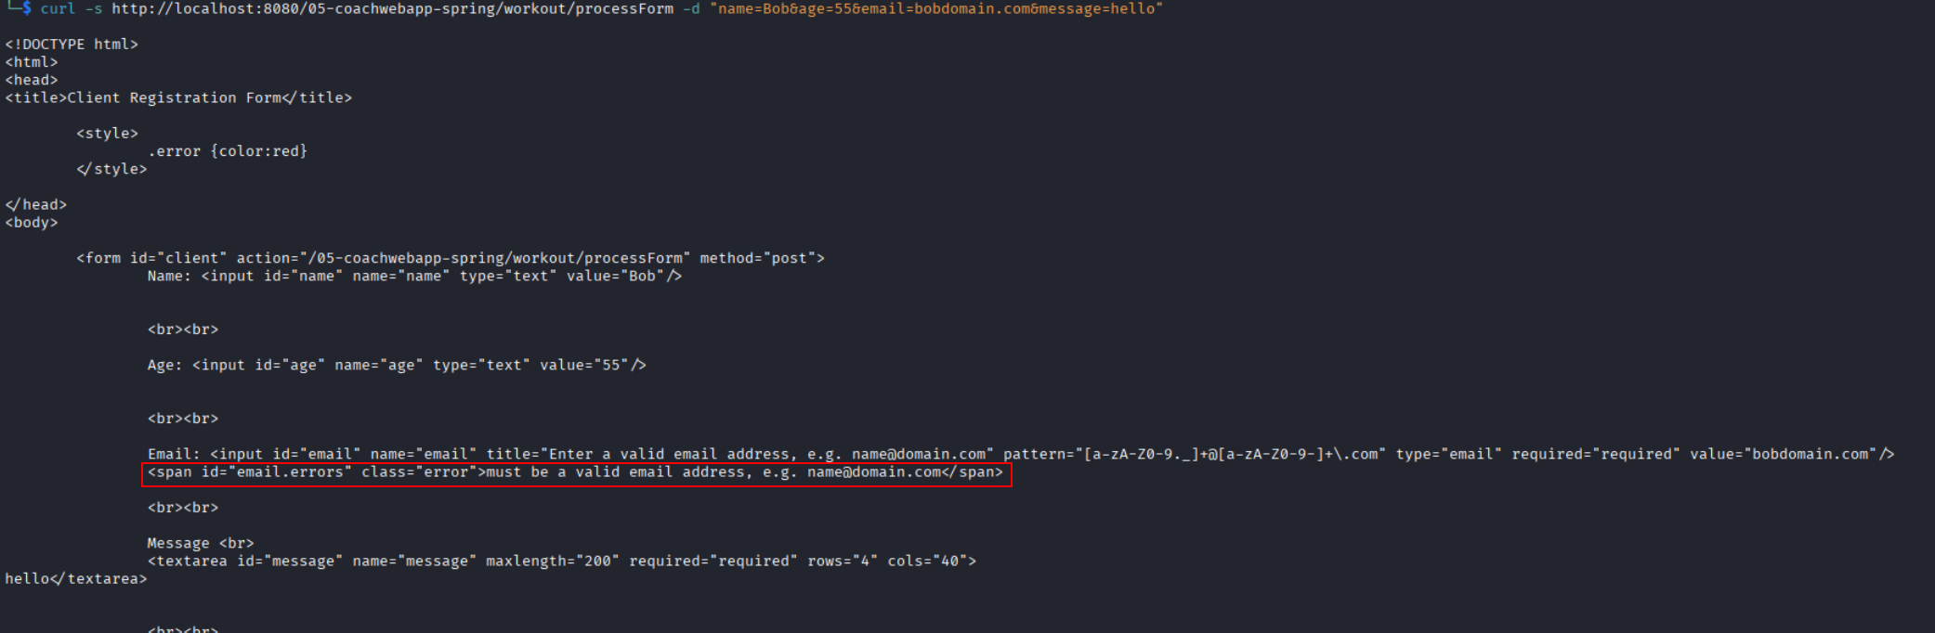
To test whether the email field blocks script injection, I used <script>@domain.com as the email address. The server rejected it because < and > are not included in the allowed character set.
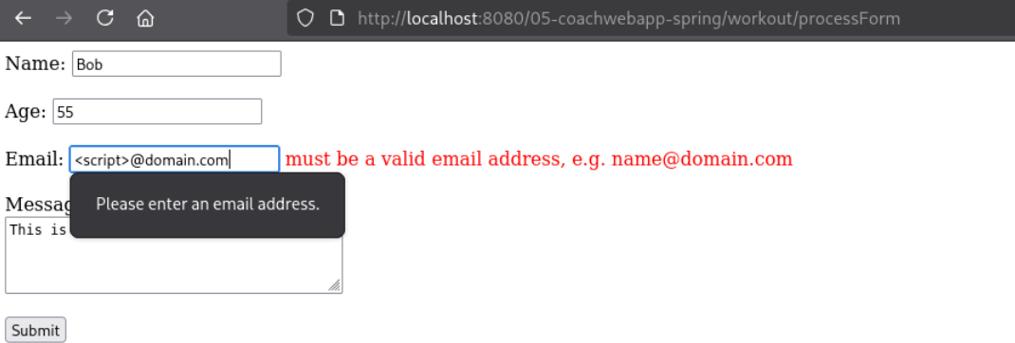
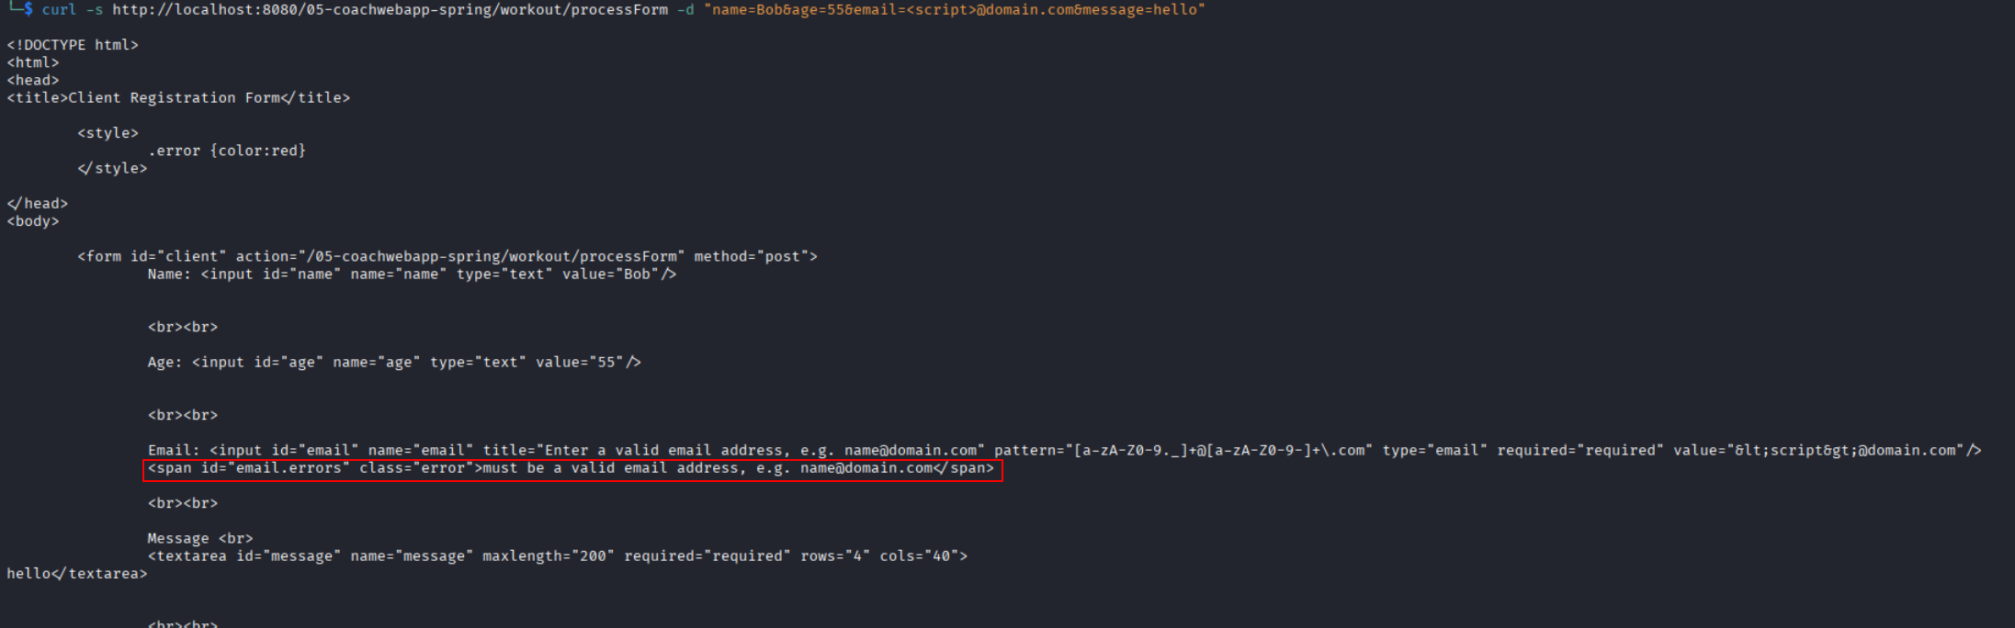
I attempted to escape the filters by encoding < and > and it failed and expected too.
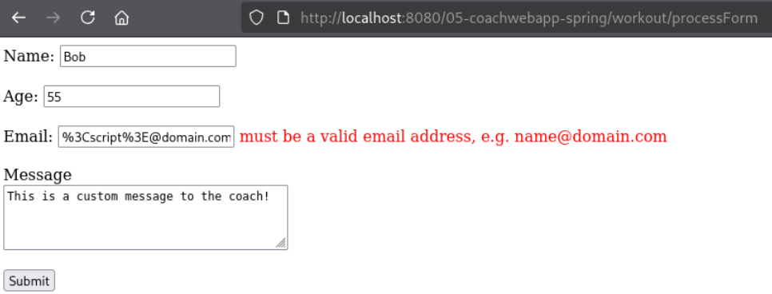

To test whether the email field blocks stray special characters, I used bob@domain.com;calc as the email address. The server rejected it because the regex does not allow the ; character.
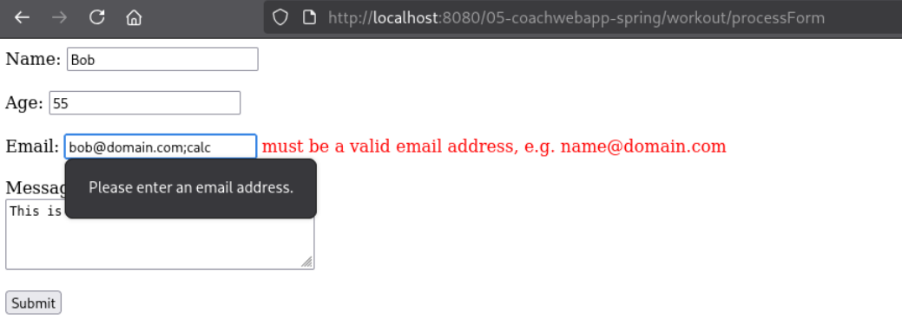
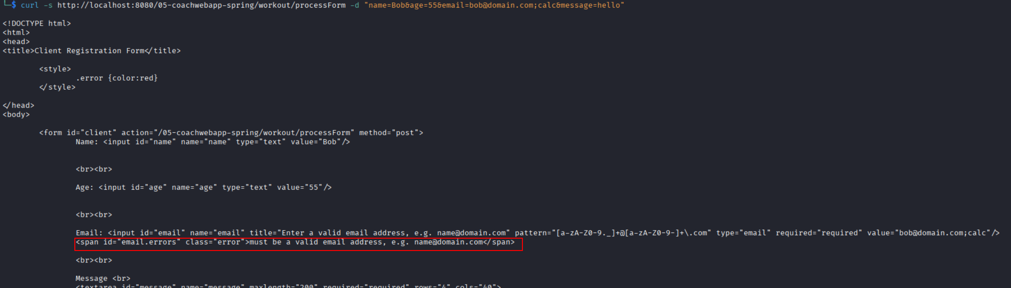

To test whether the email field is required, I left it blank. The server rejected the submission because @NotNull requires the field to have a value.
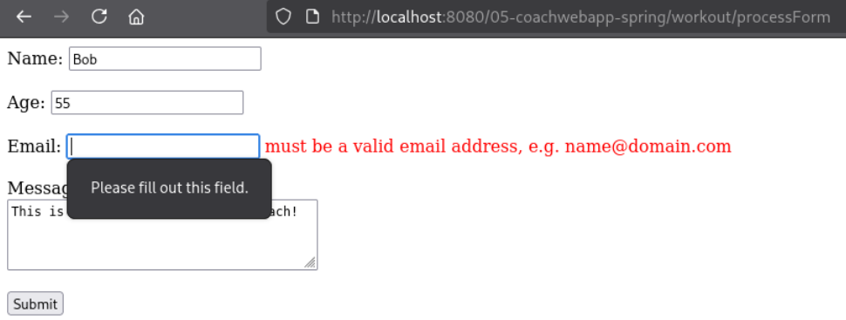
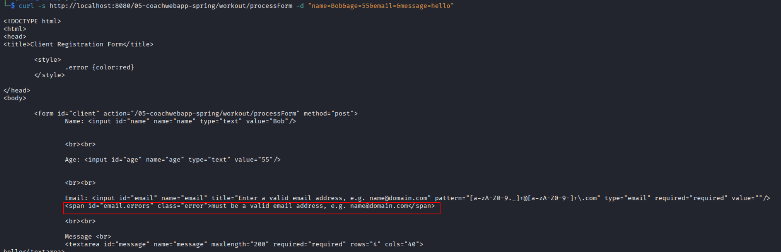

Invalid Messages
To test whether the message field blocks a classic XSS payload, I used <script>alert('XSS')</script> as the message. The server rejected it because <, >, and ' are not included in the allowed character set [a-zA-Z0-9 .,!?@#*_-].
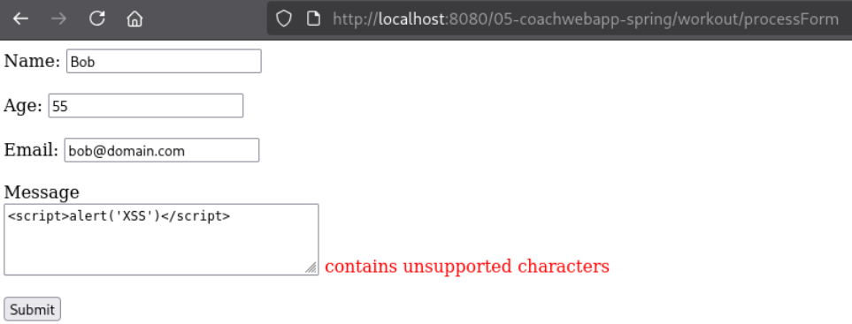
To test whether the message field blocks an event-handler-based XSS payload, I used <img src=x onerror=alert(1)> as the message. The server rejected it because <, >, and = are not included in the allowed character set.
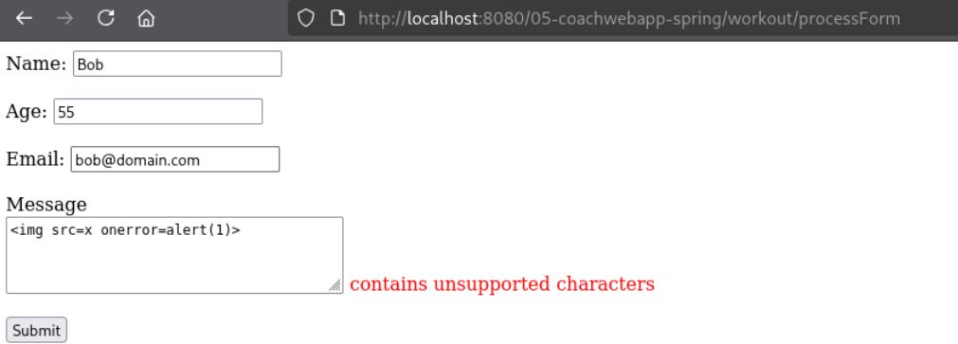
To test whether the message field blocks SQL-injection-style input, I used '; DROP TABLE clients; -- as the message. The server rejected it because ' and ; are not included in the allowed character set.
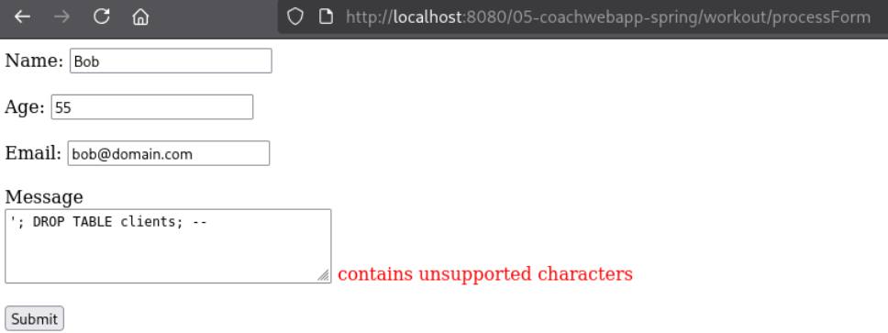

To test whether the message field accepts the maximum allowed length, I used a message containing exactly 200 characters.
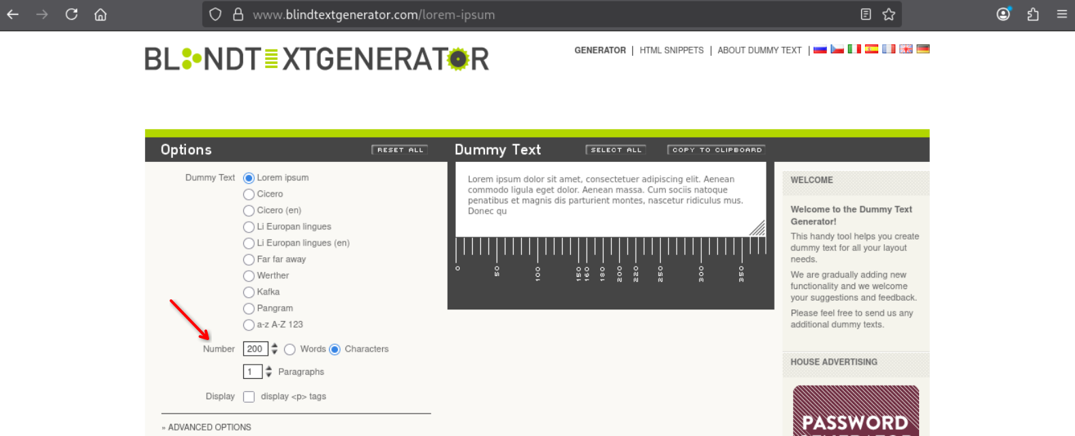

The form submitted successfully, confirming that messages with up to 200 characters are accepted.
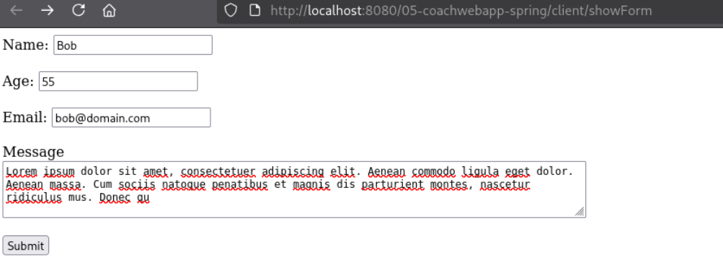
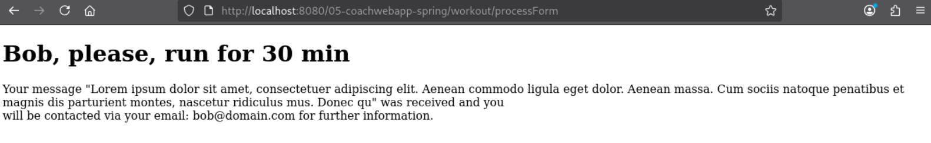
The frontend prevents users from entering more than 200 characters in the text area. Because of this, I used curl to send a message containing 201 characters directly to the server.
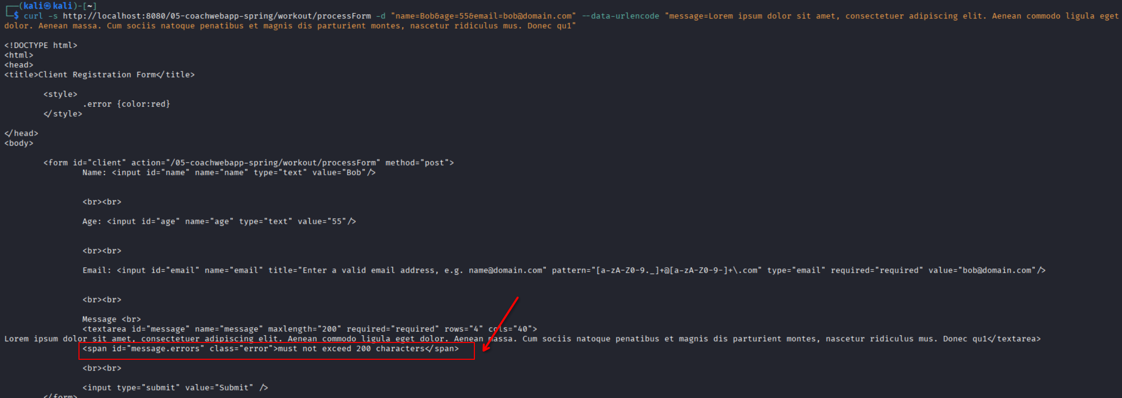
The server rejected the request because the message exceeded the 200-character limit. It also displayed the correct validation error, confirming that @Size(max = 200, ...) works as expected.
The frontend also prevents users from submitting an empty message.
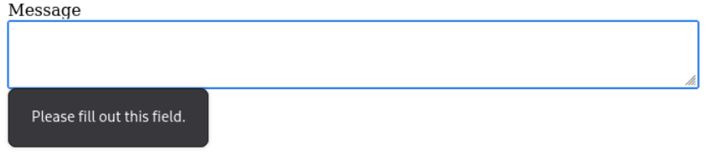
However, this validation can be bypassed using curl, and the server accepts the empty value.
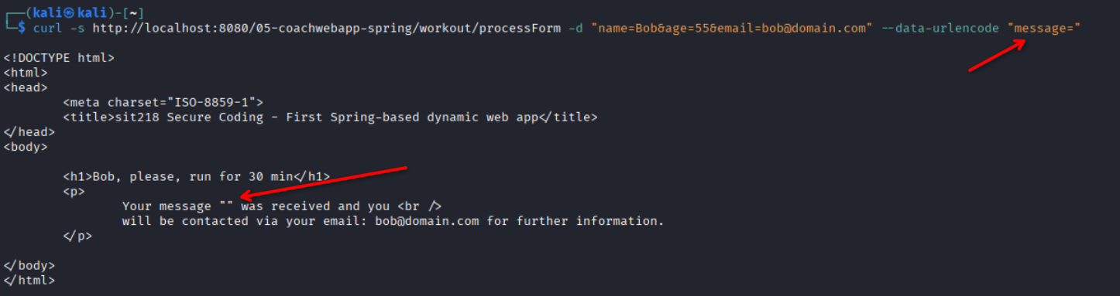
This happens because @NotNull only checks whether the value is null. An empty string is still a value, so it passes the validation. This can be fixed by replacing @NotNull with @NotEmpty, which rejects both null and empty values.
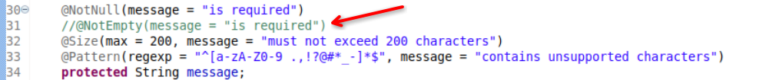
To confirm this further, I sent another curl request without including the message field. The server rejected the request because the missing value was treated as null, which triggered the @NotNull validation.
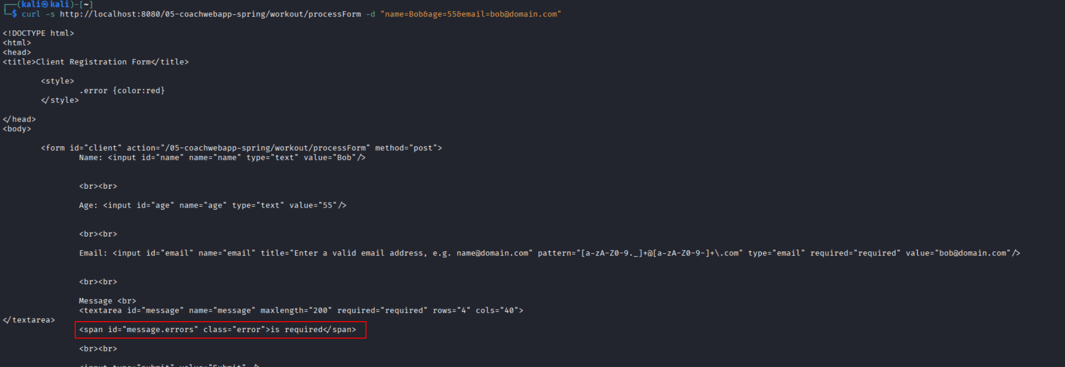

Source Code
java/edu/deakin/sit218/coachwebapp/Client.java
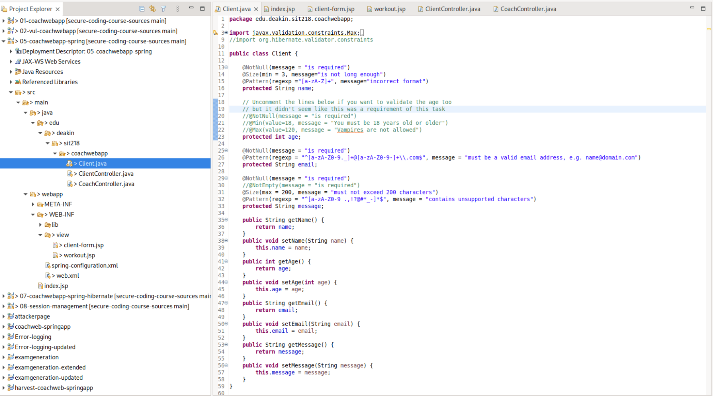
java/edu/deakin/sit218/coachwebapp/ClientController.java
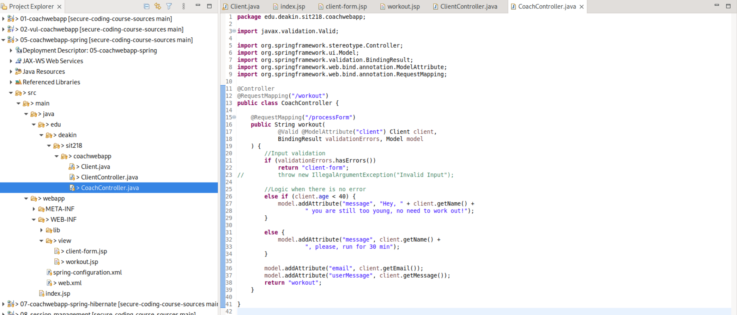

java/edu/deakin/sit218/coachwebapp/CoachController.java
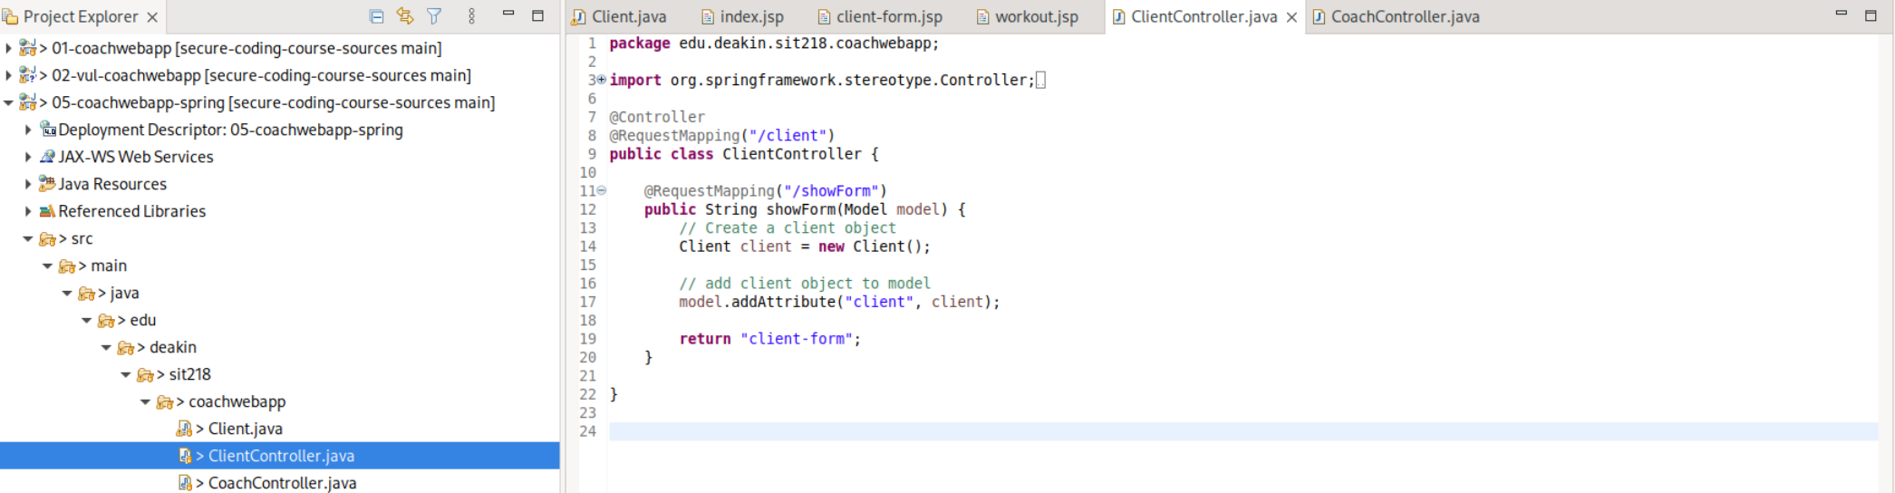
webapp/WEB-INF/view/client-form.jsp
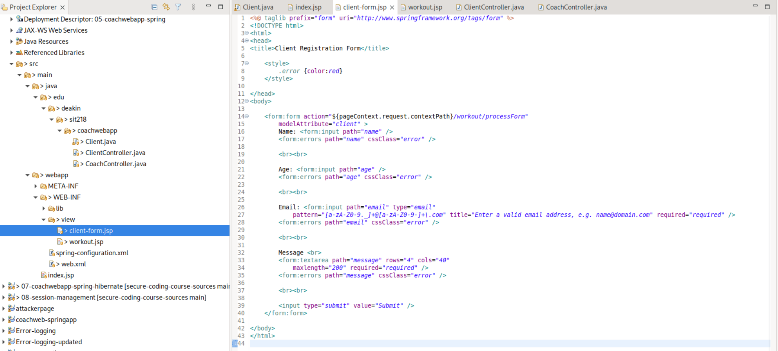
webapp/WEB-INF/view/workout.jsp
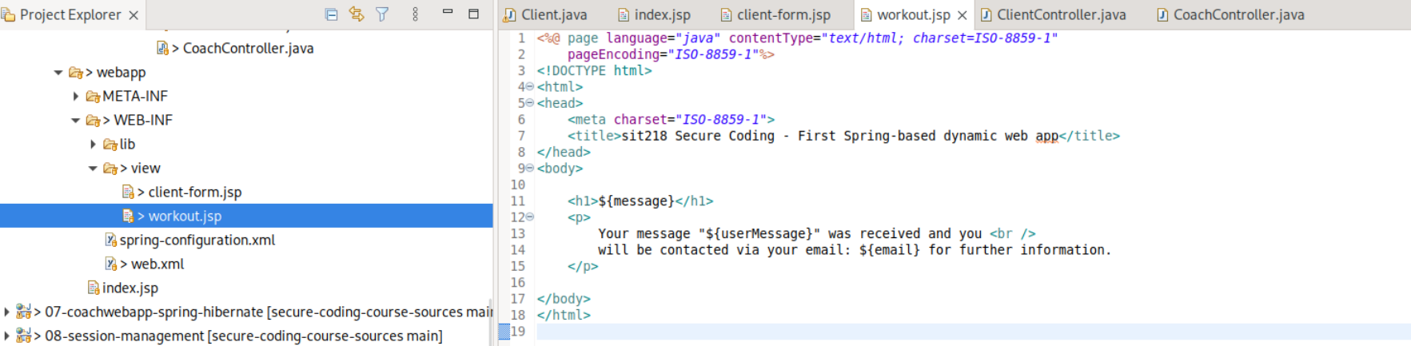
webapp/index.jsp

References
[1] Stack Overflow, “How can I validate an email address using a regular expression?,” Answer 201378. [Online]. Available: https://stackoverflow.com/a/201378/14819138. [Accessed: Aug. 24, 2026].
[2] P. Warren, “Mail::RFC822::Address.” [Online]. Available: https://pdw.ex-parrot.com/Mail-RFC822-Address.html. [Accessed: Aug. 24, 2026].
[3] EmailRegex.com, “Email Address Regular Expression That 99.99% Works.” [Online]. Available: https://emailregex.com/. [Accessed: Aug. 24, 2026].

