Task 5.1P

5.1P Activity Start (Activity 1-4)
I started the mysql server.
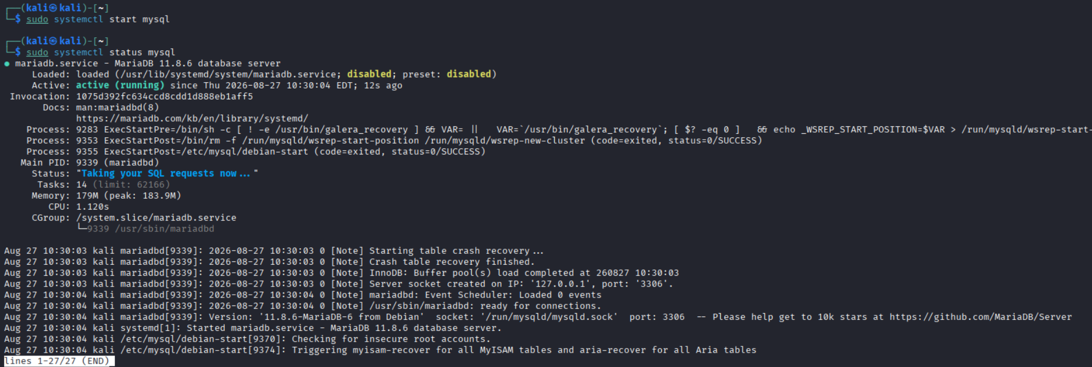
I located the two said files as instructed.
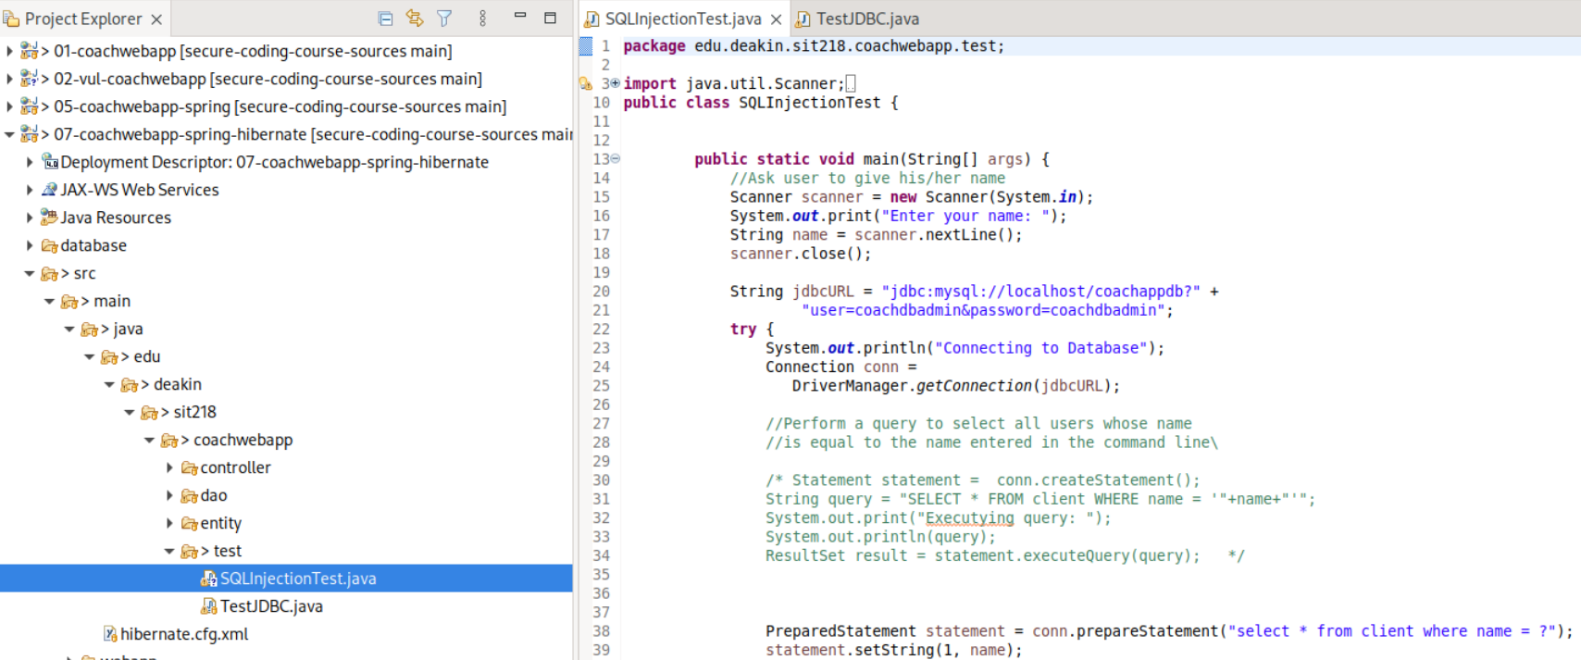
Uncommented the first block and commented the second block out as instructed.
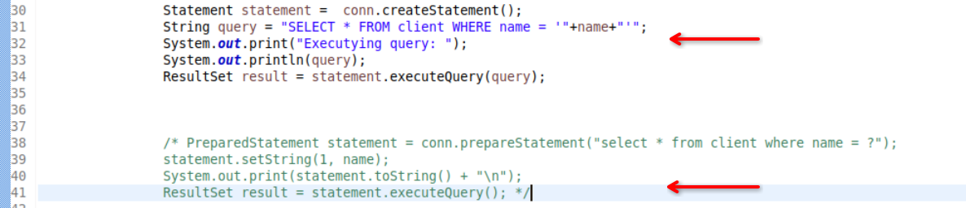

Testing the value “Bob” shows that this works.
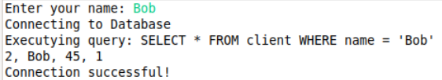
Because the input is badly handled and shoved directly into the SQL query, the injection attack worked.
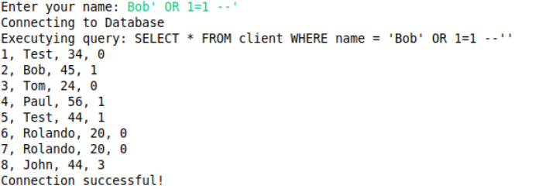
I commented out the unsafe query execution and uncommented the parameterized approach.
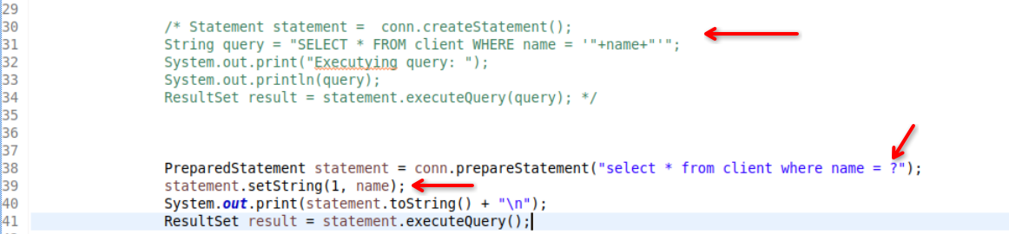
Now when you attempt the escape out the statement by performing some basic injection, it won’t work as the query is prepared properly and the parameters are set to this statement as shown with the arrows in the above diagram.
I updated the ClientDAOImpl.java as instructed.
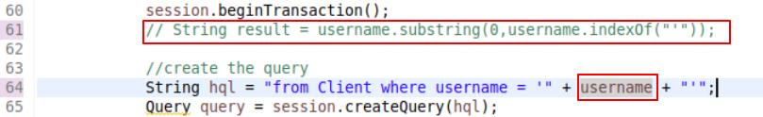

I then started the web server.
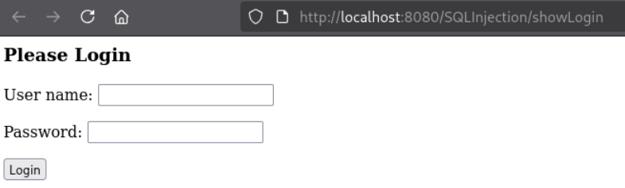

5.1P Task Sheet – Part 1
After attempting some payloads, I was able to bypass the authentication with this username. The password can just be anything here
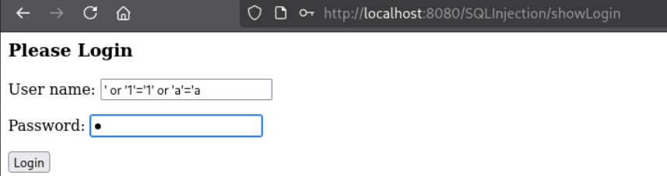
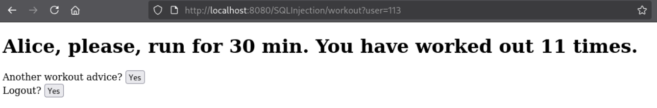
Note that I also attempted ‘ or ‘1’=’1 but that didn’t work. Neither did commenting out worked. But this payload did: ‘ or ‘1’=’1’ or ‘a’=’a.
Also, attempting to comment out like Alice’ -- threw an exception and the web server returned a 404.
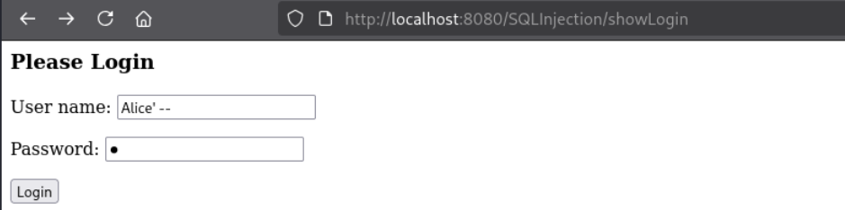
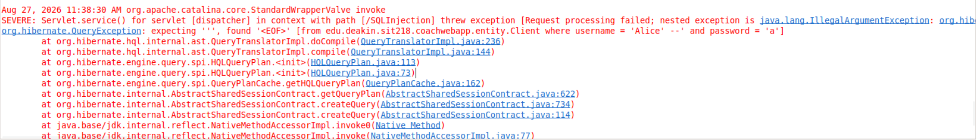

The highlighted lines of code here shows the vulnerable code.
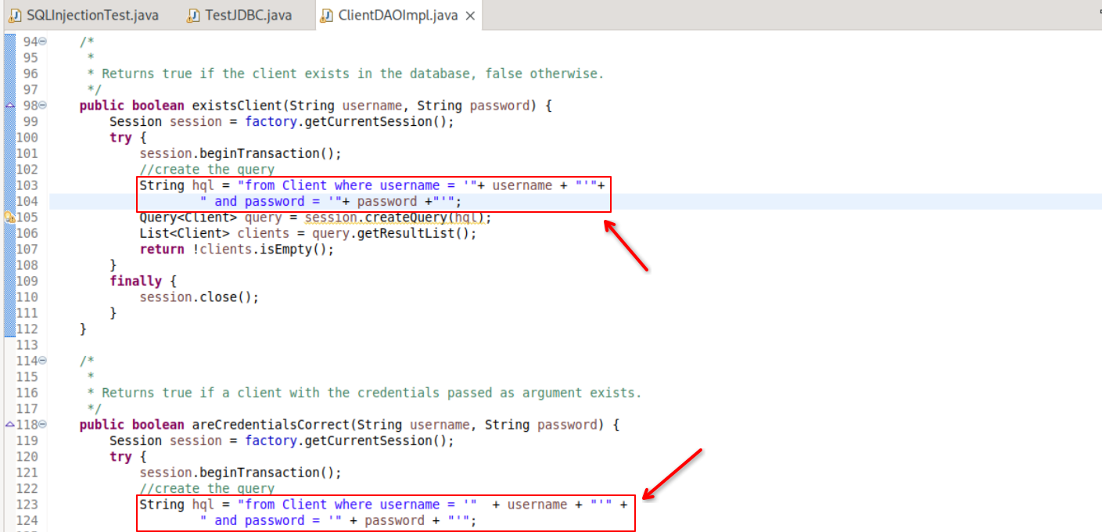
Now that I can actually see the query being executed, it makes sense as to why some payloads worked and why some failed.
' or '1'='1 failed because AND has higher priority than OR in HQL. The query was interpreted as:
username='' OR ('1'='1' AND password='x')
The password didn’t match and therefore, the AND section was false. username='' was also false because there was no user with an empty username, making the full condition false. Adding OR 'a'='a fixed it because it added an unconditional OR true at the end. This made the full WHERE condition true no matter what the password is. The -- comment didn’t work because the application uses HQL rather than raw SQL. The HQL parser didn’t recognise it as a comment, so it returned a parse error instead of ignoring the rest of the query.
This code is vulnerable because it directly concatenates the raw user input into the HQL query. This allows the user input to change the query logic instead of being treated only as a value. To fix this, we can use bind parameters, like: query.setParameter("username", username);. This will keep the input seperate from the query structure by injecting it safely.

5.1P Task Sheet – Part 2

Task 1
The original function built the HQL query by directly concatenating the input username and password to the query string. This allowed user input to change the query logic, thus making the code vulnerable to SQL injection attacks.
To fix this, I first referred to the main() method in SQLInjectionTest.java. That example used a JDBC PreparedStatement with ? placeholders and setString() to bind the values separately. This means t hat the username and password are treated only as data and cannot become a part of the SQL syntax^{[1]}.
The first possible approach was to follow the test file exactly and open a new connection using DriverManager.getConnection(). This was required in SQLInjectionTest.java because it was a standalone program without an existing database session^{[2]}.
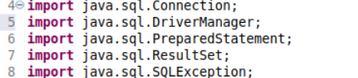
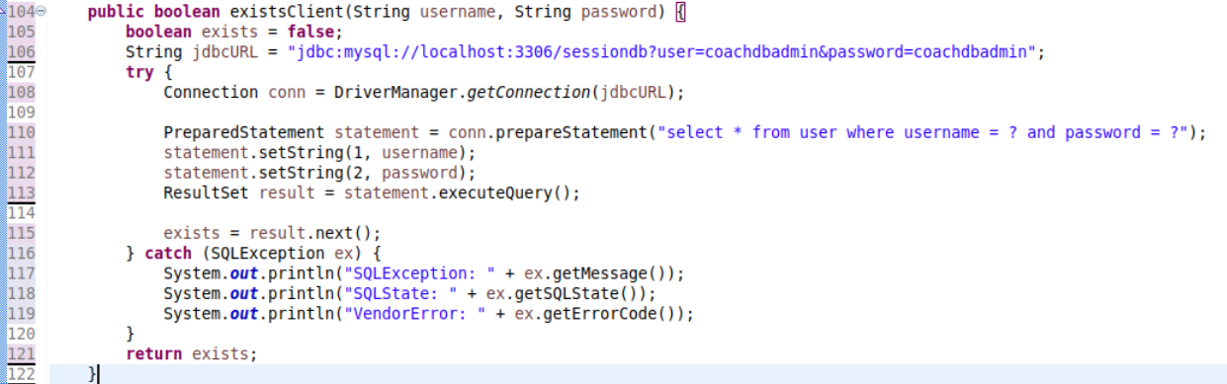
However, ClientDAOImpl already uses Hibernate ORM and has access to the current Session through factory.getCurrentSession(). Opening another connection inside existsClient() like done above would create a seperate JDBC connection outside the Hibernate’s existing connection and transaction management.. It would also require the DB connection string / URL and credentials to be added again, even though they were already configured for Hibernate.
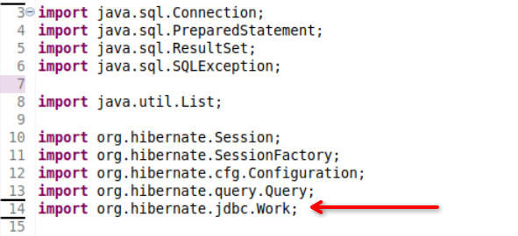
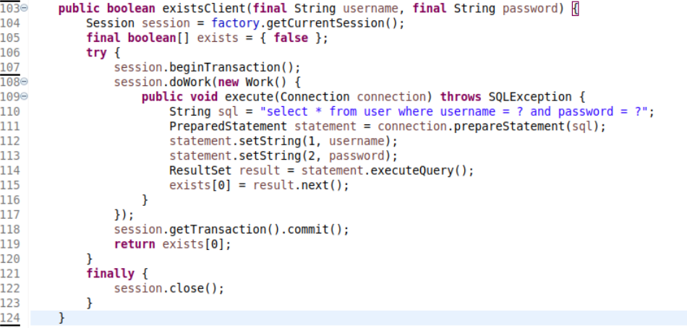
Instead, I used session.doWork() with the Hibernate’s Work interface. doWork() provides access to the JDBC Connection already managed by the current Hibernate session^{[3][4]}. This let me use a normal PreparedStatement and setString() without opening another connection^{[6]}.
I also perform this operation within a Hibernate transaction using session.beginTransaction(). Once the query has completed successfully, I call session.getTransaction().commit() to complete the transaction. This keeps the JDBC query within the same session and transaction context already used by the DAO^{[5]}.
The Work.execute() method does not return a value, so the result from result.next() is stored in the exists Boolean array and returned after doWork() finishes. Hibernate also provides doReturningWork() for cases where the JDBC operation needs to return a value directly^{[3][4]}.
This approach suits the application better because it works with Hibernate’s existing session instead of creating a separate connection.

Task 2
I accessed the secured web app as instructed.
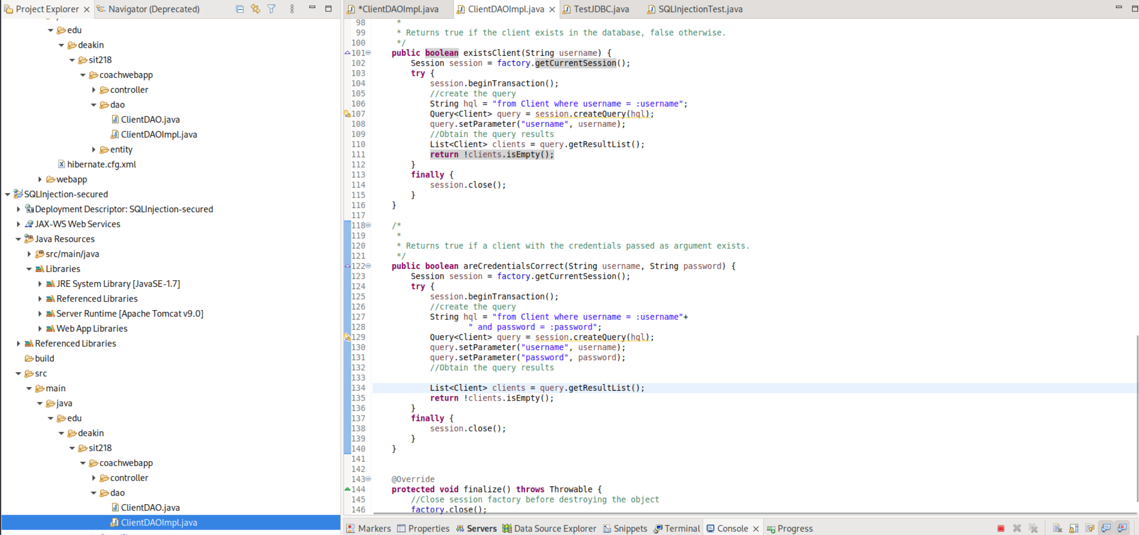
In the existsClient() and the areCredentialsCorrect() functions, the queries seem to be very secure. Instead of concatenating the username and the password to the HQL string directly – making it vulnerable, we use named parameters :username and :password as place holders. The actual values are then bound seperately query.setParameter(). Hibernate converts this into a JDBC PreparedStatement with ? placeholders and binds each value using the equivalent of setString()^{[7]}. This means the input is sent to the database only as data. Any injected quotes or operators remain part of the value and cannot change the query structure.
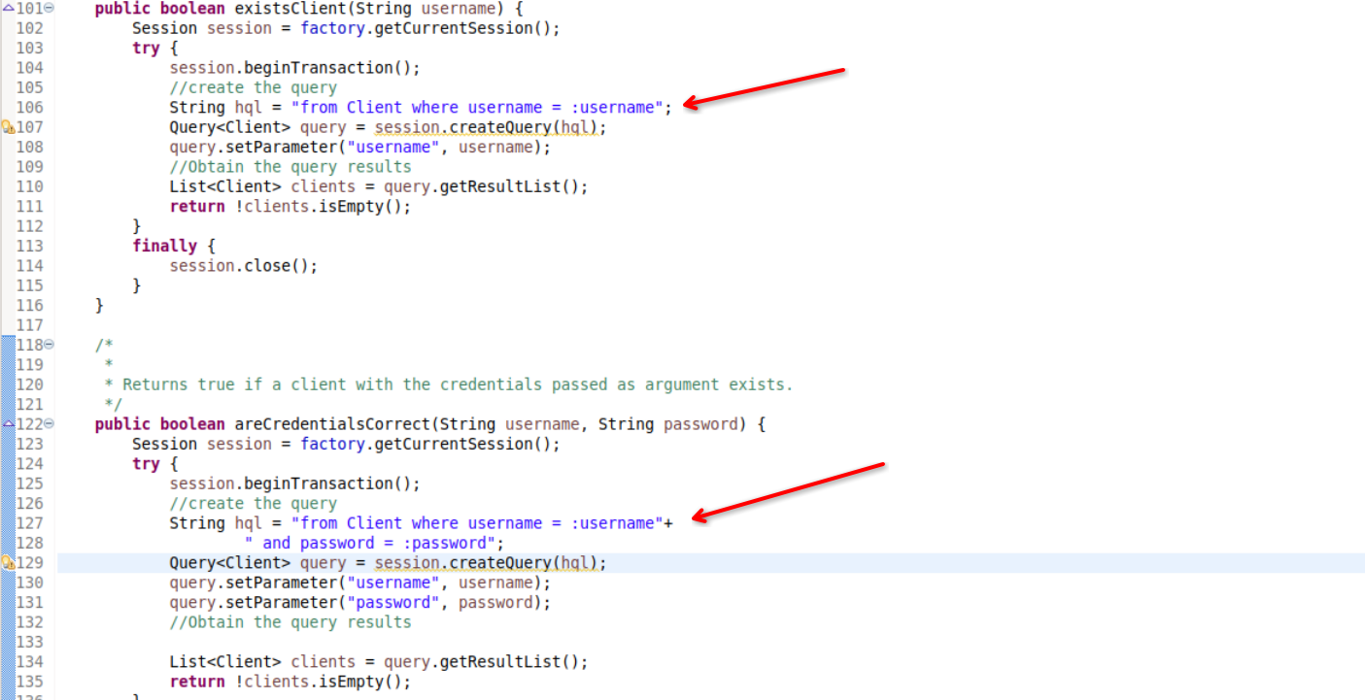
Below is the console output (further confirming the aforementioned point) when attempting to log in.
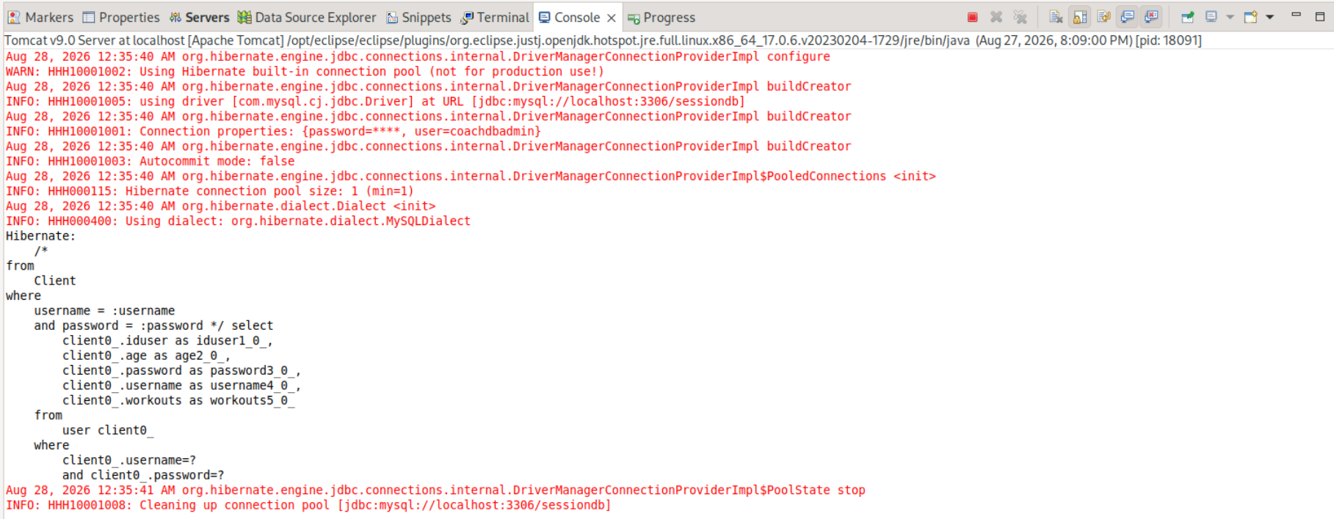

I tried a lot of common SQL Injection approaches, both manually trying to escape out of it as well as running other commonly used tools used in standard penetration testing methodologies.
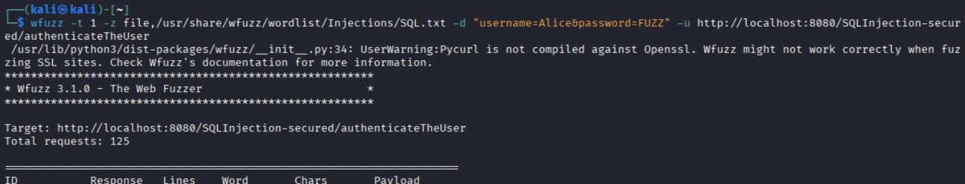
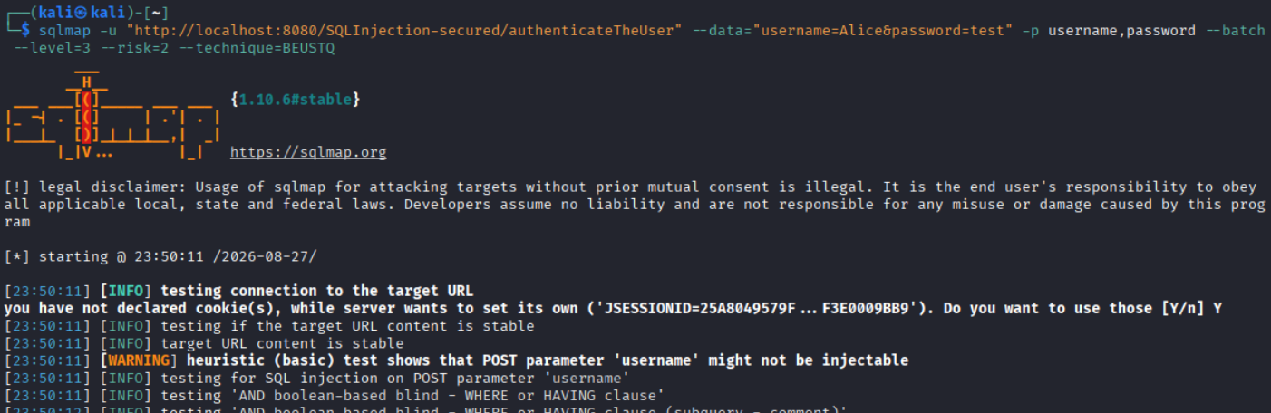
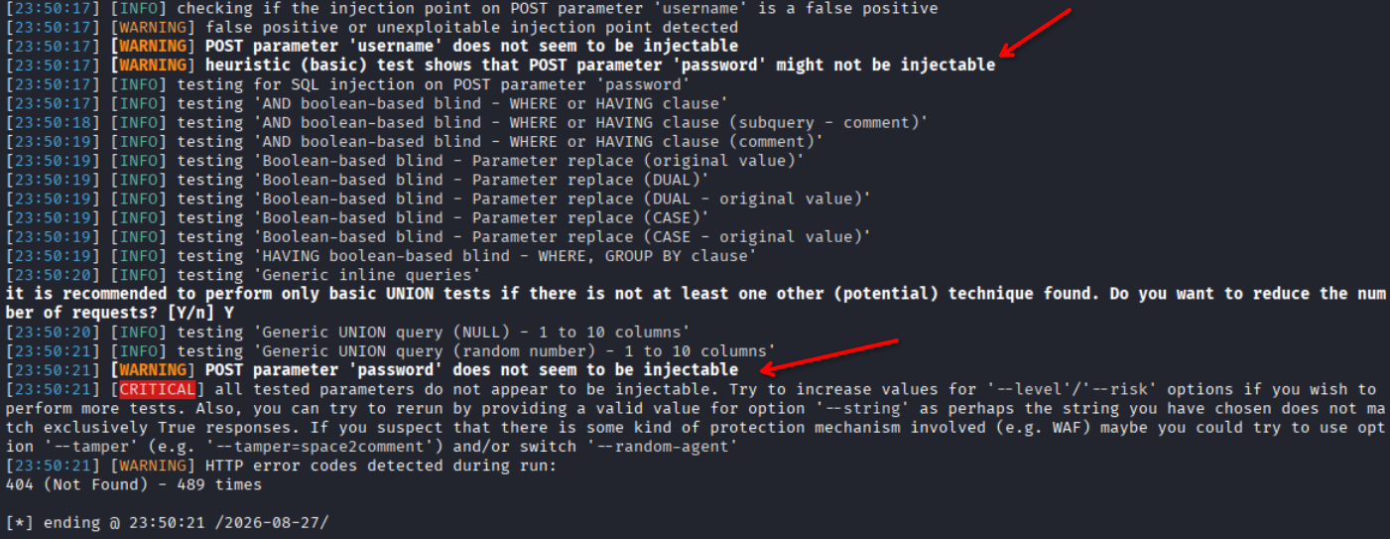
No injection approach worked across hundreds of payloads, a differential fuzz of an entire dedicated SQLi wordlist, and a full sqlmap sweep. Because of the secure coding practices followed here, the inject input is always treated as a literal value and never as more SQL syntax.

However, I found the credentials hardcoded in the hibernate.cfg.xml file.
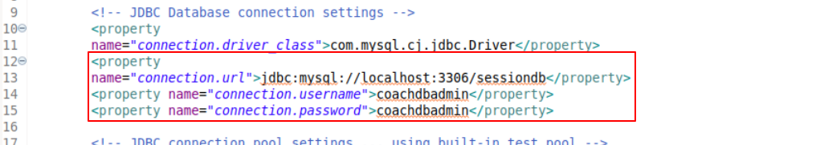
Using these credentials and by inspecting the code, I was able to extract the record for user Alice.
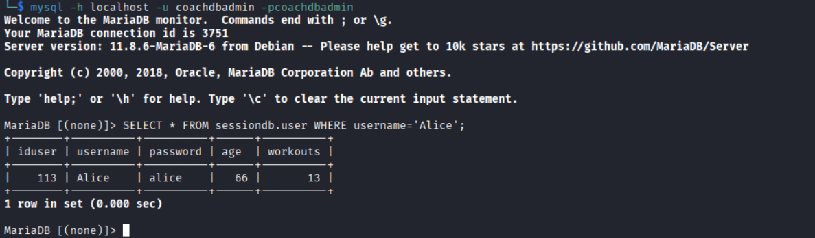
The password was not hashed (+salted) and has just been stored as plain text. Using “alice” as the password, I was able to log in.

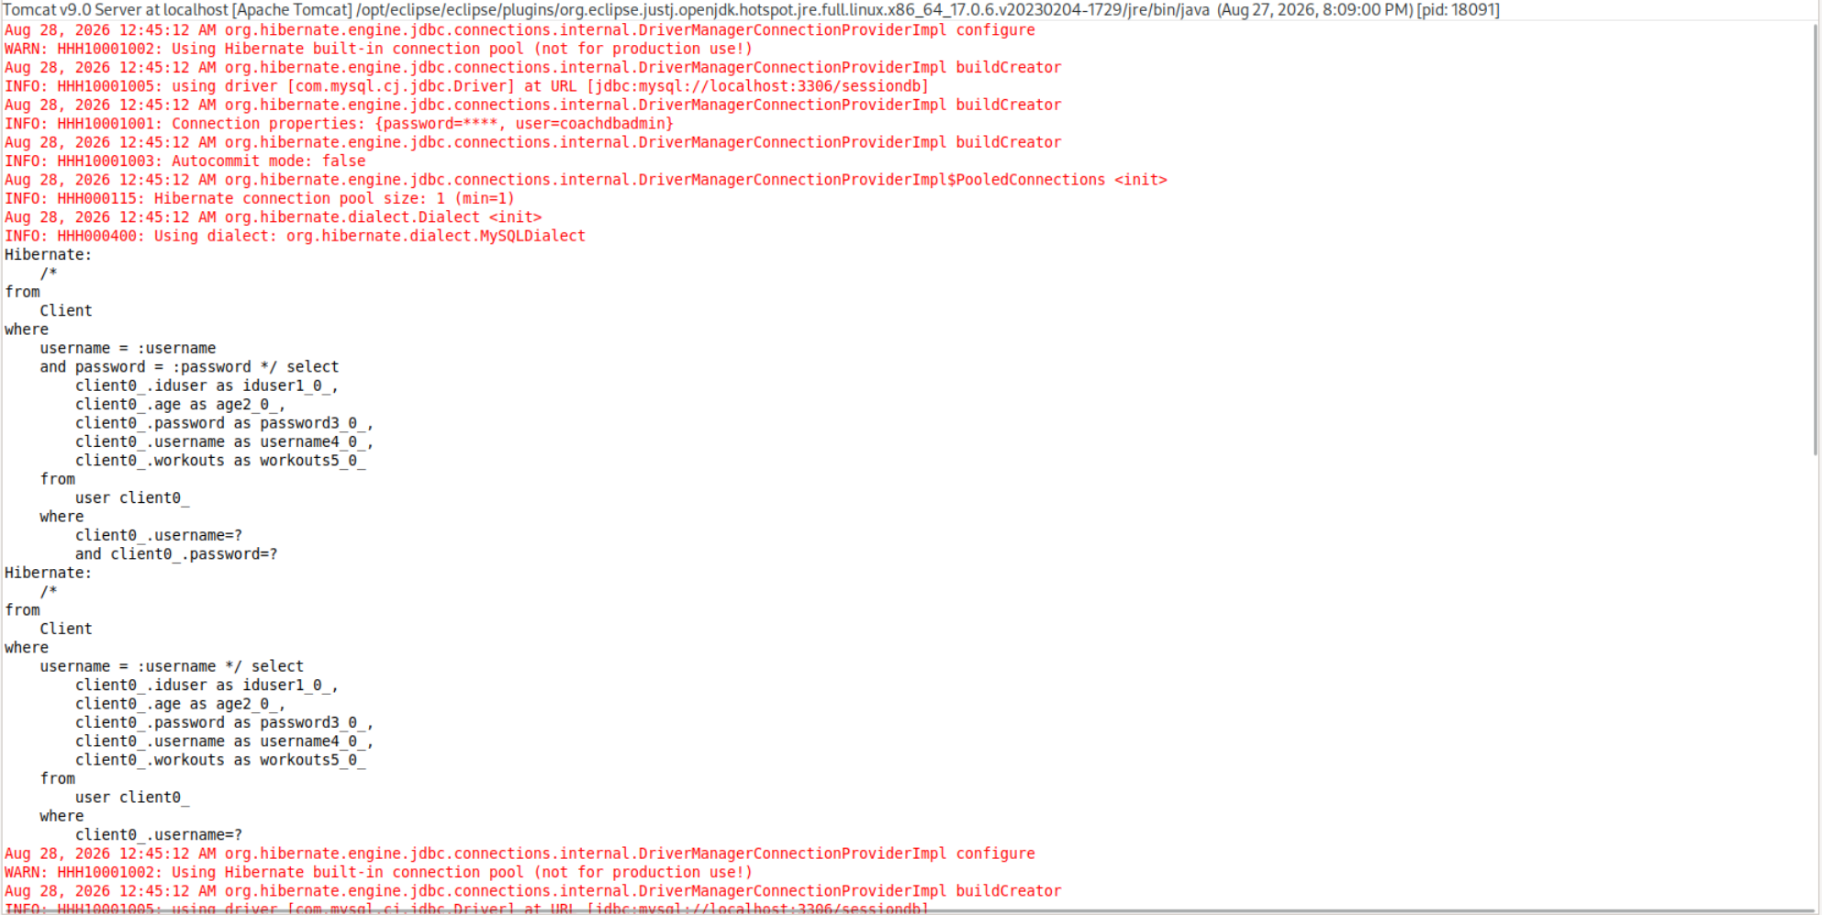

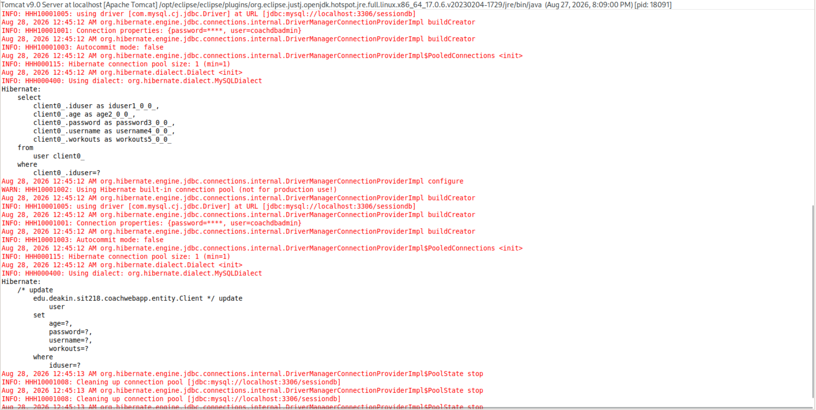

Execution flow^{[8]}:
When the web server receives a POST /authenticateTheUser request, web.xml sends it to Spring’s DispatcherServlet. This is the front controller. It handles the incoming requests for the application.
When the application starts, the DispatcherServlet will read spring-configuration.xml. The component scan finds the controller classes. The view resolver also connects view names to JSP files inside /WEB-INF/view/.
The request will then go to LoginController. Spring reads the username and password using @RequestParam, then calls the authenticateTheUser() method.
The controller passes the details to ClientDAOImpl.areCredentialsCorrect(). This method uses named parameters and query.setParameter() instead of adding the input directly into the HQL query. Hibernate will use a parameterised query, so the input cannot change the query structure.
The database connection details comes from hibernate.cfg.xml. Hibernate runs the query against the user table and maps the result into a Client object.
If the details match, the controller redirects the user to the workout page. If it doesn’t match, an error message is added to the model. The plain-login.jsp page reads this message and shows it to the user.
In summary:
Browser submits username and password --> web.xml sends the request to DispatcherServlet --> LoginController receives /authenticateTheUser --> ClientDAOImpl checks the credentials using HQL and setParameter() --> Hibernate runs a parameterised PreparedStatement using hibernate.cfg.xml --> MySQL checks the user table --> Hibernate maps the result to a Client object --> controller checks the result --> plain-login.jsp displays ${errorMessage} or redirects to /workout

Task 3
Task 2 used named parameters like :username and :password. The values were bound by name using setParameter("username", ...).
This version uses JPA style ordinal parameters instead. ?1 is used for the username and ?2 is used for the password. The values are then bound by position using setParameter(1, username) and setParameter(2, password). The security doesn’t change. Hibernate still creates a JDBC PreparedStatement and passes the values separately. The input is treated as data, so it can’t change the query structure.
The main difference is how the parameters are identified. Named parameters use a name, while ordinal parameters use a number like seen here. The numbers must match correctly. If ?1 and ?2 are mixed up, the wrong values could be checked. It still won’t cause SQL injection as long as the values are bound instead of being added directly to the query.
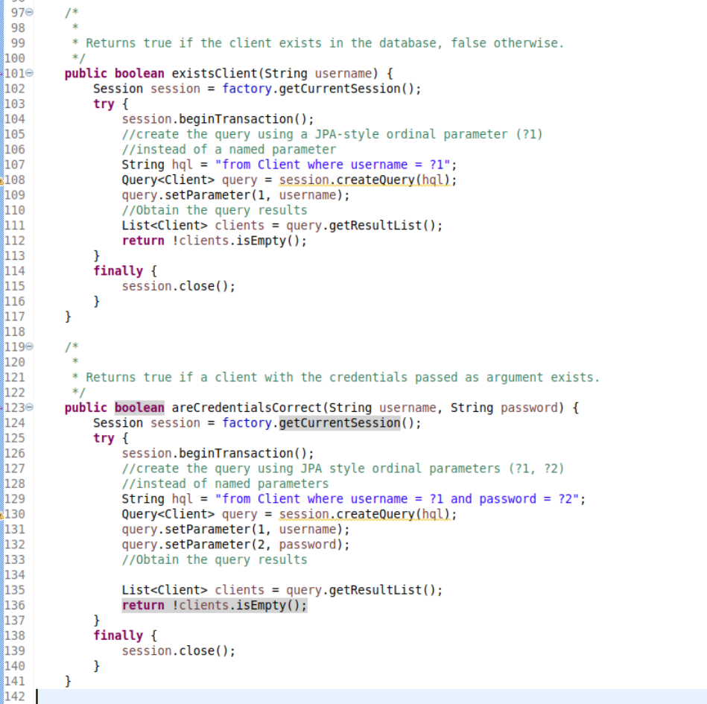

—> Next Page
Attempting a SQLi payload still fails as expected.
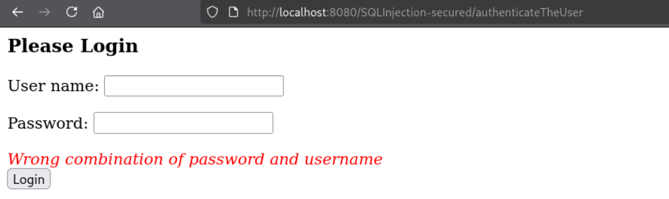
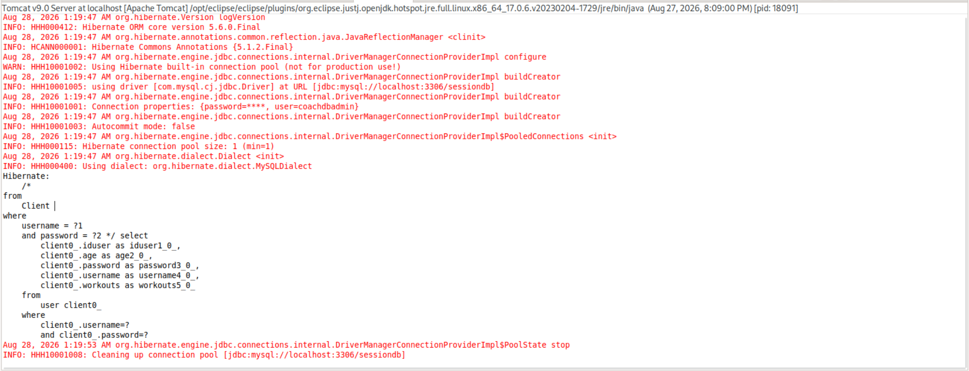
However, you can still log in using the correct credentials.
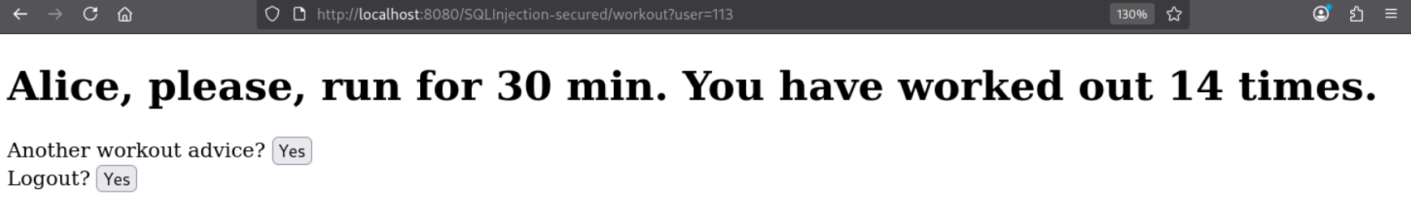
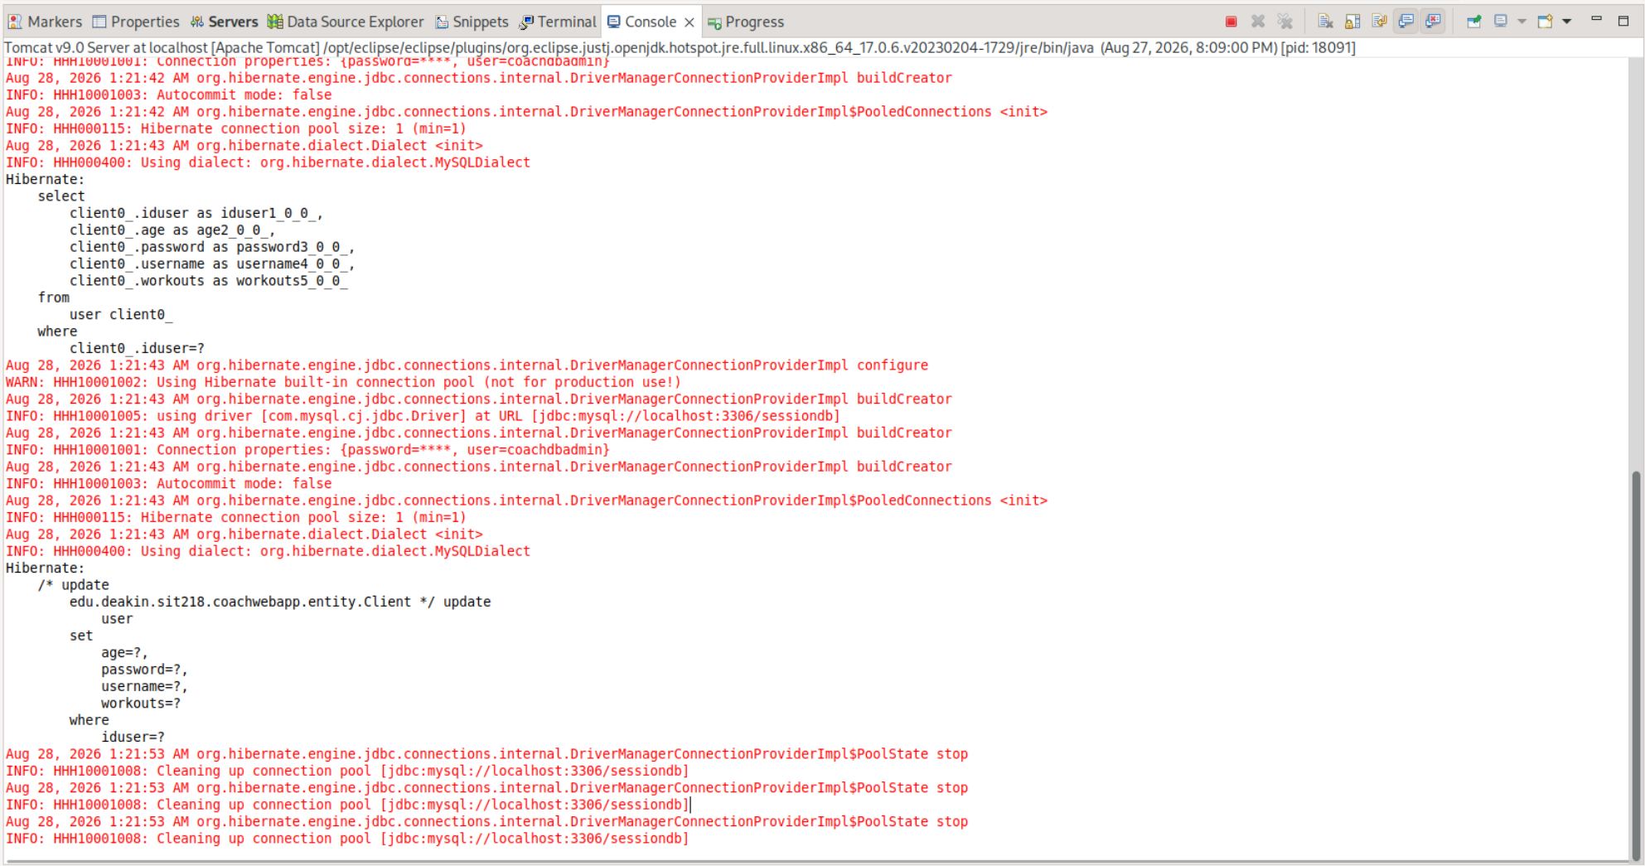

References
[1] Oracle, “Using prepared statements,” The Java Tutorials. [Online]. Available: https://docs.oracle.com/javase/tutorial/jdbc/basics/prepared.html. [Accessed: Aug. 28, 2026].
[2] Oracle, “Establishing a connection,” The Java Tutorials. [Online]. Available: https://docs.oracle.com/javase/tutorial/jdbc/basics/connecting.html. [Accessed: Aug. 28, 2026].
[3] Hibernate ORM, “Work interface,” Hibernate ORM 5.6 JavaDocs. [Online]. Available: https://docs.hibernate.org/orm/5.6/javadocs/org/hibernate/jdbc/Work.html. [Accessed: Aug. 28, 2026].
[4] Hibernate ORM, “SharedSessionContract interface,” Hibernate ORM 5.6 JavaDocs. [Online]. Available: https://docs.hibernate.org/orm/5.6/javadocs/org/hibernate/SharedSessionContract.html. [Accessed: Aug. 28, 2026].
[5] Hibernate ORM, “Transaction interface,” Hibernate ORM 5.6 JavaDocs. [Online]. Available: https://docs.hibernate.org/orm/5.6/javadocs/org/hibernate/Transaction.html. [Accessed: Aug. 28, 2026].
[6] KeatsPeeks, “Answer to ‘session.connection() deprecated on Hibernate?’,” Stack Overflow, Aug. 19, 2010, updated Aug. 15, 2022. [Online]. Available: https://stackoverflow.com/questions/3526556/session-connection-deprecated-on-hibernate. [Accessed: Aug. 28, 2026].
[7] Hibernate ORM, “Hibernate Query API,” Hibernate ORM 5.6.15.Final User Guide, sec. 15.2.2. [Online]. Available: https://docs.hibernate.org/orm/5.6/userguide/html_single/. [Accessed: Aug. 28, 2026].
[8] Spring Framework, “Web MVC framework,” Spring Framework Reference Documentation, ver. 4.1.7.RELEASE. [Online]. Available: https://docs.spring.io/spring-framework/docs/4.1.7.RELEASE/spring-framework-reference/html/mvc.html. [Accessed: Aug. 28, 2026].
[9] K. Sierra and B. Bates, SCJP Sun Certified Programmer for Java 6 Study Guide: Exam 310-065. New York, NY, USA: McGraw-Hill Professional, 2008.

