Task 5.2C
The header uses flexbox with a collapsible hamburger menu (a hidden checkbox toggled by a label, no JavaScript) below 48rem, so that the navigation stays reachable with one thumb instead of eating screen space from 48rem it expands into an inline row across the header.
CSS grid organizes the feature cards, result cards, and footer links into a single column on mobile and three columns from 48rem. So, related content groups visually rather than running as one long scroll. A 2nd breakpoint at at 64rem widens the hero image/copy split and increases section padding and grid gaps, giving the page breathing room on larger monitors instead of just stretching mobile spacing.
Headings use use `clamp()` with `vw` units so font size scales smoothly across the whole range instead of jumping at each breakpoint.

The Responsive Table
The new "Compare across scanned products" table lists four yoghurt products against their key additive, category, and a shopper note.
On smaller screens, the table can be scrolled sideways instead of squeezing all the columns together. The table keeps a minimum width so the content stays readable and does not wrap awkwardly. The intro text and the caption also make it clear that users can scroll or swipe across the table to view the remaining columns.

All Changes
Changes:
- In 5.1P, the navigation was always expanded. In this version, I added a collapsible hamburger menu so the navigation works better on smaller screens.
- 5.1P only used one breakpoint. I added another breakpoint at 64rem to make some extra layout adjustments for wider desktop screens.
- I added a responsive comparison table that can scroll horizontally on smaller screens, so the columns stay readable instead of getting squeezed together.
- I changed the heading sizes to use clamp() and vw, allowing them to scale more smoothly depending on the screen size.
- I also added more comments throughout the CSS to explain what each section does and why the different responsive techniques are being used.
Updated navigation bar:
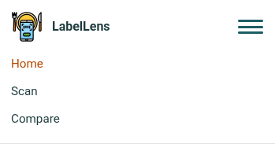


Screenshots of the app can be found in the following pages.
