Task 2.4P

Task 1
An image of Eclipse with the web server running. Since I already had the tomcat.service systemd service running and using those ports, I had to stop it and start this web app again for it to work.
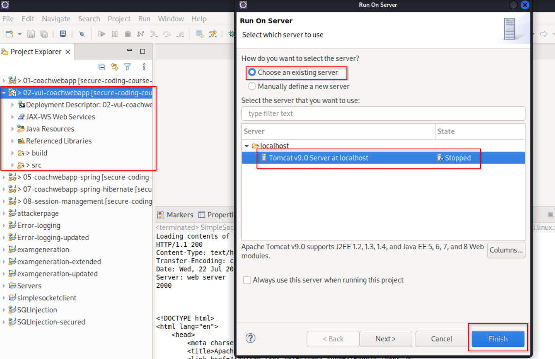
This is what a normal response looks like.
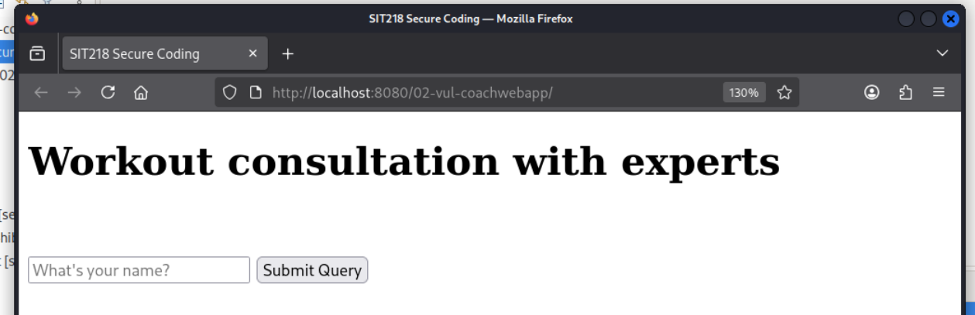

Response showing “bob” has a level one heading. This proves that the HTML is not sanitized before it gets injected to the DOM.
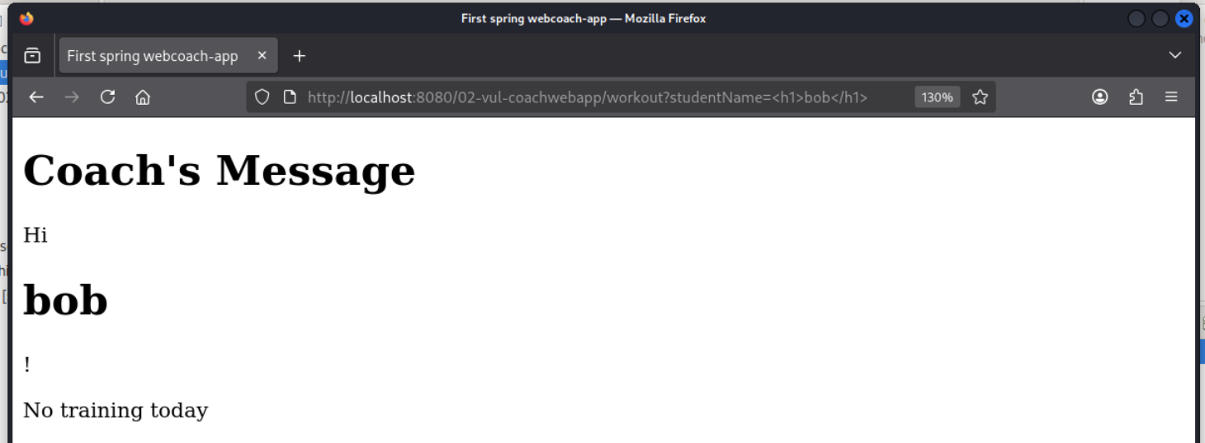
Testing out a multi-element payload.
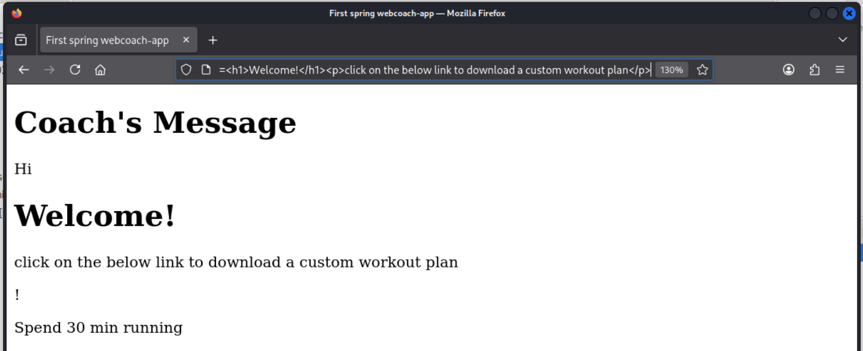
Executing javascript code (an alert() box).
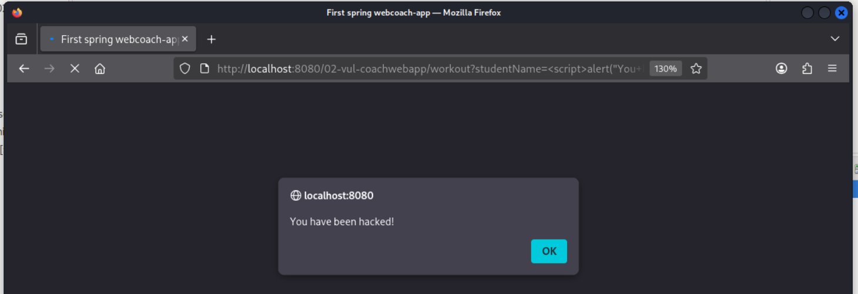
Updating elements in the DOM using JavaScript:
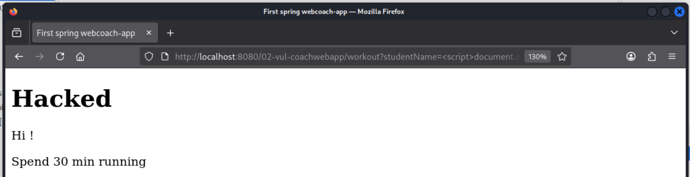

Question 5
String htmlResponse = "<p>" + comment + "</p>"; // Vulnerable line
This is a line of code written in Java. It’s vulnerable to XSS because whatever the value in comment is directly inserted into the HTML without escaping it or sanitizing it. The users’ input might have <script> tags or any other tags executing malicious javascript, thus allowing arbitrary code execution in the browser. Judging by the entire code snippet, this seems to be a reflected XSS vulnerability.

Task 2
Screenshots from both the payloads:
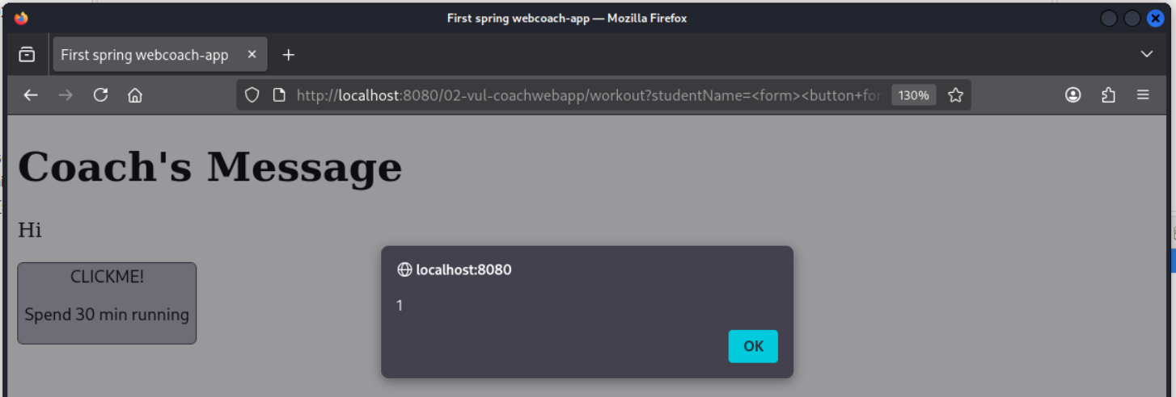
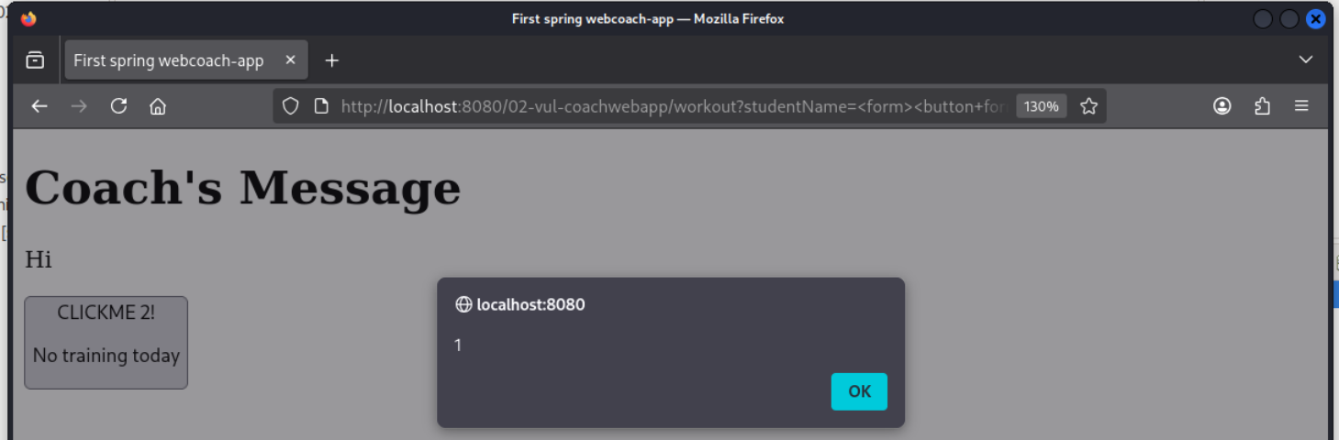

This doesn’t use the <script> tag at all. If there is a filter in a webapp to either block or remove the <script> tag, our XSS payload will not get detected. Due to the unsafe approach used to deal with the users’ input, the browser will still read the <form> and <button> tags as real HTML elements. The onclick and formaction attributes/events usually contain javascript in more modern web development standards. However, you could also explicitly say `javascript:` and have JS there as a URI. No matter what you do, the browser will execute that javascript whenever the button is clicked.
This shows why XSS protection should properly escape or encode all special characters in HTML instead of only blocking specific tags.
Another pupular POC payload used is <img src=”” onerror=”alert(1)” />. This is an image tag trying to load the `src` image, but since it has not been properly set, the onerror trigger will execute the javascript mentioned there.

Task 3
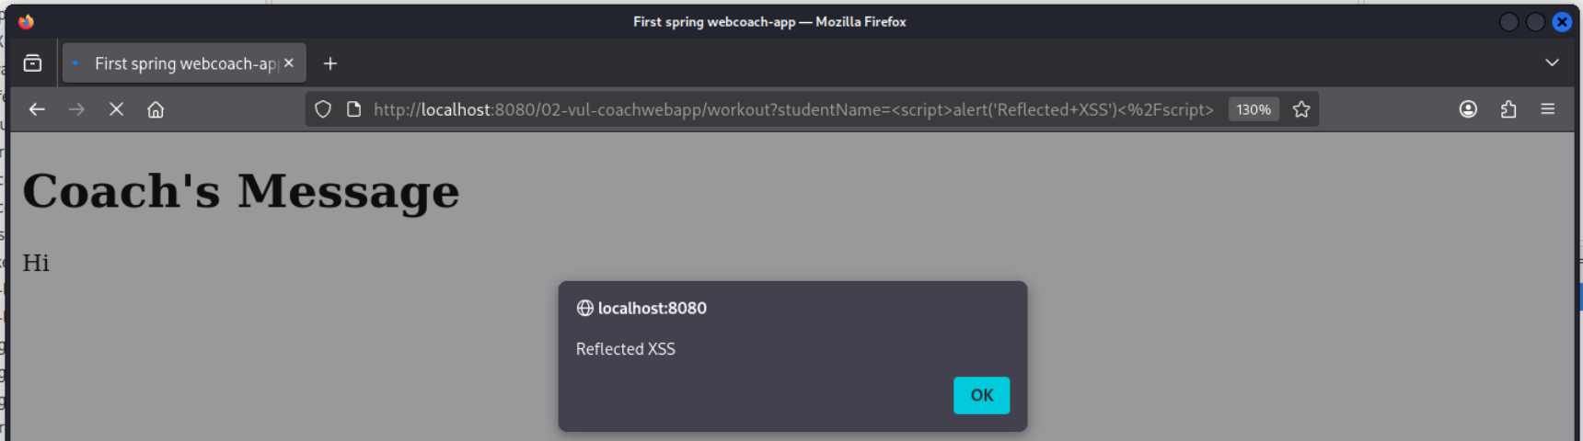
a. Note whether the alert executes and explain why
Yes, the server sends the raw input directly back in the HTML response without encoding it. The browser then reads and interprets it as a real <script> tag and executed the JS.
b. Did the processing of your input occur on the server side or client (browser) side?
The server simply processes the input and places it into the response without escaping it. The browser then executes the JS after reading the response. This is called a reflected XSS attack – here, the server directly reflects the users input straight back into the page.

Task 4
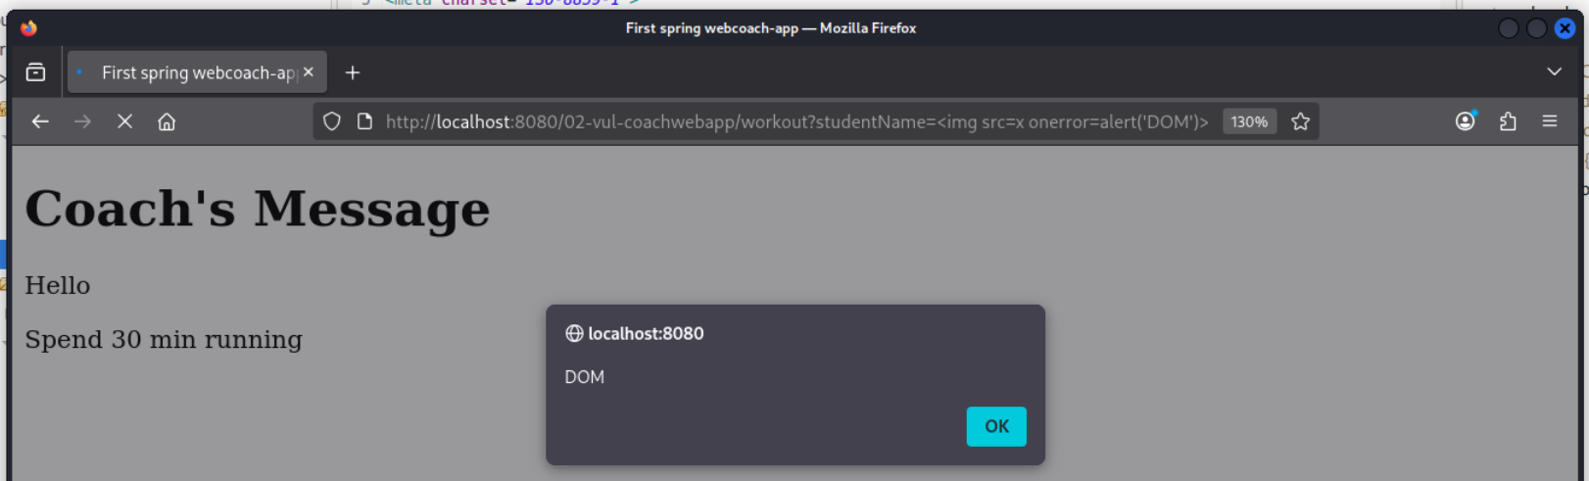
a. What differences did you observe between the first and second injection attempts?
The first relied on the server injecting the payload into the page but we disabled it. Now, it completely bypasses the server because the client side JS reads the payload directly from the URL.
b. What was the source of the input that triggered the alert?
It comes from the URL query string named “studentName” and we access it using the URLSearchParams javascript method and it’s very widely compatible^{[1]}.
c. Was your input processed on the server side or in the browser (client side)?
It’s now being processed entirely on the client side.
d. In the case of DOM-based XSS, was the injected script reflected back to the client side?
No. Nothing is sent to the server to be reflected back. The script is taken from the URL and inserted into the DOM directly by the browser, all in the client side.
e. Compare the location of the vulnerability in both the reflected and DOM-based XSS attempts. Did it occur in the CoachController class (processed on the server) or in the workout.jsp page (executed in the client browser)?
The reflected XSS vulnerability was caused in the CoachController.java file on the server side. The DOM based XSS vulnerability is in the embedded JS inside workout.jsp on the client side.
f. Can static HTML pages be vulnerable to DOM-based XSS attacks? Provide a brief explanation.
Yep, even a completely static page can have DOM XSS if its JS reads attack controlled data like a URL, a hash or referral and inserts it into the DOM without properly sanitizing or escaping it. No server side code is required at all for this.

Task 5

References
1: https://developer.mozilla.org/en-US/docs/Web/API/URLSearchParams/get#browser_compatibility

