Number Theory

Reflection
This was more like an extension to the number theory related units that I learned in SIT192 – Discrete Maths.

Basics

Congruence
When a, r, m ∈ ℤ, and m > 0, and if m divides (a - r) we can say the statement below. This basically means that a and r leave the same remainder when divided by m.
a = r mod m when m | (a - r)
To reduce a number modulo m, just divide it by m and keep the remainder. For example,
-27 ≡ 34 (mod 61), because 34 - (-27) = 61.

Euclidean algorithm
gcd(a,b) is the largest positive integer that divides both a and b. Two numbers are said to be relatively prime when their gcd is 1. This check is important for modular inverse, Fermat's Little Theorem, Euler's Theorem and the Chinese Remainder Theorem down the line.
When b > a, do this until r_{i+1} = 0. Then, r_{i} is the gcd.
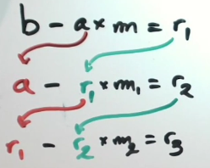
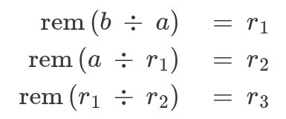

Bezouts Lemma
If gcd(a, b) = c, then, m ⋅ a + n ⋅ b = c
a and b are relatively prime only if numbers m and n suffice m ⋅ a + n ⋅ b = 1
Instead of trying to guess m and n by substituting a and b, just re-arrange the equations. Use the b – a*m = r₁ method (Eucledian algorithm), and substitute values from where necessary and keep on doing that until the final equation comes to the form said above, with m and n being real integers.

Modular Inverse
The modular inverse of a modulo m is a number x such that: a * x ≡ 1 (mod m). A modular inverse exists if and only if gcd(a, m) = 1 (aka. they are relatively prime).
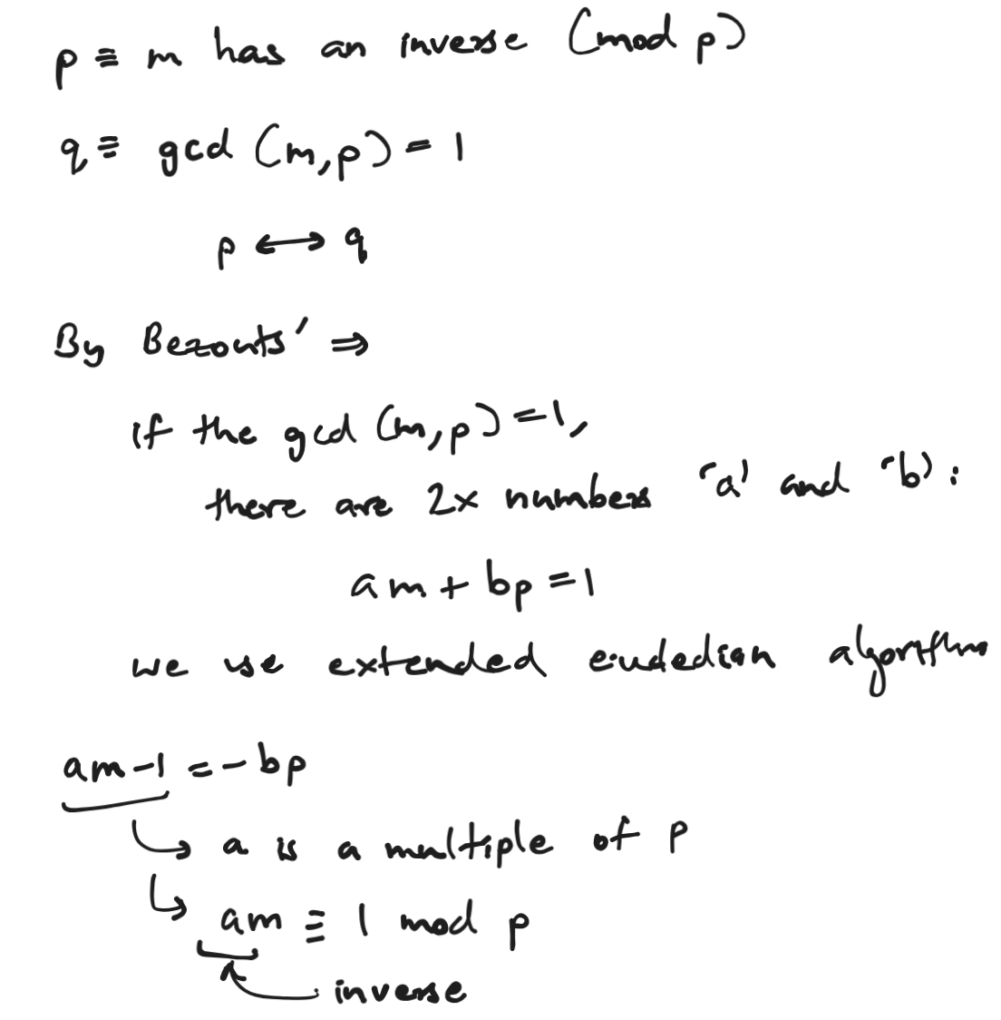
To find the inverse of a 89 mod 28, find m and n (Bezouts coefficients) such that 89m + 28n = 1. So in this case, it would be 1 = -11*89 + 35*28. This means that -11 is an inverse of 89 mod 28. Also note that finding just the Bezouts coefficient of 89 (-11 in this case) is enough just for the sake of solving these quickly. As -11 is out of the 0-27 range (for mod 28), we will reduce it to get -11+28 = 17. Now, you can say that the inverse of 89 is 17 (mod 28).

Solving Linear Equations in Modular Arithmetic
If gcd(m, p) = 1, then for any number x the equation mx = a (mod p) has a solution.
To solve a *x ≡ b (mod m), first check gcd(a, b). If this is equal to 1, find the inverse of a and multiply both sides by it. For example, let’s look at 70x ≡ 41 (mod 61):
- Reduce 70 mod 61 —> 70 ≡ 9 (mod 61)
- Use the extended euclidean algorithm —> 1 = 4*61 - 27*9
- The inverse of 9 is -27 ≡ 24 (mod 61)
- Multiply both sides by 34: x ≡ 34 * 41 = 1394 ≡ 52 (mod 61).
Or when generalized, it will look as follows, to solve ax ≡ b (mod p) if gcd(a, p) = 1,
- Find the inverse s of a modulo p using the extended Euclidean algorithm.
- Multiply both sides of the equation by s: asx ≡ bs (mod p).
- This results in the solution x ≡ bs (mod p).

The Chinese remainder theorem
This theorem lets us combine two modular equations into one equation, as long as the two moduli have no common factor other than 1. In other words, the gcd of the two moduli should be 1 to apply this algorithm.
For the two equations:
x ≡ a (mod m)
x ≡ b (mod n)
First, check if gcd(m,n)=1. If it is, proceed. Then, use the extended Euclidean algorithm to find m(s) and n(t).
m*s + n*t = 1
Using these values, substitute them to the final formula to get the solution.
x ≡ bms + ant (mod mn)
When there are three equations, solve the first two and then solve it again using it’s solution and the third equation.

Fermat’s Little Theorem
When p is prime and p does NOT divide a, Fermat’s Little Theorem says that:
a^{p-1} ≡ 1 (mod p)
This lets us use a large exponent modulo p-1. For example, let’s look at 11²⁷⁶⁹⁹ mod 13.
- 11¹² ≡ 1 (mod 13), because 13 is prime
- And, 27699 = 12 * 2308 + 3
- So,
  - 11²⁷⁶⁹⁹ ≡ (11¹²)²³⁰⁸⁺³
  - 11²⁷⁶⁹⁹ ≡ (11¹²)²³⁰⁸ x 11³
  - 11²⁷⁶⁹⁹ ≡ 11³
  - 11²⁷⁶⁹⁹ ≡ 5 (mod 13)
However, if the p is not a prime number, you will have to use another method using the Euler's Totient Function. Only the first part changes, the rest of it remains almost identically.

Proof of a^{p} ≡ a (mod p) —>
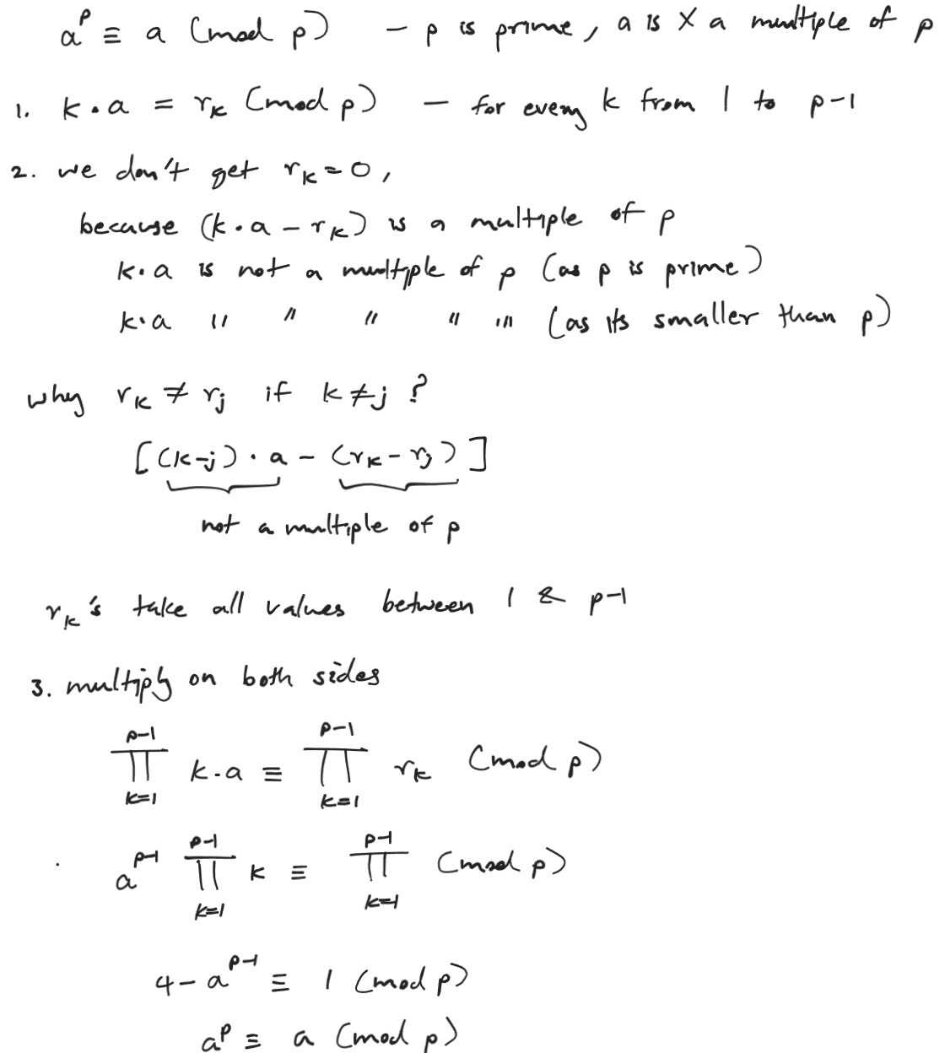

Euler’s Totient Function: ϕ
ϕ(n) counts the integers from 1 to n-1 that are relatively prime to n. To calculate this, either list out all the numbers from 1 to n-1 (excluding n and 0) and count the relatively prime numbers to n manually.
Or, you can break n down into it’s prime factors (powers), and use this algorithm.
If n = p₁^{a1} x p₂^{a2} x ... x p_{k}^{ak}
Then, ϕ(n) = n * ($1-\frac{1}{p1}$) * ($1-\frac{1}{p2}$) ... ($1-\frac{1}{p2}$)
Perform prime factorization for n, take each prime factor p (without the powers) and multiply n by ($1-\frac{1}{p}$).

Euler's Theorem
When gcd(a, n) = 1, Euler’s theorem says:
a^{ϕ(n)} ≡ 1 (mod n)
Fermat’s Little Theorem is the prime version of Euler’s Theorem. This is because ϕ(p) = p-1 when p is prime. To simplify a large power, divide the exponent by ϕ(n) and keep the remainder

Examples

Fermat's Little Theorem & Euler's Totient Function
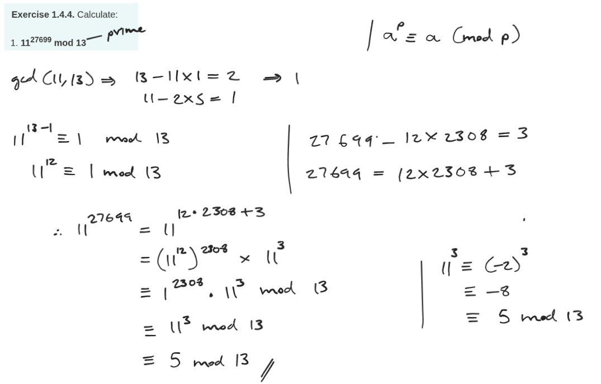
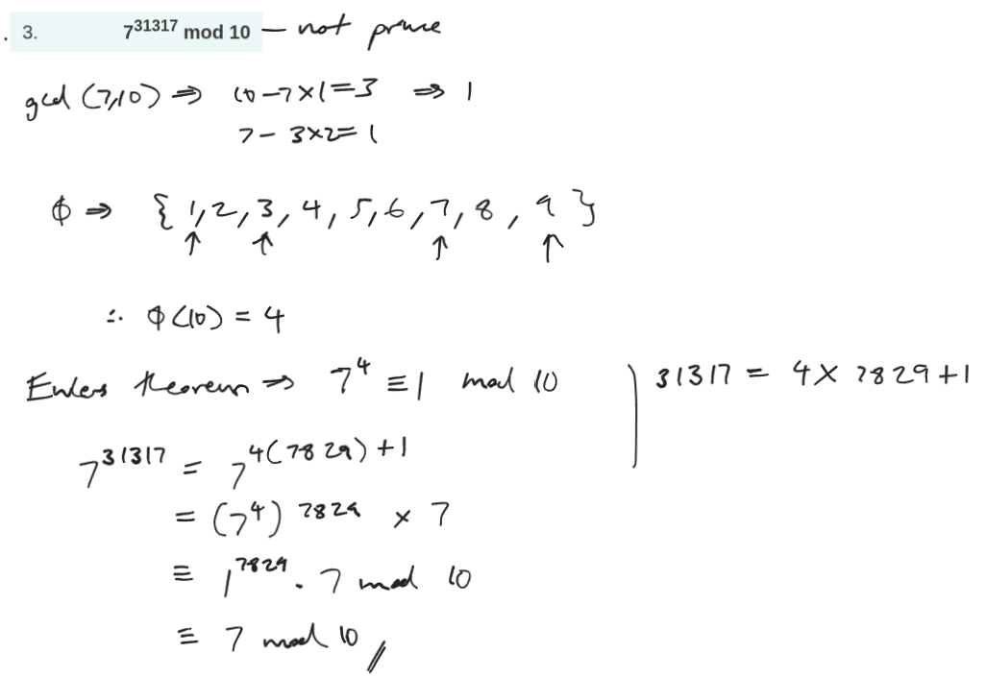

Finding the Last Digits of a Large Power
For the last k digits of a number n, calculate: n mod 10^{k}.
- For the last digit: mod 10.
- For the last two digit: mod 100.
- For the last three digit: mod 1000.

