Task 3.1P
I extracted the linked resource file from Cloud Deakin.
The theme I chose was computers. I searched for images in Unsplash as instructed.
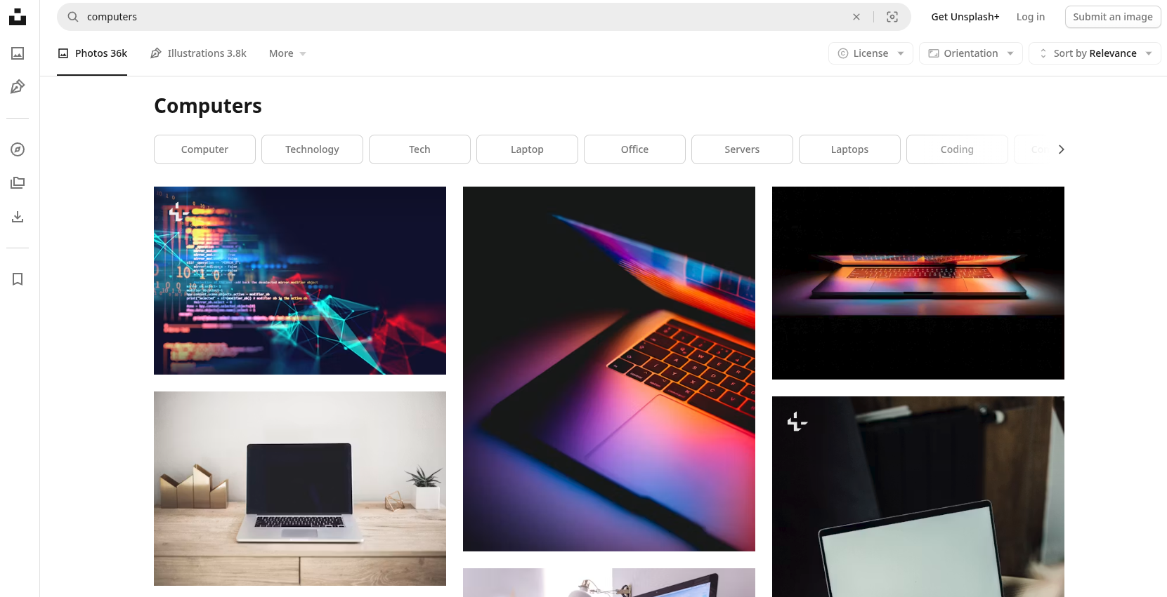
And I added them to my web page. The scroll behavior was set to smooth for much more smoother scrolling in the web page.

I added hyperlinks to the top for easier navigation throughout the page’s contents. We could technically put them into a section tag and scroll down to there but in this case, the fragment that it takes you down to is the id of the title of that section – which works identically.
The new sections added to my already existing page can be found in the next page.
Demonstration Video: https://youtu.be/oHe5SbnVOCs (2 minutes and 12 seconds).
- 00:00 :- Demonstration
- 01:49 :- Quick Code Overview

