Task 3.2P
I had to refer to w3schools^{[1][2]} to some things, but it was pretty easy, specially with intellisense and emmet abbreviations in VS Code.
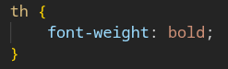
This section is not really required. When you open chrome’s development tools without this style set, you can see that the font weight of bold is the default for th.
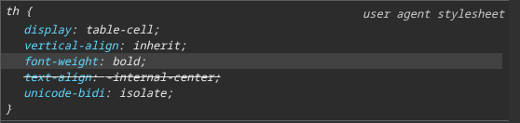
To ensure the header “Season” has a font weight of normal, I added wrote this class .font-normal and I added it to that element only. We could have also used inline css for that line, but I prefer this just because i”m familiar with Tailwind CSS.
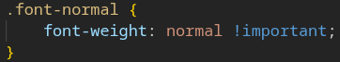
Below is what the website looks like:
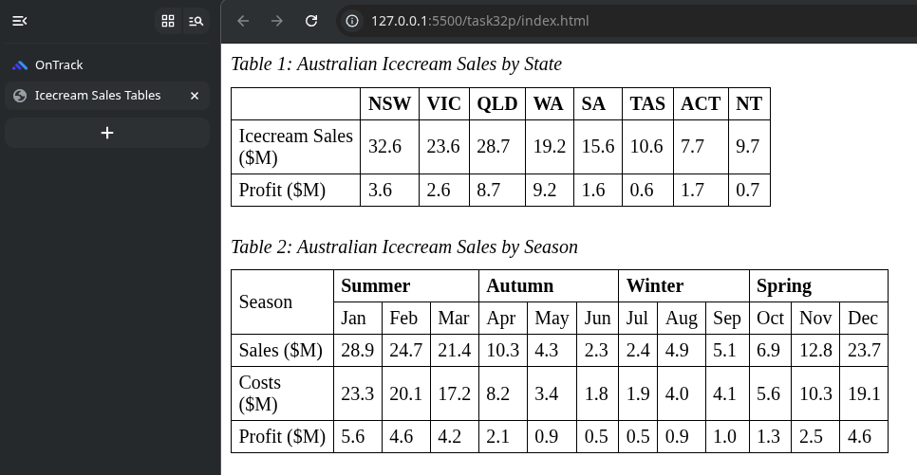

References
[1] w3schools, “CSS Styling Tables,” W3schools.com, 2019. Available: https://www.w3schools.com/Css/css_table.asp. [Accessed: Jul. 04, 2026]
[2] “CSS border-collapse property,” www.w3schools.com. Available: https://www.w3schools.com/cssref/pr_border-collapse.php. [Accessed: Jul. 04, 2026]

