Task 3.3P
aaa

Step 1
The &emsp; stands for “em space” and is used like a tab, just like &nbsp; stands for “non breaking space” and is used to represent a whitespace character by properly escaping it in HTML^{[1]}.
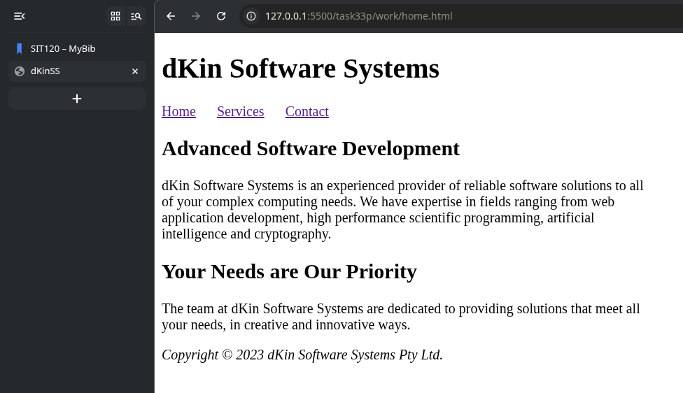

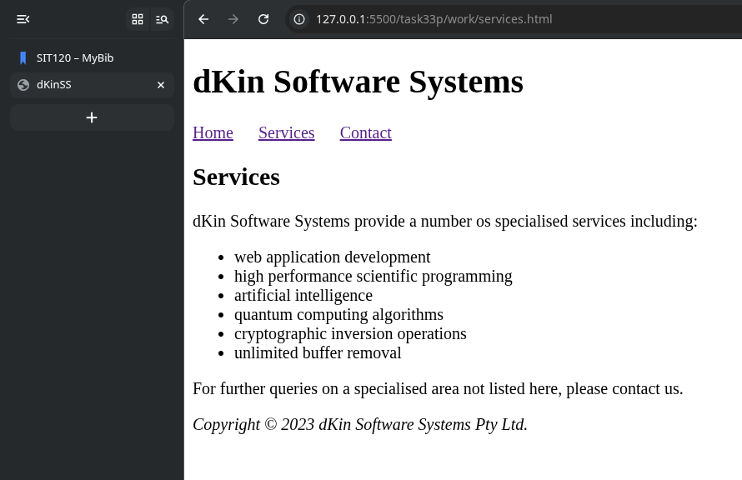

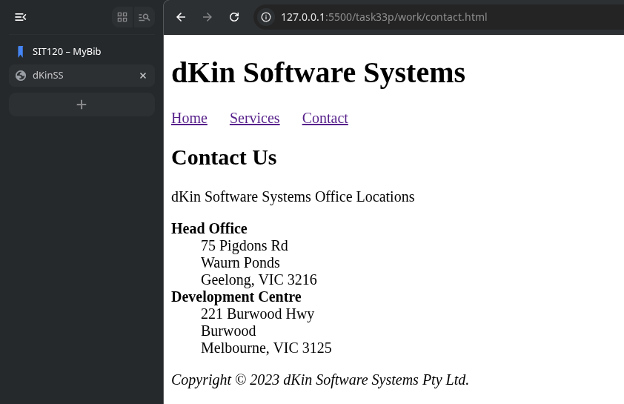

Step 2
I uploaded and validated all the three HTML files. Screenshots of the results are found below.
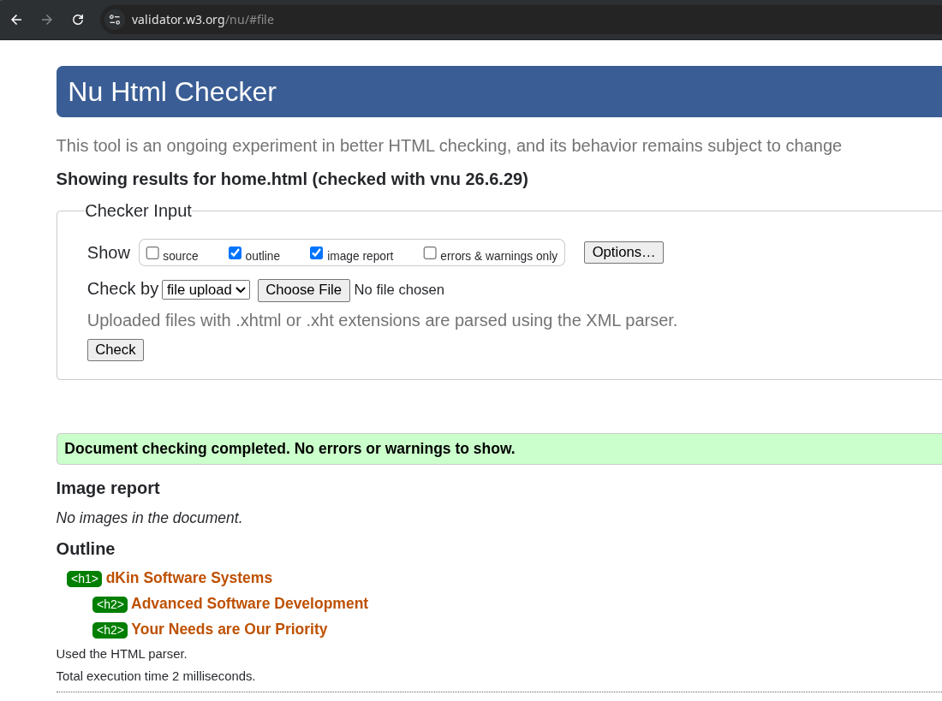
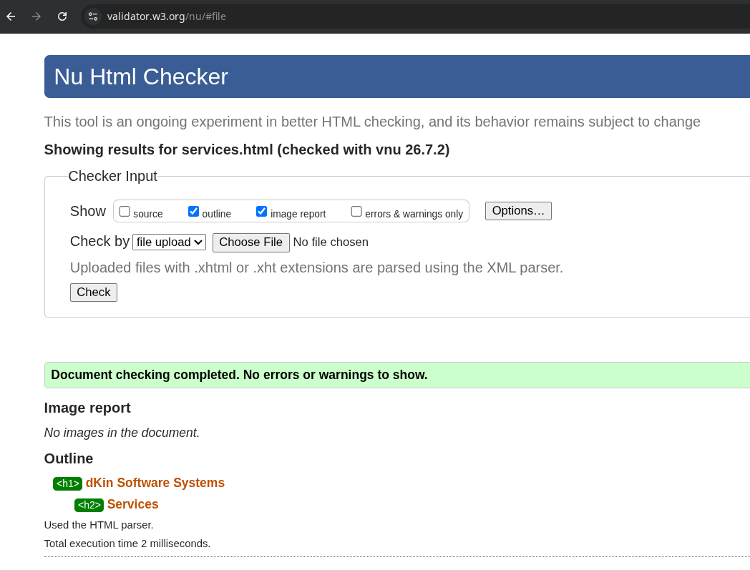

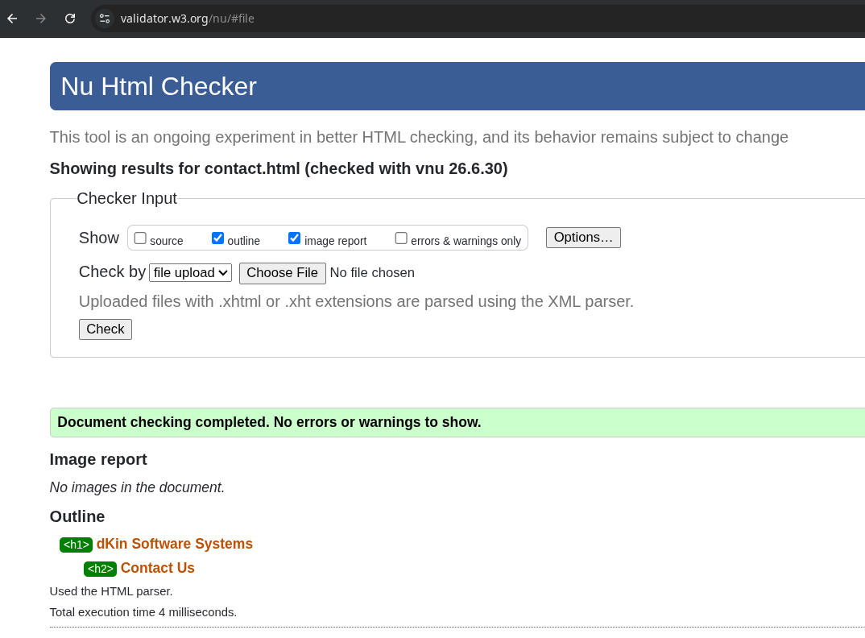

Step 3

Publishing to the World

Publishing Locally

References
[1] “How do I replicate a \t tab space in HTML?,” Stack Overflow, 2026. Available: https://stackoverflow.com/a/56942318. [Accessed: Jul. 04, 2026]

