Task 6.1P

Evidence of Learning

Exercise 4.2

Consider we have a network with a subnet along with prefix 192.168.40.128/26. Can you list down two IP addresses that can be assigned to two PCs connected to this network?
The /26 CIDR prefix means that 26 bits are reserved for the network and the remaining 32-26=6 bits are for the host. This means that there can be 2^6 = 64 total addresses, out of which, we will have 64-2=62 usable addresses. The reason we removed two from here is because one is the network address and the other one is for broadcast.
From 256-64 = 192, the /26 subnet mask is 255.255.255.192. Therefore, the subnet ranges for the last octet are 0-63, 64-127, 128-191 and 192-255. Because the network address is 192.168.40.128, we will be dealing with the 128-191 set. This means the first usable IP is 192.168.40.129, the last usable IP is 192.168.40.190 and the broadcast address is 192.168.40.191.
This means that the two PCs can use addresses like: 192.168.40.129 and 192.168.40.130.

Exercise 4.3.1

Open the installed Cisco Packet Tracer and get yourself familiarised with CiscoPacket Tracer.
Done.

Exercise 4.3.2

When you are working in Cisco Packet Tracer, can you show all the port labels in your logical workspace? Tip: Check Options > Preferences
This is what it looks like now, without this option turned on.
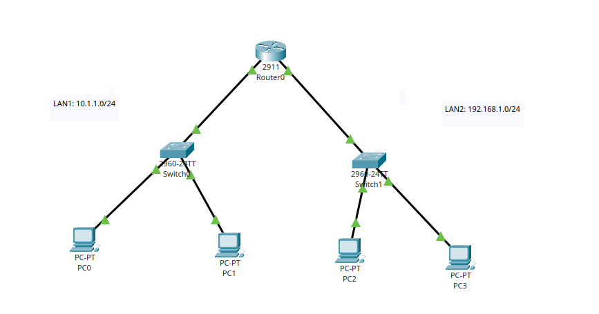
I then checked this option in Option —> Preferences.
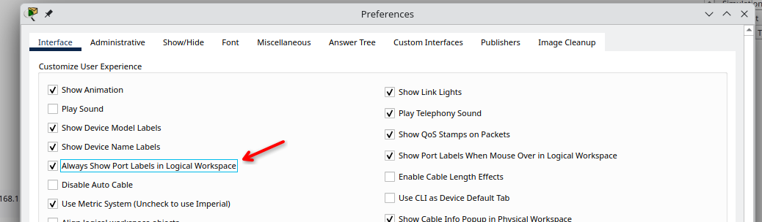
Now, this is what it looks like. I had to rearrange the items here to ensure that all the labels are clearly visible and readable.
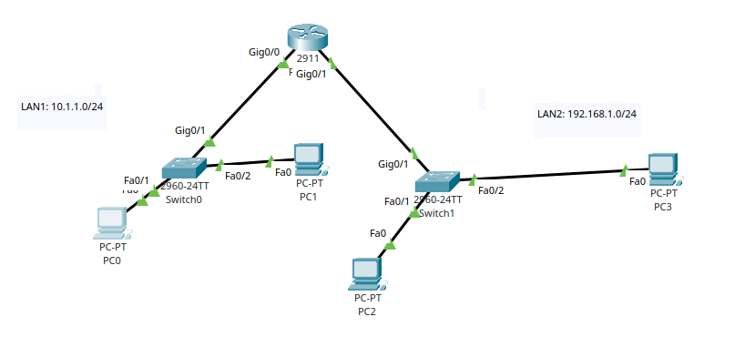

Active Class Week 6: 6.2 Activity 1
I used two packets that were outgoing from my capture. The first one is frame 16, which is a TCP SYN packet sent to port 443. The second one is frame 7, which is a DNS request sent using UDP.

1. Examine the IP datagram’s header. Can you identify the IP address of your device and the IP address of the destination host?
For the first analysis, I selected frame 16. The IP address of my device is 10.141.41.155. The destination host IP address is 172.66.147.243. I identified them using the Source Address and Destination Address fields inside the Internet Protocol Version 4 section.
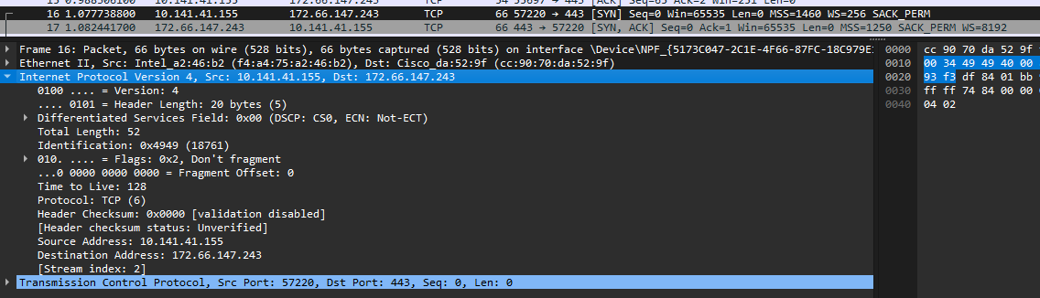

2. Can you identify the version of IP addresses?
As seen in the above image, the Version field is set to 4. So, both addresses are IPv4 addresses. They are also written using the dotted-decimal IPv4 format.

3. By examine the IP header, can you identify the transport layer protocol used? Does this match with the transport layer protocol listed in in the packet details window?
The Protocol field in the IP header shows TCP (6). Protocol number 6 represents Transmission Control Protocol. This matches with the Transmission Control Protocol section shown separately in the packet details window. The packet uses source port 57220 and destination port 443. It is a SYN packet, so it’s safe to assume that it’s starting a connection to an HTTPS service.

4. What is the size of IP header in Bytes? What is the size of the payload (in Bytes) of this IP datagram? How did you calculate the size of the payload?
The Header Length field shows the IP header is 20 bytes. The Total Length of the IP datagram is 52
IP payload = Total Length - IP header length à 52 - 20 = 32 bytes
Therefore, the IP payload is 32 bytes. This contains the TCP header and its options. Since this is a SYN packet, it doesn’t contain any application data yet. The captured frame size is 66 bytes, but I didn’t use that value because it also includes the 14-byte Ethernet header.

5. Can you check whether this IP datagram is fragmented or not? Explain your answer.
This IP datagram is not fragmented. The screenshot shows the Flags field as 0x2, with Wireshark labelling it as Don’t fragment. This means the Don’t Fragment flag is set.
The Fragment Offset is also 0, and the More Fragments flag is not set. Together, these fields confirm that the packet is a complete IP datagram and not one part of a fragmented packet.

6. Examine other important fields in the IP header.
The screenshot shows several other important fields:
- Differentiated Services Field: The value is 0x00, with DSCP set to CS0. This means the packet is using the default service level without any special traffic priority.
- ECN: It shows Not-ECT, meaning the packet is not using Explicit Congestion Notification.
- Total Length: The complete IP datagram is 52 bytes, including the 20-byte IP header and 32-byte payload.
- Identification: The value is 0x4949, or 18761. This value can be used to identify and reassemble fragments if fragmentation happens.
- Time to Live: The TTL is 128. Each router reduces this value by one, and the packet is discarded if it reaches zero.
- Protocol: The value is TCP (6), showing that the IP payload contains a TCP segment.
- Header Checksum: The value is 0x0000, with validation disabled and the status shown as unverified. This means Wireshark did not verify the checksum, so it does not automatically mean the header is invalid.
- Source Address: 10.141.41.155
- Destination Address: 172.66.147.243

7. Now, conduct a similar analysis using a different type of packet (if you have used HTTP before, now you can use DNS) and compare the findings.
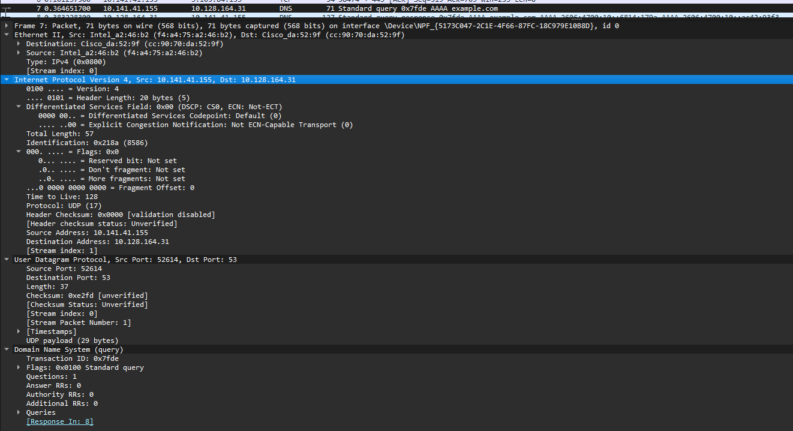
For the second analysis, I selected frame 7. This is a DNS query for example.com, sent from my device using UDP.
The Source Address is 10.141.41.155, which is still my device. The Destination Address is 10.128.164.31, which is the DNS server.
The Version field is 4, so this is also an IPv4 datagram. The DNS query is asking for an AAAA record, but the packet carrying the request is still IPv4.
The Protocol field shows UDP (17). This matches with the User Datagram Protocol section in the packet details. The source port is 52614 and destination port is 53, which is the normal DNS port.
The IP header length is 20 bytes and the Total Length is 57 bytes.
IP payload = 57 – 20 = 37 bytes.
The 37-byte payload includes an 8-byte UDP header and a 29-byte DNS message.
This packet is also not fragmented. Its More Fragments bit is 0 and Fragment Offset is 0. The Don’t Fragment bit is 0, which means fragmentation was allowed, but the packet itself still wasn’t fragmented.
Other fields in this packet include:
- DSCP: 0
- ECN: 0
- Identification: 0x218a or 8586
- Time to Live: 128
- Protocol: UDP (17)
- Header Checksum: 0x0000
Both packets use IPv4, have a 20-byte IP header, uses the same source address and has a TTL of 128. The main difference is frame 16 uses TCP and frame 7 uses UDP. The TCP packet has a 32-byte IP payload, while the DNS/UDP packet has a 37-byte IP payload. Frame 16 also has the Don’t Fragment bit set, while frame 7 does not.

Active Class Week 6: 6.3 Activity 2

1. Assume you are sending a present to a friend in another country. Can you list the various places and steps that your parcel would go in the postal system before it reaches your friend?
The parcel would go through these places and steps:
- I pack the present and write my friend’s address and my return address.
- I take it to a local post office or arrange for it to be collected.
- The parcel goes to a local sorting centre.
- It is sorted based on the destination country and sent to an international sorting centre.
- The parcel is transported by air or sea to the destination country.
- It goes through customs and security checks.
- The destination country’s postal service receives and sorts it.
- It is sent to the local delivery centre closest to my friend.
- A delivery driver takes the parcel to my friend’s address.
Each postal centre only needs to decide where the parcel should go next. It doesn’t need to know every part of the complete journey.

2. How this analogous to a situation where you want to send a message to a friend in another country over the computer networks?
Sending a message over a computer network works in a similar way. The message is divided into packets before being sent. Each packet contains a source IP address and destination IP address, similar to the sender and receiver addresses written on a parcel.
The packet first goes through the local network to the default gateway. Routers then examine the destination IP address and use their routing tables to decide the next place the packet should go. This continues until it reaches the destination network and the receiver’s device.
The postal and network parts can be compared like this:
Postal system | Computer network
Present or parcel | Data packet
Sender address | Source IP address
Friend’s address | Destination IP address
Local post office | Default gateway
Sorting centre | Router
Road, air or sea transport | Ethernet, fibre or wireless link
Postal route information | Routing table
Local delivery centre | Destination router
Friend receiving the parcel | Destination device receiving the packet

A message may contain several packets. These packets can sometimes take different routes, but they are placed in the correct order when needed at the destination after they are recieved.

3. Assume we need to build the following network with two LANs (LAN1 and LAN2). Each group member has a role to play. One group member can be the router and four other group members could be PCs (PC1 and PC2 belong to LAN1 and PC3 and PC4 belong to LAN2). Each device needs to set their own network configuration. The Router needs to set its interfaces/port and PCs need to set its IP address and gateways to be able to make a communication between two LANs. Discuss the configurations of your own device with your group members.
The diagram contains two separate LANs:
- LAN1 uses the 10.1.1.0/24 network.
- LAN2 uses the 192.168.1.0/24 network.
A /24 network uses the subnet mask 255.255.255.0. Each device needs a unique IP address within its own network. The router interface connected to each LAN will be used as the default gateway. A possible example configuration is:
Device | IP address | Subnet mask | Default gateway
Router interface for LAN1 | 10.1.1.1 | 255.255.255.0 | Not required
PC1 | 10.1.1.2 | 255.255.255.0 | 10.1.1.1
PC2 | 10.1.1.3 | 255.255.255.0 | 10.1.1.1
PC3 | 192.168.1.2 | 255.255.255.0 | 192.168.1.1
PC4 | 192.168.1.3 | 255.255.255.0 | 192.168.1.1

The router member can configure its two interfaces using commands similar to these:
enable
configure terminal

interface GigabitEthernet0/0
ip address 10.1.1.1 255.255.255.0
no shutdown
exit

interface GigabitEthernet0/1
ip address 192.168.1.1 255.255.255.0
no shutdown
exit

end
The exact interface names may change depending on the router model. Static routes aren’t needed here because both networks are directly connected to the same router.
The switches don’t need an IP address to forward normal Ethernet frames. They would only need an IP address if remote switch management is required.

4. Assume PC1 needs to send a packet to PC3, discuss the steps that the packet needs to go through to reach to PC3.
The steps will be as follows:
- PC1 creates a packet with 10.1.1.2 as the source IP address and 192.168.1.2 as the destination IP address.
- PC1 compares the destination address with its own network. It can see that PC3 belongs to a different network, so the packet must be sent to the default gateway at 10.1.1.1.
- PC1 uses Address Resolution Protocol, or ARP, to find the MAC address of the router interface if it isn’t already stored in its ARP table.
- PC1 places the packet inside an Ethernet frame. The frame uses PC1’s MAC address as the source and the router’s LAN1 MAC address as the destination.
- Switch 1 receives the frame and forwards it to the router.
- The router removes the Ethernet frame and examines the destination IP address. Its routing table shows that 192.168.1.0/24 is directly connected through the interface leading to LAN2.
- The router uses ARP to find PC3’s MAC address if needed. It then places the same IP packet inside a new Ethernet frame. This frame uses the router’s LAN2 MAC address as the source and PC3’s MAC address as the destination.
- Switch 2 forwards the frame to PC3. PC3 removes the Ethernet frame, checks the destination IP address, and passes the received data to the correct application.
The source and destination IP addresses stays as 10.1.1.2 and 192.168.1.2 through the full process. But the source and destination MAC addresses changes when the packet goes through the router.

Active Class Week 6: 6.3 Activity 2
I added all the devices to packettracer and connected them with Copper Straight Through cables.
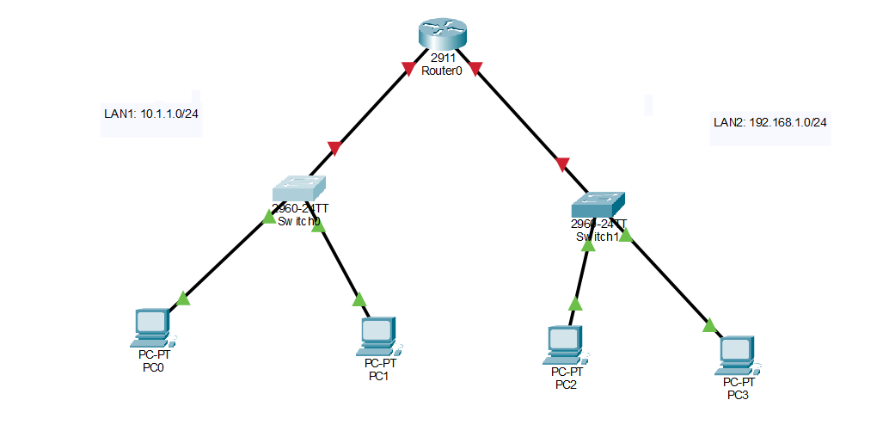

I then started to configure the router.
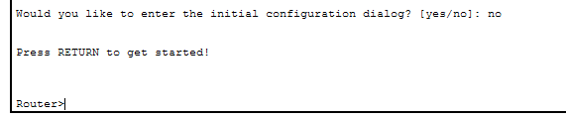
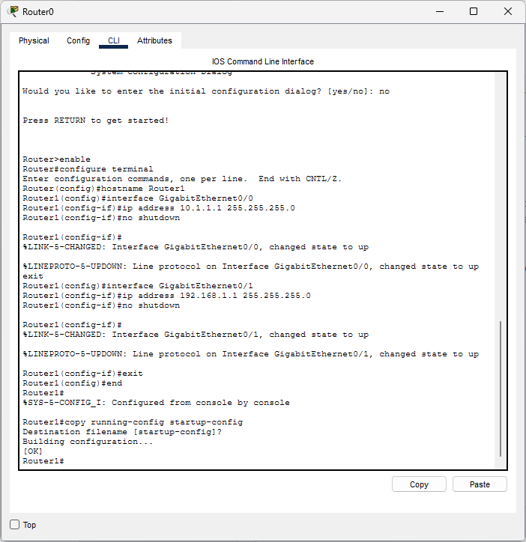
After that, I verified that everything has been set as required for the network to function in the given configuration.
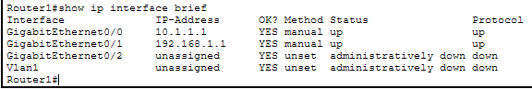
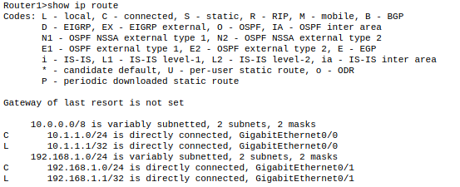

I then assigned static IP addresses for all the computers. PC0 and PC1 are in LAN1 and PC2 and PC3 are in LAN2.
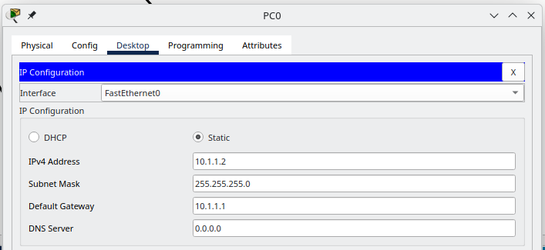
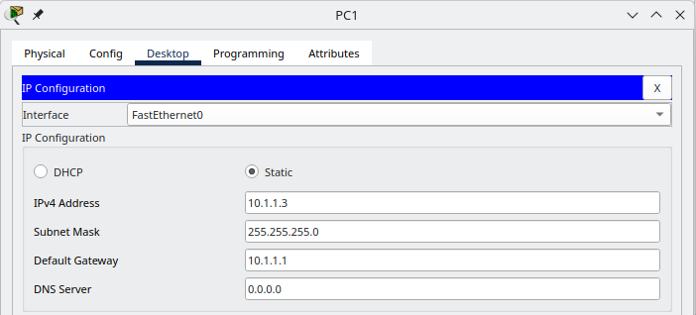
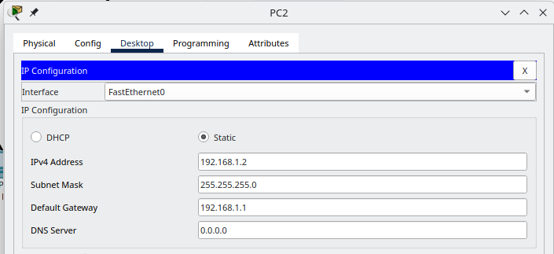
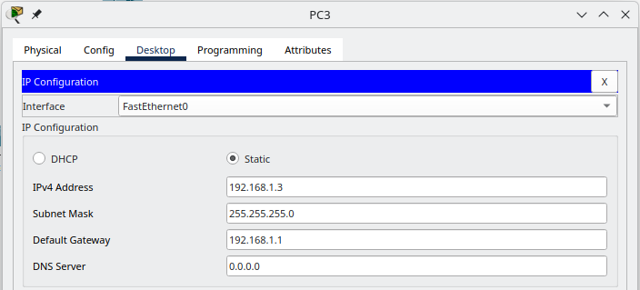
I then opened PC0’s Command Prompt to test connectivity. I initially configured the IP configuration before proceeding to ping the devices in the network.
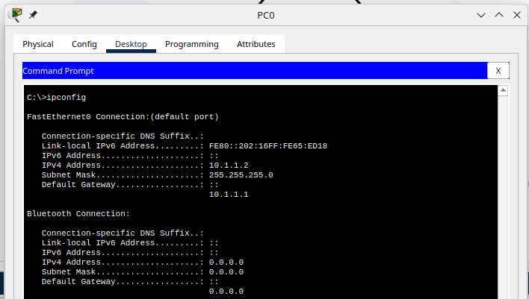
I can ping the router.
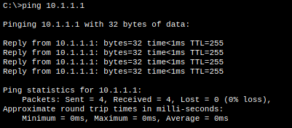
I can ping PC1, which is in the same network / LAN1.
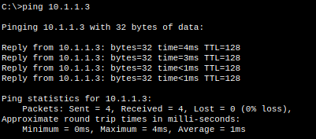
I can also ping the other router interface.
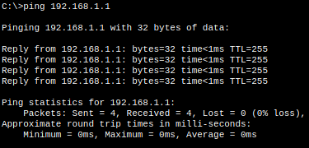
Along with PC2 in LAN2
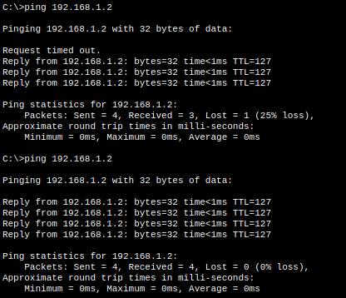
And PC3 in LAN2.
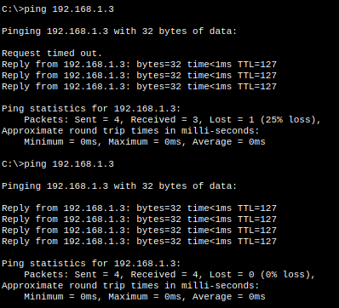
When pinging devices in the other LAN, the first ICMP Echo Request timed out in both tests. This happened because ARP was still finding the MAC addresses needed to forward the packet. When I ran the ping again, it didn’t time out because the required addresses were already saved in the ARP tables.
Demonstration of the Simulation: https://youtu.be/76peT8rW1XM
Simulation of a single ping showing the ICMP Echo Request and Echo Reply between PC0 and PC3:
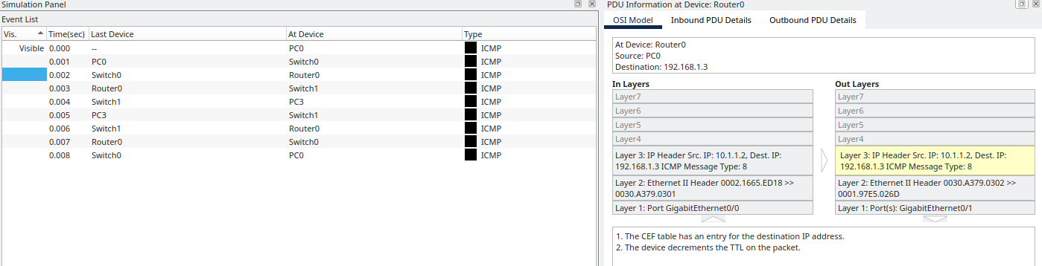

The OSI Model shows Router0 receiving the ICMP Echo Request through GigabitEthernet0/0 and forwarding it through GigabitEthernet0/1. The source IP stays as 10.1.1.2 and the destination IP stays as 192.168.1.3. Router0 checks its CEF table for the destination and decreases the packet’s TTL before forwarding it. The Ethernet MAC addresses change because the router creates a new frame for LAN2.

