Task 6.1P

Evidence of self-assessment
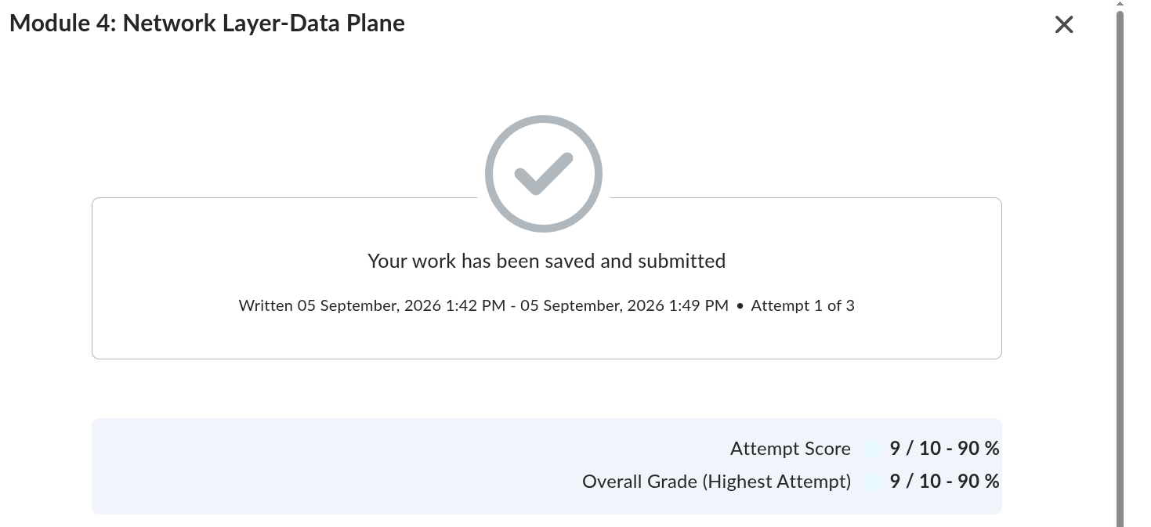
As seen here, I got one question wrong.
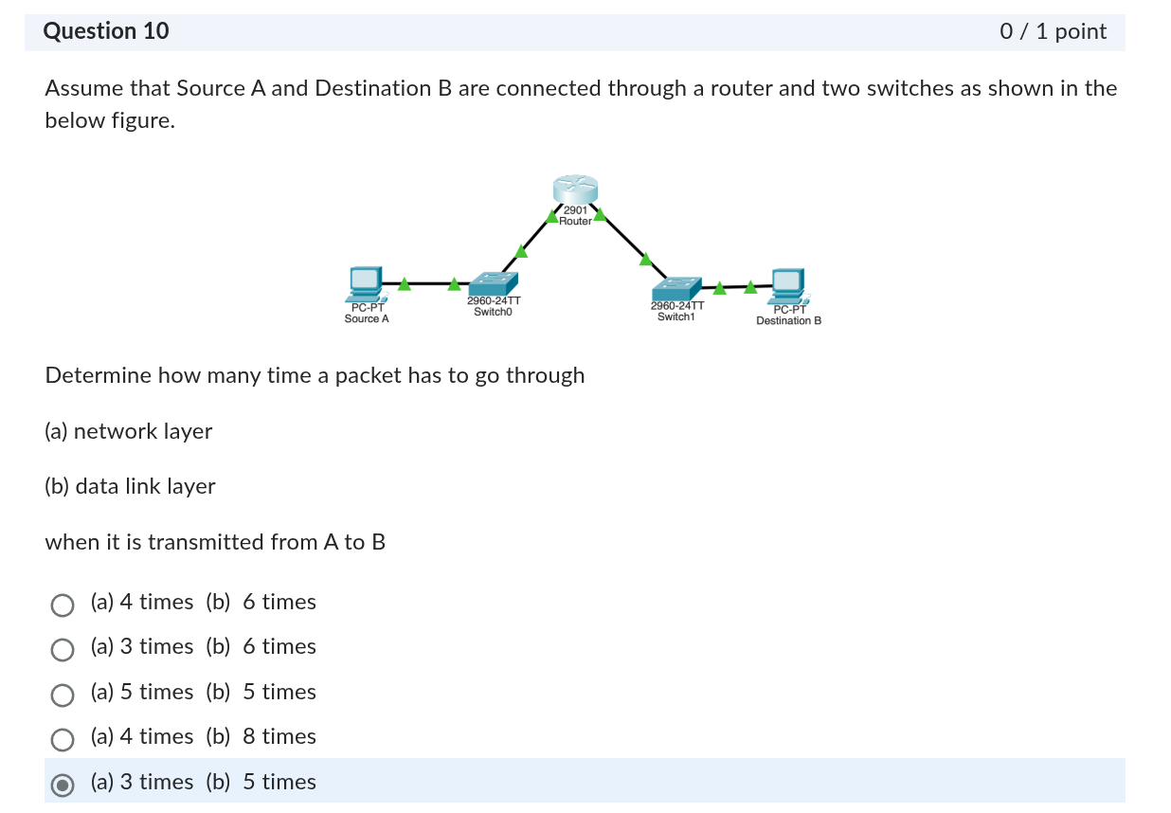
In my first attempt, I selected 3 times for the network layer and 5 times for the data link layer because I counted each device only once. After it was marked wrong, I went through it again and now think the correct answer is 3 times and 6 times. The router processes the network layer once, but handles the data link layer twice by removing the incoming frame and creating a new frame for the other LAN.

