Task 5.2C - My DNS Server Draft

Introduction
For this task, after confirming with my tutor in the Monday 2PM workshop, I confirmed that the DNS query doesn’t have to follow the actual real world formats. Therefore, I will be keeping it very straight simple and forward.

Pseudocode

Server
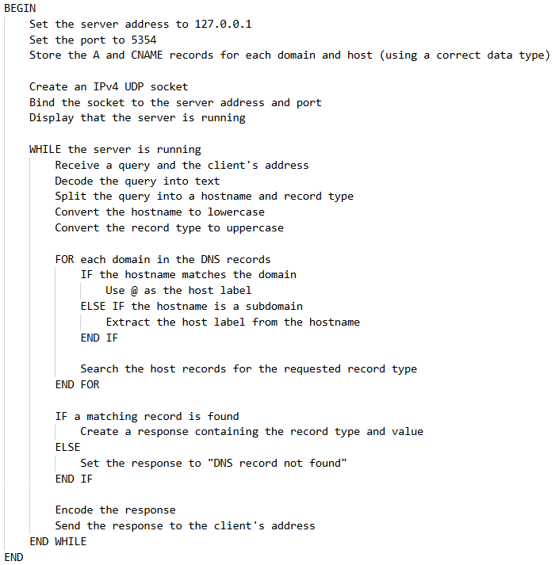

- Next page

Client
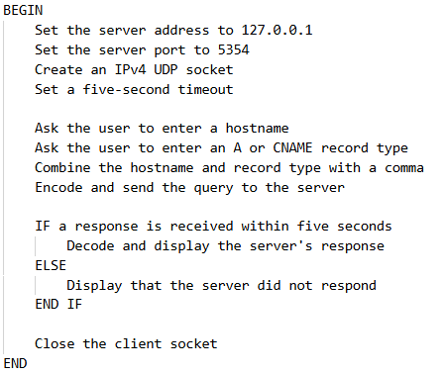

Python
The python source files for both the server and client (server.py and client.py) are attached to the end of this file.
I used the python sockets API with UDP (as that’s what DNS usually uses) and used a simple dictionary to emulate a real world DNS record holding configuration with subdomains and multiple record type supports.
The server listens for incoming requests from the client, then checks for the hostname & record type (in the query) and then sends a response back to the client with the correct result or an error if that record doesn’t exist.
Each main domain can contain multiple subdomains, and each subdomain can contain different record types like A records, CNAME records, etc… The @ system here is used to represent the root domain, while labels like www, mail, api represents subdomains here.
This is a really simple minimum viable implementation. It doesn’t generate or parse real DNS packets, perform recursive DNS lookups, cache records, validate IP addresses, support record expiry, include proper security and error handling or any advanced features. The primary goal of this project is to demonstrate the main logical flow of DNS communication at a simpler, higher level, using UDP sockets.
Lessons learned: I didn’t want to test around with port 53. Therefore, I tried port 5353 and apparently that port is always used by a Microsoft system service. Therefore, I changed the port to 5354 and tested with that configuration.

