Task 6.2C - My DNS Server

Introduction
This is basically the same code that I submitted in Task 5.2C.
Below is a screenshot of myself running this simple implementation:
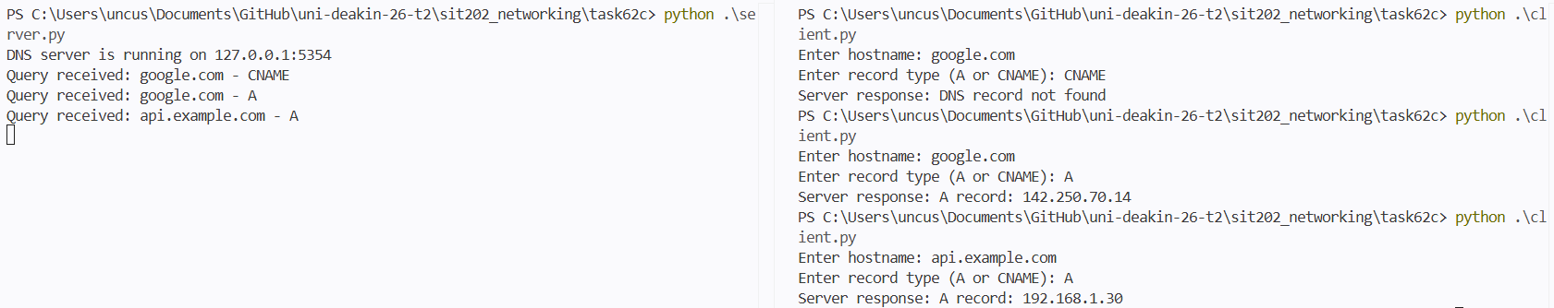

Source Code
The python code has been attached to the end of this document.

- Next Page

