Lesson Review

Response to and Request for feedback

If you are resubmitting, please address every piece of feedback you have received. Addressing all the feedback means that you copy them at the beginning of the new submission, and you provide an answer to each of them. Please also include where the tutor can find the new information.
The new information should be written in red. This makes it easier for the tutor to review this part quickly.
If this is your first submission, include a statement about which part of the lesson review you would most like to receive feedback on (and why). Your tutor will consider this when reviewing your work, although they may choose to give you feedback on a different aspect if they think it’s more appropriate.

Your submission must contain three parts: Module summary, Evidence of learning, and Evidence of self-assessment. Please clearly state headings for each part, namely Module summary, Evidence of learning, and Evidence of self-assessment, as given in the template.

Module Summary
I certify that I achieved the following learning objectives for the module (these objectives can be found in the module introduction):
Objective 1

Summarising the content of Objective 1:
- Identify the key terms and concepts in the module related to the objective. For each of these terms and concepts:
  - Define the term and explain the concept in your own word.
  - Summarise the most important results related to these concepts, including theorems and propositions, algorithms, and procedures.
  - Provide examples, figures, diagrams, but only if they help illustrate your point. This is a summary, so restrict explanations to the main points.
- How is this useful? Relate the concepts you learned in this learning objective to other objectives or the broader context (other modules, other units within your degree, and more generally).
…
Objective n

Summarising the content of Objective n:
- Identify the key terms and concepts in the module related to the objective. For each of these terms and concepts:
  - Define the term and explain the concept in your own words.
  - Summarise the most important results related to these concepts, including theorems and propositions, algorithms, and procedures.
  - Provide examples, figures, diagrams, but only if they help illustrate your point. This is a summary, so restrict explanations to the main points.
- How is this useful? Relate the concepts you learned in this learning objective to other objectives or the broader context (other modules, other units within your degree, and more generally).

Reflecting on the content:
- What is the most important thing you learned in this module?
- How does this relate to what you already know?
- Why do you think your course team wants you to learn the content of this module for your degree?

Evidence of learning

Objective 1
This is the collection of scanned/photographed/digital notes and exercise attempts or solutions you will have produced to cover this learning objective.
The relevant exercises can come from the activity in the module that covers the objective.

These materials do not need to be formal and can include a representative selection of incorrect as well as correct attempts, handwritten or typed notes, annotated references and so on. There should be evidence relating to each of the learning goals and key concepts covered.

It is a good idea to include short comments together with your evidence.
…
Objective n
This is the collection of scanned/photographed/digital notes and exercise attempts or solutions you will have produced to cover this learning objective.
The relevant exercises can come from the activity in the module that covers the objective.

These materials do not need to be formal and can include a representative selection of incorrect as well as correct attempts, handwritten or typed notes, annotated references and so on. There should be evidence relating to each of the learning goals and key concepts covered.

It is a good idea to include short comments together with your evidence.

Evidence of self-assessment
Print the results summary followed by solutions to all assessment exercises. For instance, see this 2025 summary pasted as images.
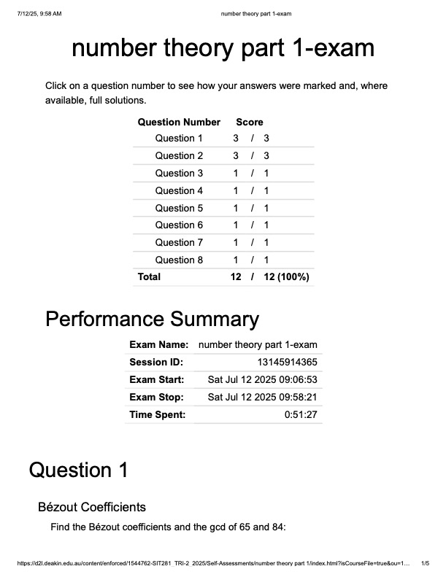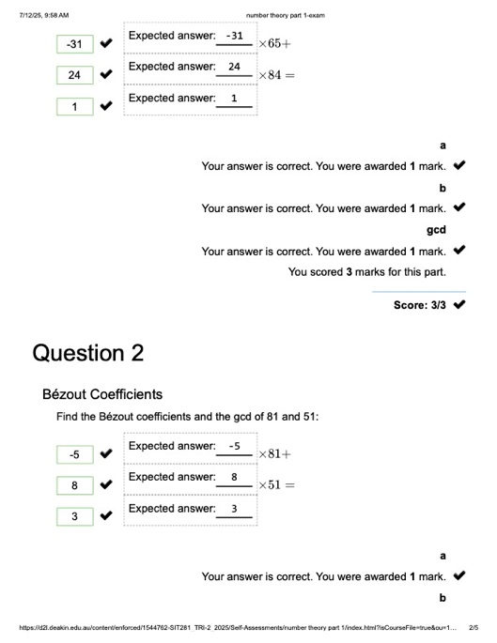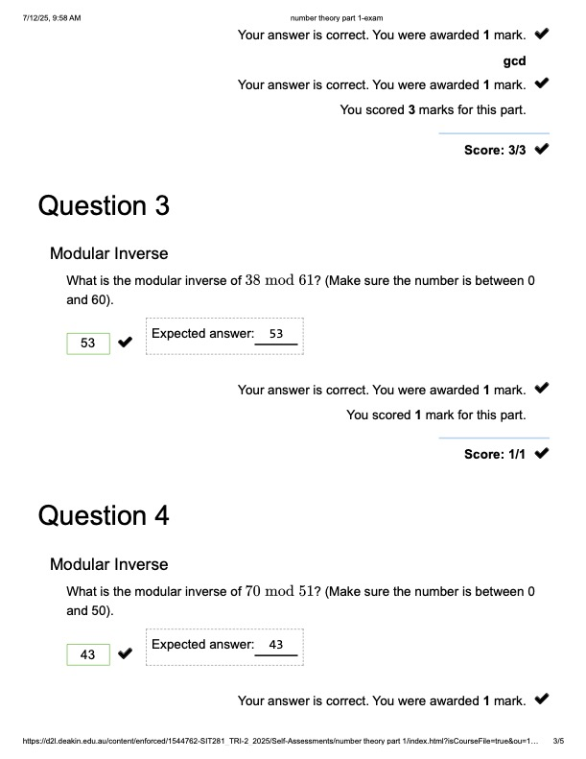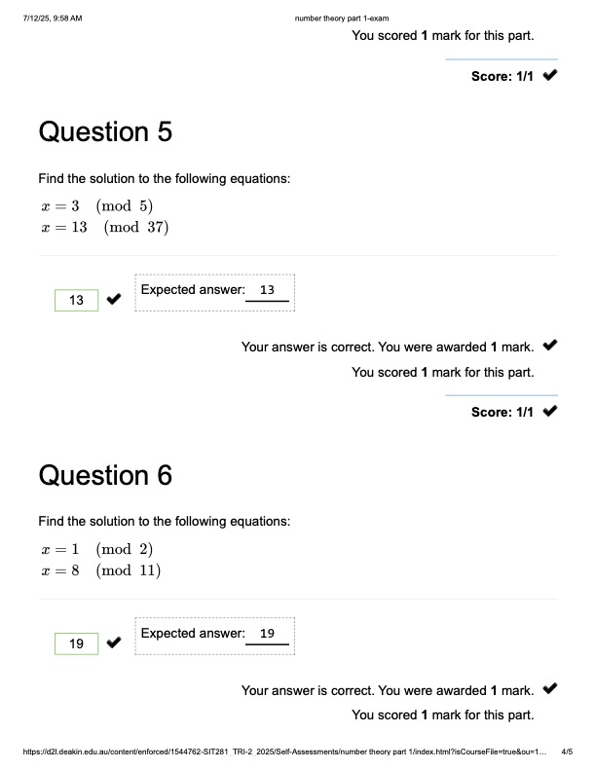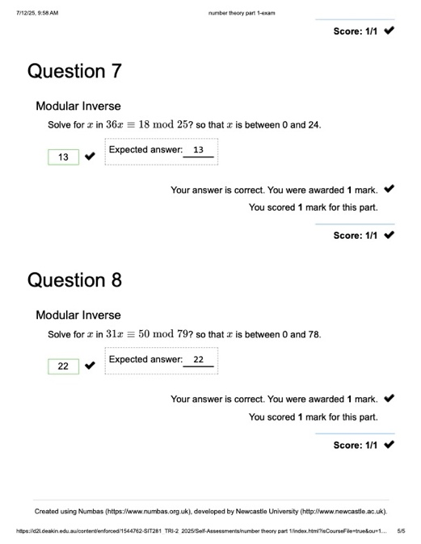

Solution to Numbas exercise 1
…

Solution to Numbas exercise n

