Task 2.2P
I extracted the linked resource file from Cloud Deakin.
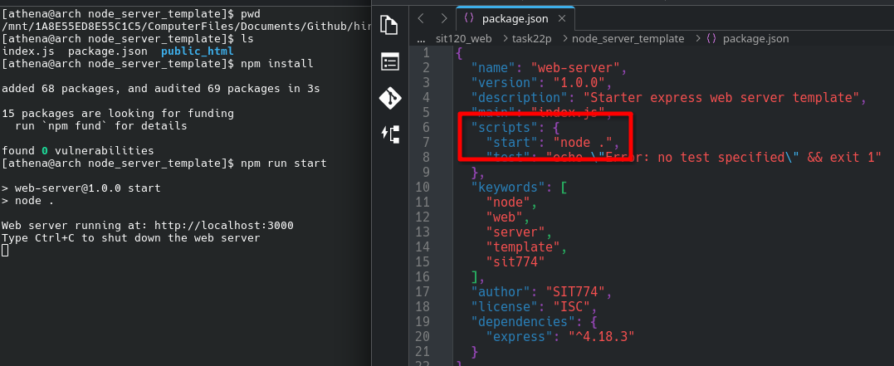
As seen in the package.json file, the main file is set to index.js (which has the expressjs code).
"main": "index.js"
Therefore, running `node .` would just run that file and an equivalent command to that would be `node index.js`. However, the script “start” has been set to `node .` as seen in the screenshot above. Therefore, we can just run it following the standard way by running `npm run start`, which would just run that command.
It’s just a simple Express JS app that serves the contents inside of the `public_html` directory as static files.
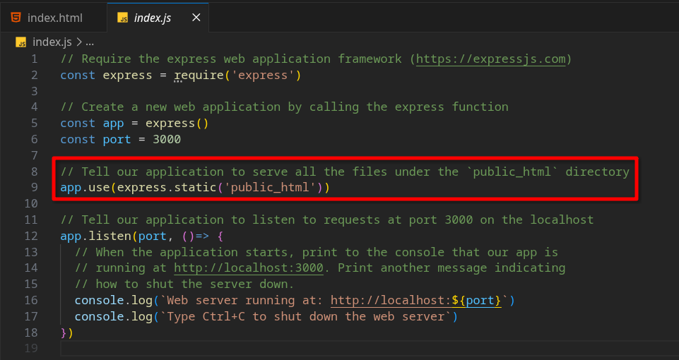
My submission contains a vanilla HTML document, and was written using the assistance of emmet abbreviations in VS Code to make my life easier. I added line breaks (even though it might not really be required) to keep my solution as identical as I can to the screenshot mentioned in the task sheet.
A screenshot of my page can be found in the next page —>

