Task 4.1P
I commented those lines as instructed.
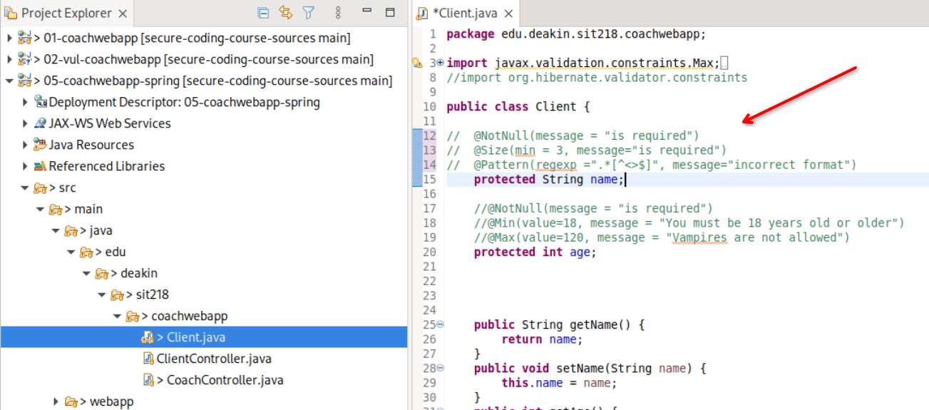
Then I started the web server.
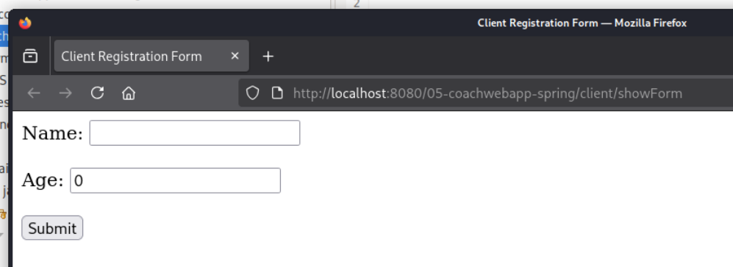

I then set the characters list up.
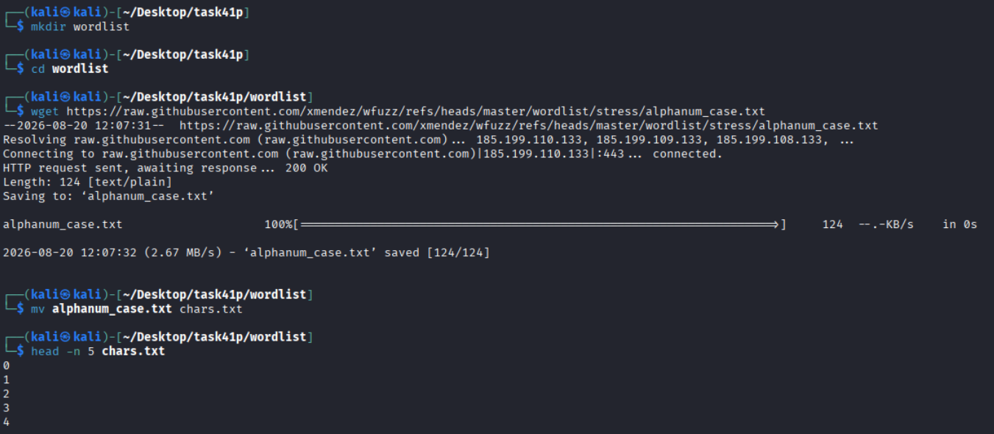
I then fuzzed the name. All characters here returns a 200 (accepted) because `name` has no validation mechanisms in place.
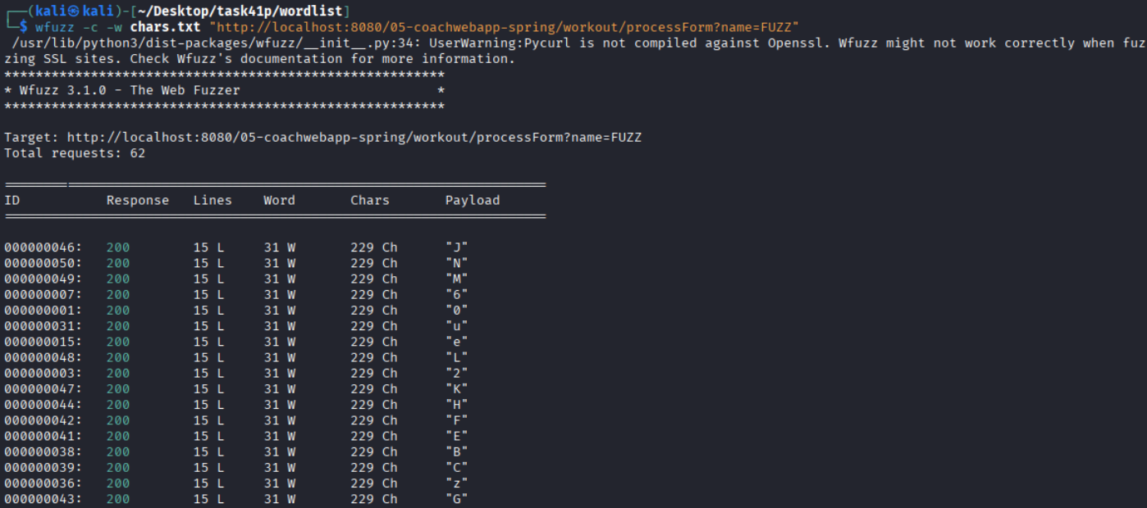
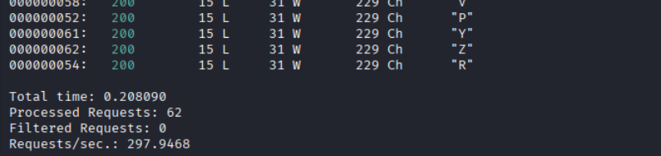

I then fuzzed the age.
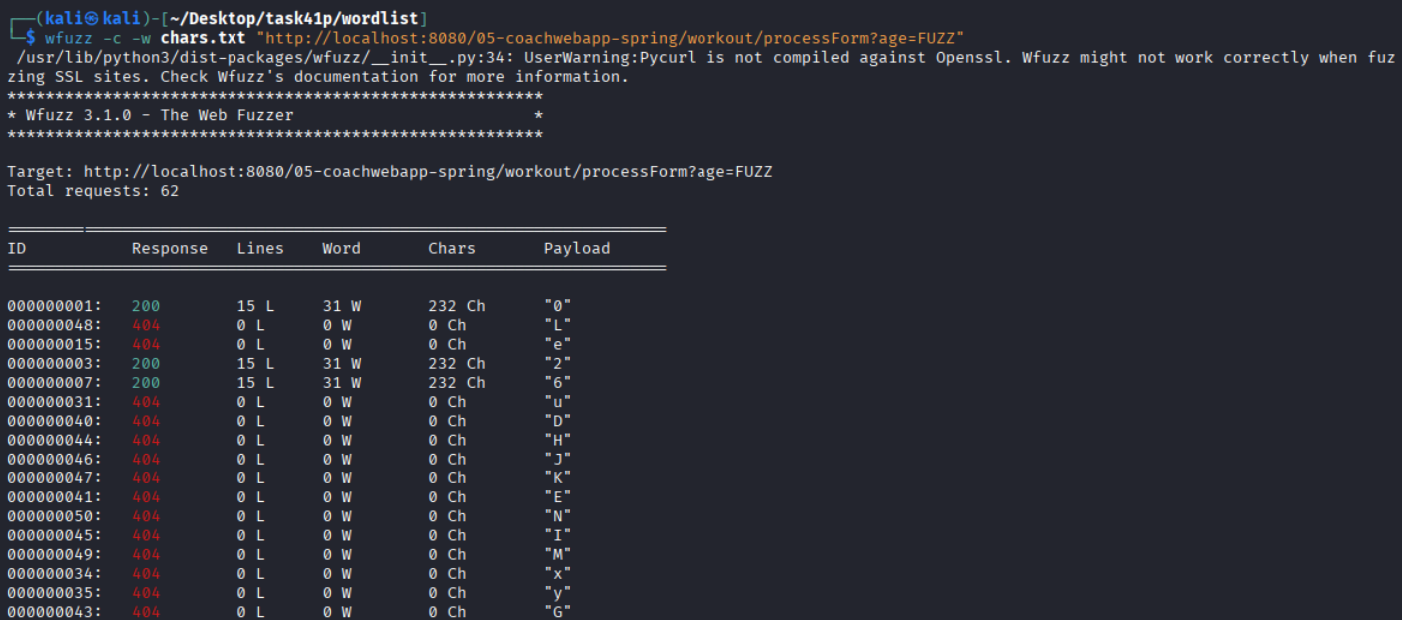
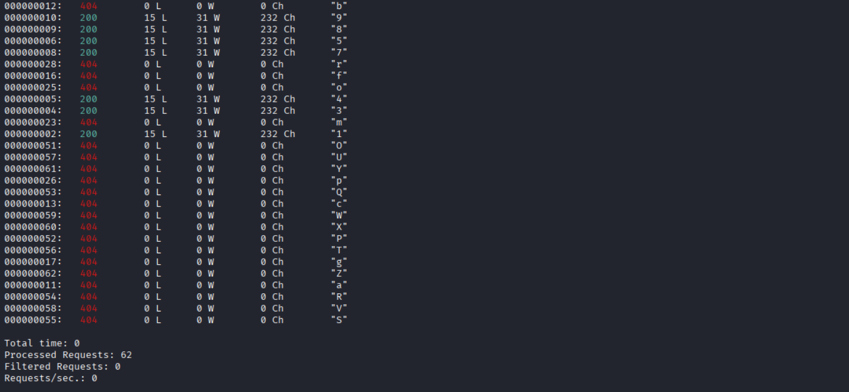
In the notes, it returns a status code of 500. However, when I tested it out, it returned a status code of 404 for alphabetical characters and returns 200s only for numeric characters. This could be because Tomcat sometimes falls back into 404 instead of showing the actual code like 500. However, the program’s validation still works as expected with no sensitive information reveal.

Below is a screenshot of the error that I received from the console. This is the full traceback.
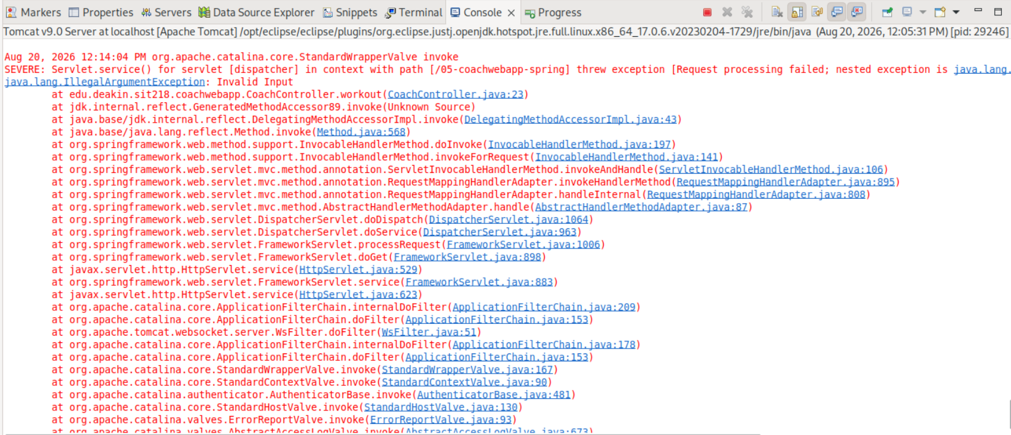
The IllegalArgumentException does make sense here as we store the age in an `int` datatype and it cannot store alphabetical characters.
I then made a file with all the bad characters as instructed.
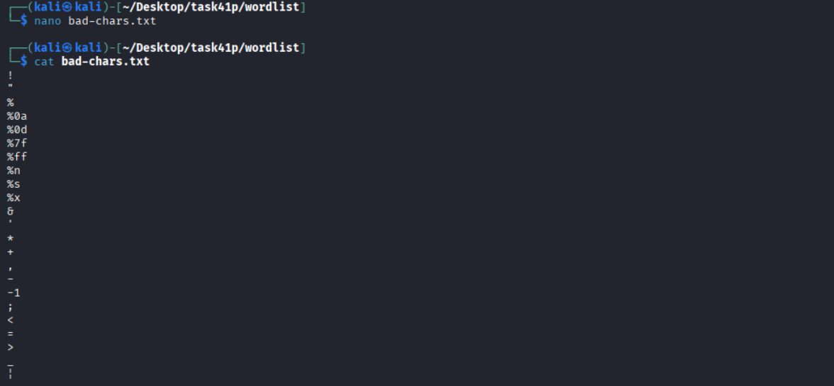

Using this file, I fuzzed the name and age again.
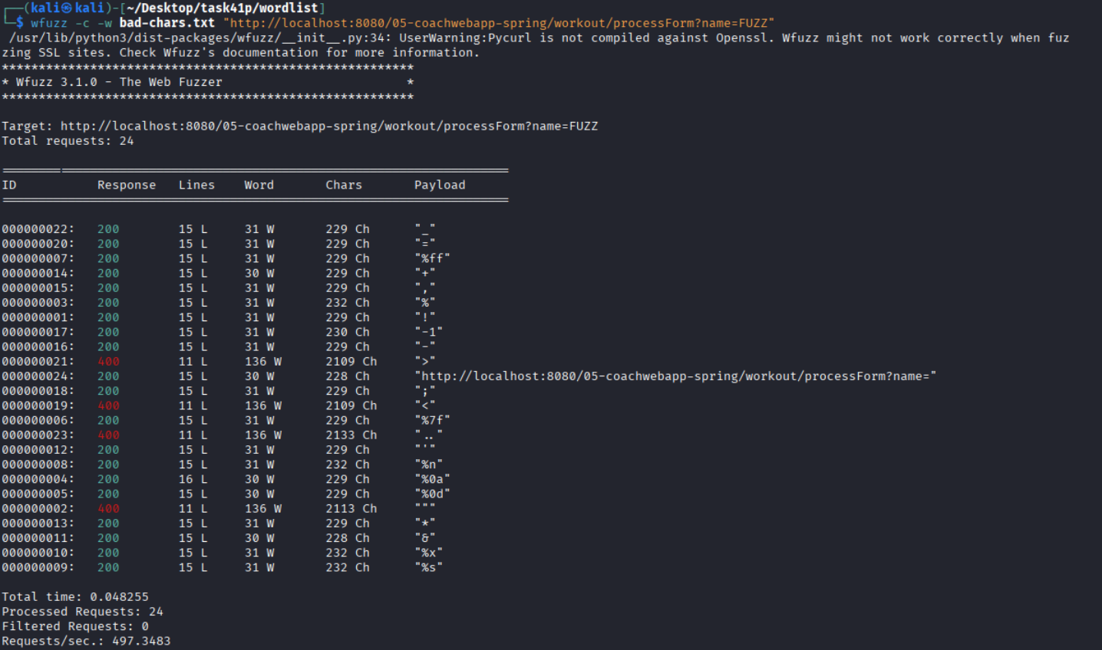
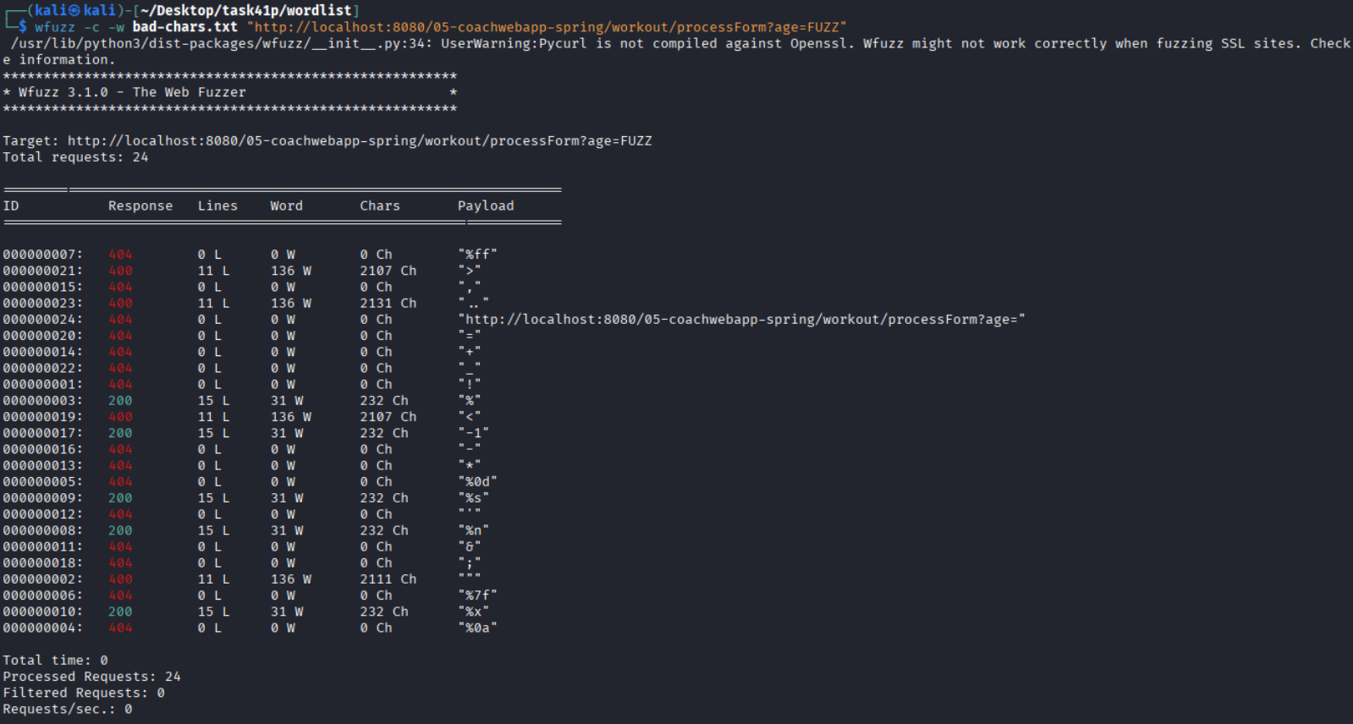
For the name field, most of the payloads are returning 200 because there is no proper validation added in Client.java yet. Some characters like <, >, .., and "" are returning 400, but this is mainly because Tomcat blocks them at the HTTP level before the request even reaches the application.Most non numeric values for age return 404 because the age is stored as an int, which cannot store letters or other non-numeric characters. Normal numeric values are working fine and returning 200.
I then added some basic validation and ensured that the development server was also updated accordingly.
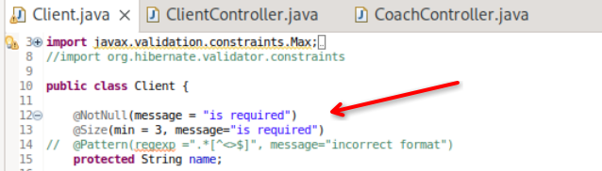
I then created the common wordlist and fuzzed the name with it.
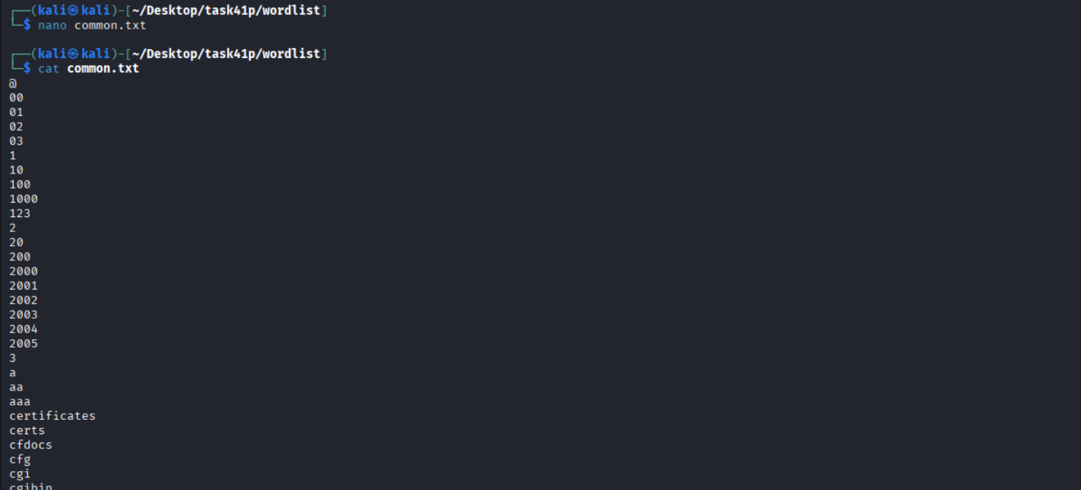
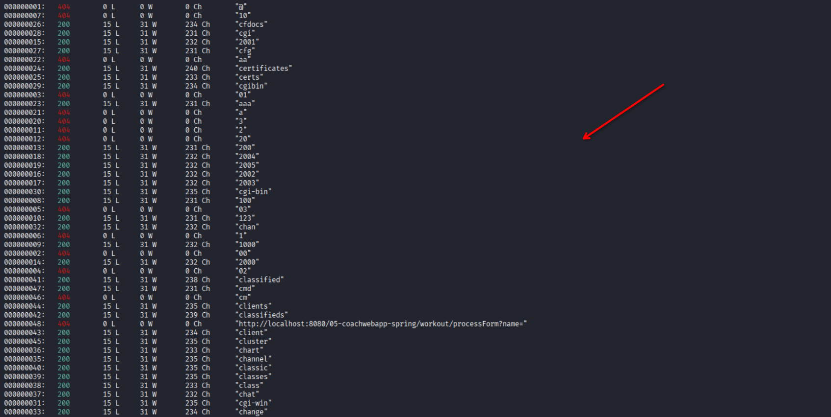
Just as expected, I can see the values with less than 3 characters being rejected from here.
I then tested the simple XSS payload.
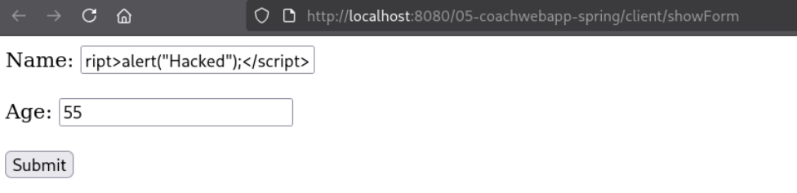
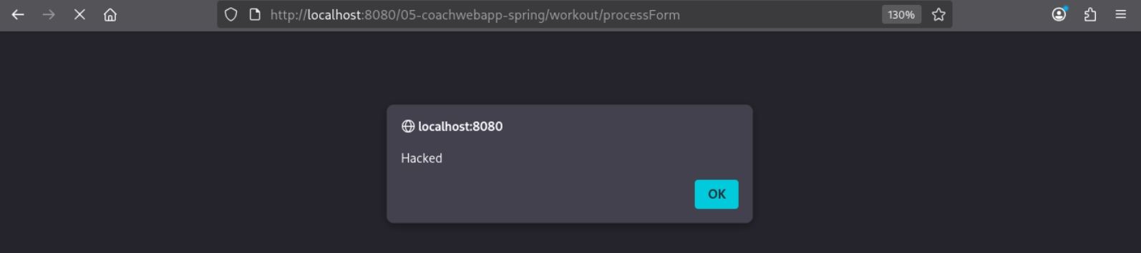
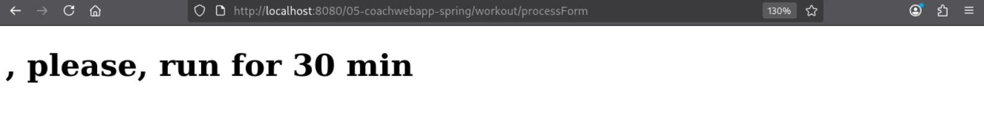
I updated the code as instructed. The `@Pattern` blocks values ending with `<`, `>`, or `$`. If the validation fails, the form is shown again with an error message instead of crashing with a `500` error.
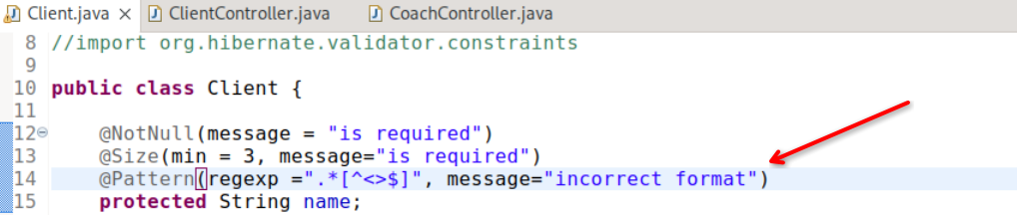
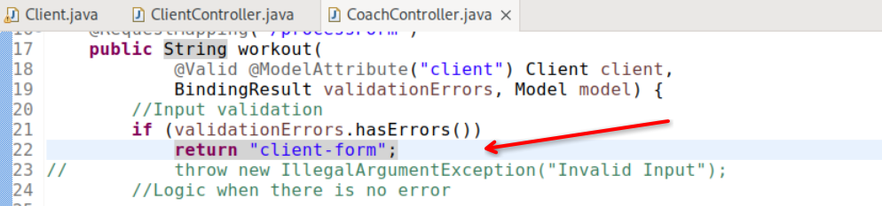

I then tested it with a value that I know will be accepted to ensure it works.
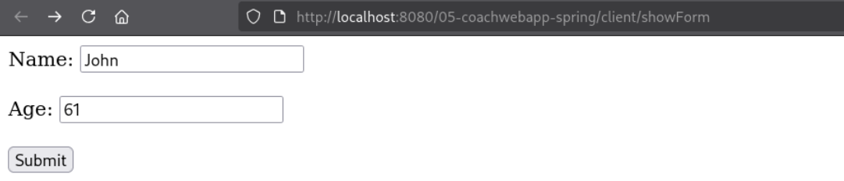
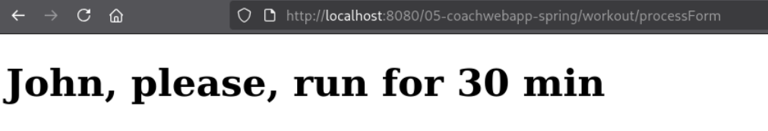
Next, I tested the initial payload and it failed as intended.
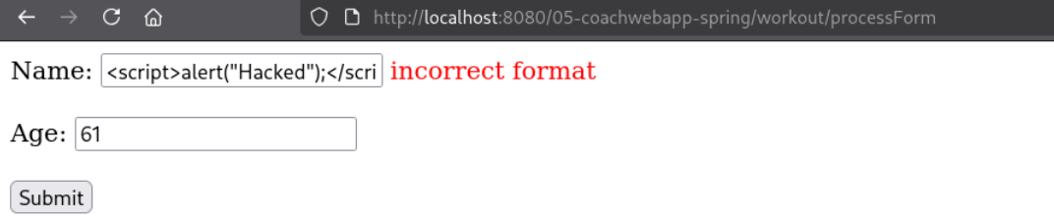
Then, I tried the first given payload.
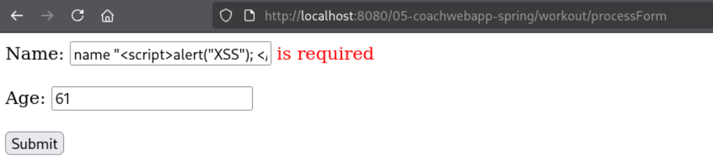
And it worked as intended.
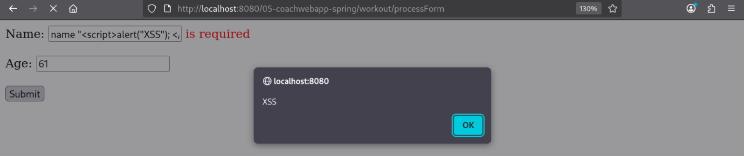

I then tested the second given payload.
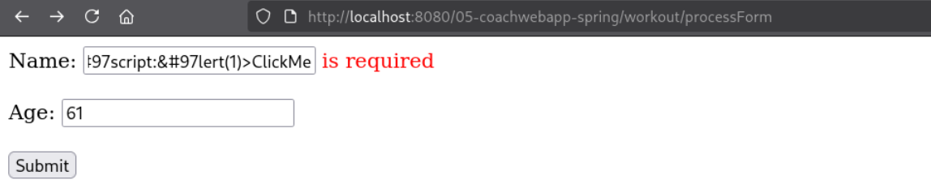
That worked too. This text is displayed and it’s a hyperlink (`<a>`).

When it’s pressed, the contents of the href’s script section will run.
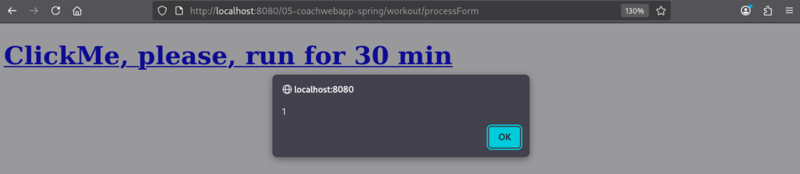
I then tested the third given payload.
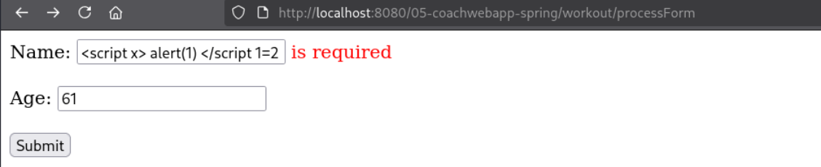
That worked too.
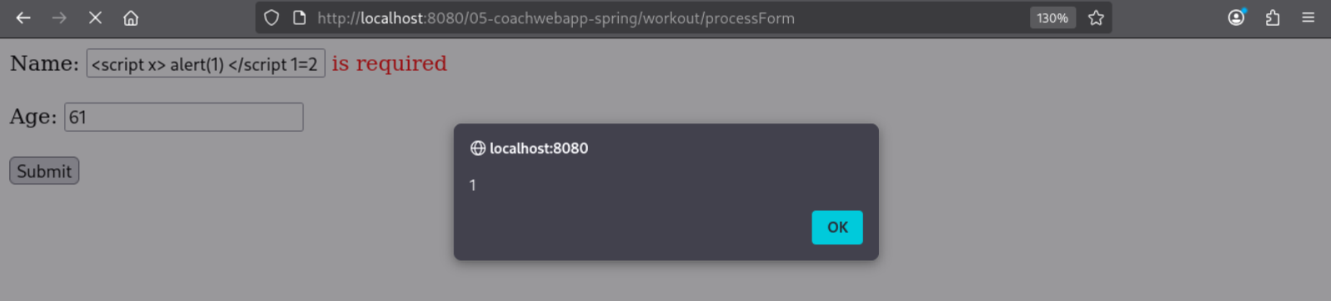

The regex allows any characters, but checks that the final character is not <, >, or $. This means it only validates the end of the input – not the full string.
Payload 1: name "<script>alert("XSS"); </script>"
This works because the input ends with a quote instead of >, so the regex allows it even though there is still a <script> tag inside.
Payload 2: <a ... href=j&#97v&#97script:&#97lert(1)>ClickMe
This uses encoded characters to hide javascript:alert(1). The browser decodes it, but the regex does not properly detect it.
Payload 3: <script x> alert(1) </script 1=2
This ends with 2, so the regex allows it. The script tag is still inside the input, showing that only checking the last character is not enough.

f) Identify the type of validations that you performed in the 05-coachwebapp, (i.e. whitelisting or blacklisting?)
The validation technique used here is blacklisting. This is because it tries to block certain characters like <, >, and $. The problem is that attackers can still bypass it by changing or encoding the input.
A better option here is whitelisting because then only allowed characters are accepted. For example, letters and spaces. This is safer because anything outside the allowed pattern is rejected.

