Task 4.2C
I updated the flavor.
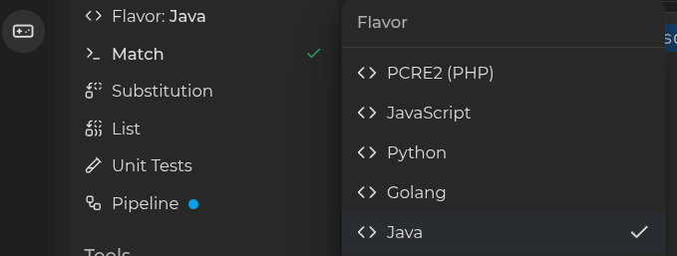
Regex: .*[^<>]
Only checks the last character, so it can be bypassed if the payload does not end with < or >.
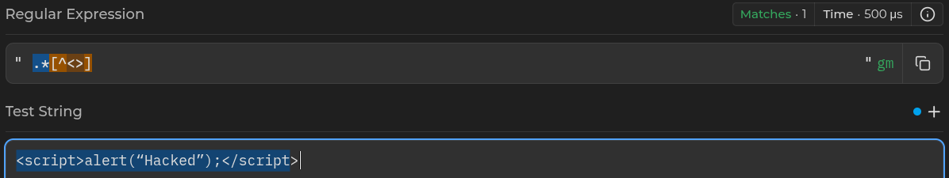
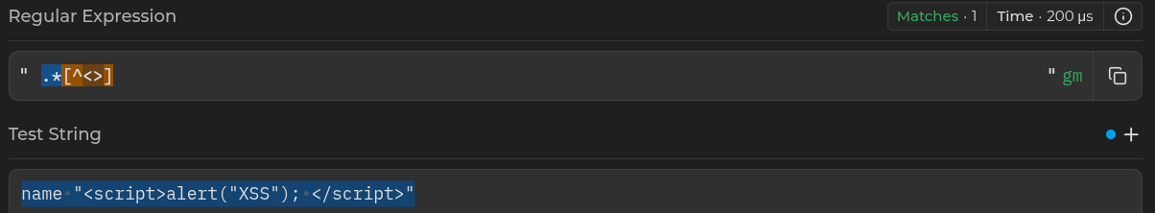
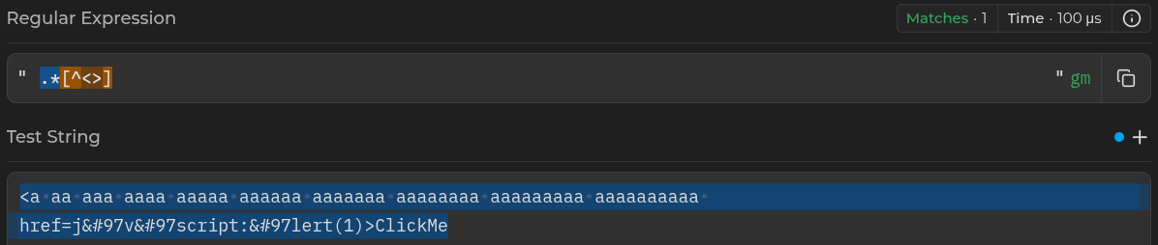
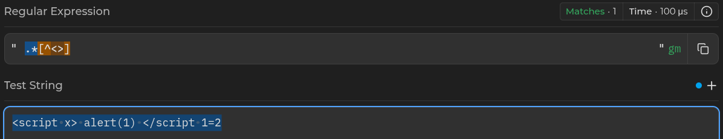

Regex: [^<>].*
Only checks the first character, so it can be bypassed if the payload does not start with < or >.
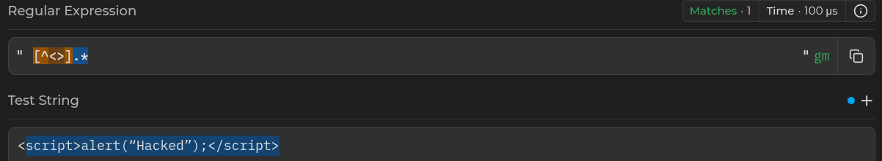
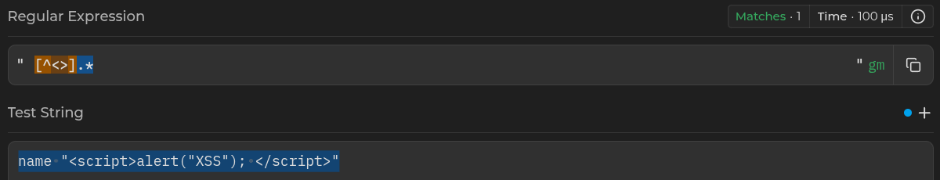
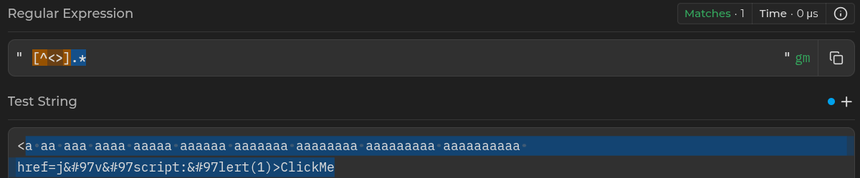
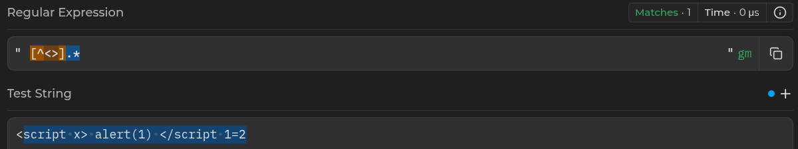

Regex: [^<>]+
Checks the whole input and blocks it if < or > appears anywhere.
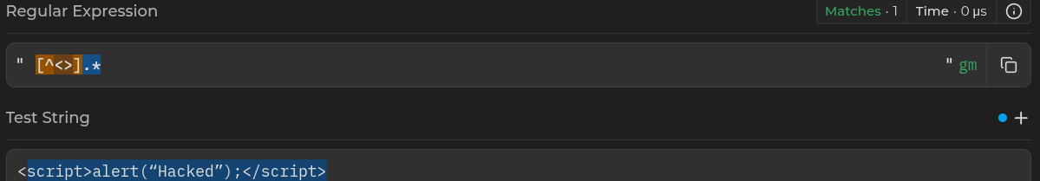
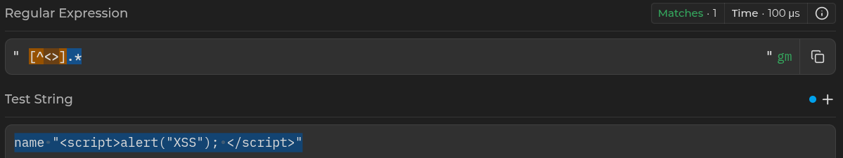
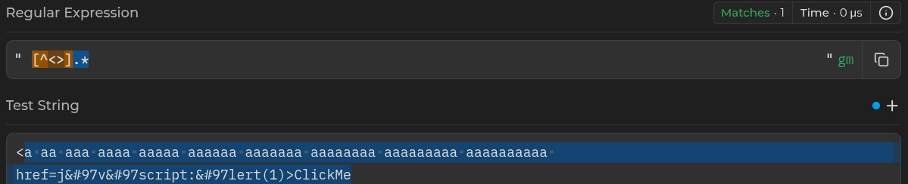
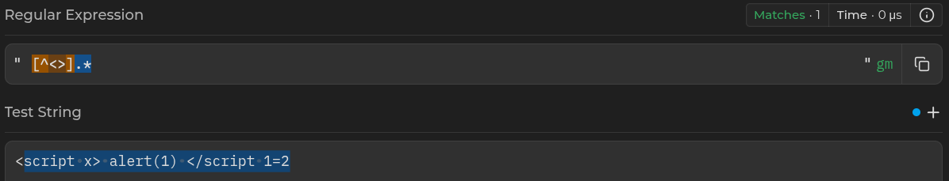

Regex: [a-zA-Z]+
Only allows letters, so anything else is rejected. This is a whitelist approach.
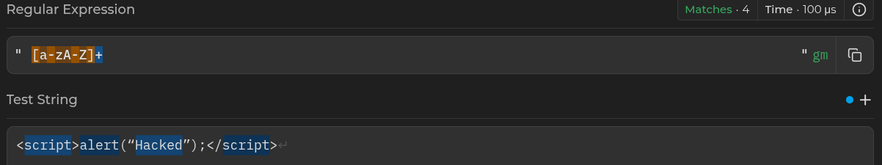
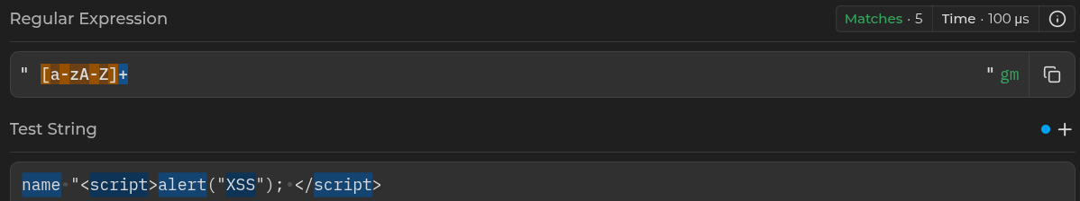
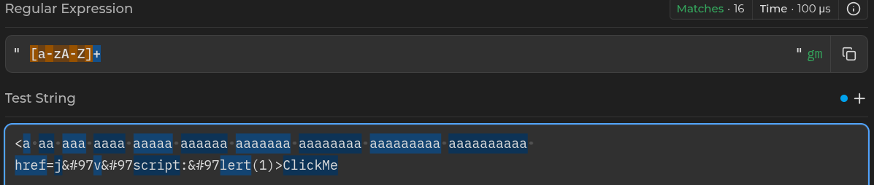
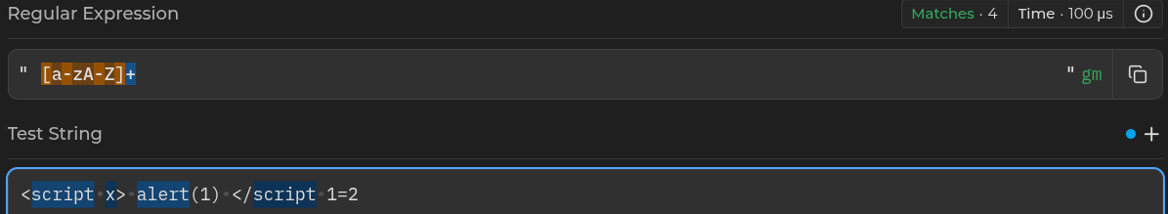
Therefore, this is the answer and this is what we will use for the rest of this task: [a-zA-Z]+ I updated the source code as necessary.
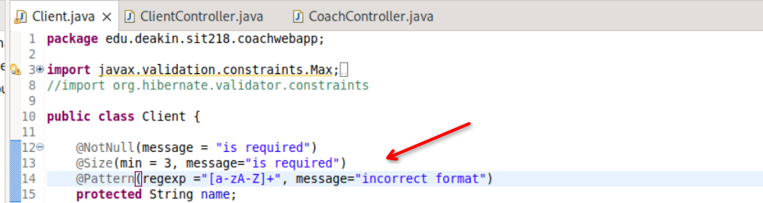
I ran the program with sample values:
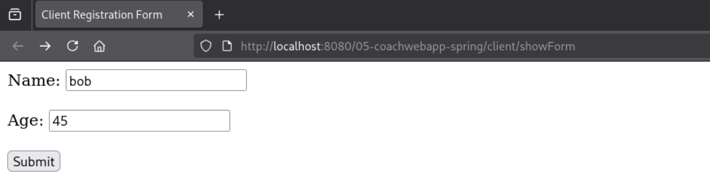
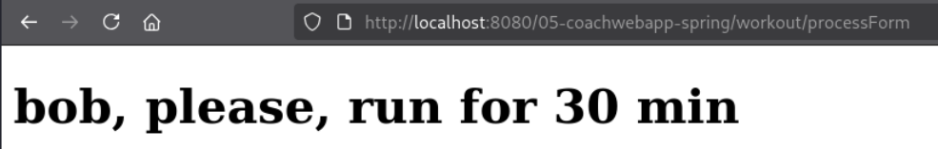
But testing with the sample XSS payloads fail as intended.
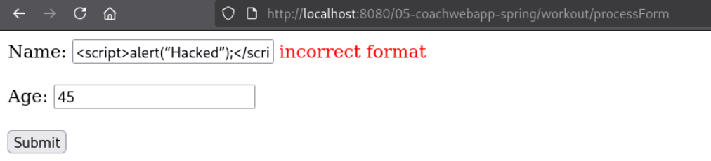
Next, I tested out the other payloads as well.
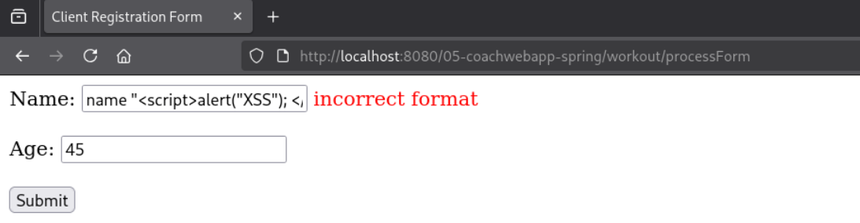
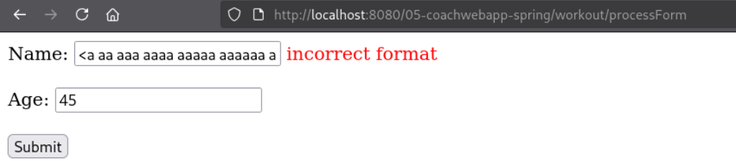
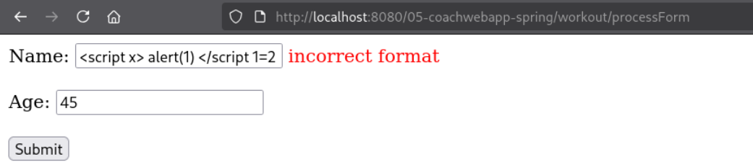

However, another thing to note is that this regex will also reject legitimate names that has spaces, or apostrophes like O’Brien.
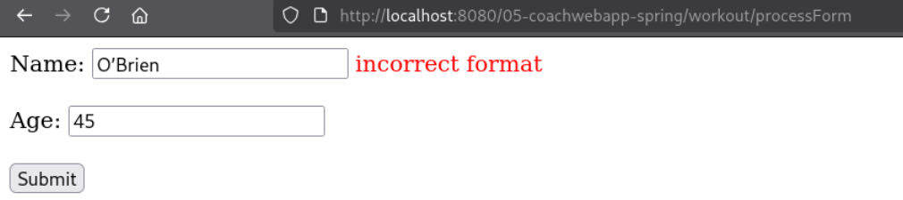
I would slightly modify the regular expression to also allow spaces, dashes and apostrophes.
[a-zA-Z\s'-]+
This would still exclude other dangerous characters like <. >, $, etc...

