Task 2.2P

I first set up the virtual machine.
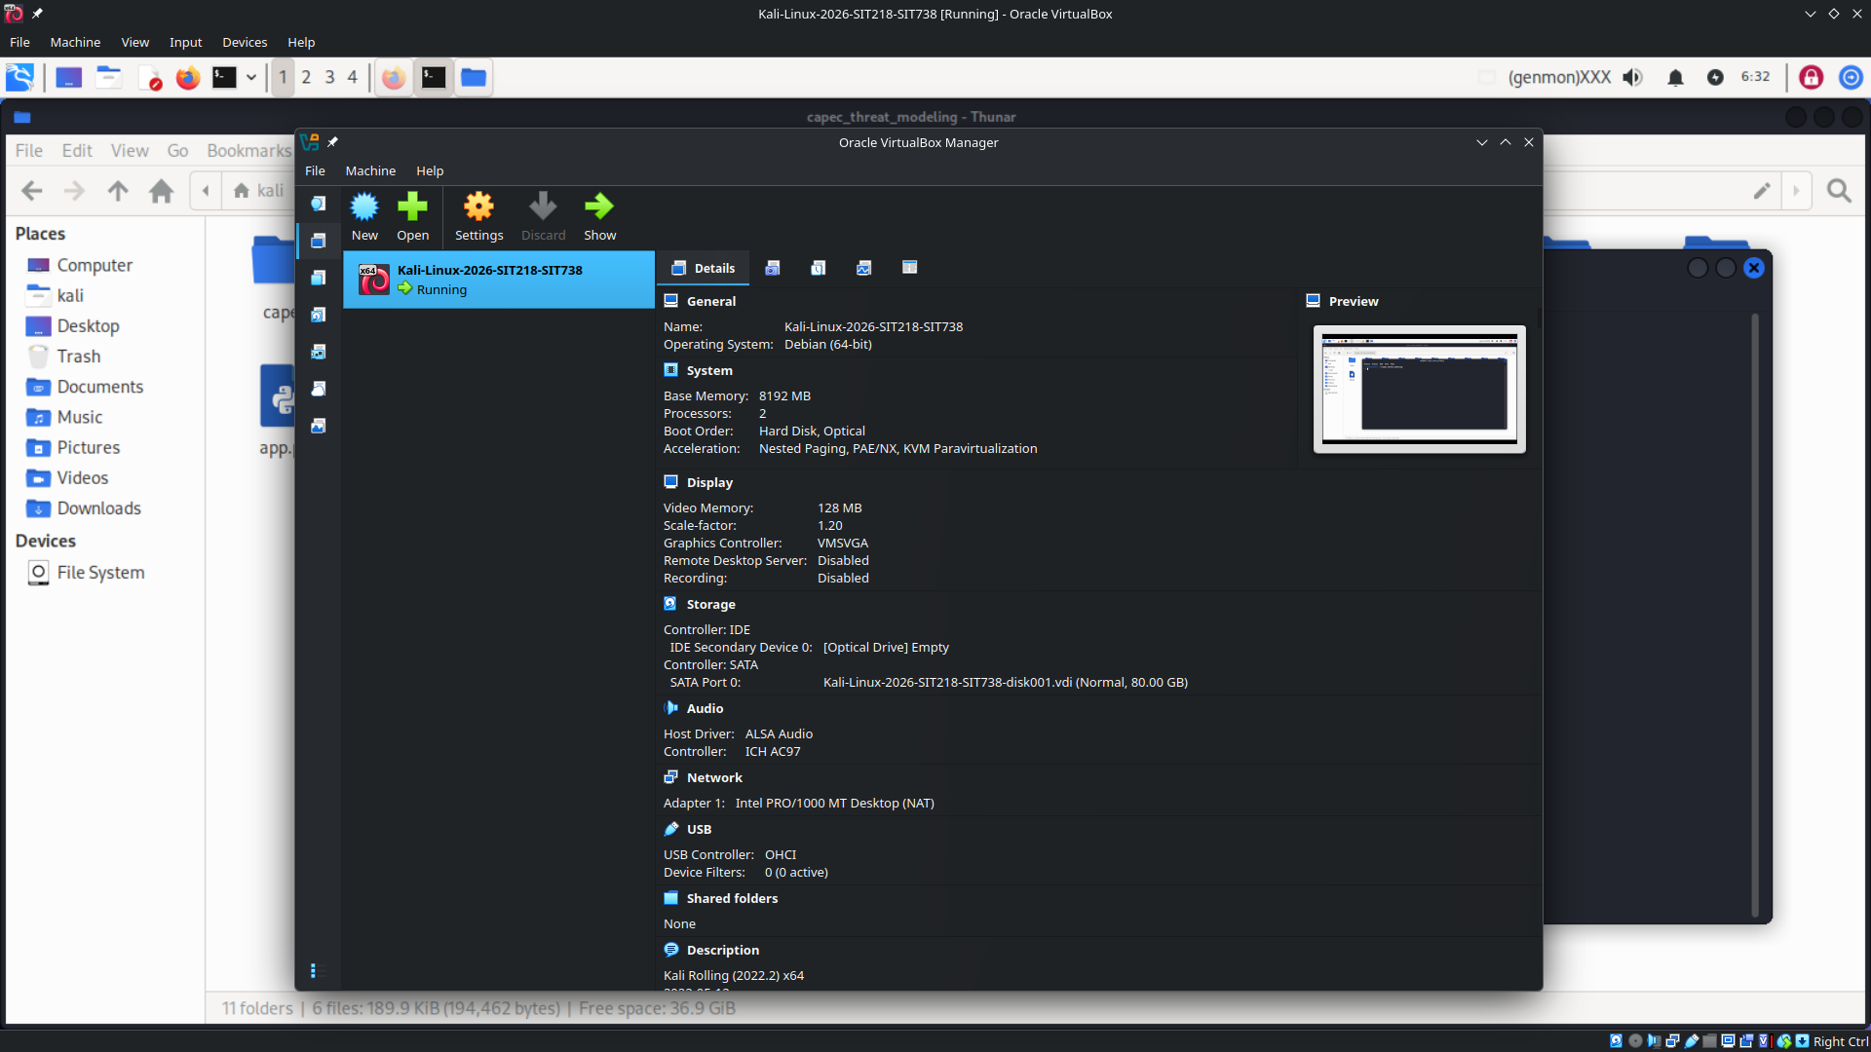

I then started the web server:
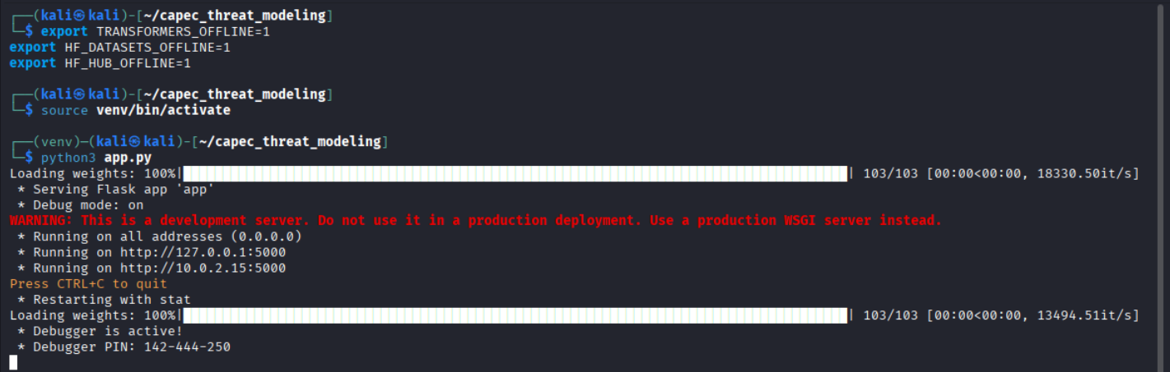

Then, I copied the initial description from Task 2.1P’s task sheet and pressed decompose system, and followed the rest of the instructions.
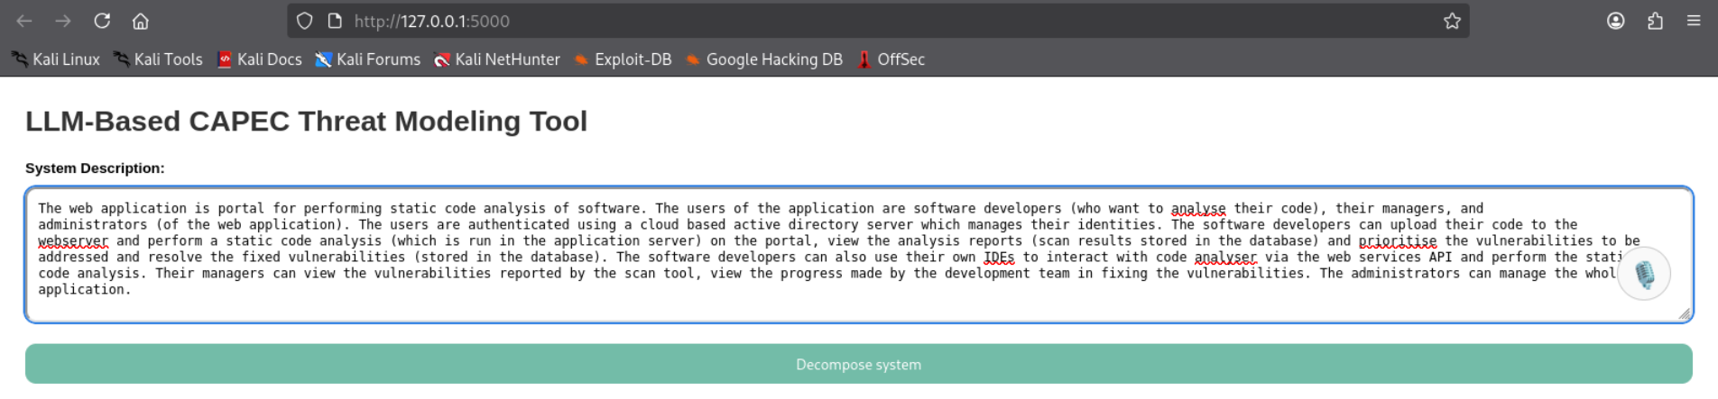
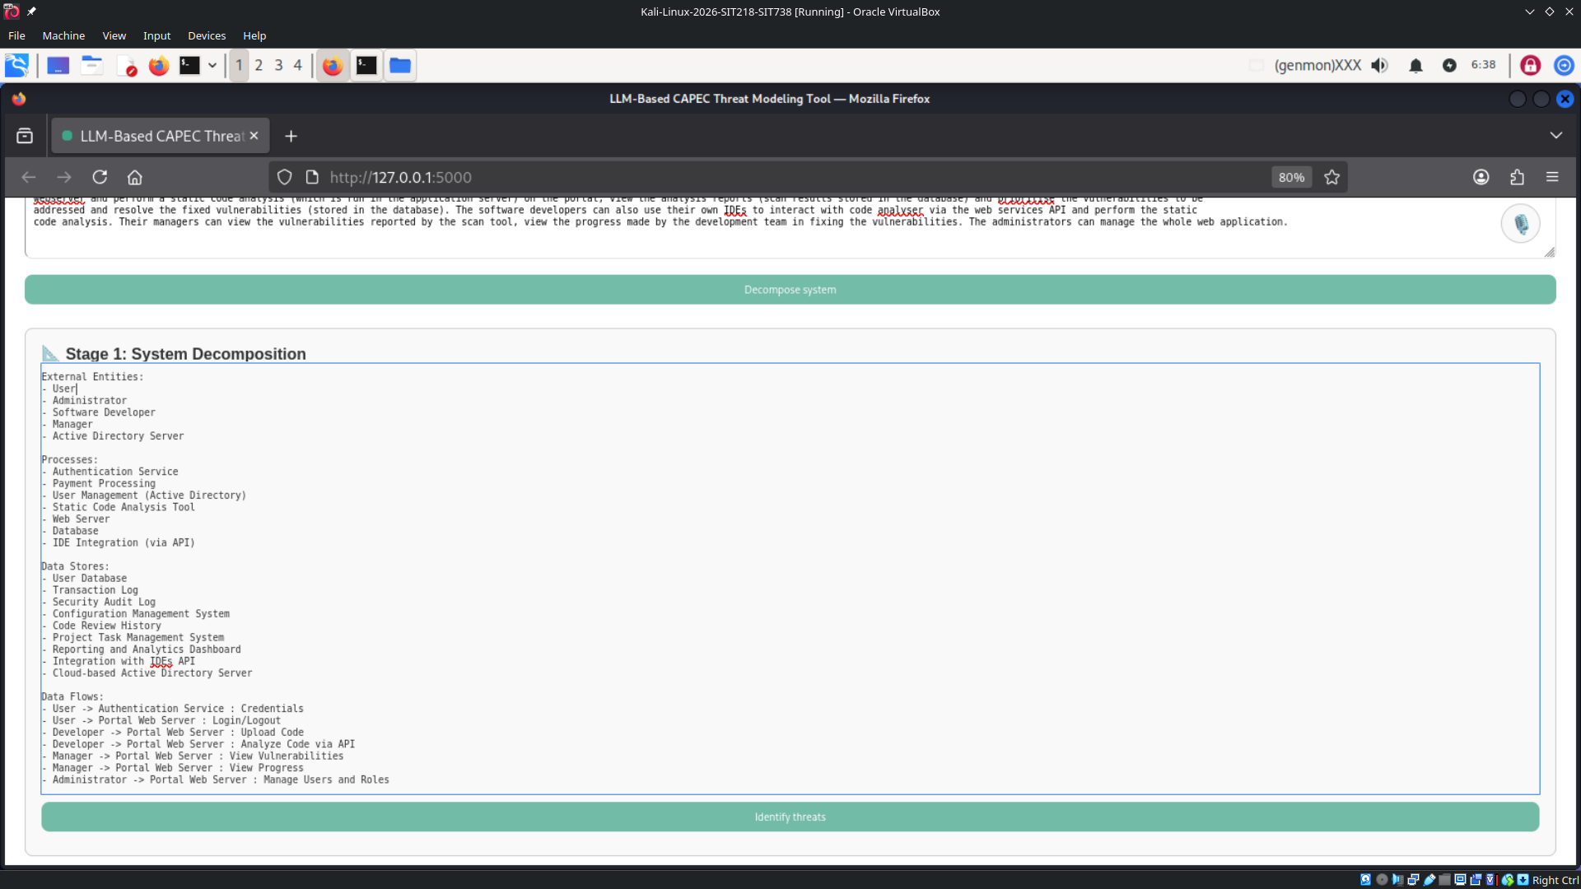
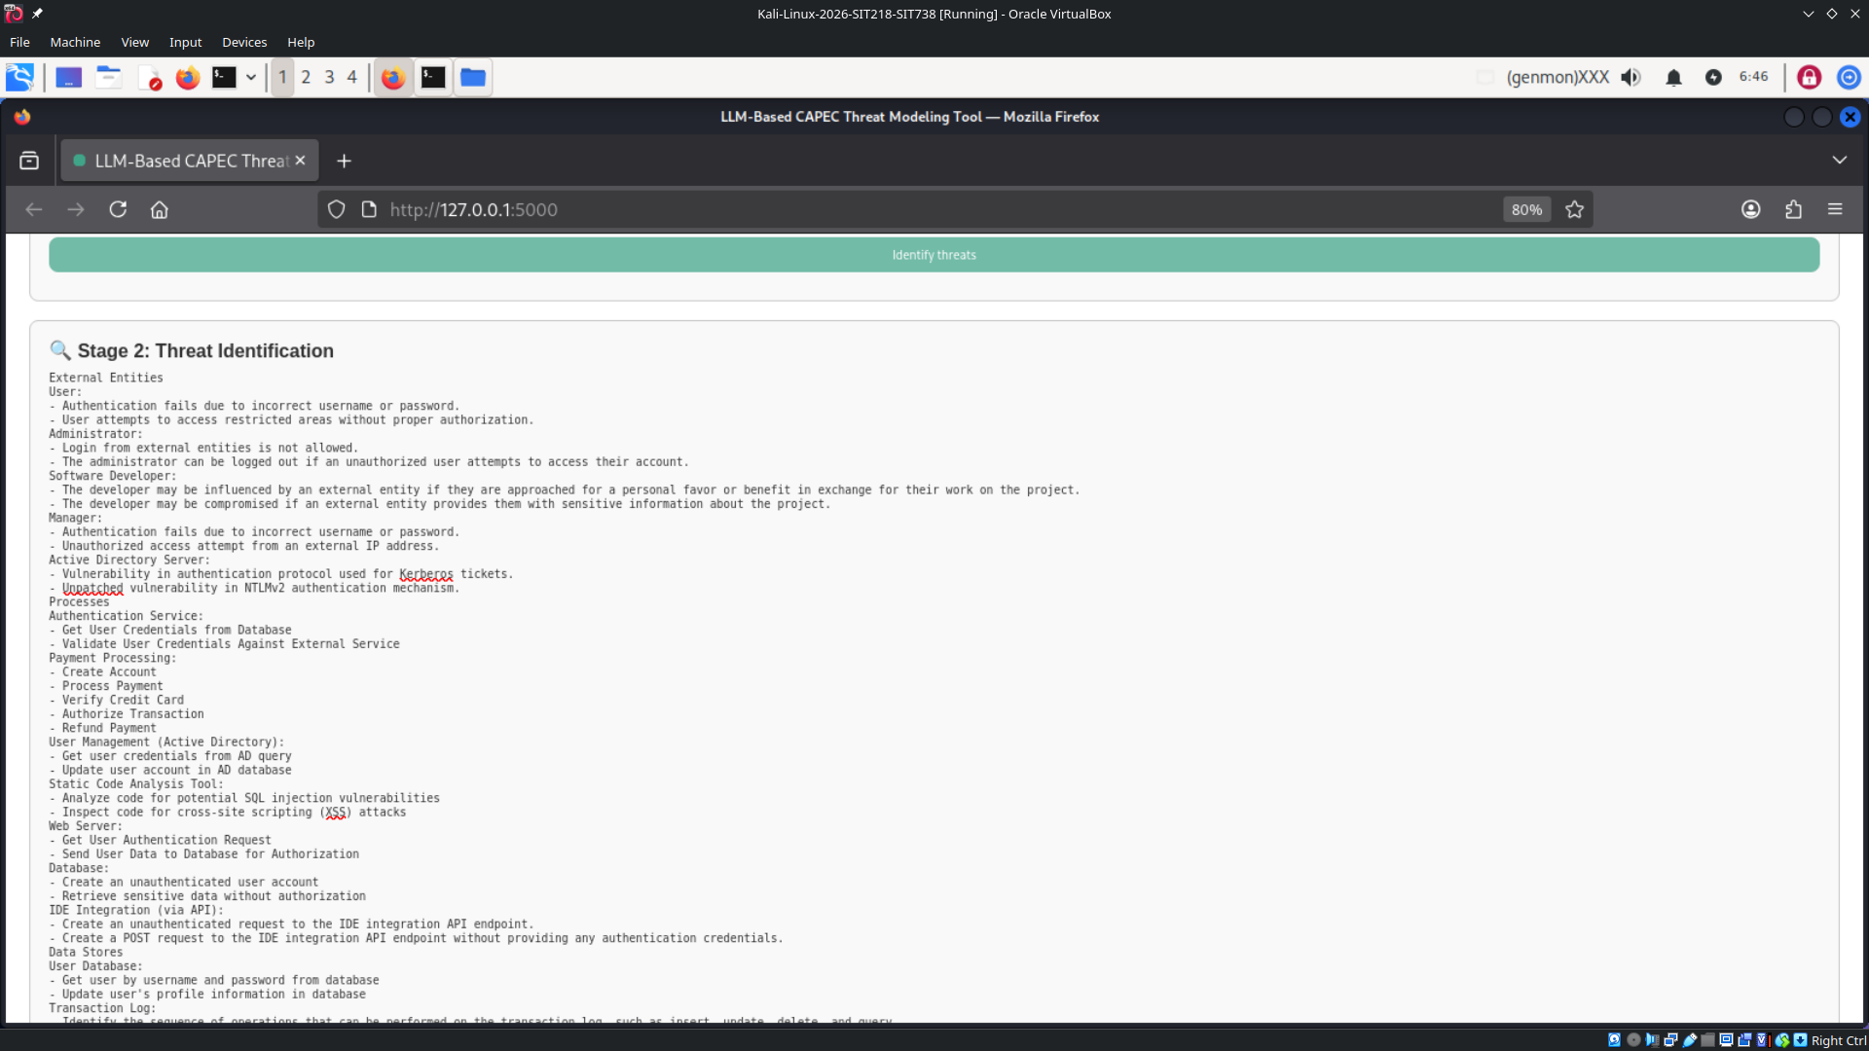
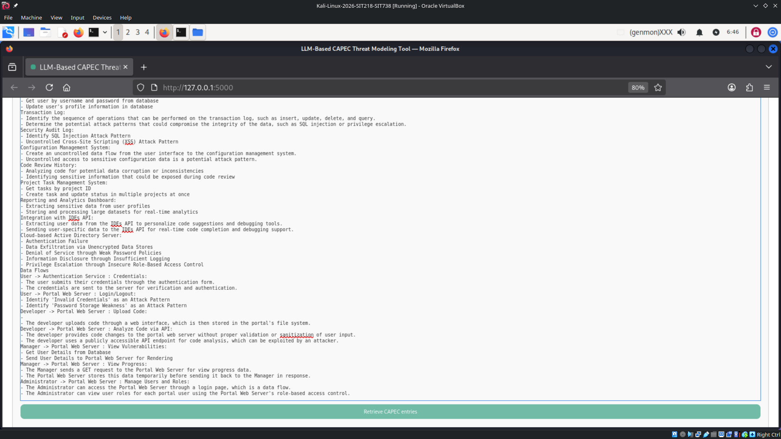

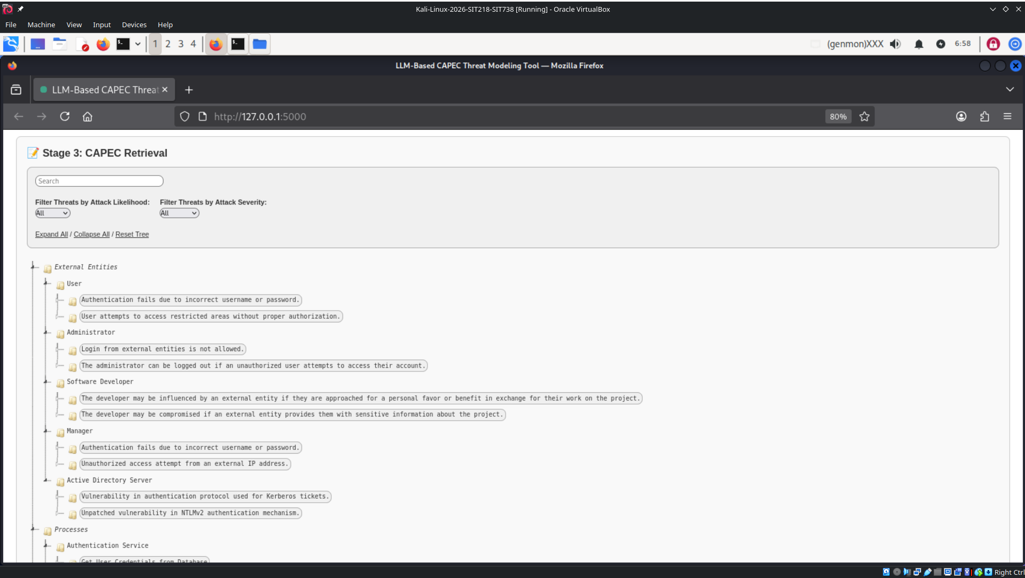
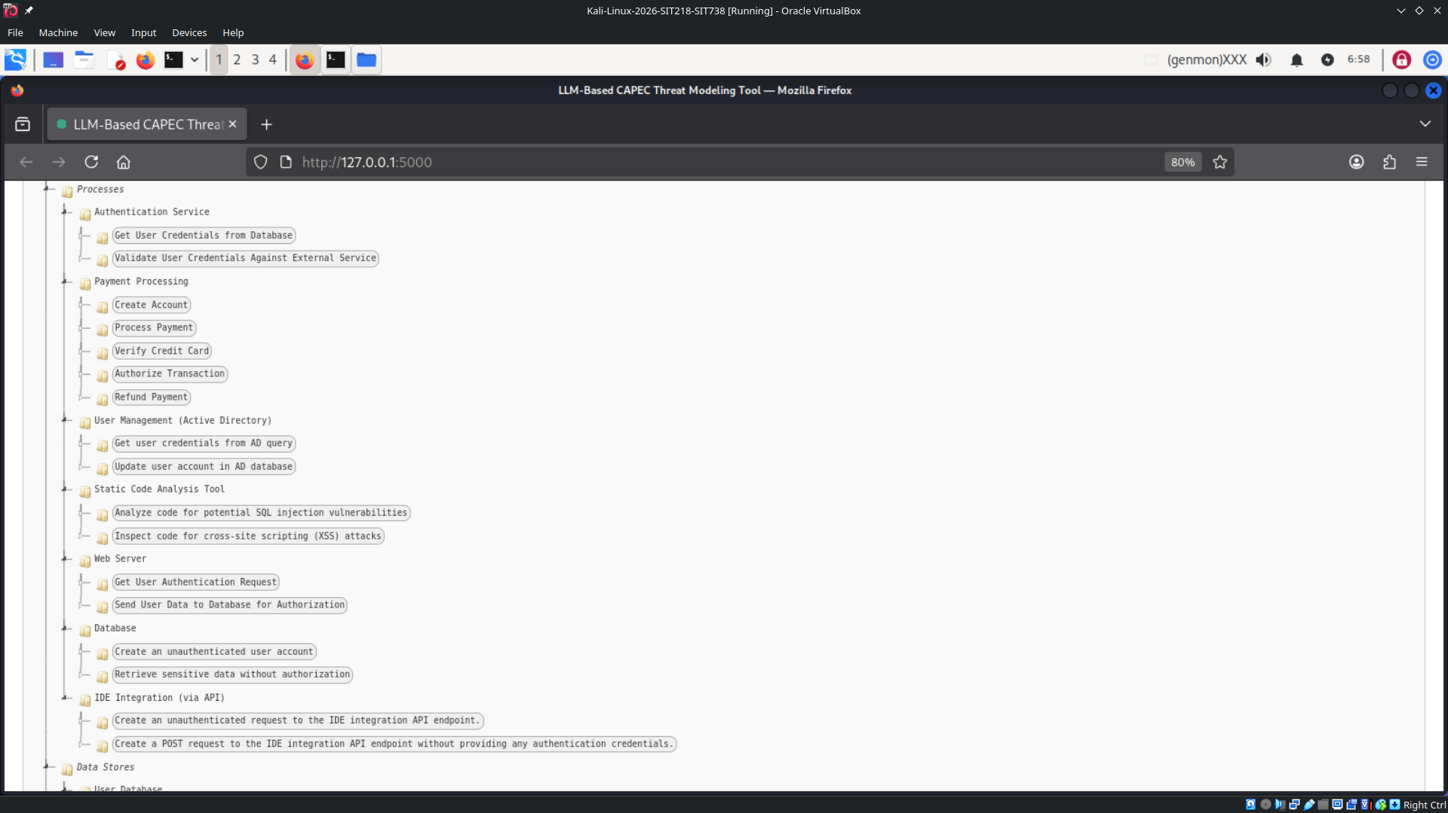

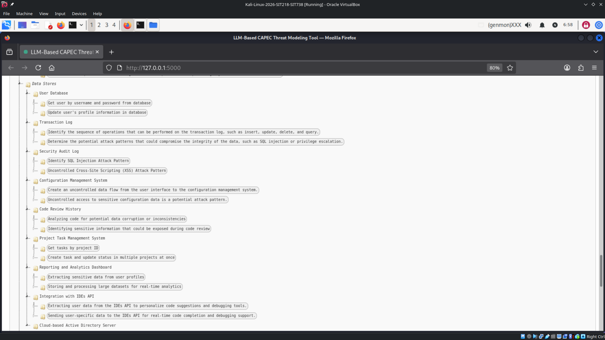
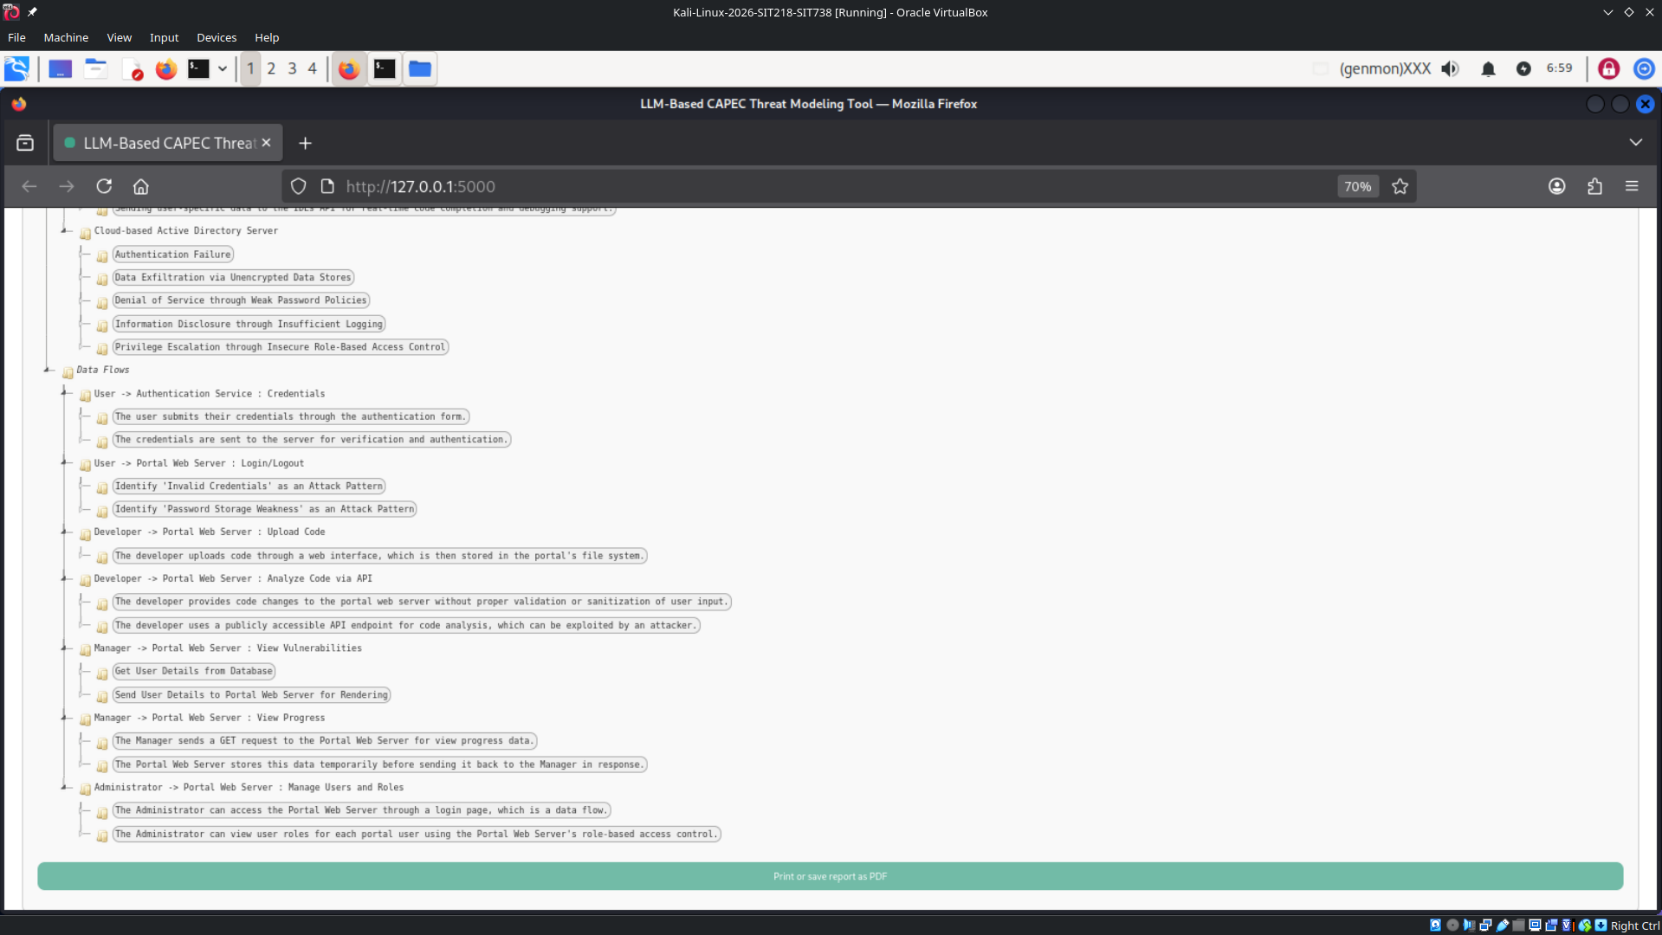

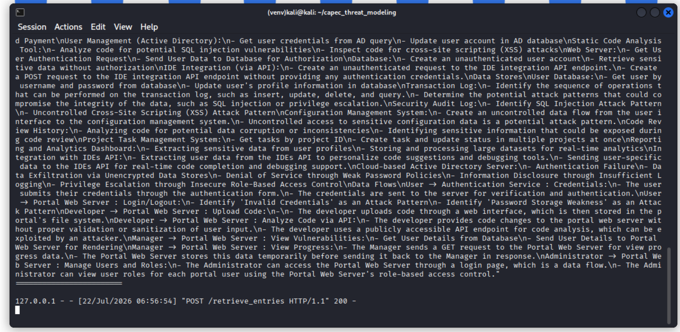

Once you are done playing around, you can press CTRL+C to exit out of the flask web server and then run the `deactivate` command to exit out of the activated python virtual environment named venv.
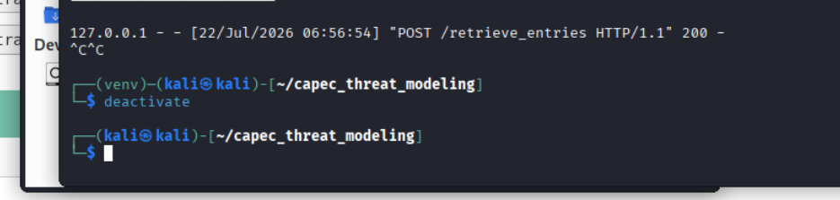

Video Demonstration: https://youtu.be/Qb3PtWuJxrw

