Task 2.2P

Subtask 1
Accessing localhost:8080/ shows this (from webapps/ROOT/index.jsp)
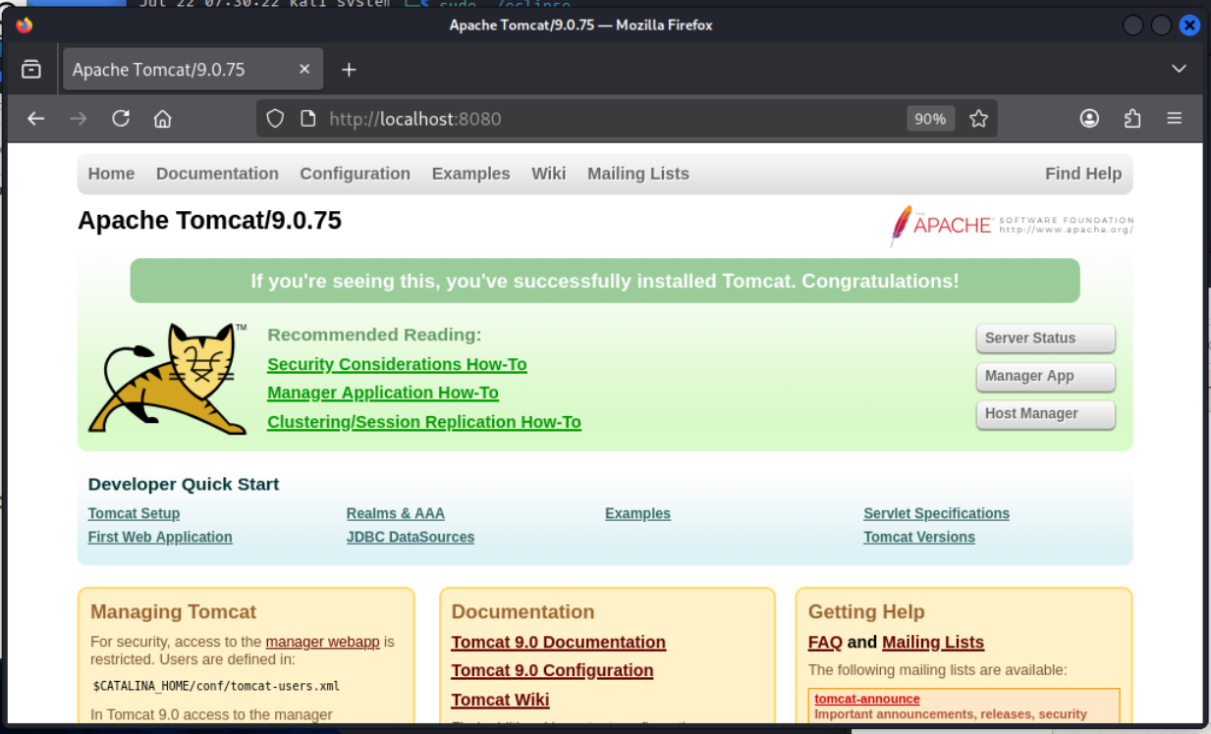
Opened this “ROOT” directory in Thunar as root.
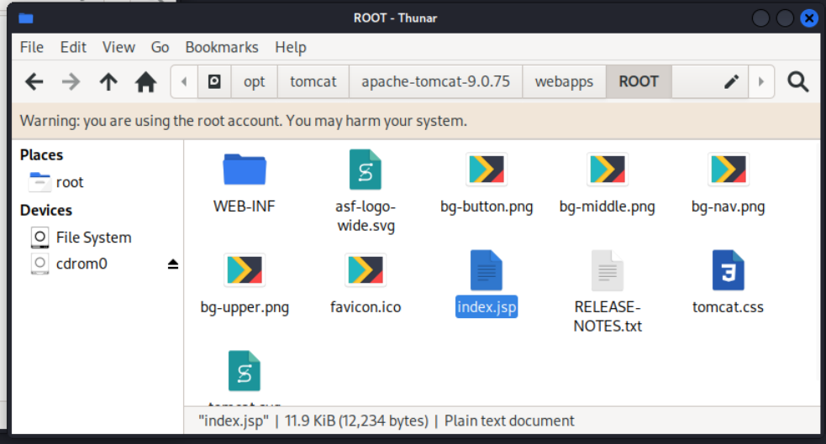

I then renamed that index.jsp file to manage-tomcat.jsp.
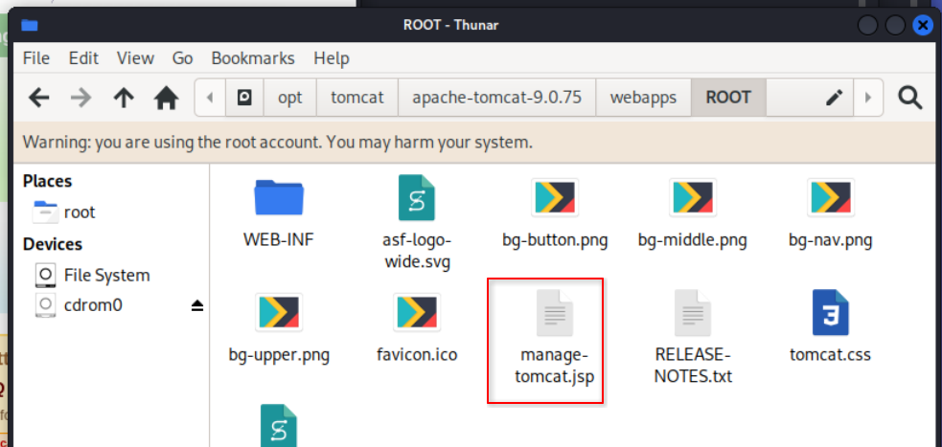
When you now access /, it returns a 404 error.
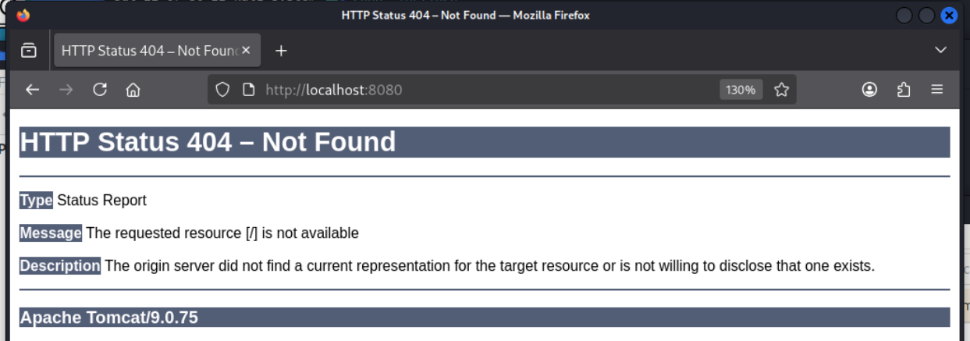
The manage page can be accessed at /tomcat-manage.jsp.
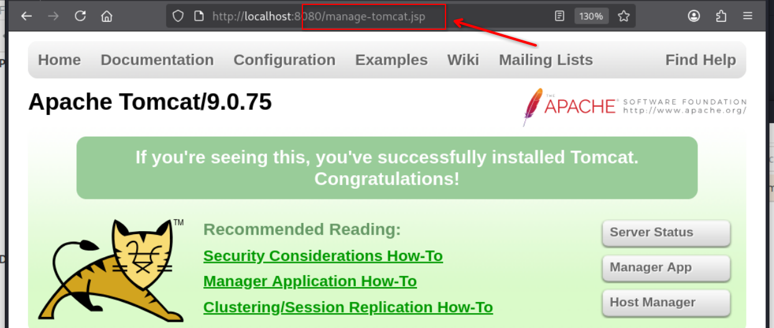

Subtask 2
I ran nmap on port “8080” (-p 8080) of host “localhost” and also scanned for service versions (-sV).
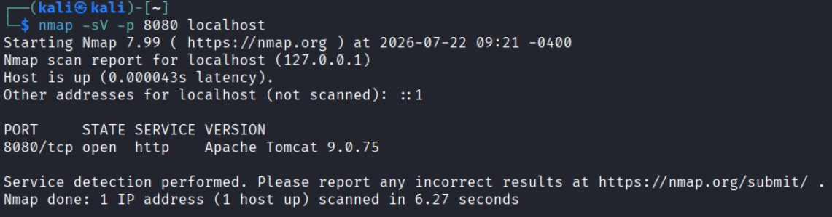

Subtask 3
I added the error.jsp file.
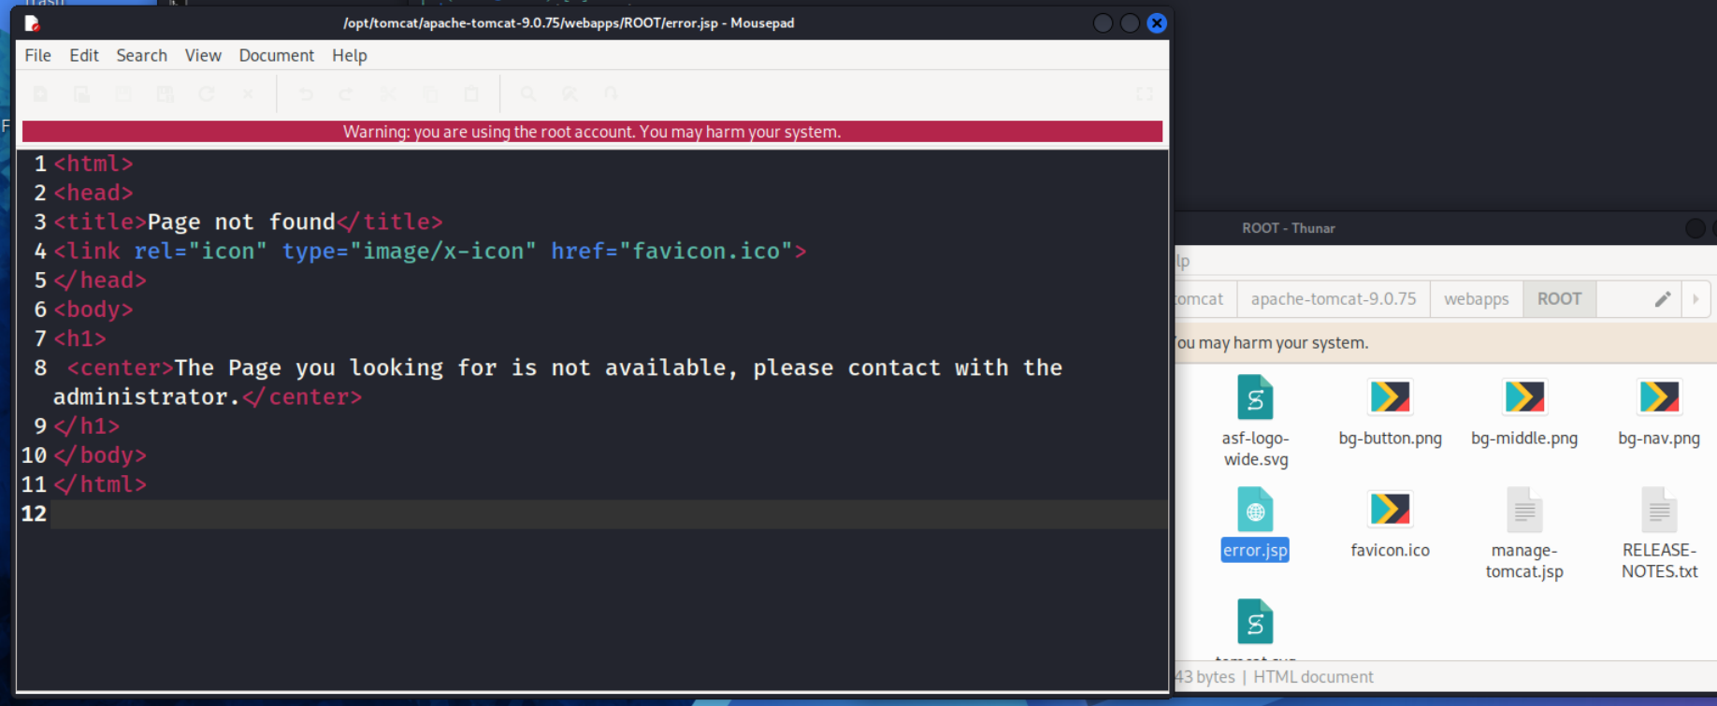

I then updated the conf/web.xml to return the error.jsp for apps when either a 404, 403 or a 500 error happens.
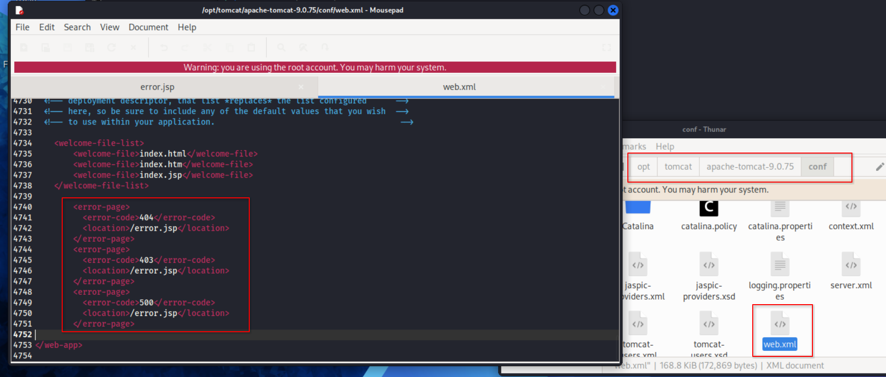
And then, finally, I restarted the service.
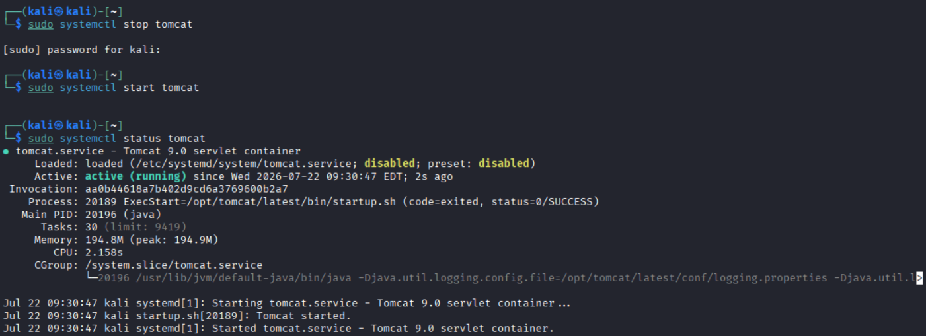

Subtask 4
Scanning with nmap again does not reveal the server information anymore.
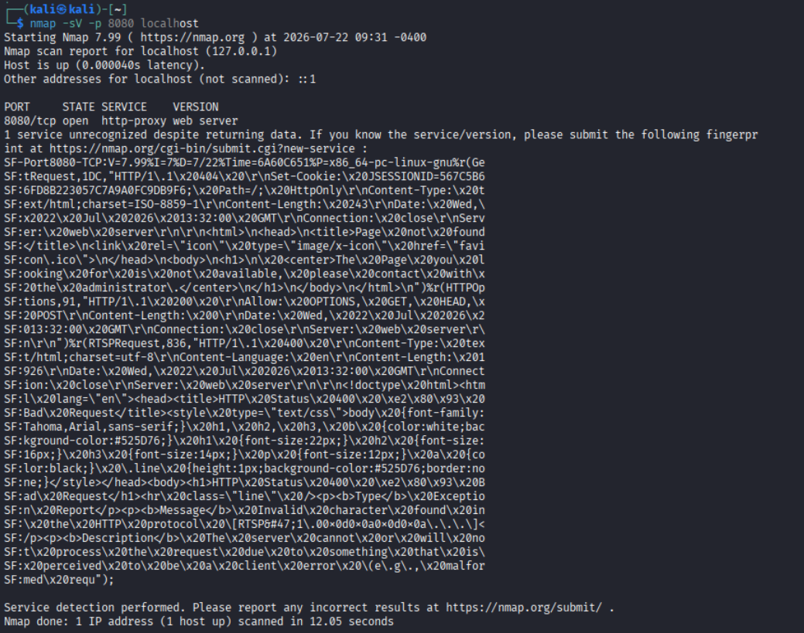
In subtask 1, nmap was able to detect server information very accurately but it couldn’t after the changes we made and attempted it again in subtask 4. This is because the default tomcat error page previously exposed information like the server name and version, which nmap waits to extract out of the response, while the custom error page that we wrote only returns a very generic response without any revealing details.
The –sV options in nmap works by sending probes to the open port and then comparing the returned responses with known patterns stored in nmap’s service detection database^{[1][2]}. The new response did not contain enough identifying information for nmap to extract the web server information. Eventhough, nmap was still able to detect that port 8080 was running an HTTP service, it could not identify the exact version of the web server in use. More information about this can be found in nmap’s official documentation about version detection^{[1][2]}.

References
[1] Nmap, “Service and Version Detection | Nmap Network Scanning.” Accessed: July 22, 2026. [Online]. Available: https://nmap.org/book/man-version-detection.html
[2] Nmap, “Technique Described | Nmap Network Scanning.” Accessed: July 22, 2026. [Online]. Available: https://nmap.org/book/vscan-technique.html

