Task 4.2P
I would personally increase this value from 0.1em to 1em to make the spacing identical to the task sheet. However, I kept this at 0.1 following the task sheet’s written instructions.
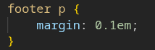
Below is a screenshot of what my page looks like.
