Evidence of successful completion of the activities and learning.

Exercise 3.2.1

Why do we need transport layer protocols?
We do need them as they allow process to process communication between applications running on different hosts. They handle things like multiplexing/demultiplexing using port numbers, and depending on the protocol, they can also provide reliability, flow control and congestion control (in TCP).

Can the Internet survive without transport layer protocols?
IP could still route packets between different hosts, but there would be no standard mechanism set to deliver the received data to the correct application process. Also, there would be no TCP reliability, ordering, flow/congestion control features. So, the network layer could still technically operate, but most internet applications will not function properly, unless another alternative standard is set as a replacement and both the client and server agrees upon it.

Exercise 3.2.2

Determine the source and destination ports of the transport layer segments that are sending from Hosts B to C and C to B, in the connectionless multiplexing and demultiplexing example that we discussed in the above video.
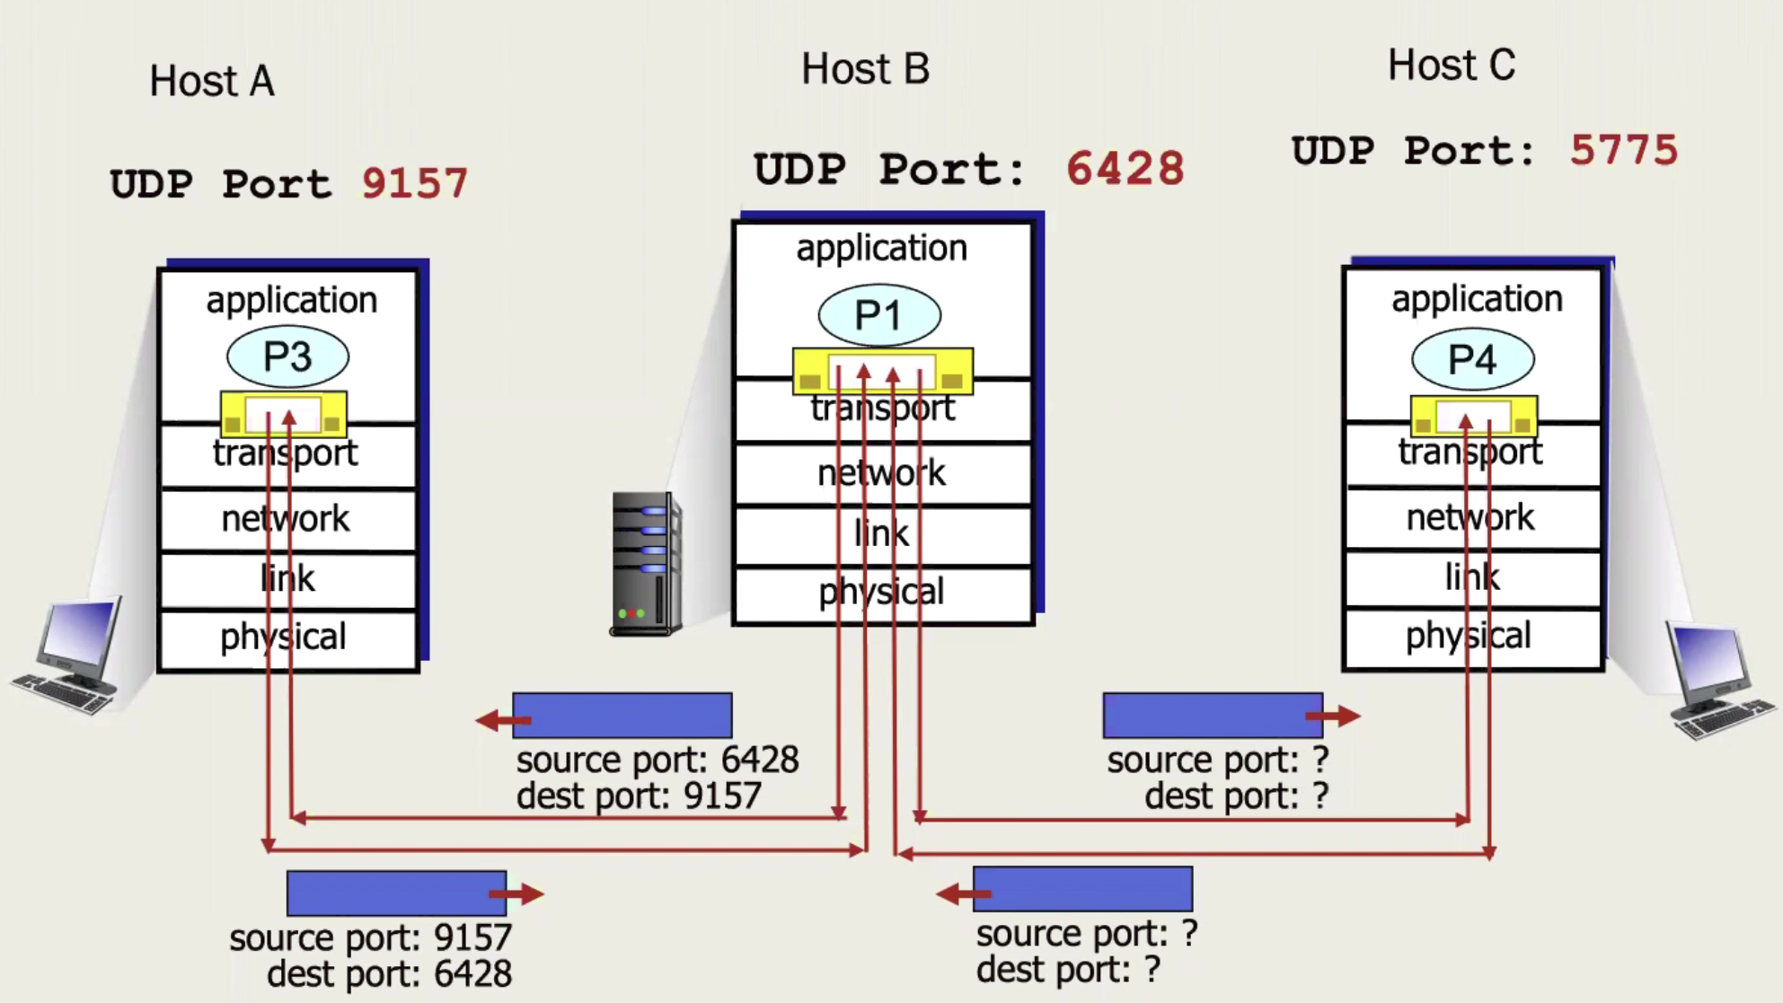
- B to C:
  - Source Port: 6428
  - Destination Port: 5775
- C to B:
  - Source Port: 5775
  - Destination Port: 6428

Exercise 3.4.1
I first filtered out this TCP connection.
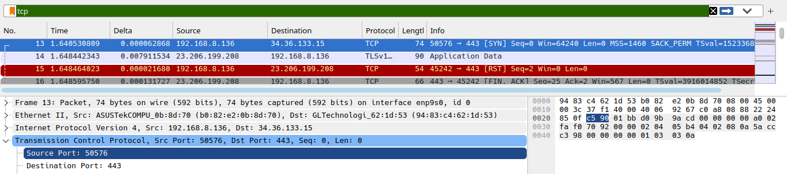

Exercise 4.3.2
I will make this a continuation of Exercise 4.3.1.
From here, I got the port number, which was 50576. To get rid of all the other noise, I then filtered the TCP traffic using `tcp.port == 50576`. After that, I was able to clearly identify the three-way handshake that had occurred.
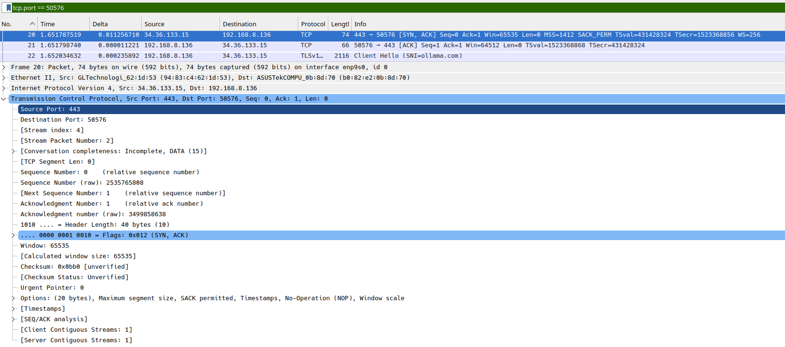
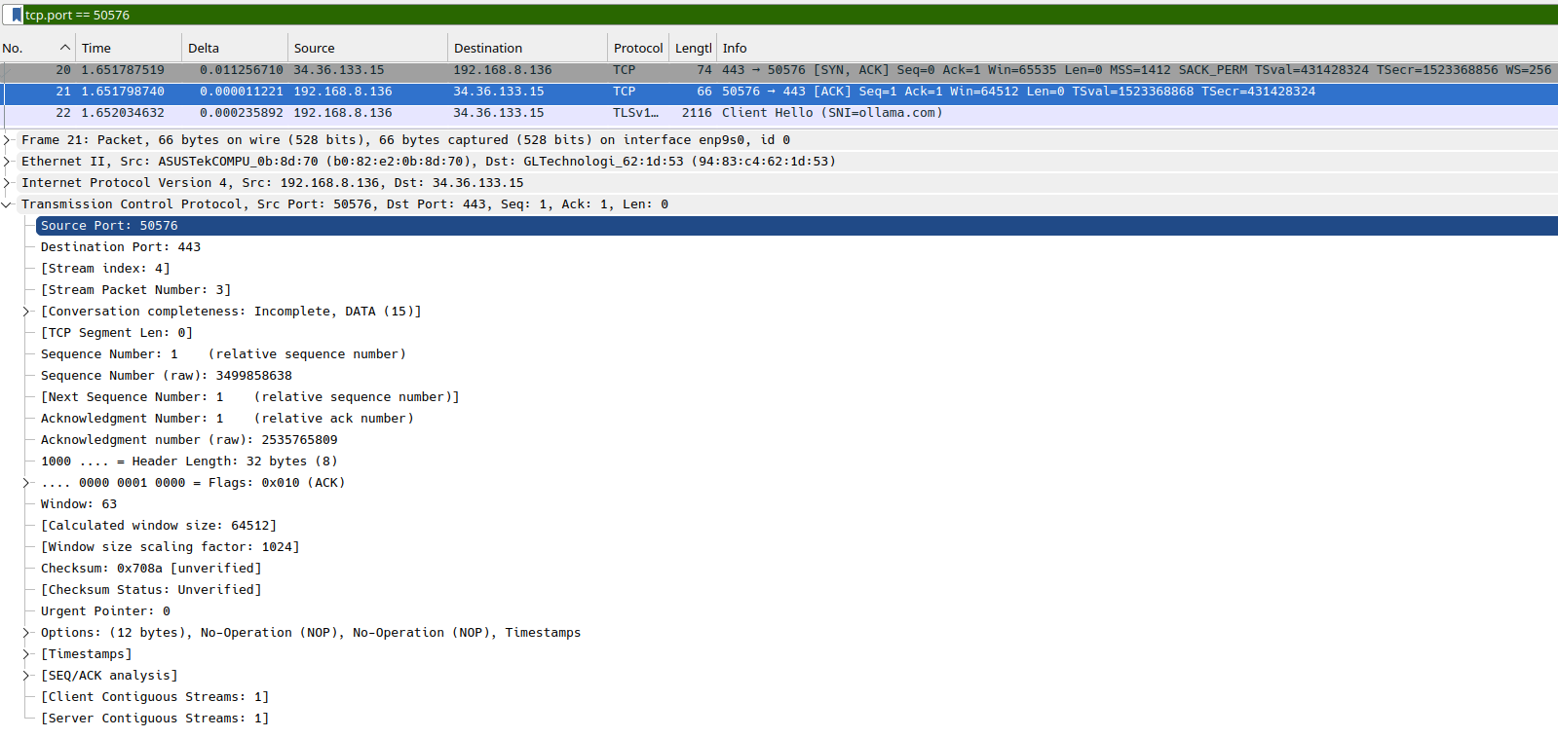

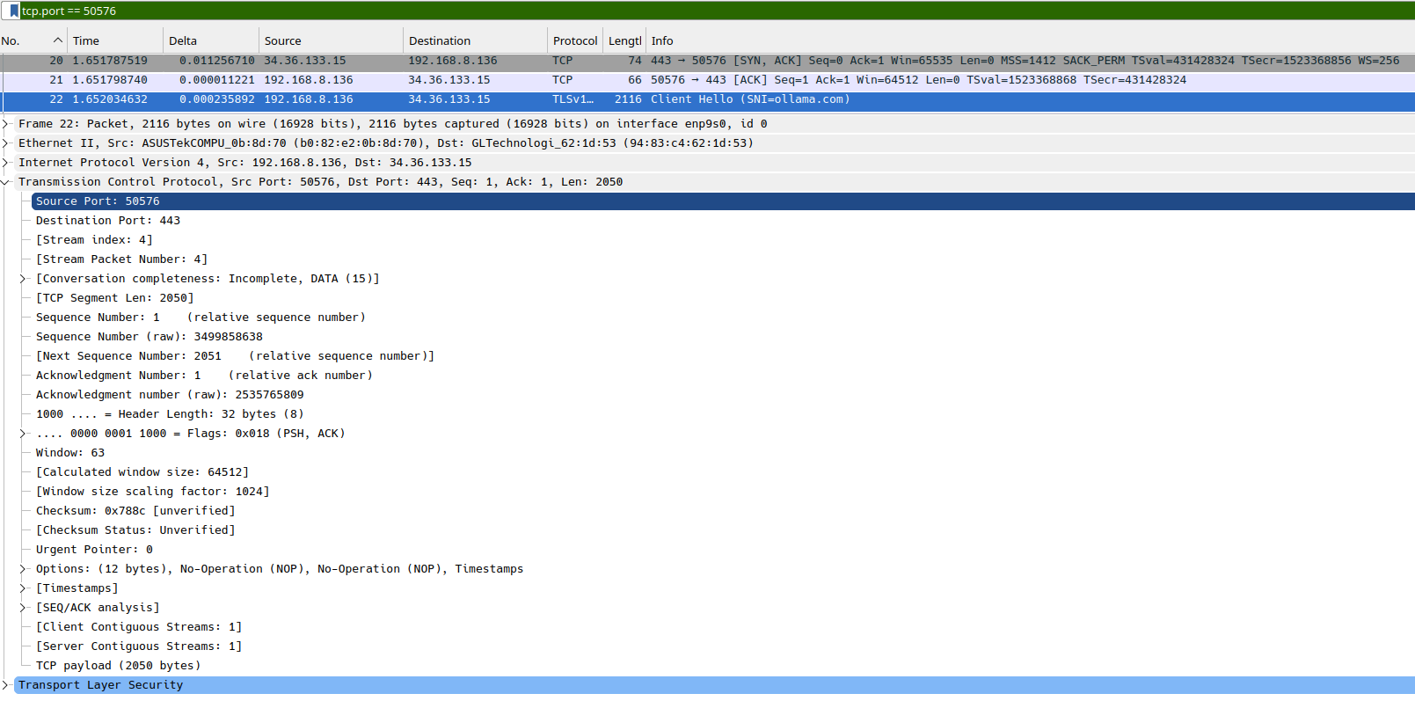
I captured the TCP three way handshake between my host using port 50576 and the server on port 443. The first segment was a SYNC from 50576 to 443 with the raw sequence number 3499858637 followed by a SYN/ACK from 443 to 50576 with raw sequence number 2535765808 and acknowledgment number 3499858638. The final segment was an ACK from 50576 to 443 with the sequence number 3499858638 and acknowledgment number 2535765809, thus completing the connection setup. The TCP headers also contained connections like the header length, window size, checksum, urgent pointer and other TCP options. The SYN and SYN/ACK segments had a header of 40 bytes size, whereas the final ACK used a 32 byte header. You can download this file here. TODO
The raw sequence numbers here also clearly show the flow of messages between the client and the server since each acknowledgment points to the next sequence number expected from the other side. The increment by 1 during the handshake also shows that the SYNC itself takes up one sequence number.
To answer the asked question, yes, I was able to identify the three way handshake. Packet 13 was the initial SYN from 192.168.8.136:50576 to 34.36.133.15:443, packet 20 was the SYN/ACK response from the server, and packet 21 was the final ACK from the client. The flags were set correctly as SYN=1, then SYN=1 and ACK=1, followed by ACK=1, thus confirming the TCP connection was established successfully.

Exercise 3.5.1
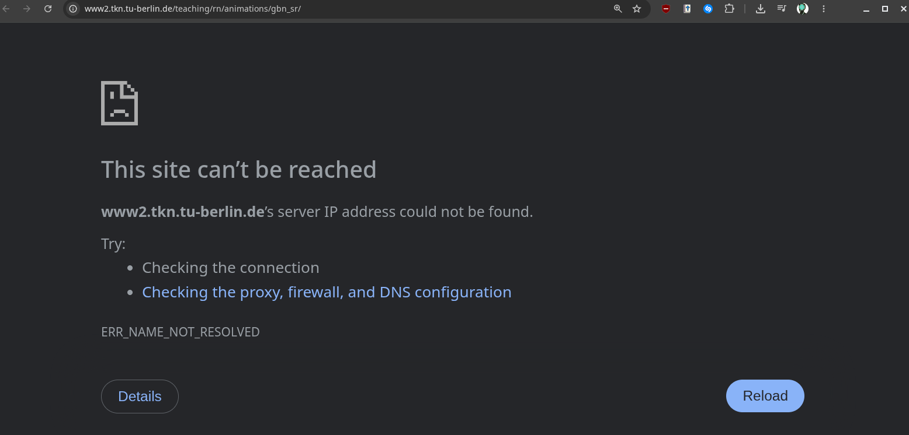
The given URL refused to work. Therefore, I opened the last snapshot of this website that I could find on The Way Back Machine: https://web.archive.org/web/20260309065145/https://www2.tkn.tu-berlin.de/teaching/rn/animations/gbn_sr/
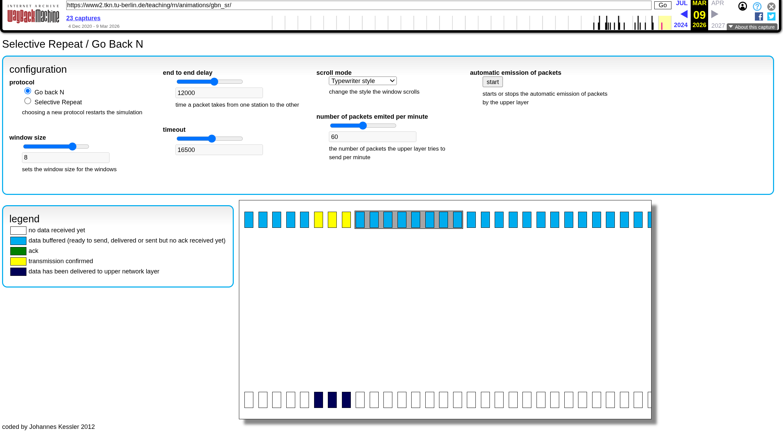
The main difference here is how they handle lost packets^{[1][2]}.
- With Go-Back-N, if a packet is lost, the sender retransmits that packet and the following unacknowledged packets in the window. The receiver can discard the out of order packets, which keeps the implementation much much simpler.
- With Selective Repeat, correctly received out of order packets are buffered and only the missing packet needs to be retransmitted.
This major difference makes Selective Repeat more efficient, but it also needs more buffering and tracking at the receiver, since it only retransmits the specific packets that were lost or received incorrectly. Go-Back-N may retransmit multiple packets after a loss, including packets that were already received successfully – wasting more bandwidth. This difference is said to become very noticeable when the window size increases^{[2]}.

Week 4 – Activity 1

1. What method would you take if your friend needs to pack everything within an hour because the moving truck will be there soon?
I would pack everything ASAP without spending too much time organizing or checking every single item. I would prioritize my speed here.

2. How would your method change if you have more time and your friend would like to make sure each item in the kitchen is safely delivered, and your friend wants to keep those on the same order it was on the previous house?
If I had more time, I would pack everything carefully, label and organize the items, and ensure they are delivered safely and is kept in the same order as before.

3. Now, can you relate the above scenarios to the well-known two transport layer protocols? Consider different scenarios including large file transfer and faster communication.
These two scenarios are identical to the two transport layer protocols TCP and UDP. UDP is more suitable when speed and low overhead matters more than reliability, as it does not establish a connection or gaurantee the delivery or its ordering. This is useful for real time communication where small amounts of packet loss is considered to be acceptable. TCP on the other hand is more suitable for things like large file transfers, and other tasks where its important that the data gets delivered reliably and in the correct order. It uses sequencing, acknowledgments and retransmissions to make sure lost data is recovered.

Week 4 – Activity 2

1. Open Wireshark to capture packets, open the web browser and use an application that uses UDP (perhaps DNS). Stop the packet capture.
To started my packet capture on Wireshark.
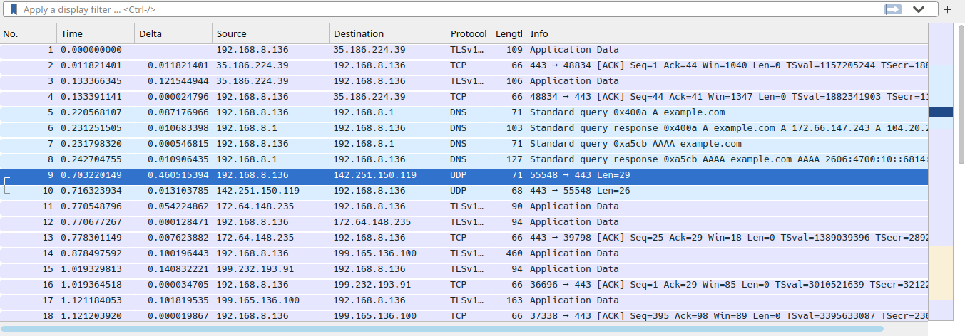
Simultaneously, to generate some UDP traffic, I ran the `nslookup` command (from the `net-binds` package).
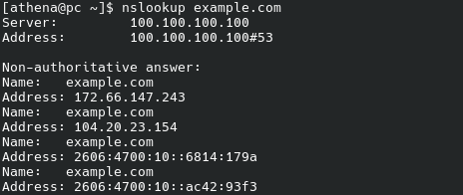

2. Use the filter to display UDP packets (it is UDP segments).
Filter: `udp`
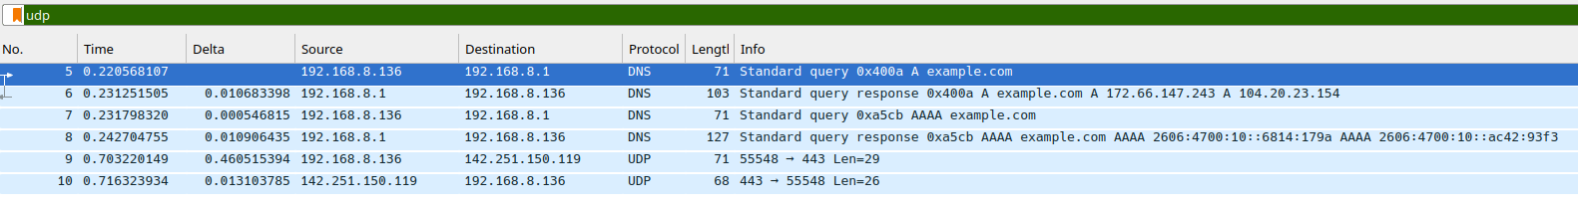

3. Now you are ready to analyze UDP. The following questions can guide you to conduct your analysis. Make sure that you take enough screenshots and notes. You will use those to prepare your task submissions.
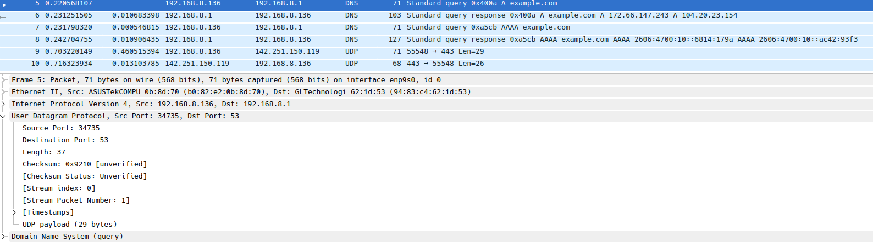
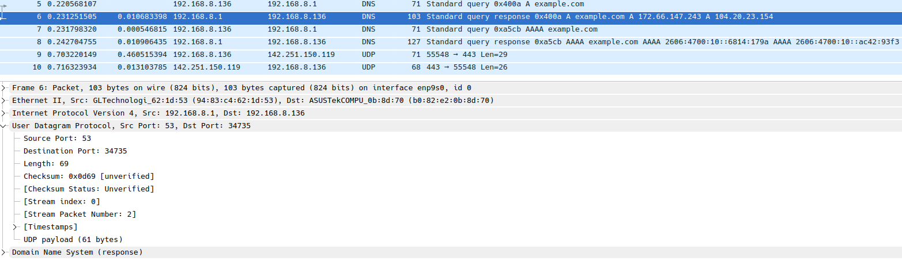

a. Pick one UDP packet from the filtered packets. Examine the number of fields that are in the header of the selected UDP packet. You can take a screenshot of the packet and name and explain the fields in the UDP packet.
I selected packet 5, which was a DNS query from 192.168.8.136 to 192.168.8.1. The UDP header here contains four fields:
- Source Port (34735), which identifies the sending application
- Destination Port (53), which identifies the receiving service,
- Length (37 bytes), which gives the total size of the UDP header and payload
- and the Checksum (0x9210), which is used for error detection

b. Can you identify the length of each UDP header field from this UDP packet? You can indicate the length in bytes. You may want to examine the displayed information in Wireshark’s packet content field.
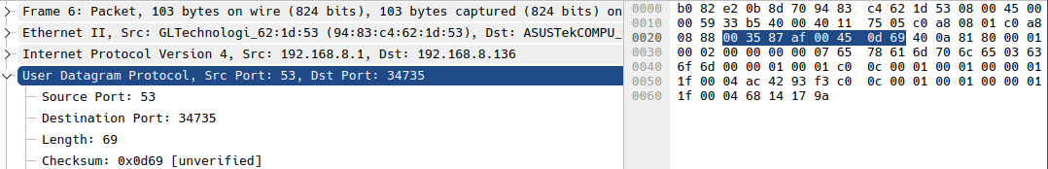
Each UDP header field is 2 bytes in size (16 bits). Therefore, Source Port = 2 bytes, Destination Port = 2 bytes, Length = 2 bytes and finally, the Checksum = 2 bytes. Therefore, this makes the total UDP header size 8 full bytes.
This also makes sense because length – payload = header —> 69 - 61 = 8.

c. Can you explain the value in the Length field? What exactly this value indicates? You can verify your answer by examining captured UDP packets.
This field represents the total size of the UDP header + UDP payload. For example, packet 5 has a UDP length of 37 bytes, containing an 8 byte UDP header and 29 bytes of payload. Packet 6 also confirms this, with 69 = 8 + 61 bytes as said above.

d. Is there a maximum number of bytes that we can include in UDP payload?
Yes, for IPv4, the maximum payload is 65,507 bytes^{[3]}. This is from: 65,535 bytes − 8 byte UDP header − 20 byte IP header.

e. Can you identify the protocol number given for UDP?
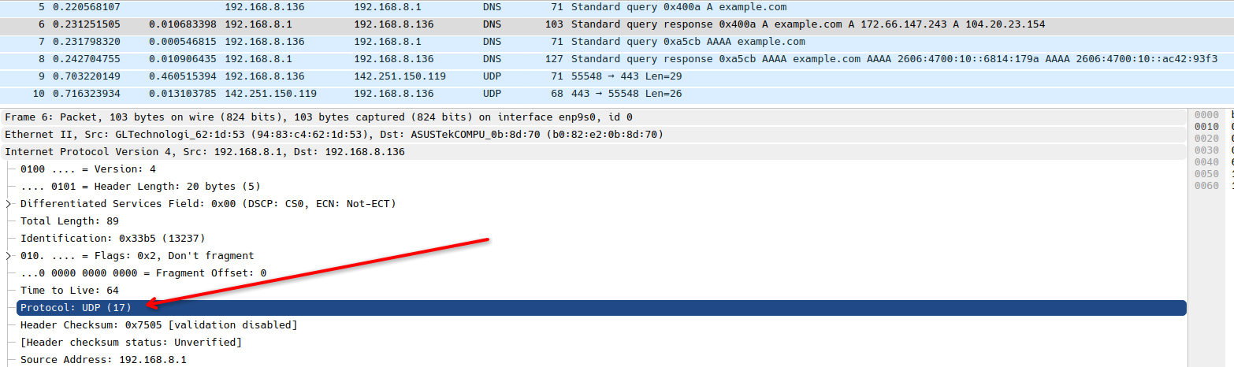
It’s 17 - Protocol: UDP (17). It can be seen inside the IPv4 header of these packets.

f. Examine two consecutive UDP packets your host sends/receives. Explain the relationship between the port numbers in these two packets.
In packet 5, my host sends a DNS query from source port 34735 to destination port 53. In packet 6, the DNS server replies from source port 53 back to destination port 34735. Therefore, the source and destination port numbers are reversed in the response, allowing the reply to be delivered back to the same UDP socket on my host. You can also see a very similar thing in packets 7 and 8 as well as 9 and 10.

g. Clear the cache and run another application such as MSTeams while using Web browsing. Capture packets of these two applications. Now you can analyze the captured UDP packets again. Do all UDP packets captured in Wireshark use the same port number? Explain your answer.
I joined a voice call in Discord while also browsing the web to generate some UDP traffic from multiple applications. In the capture, I could see large amounts of UDP traffic between my host on port 37054 and the remote host on port 19301, which was likely generated during the discord all. I could also see other UDP traffic like web/QUIC using port 443 (HTTP/3) and DNS traffic using port 53.
And to answer the question, no! The captured UDP traffic uses different ports depending on the application and the service. As mentioned above, DNS used port 53, web traffic used port 443 while discord voice traffic used different dynamically assigned ports. This allows the transport layer to multiplex and demultiplex UDP traffic to the correct application process accordingly.
Both the previous pcapng file as well as this file can be downloaded here. TODO.
Some screenshots from this capture are to be found in the next page.

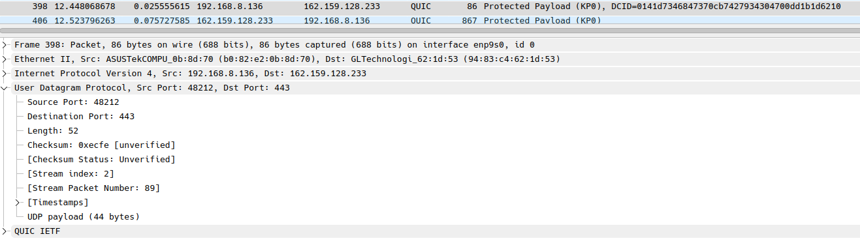
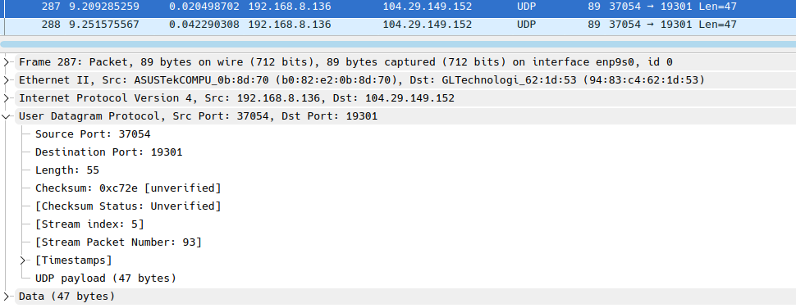
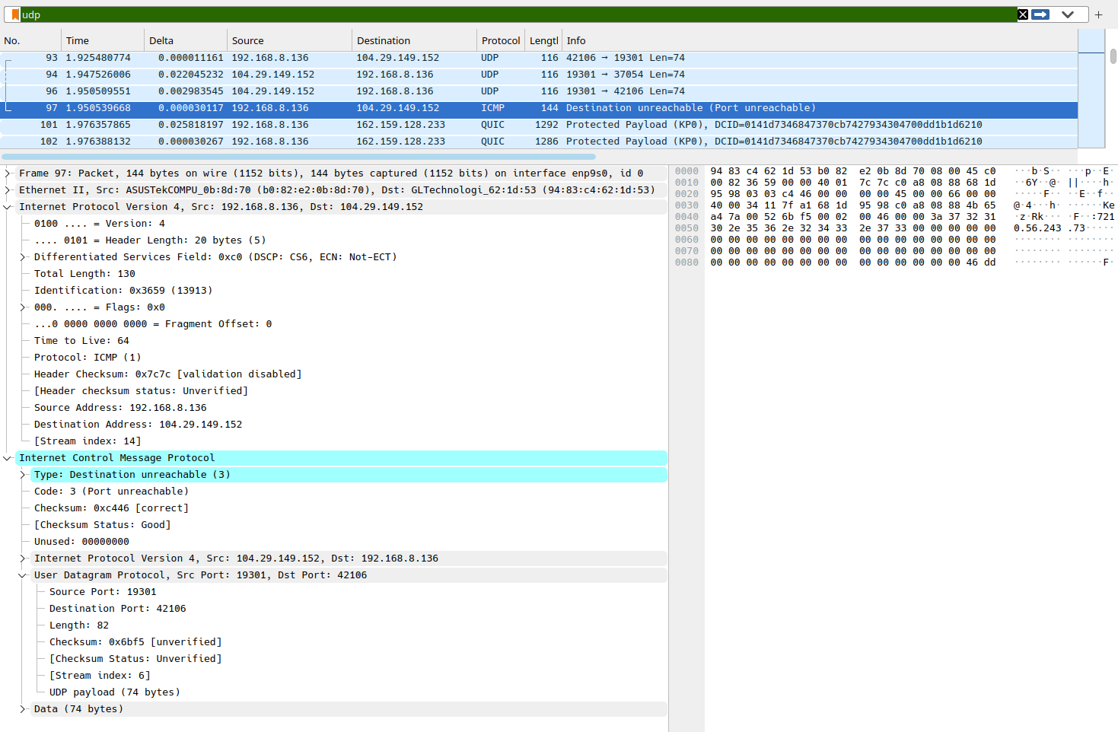

The third image here is a bit of an interesting one. It shows an ICMP packet, and the reason it shows up there even when my display filter is set to `udp` is because it contains the original UDP packet that caused the error (can be seen when expanded, as seen in the screenshot). Wireshark sees that embedded UDP header, so the packet still matches the udp filter. In this case, the ICMP message is a Destination Unreachable (Port Unreachable) response, meaning the UDP packet was sent to a port where there was no application actively listening at that point. Since this was captured while I was in a Discord voice call, this could have happened because Discord had already closed or switched away from that temporary UDP port while another packet was still arriving – could be either, or some completely other yet identical reason.

Week 4 – Activity 3
Source Code (client):
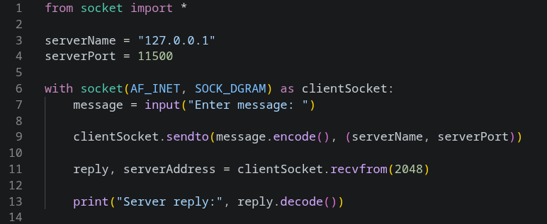
Source Code (server):
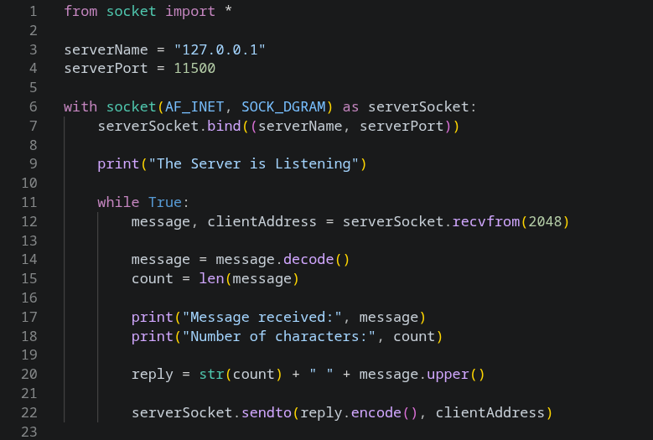
Execution:
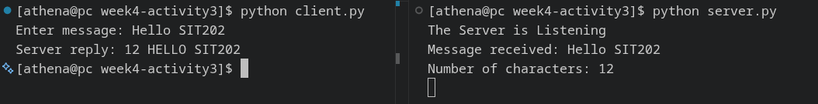

References
1: Kurose & Ross, Computer Networking: A Top-Down Approach, Chapter 3
2: https://ocw.mit.edu/courses/16-36-communication-systems-engineering-spring-2009/9b06e175ee2b383dc35490581a45267a_MIT16_36s09_lec18.pdf
3: https://en.wikipedia.org/wiki/User_Datagram_Protocol

