Task 1.2P
Below is my very highly detailed Level 1 Data Flow Diagram.
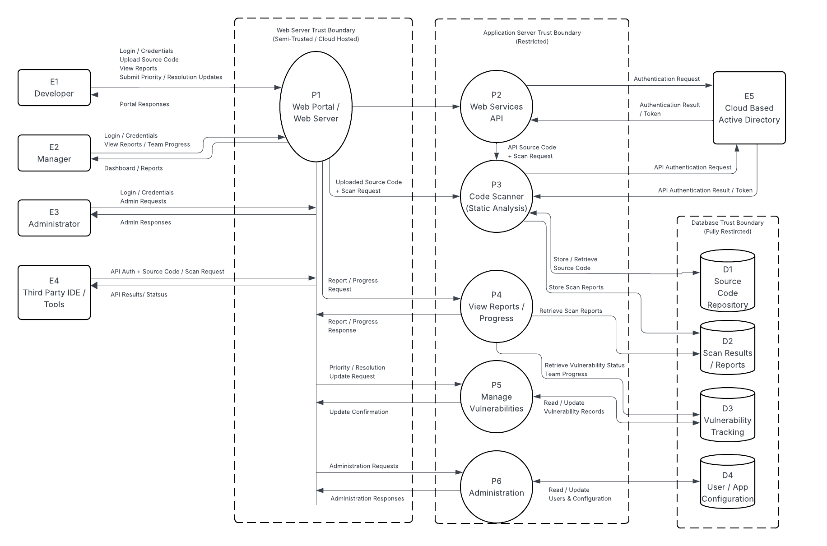
Entities:
- E1-E5: External Entities
- P1-P6: Processes
- D1-D6: Data Sources
The different entities have been properly labeled in the diagram.

