Publishing Locally
I set everything up as instructed, and installed the dependencies with `npm ci` because I already have a package-lock.json file and I don’t want to start all over again with dependency resolution and all other processes.
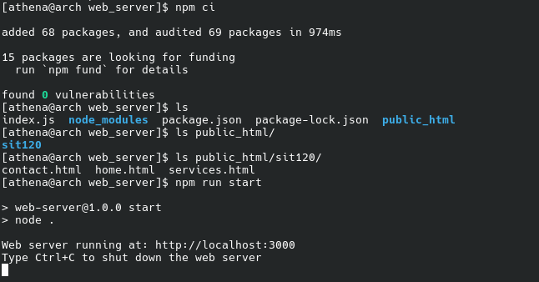
The screenshot below shows the website functioning as expected.
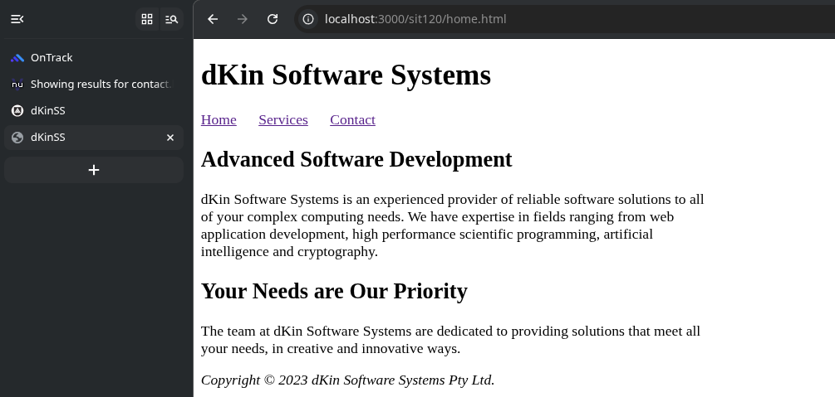
This short demonstration video: https://youtu.be/IshwPRml7lY (1m 15s) shows both of them being hosted and accessed by myself and proof that the page navigation functions flawlessly, along with additional explanations.
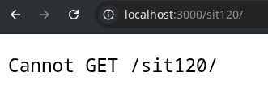
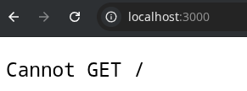

You get this error from the expressjs web server when you attempt to access / or /sit120/. This is because by default, and by convention, most web servers look for the index.html and serves it at /. Since our main page is called /sit120/home.html instead of /sit120/index.html, we have to mention the absolute path explicitly. This has also been explained in my quick demonstration video that was uploaded above.

