Publishing to the World
I already have the network share set up from SIT103 over the VPN on my windows computer. I copied the three files to this directory.
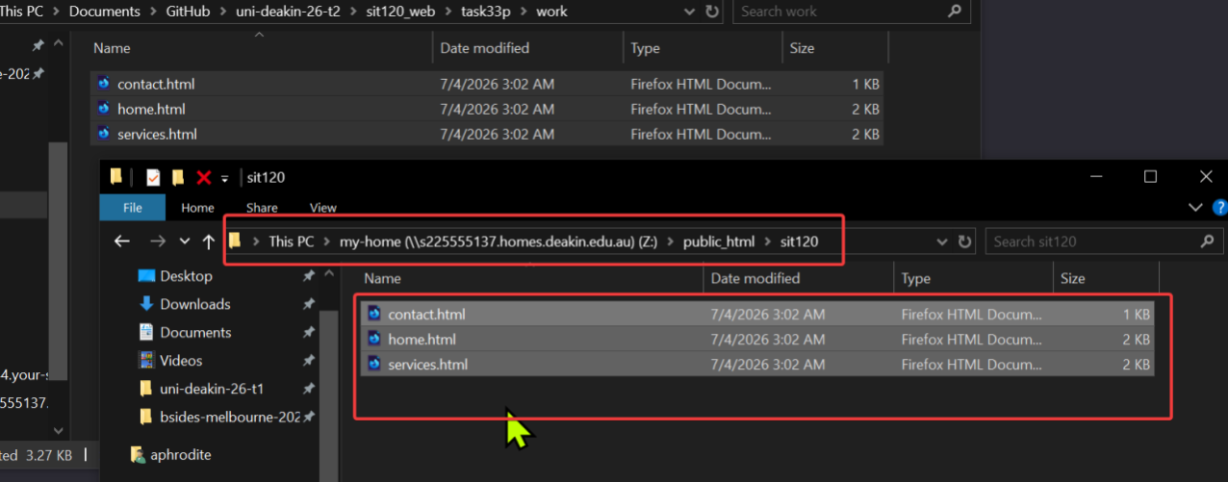
This can be accessed here: http://personal-sites.deakin.edu.au/~s225555137/sit120/home.html as seen below.
