Task 3.3P
All the tasks have been completed as instructed.

Step 1
The &emsp; stands for “em space” and is used like a tab, just like &nbsp; stands for “non breaking space” and is used to represent a whitespace character by properly escaping it in HTML^{[1]}.
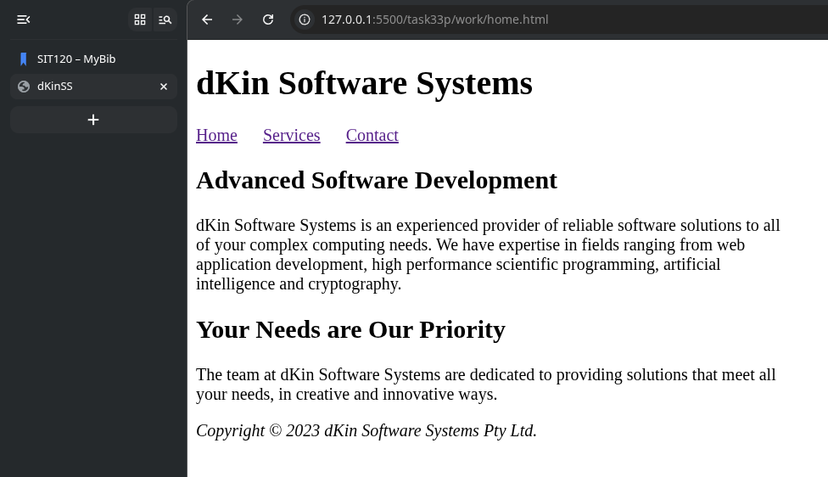

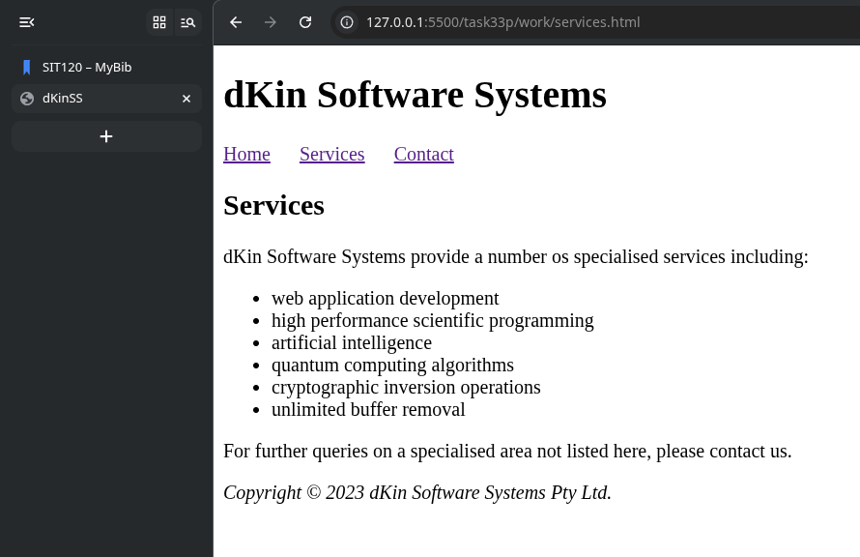

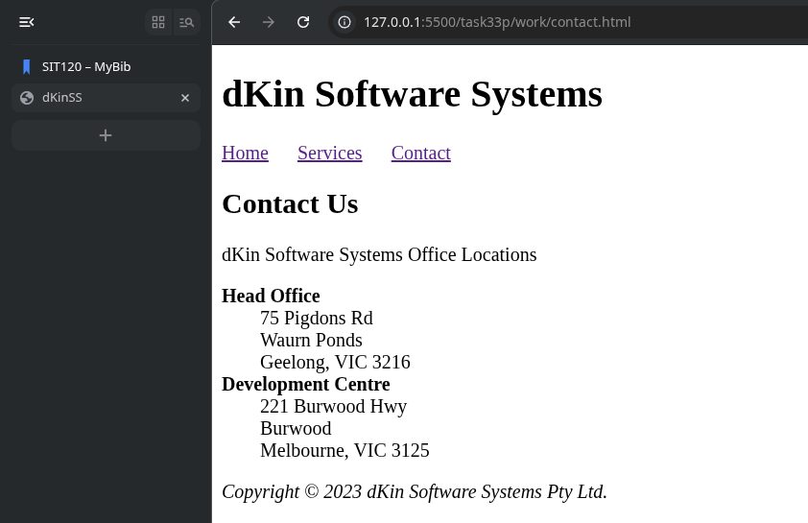

Step 2
I uploaded and validated all the three HTML files. Screenshots of the results are found below. I didn’t run into any errors while attempting this task. Therefore, step 2.4 and 2.5 are not applicable.
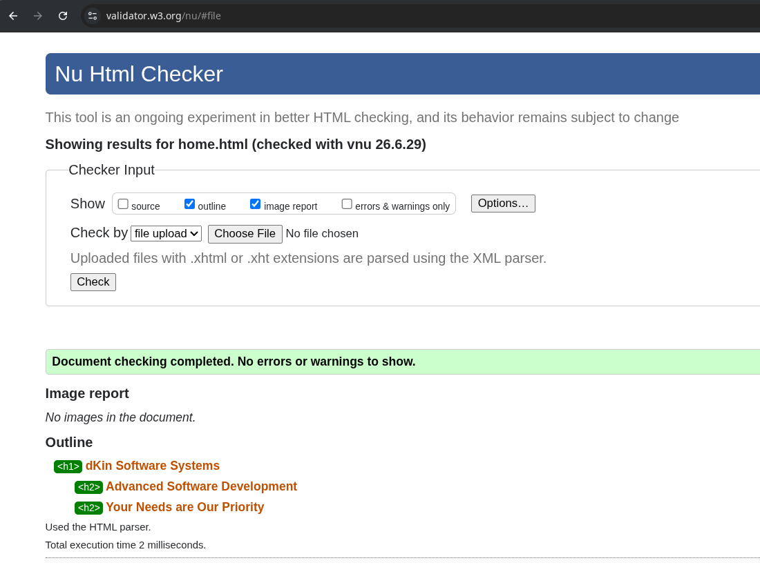
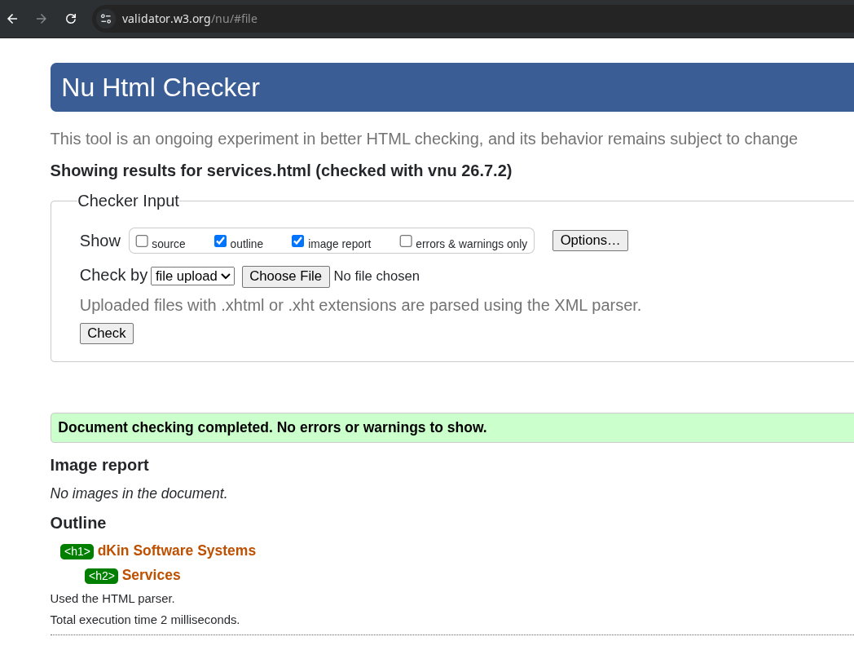

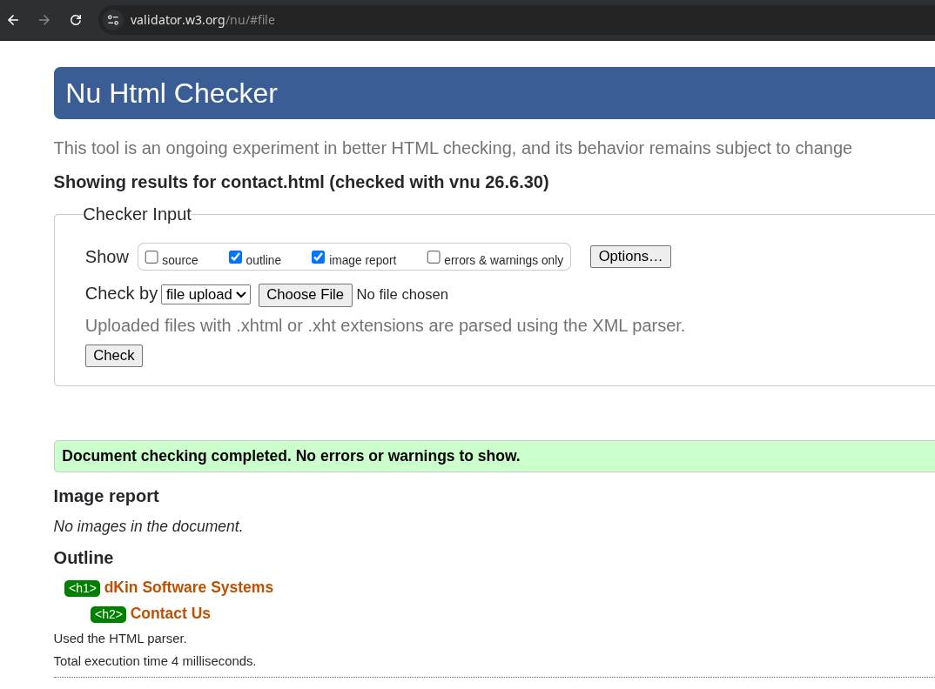

Step 3
I completed both the hosting approaches as instructed.

Publishing to the World
I already have the network share set up from SIT103 over the VPN on my windows computer. I copied the three files to this directory.
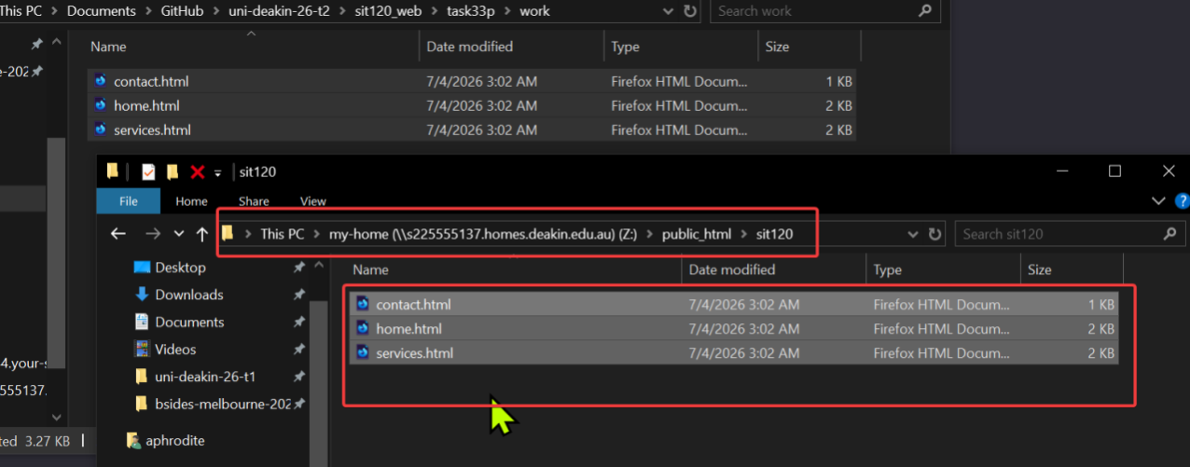
This can be accessed here: http://personal-sites.deakin.edu.au/~s225555137/sit120/home.html as seen below.
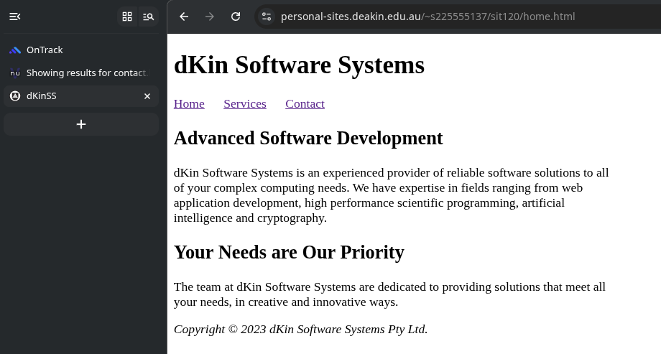

Publishing Locally
I set everything up as instructed, and installed the dependencies with `npm ci` because I already have a package-lock.json file and I don’t want to start all over again with dependency resolution and all other processes.
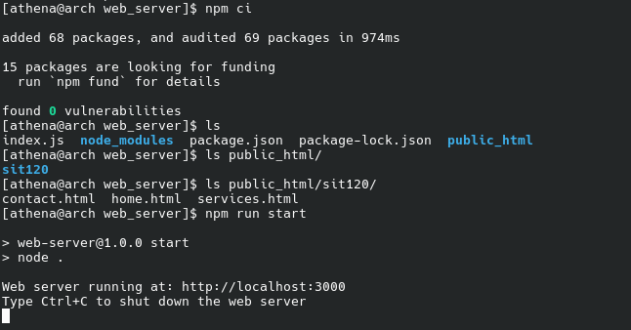

Next Page —>
The screenshot below shows the website functioning as expected.
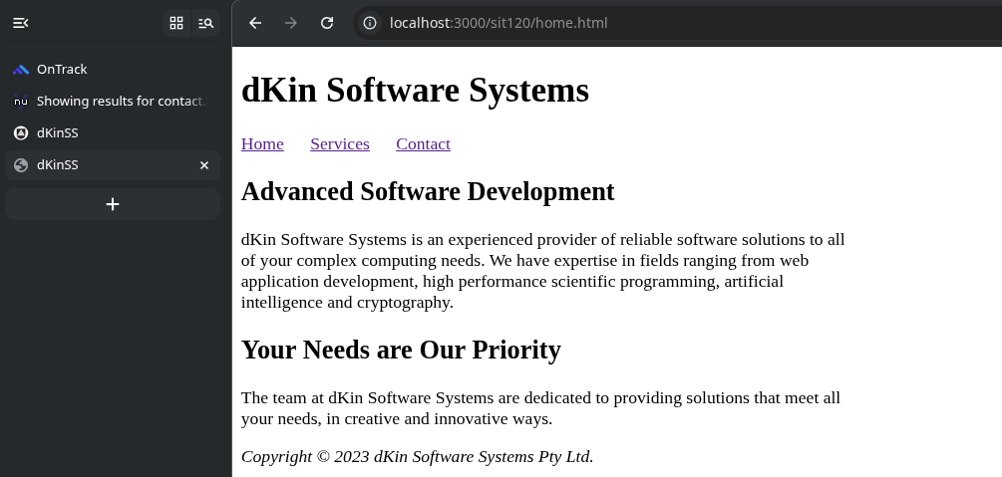
This short demonstration video: https://youtu.be/IshwPRml7lY (1m 15s) shows both of them being hosted and accessed by myself and proof that the page navigation functions flawlessly, along with additional explanations.
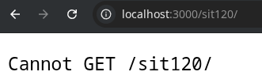
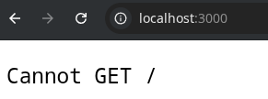

You get this error from the expressjs web server when you attempt to access / or /sit120/. This is because by default, and by convention, most web servers look for the index.html and serves it at /. Since our main page is called /sit120/home.html instead of /sit120/index.html, we have to mention the absolute path explicitly. This has also been explained in my quick demonstration video that was uploaded above.

References
[1] “How do I replicate a \t tab space in HTML?,” Stack Overflow, 2026. Available: https://stackoverflow.com/a/56942318. [Accessed: Jul. 04, 2026]

