Number Theory

Basics

Congruence
When a, r, m ∈ ℤ, and m > 0, and if m divides (a - r) we can say that:
a = r mod m when m | (a - r)

Euclidean algorithm
When b > a, do this until r_{i+1} = 0. Then, r_{i} is the gcd.
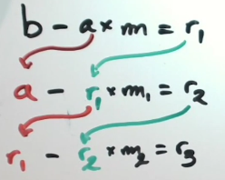
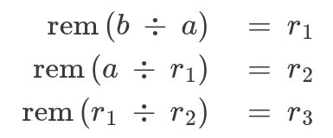

Bezouts Lemma
If gcd(a, b) = c, then, m ⋅ a + n ⋅ b = c
A and b are relatively prime only if numbers m and n suffice m ⋅ a + n ⋅ b = 1

