Part 2: Evidence of successful completion of the activities and learning

Exercise 1.2.1

What types of networks do you use for your daily activities?
My Arch Linux desktop (wired), my home server / previous computer (wired), phone (wireless), and other devices communicate through my router. They are connected over either Ethernet or WiFi.
My home network configuration is quite interesting. My GL.iNet SFT1200 operates in wireless repeater / WISP mode, using the landlord’s WiFi as its WAN uplink to create a separate private LAN for my home server and other devices. It performs its own NAT, DHCP, firewalling, routing, and local DNS resolution on its own subnet, thus isolating my network from my landlord’s LAN. This basically creates a nested network.

How many different types of network connections do you use on a daily basis?
I normally use four main types every day. They are Ethernet, WiFi, 4G/5G cellular, and Bluetooth BR/EDR and sometimes Bluetooth BLE.

Exercise 1.2.2

Can you use layered architecture to explain any other complicated system that you use on daily basis?
A web application would be a really good example. At the top, I interact with the user interface through my web browser. The browser will then communicate with the application layer, which will handle the website logic and user requests. The backend will then process the request, communicate with databases or any other external APIs/services as necessary, and then will pass the response back through the same layers. Underneath this, the operating system, network protocols and the physical connection handles the actual data transfer. Each layer has a separate responsibility, making the overall system more modular.

Exercise 1.6.1

What else was captured? For this you can capture your own traffic.
As seen below, my computer performed a standard DNS query for `cdn.jsdelivr.net` and got those responses.
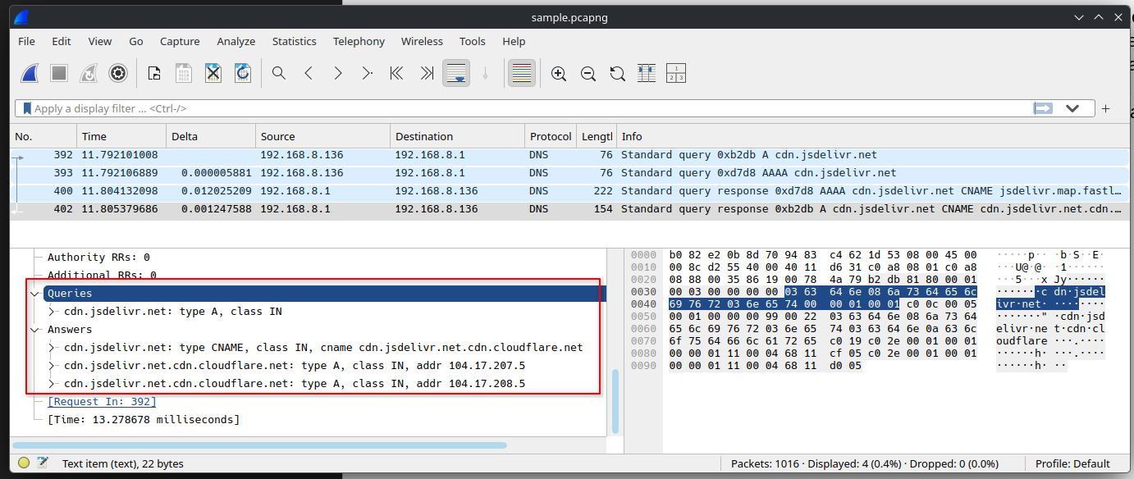

Exercise 1.6.2

Try using both the filter syntax as shown above, and the expression builder, to find filters for the following conditions: All frames containing the DNS protocol;
The best way to filter out DNS traffic is to use the `dns` filter.
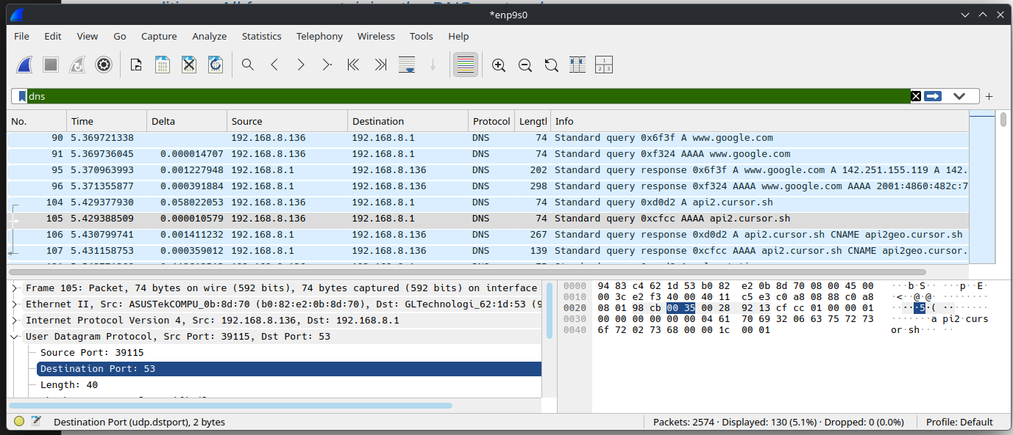
As seen above, all DNS traffic goes through UDP port 53. Therefore, `udp.port == 53` filter should also work. But note that it might display any other UDP traffic that’s sent over port 53 as well.
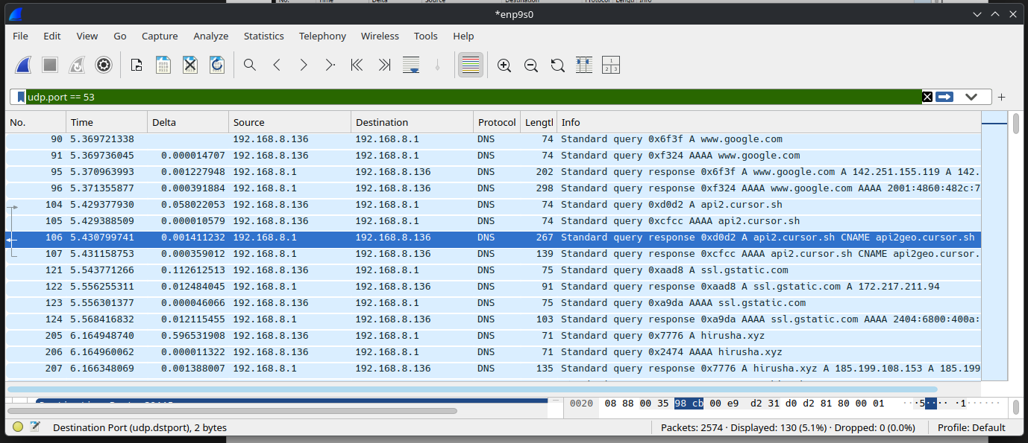

All frames sent by your local machine;
As seen here, my local IP address for this interface connected to my host machine is 192.168.8.136.
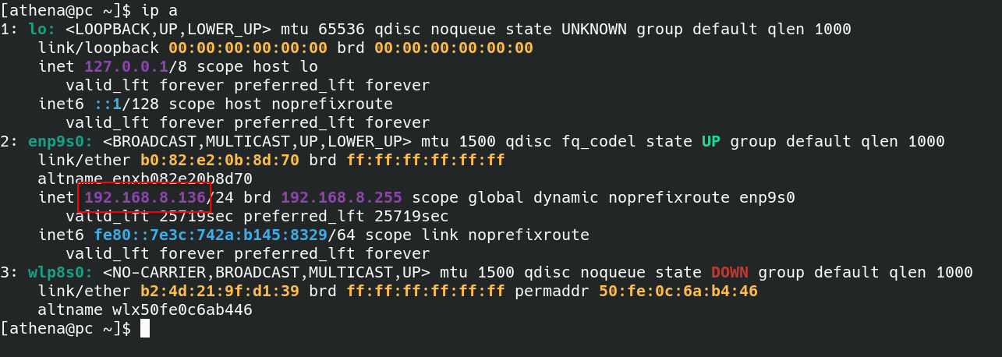
To filter by the source IP address, you can use this filter: `ip.src == 192.168.8.136`
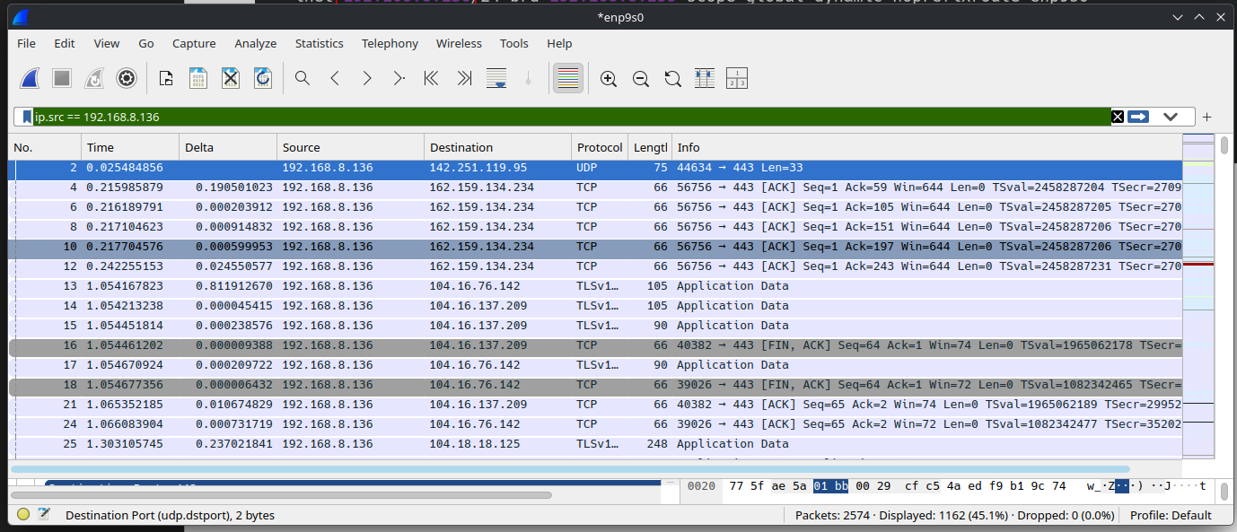

—> Next Page

Then, I visited http://neverssl.com/ , which is a public website on the internet that can be accessed without HTTPS. This lets us see the traffic clearly.
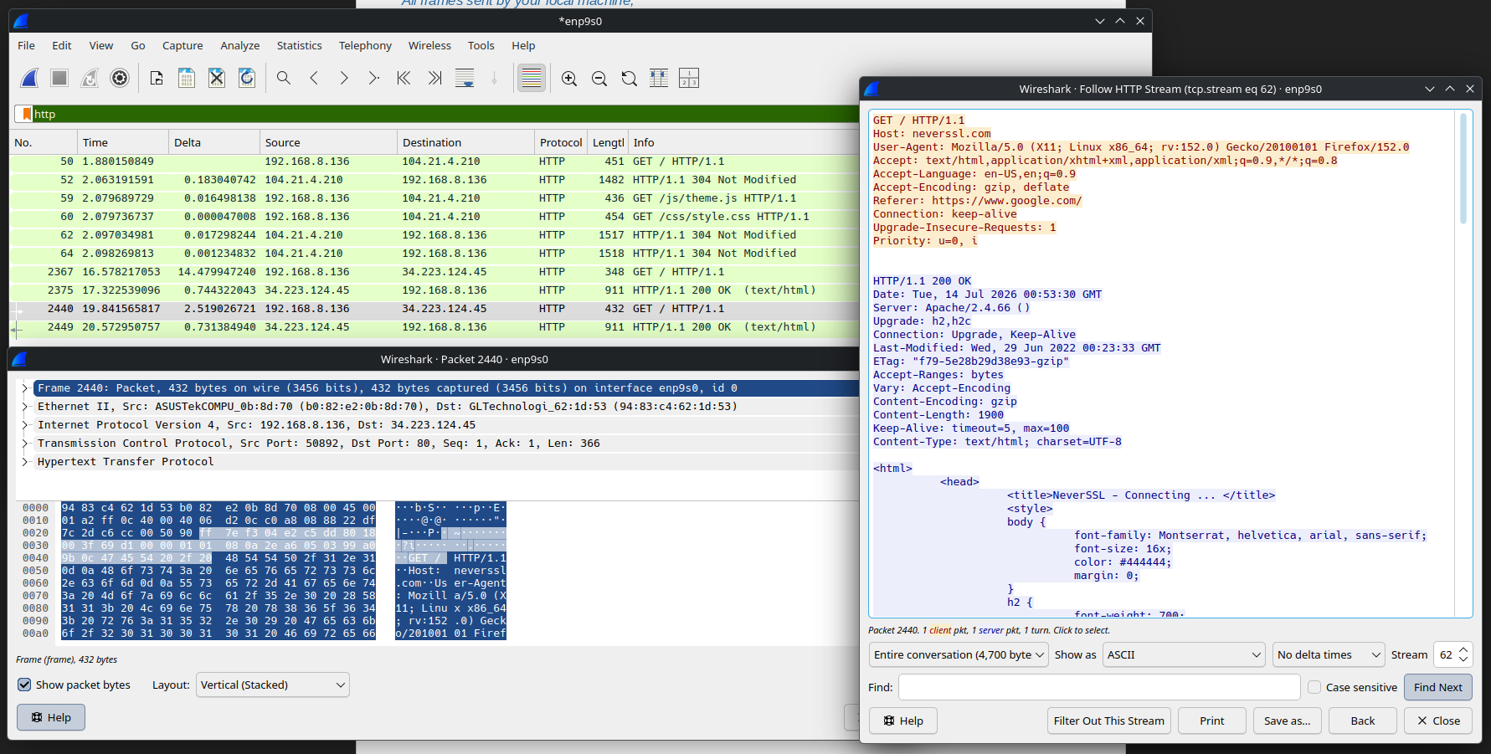
As seen above, you can see the response received for the HTTP GET request sent.

Activity 1

Why we need protocols to communicate? What are the five layers in the Internet protocol stack?
A network protocol is basically a standardized set of rules for formatting and processing data.

