Module reflection and Summary.

Notes from Principles of Network Applications (2.2)
Some points:
- The application layer in the TCP/IP model is the interface that prepares our communication for trasmission over the computer networks.
- Sockets are identified by an IP:PORT
- for client-server communication, thre should be two sockets involved (one socket on each side).
- physical, link, network & transport layers and managed by the OS
- between the transport and the application layer sits the socket API.
- 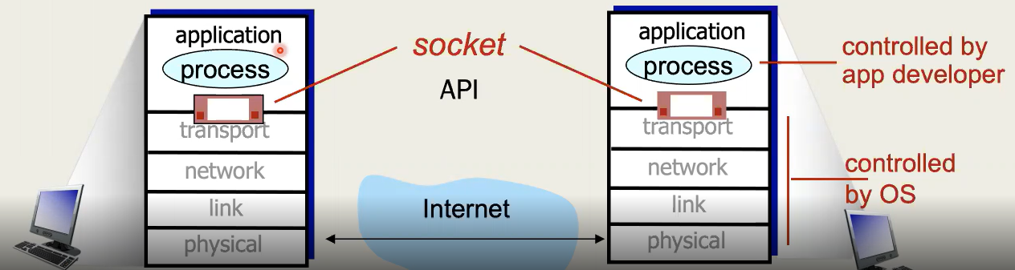
- To use a socket, you need to decide what transport layer protocol to use
- This can be either TCP or UDP
The table below has been yoinked from the lecture video into chatgpt to generate a table in markdown with the RFC specification documents properly linked.
Application | Application-layer protocol | Transport-layer protocol
File transfer/download | FTP — RFC 959 | TCP — RFC 9293
E-mail | SMTP — RFC 5321 | TCP — RFC 9293
Web documents | HTTP/1.1 — RFC 9110: HTTP Semantics and RFC 9112: HTTP/1.1 | TCP — RFC 9293
Internet telephony | SIP — RFC 3261, RTP — RFC 3550, or proprietary protocols | TCP — RFC 9293 or UDP — RFC 768
Streaming audio/video | HTTP — RFC 9110, MPEG-DASH — ISO/IEC 23009-1 | TCP — RFC 9293
Interactive games | World of Warcraft, first-person shooters and other proprietary protocols | UDP — RFC 768 or TCP — RFC 9293

Notes from Application layer protocols (2.3)
The application layer protocols are essential.

Notes from Application layer protocols (2.3)
The application layer protocols are essential.

Notes from HTTP (2.4)
The RFC documents for these protocols are:
- HTTP/1.1 - RFC 2616
- HTTP/2 - RFC 7540
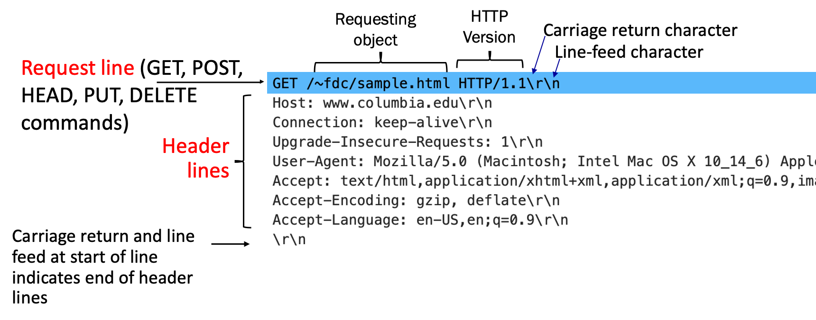
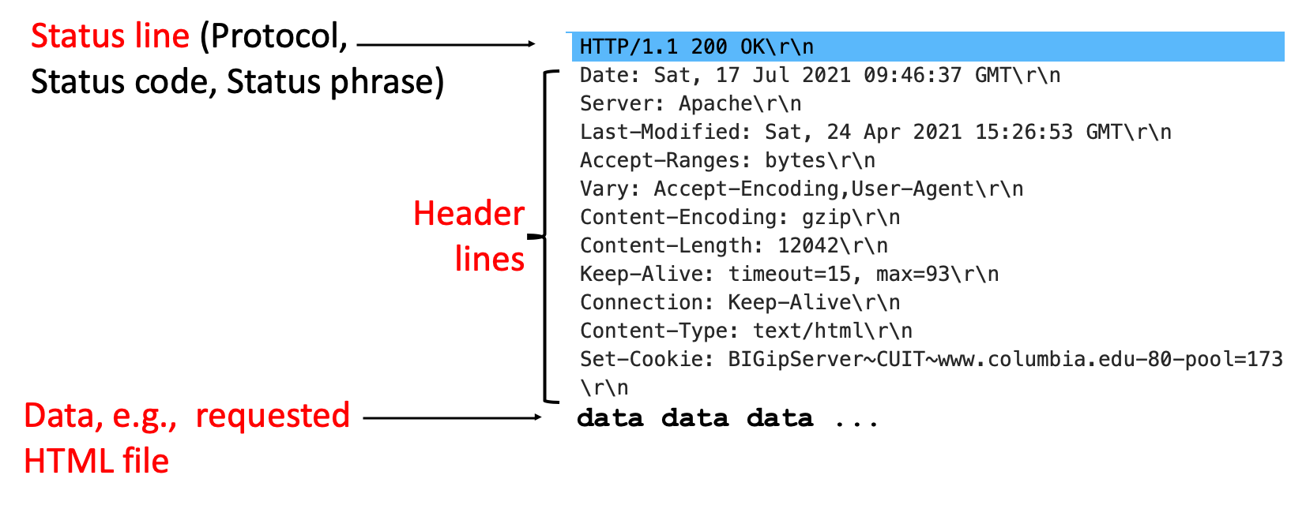

Notes from other sections
HTTP cookies use 4 main concepts.
- The server’s Set-Cookie response header,
- The browser’s Cookie request header,
- A cookie file stored in the client device,
- And a server side database linked in the cookie’s unique ID.
Cookies are used for authentication, shopping carts, to store preferences and personalized recommendations. However, cookies can also create privacy risks, or even open the attack surface to session hijacking attacks.
TLS is the modern and much more secure replacement for SSL. It encrypts communication between the client and the server, so that intercepted data cannot be easily understood. After the TCP connection is established, if the website being accessed uses TLS, the TLS handshake will happen. This allows the client and the server to authentication, agree upon encryption algorithms and generate session keys.
A proxy server with web caching support can be placed between the client and the original web server. It stores copies of recently requested web objects like images, static pages, and other resources. When another client requests the same object, the cache may return its stored copy without contacting the original server. This reduces the response time, the bandwidth usage and the actual workload on the web server.

DNS (Domain Name System) translates human readable domain names like www.nasa.gov to IP addresses that network devices actually understand. When a domain name is entered into a browser, it will first check whether the IP address is already stored locally. If its not available, the device sends a DNS query to its configured local DNS resolver – which most of the time is provided by the ISP for home routers or managed by a network administrator in big corporations.
This local DNS resolver will contact several servers to find the answer. It might query a root DNS server, a TLD server (in this case, the one responsible for .gov) and finally the authoritative DNS server for the requested domain. The authoritative server is what will return the DNS record containing the corresponding IP address.
DNS commonly uses 53/udp, and most queries and responses are very small and needs very low overhead. 53/tcp might also be for large responses, zone transfers or when a UDP response gets truncated.
DNS information is stored in records. A records store IPv4 address, AAAA for IPv6, CNAME for aliases, MX or mails servers and NS records for authoritative name servers.
DNS caching stores the previously fetched domain to IP mappings so that the lookup value does not need to be repeated. Cached records improve response speed and reduce the number of queries sent across the DNS hierarchy. Each record that was cached has a TTL, which tells how the long that record will be valid for before it needs to be requested again.

