UVA WELLASSA UNIVERSITY OF SRI LANKA
Faculty of Applied Sciences
Department of Computer Science and Informatics
Industrial Information Technology Degree Program

CST 226-2 — Web Application Development
Group Project — Project Report

SERENDIB GRAND
Hotel Reservation System

Group Number: 08

Index Number | Student Name
UWU/IIT/23/011 | W. Hirusha Suhan
UWU/IIT/23/020 | G. C. Sandeep
UWU/IIT/23/030 | D. L. Chathuranga
UWU/IIT/23/015 | L. A. S. Dilshi
UWU/IIT/23/014 | W. A. M. S. Wickramarachchi
UWU/IIT/23/016 | M. A. T. Emalsha
UWU/IIT/23/047 | M. R. A. D. Abeyrathne

GitHub Repository:
https://github.com/hirushasuhan/serandib_grand

August 2026

1. Project Title
Serendib Grand — Hotel Reservation System, a web-based reservation and front-office management platform built for the Web Application Development (CST 226-2) group assignment, developed as a dynamic PHP + MySQL web application under the "Hotel Reservation System" topic.

2. Group Member Details
Group Number: 08 — Industrial Information Technology, Uva Wellassa University of Sri Lanka.
# | Index Number | Student Name | Module Owned
1 | UWU/IIT/23/011 | W. Hirusha Suhan | M1
2 | UWU/IIT/23/020 | G. C. Sandeep | M2
3 | UWU/IIT/23/030 | D. L. Chathuranga | M3
4 | UWU/IIT/23/015 | L. A. S. Dilshi | M4
5 | UWU/IIT/23/014 | W. A. M. S. Wickramarachchi | M5
6 | UWU/IIT/23/016 | M. A. T. Emalsha | M6
7 | UWU/IIT/23/047 | M. R. A. D. Abeyrathne | M7

GitHub Repository: https://github.com/hirushasuhan/serandib_grand

3. Project Description
Small and mid-sized hotels commonly manage room bookings with paper registers, phone calls, and spreadsheets. This causes double bookings, no real-time visibility into room availability, lost revenue records, and no way to report on occupancy or monthly income. Serendib Grand replaces this manual process with a single, role-based web application covering the full guest journey — from browsing rooms and checking live availability, to booking, front-desk check-in/check-out, billing, and management reporting.
The system is built around four user roles with a strict permission matrix enforced in one place (Auth::can()): Guests browse rooms, search live availability by date range, book online, manage their own bookings, and leave a review after checkout. Receptionists handle walk-in bookings, check guests in and out, update room housekeeping status, record payments, and print invoices. Managers approve cancellations, refunds and large discounts, moderate guest reviews, and view occupancy and revenue reports. Admins manage staff accounts, room types, physical rooms, system settings, and the security audit log.
The project deliberately keeps a few things out of scope to stay reliable within the assignment timeframe: there is no real payment gateway (guests pay at the hotel and receive a printable invoice instead), no outbound email/SMS (in-app notifications are used instead), and — per the module’s instruction for this project — no PHP framework of any kind. Every request is handled by hand-written PHP using PDO with prepared statements only.
The application currently ships 10 primary pages (home, rooms/availability search, room details, login/register, the guest booking form, "My Bookings", the front-desk room-status board, payments & invoicing, the admin room/room-type CRUD screens, and the manager reports page), well above the assignment’s 6–10 page requirement, plus supporting pages for profile management, settings, and audit logs.

4. System Functions / Features

4.1 Authentication & Account Security
- Guest self-registration with a live, server-enforced password-strength policy.
- Login with Argon2id password verification and role-based redirect to the correct dashboard.
- Login throttling — 5 failed attempts soft-locks the account for 15 minutes.
- Session hardening: fingerprinting, 30-minute idle timeout, 8-hour absolute timeout, session ID regeneration on login.
- Profile management (name, phone, NIC/passport, address) and password change.

4.2 Room Type & Room Management (Admin CRUD)
- Create, edit, and soft-delete room type categories — name, description, base price, capacity, bed type, size, cover image.
- Create, edit, deactivate, and delete physical rooms; a bulk generator can create a range of rooms across a floor in one action.
- Deleting a room that has active bookings is blocked with a friendly message instead of a database error.
- Image upload with MIME sniffing, a 2 MB size limit, and randomly generated filenames.
- Housekeeping status per room: available / occupied / cleaning / maintenance.

4.3 Public Site & Availability Search
- Home page with an inline availability search (check-in, check-out, adults, children) and featured room types.
- Rooms & Suites page — the information display page — with live "X rooms available" badges, filters (price, capacity, bed type), sorting, and pagination.
- Room details page with an image gallery, full amenity list, and a price calculator that recalculates live via AJAX as dates change.
- About and Contact pages, with the contact form storing each message for staff follow-up.

4.4 Guest Booking Module
- A 3-step booking form (dates & occupancy → guest details → review & confirm) with progress indicator and full server-side re-validation.
- Automatic pricing: nights × room rate, plus seasonal surcharge, service charge %, and tax %, all read from system settings.
- A unique, human-readable booking reference is generated for every reservation (e.g. HRS-20260805-4F7A).
- "My Bookings" — the second information display page — with tabbed Upcoming / Past / Cancelled views and update/cancel actions.
- Editing is only allowed while a booking is still pending; cancelling raises a request that a manager must approve.
- Post-checkout review submission (1–5 stars + comment), one review per stay.

4.5 Front Desk Operations (Receptionist)
- A floor-by-floor, colour-coded Room Status Board for updating housekeeping status with a single click.
- Today's arrivals, departures, and in-house guest lists.
- Walk-in booking — search an existing guest or create one inline, then book directly as confirmed.
- Check-in (validates the booking and date, marks the room occupied) and check-out (shows the folio and blocks checkout while a balance remains).
- Confirm or reject pending online bookings with a reason.

4.6 Payments, Extra Charges & Invoicing
- Record full or partial payments (cash, card-at-hotel, bank transfer) with automatic unpaid/partial/paid status.
- Extra charges ledger for minibar, laundry, and other incidentals.
- Sequential invoice numbering generated inside a database transaction, with line items snapshotted so later price changes never alter an issued invoice.
- A print-optimised invoice page (dedicated @media print stylesheet) usable as the project’s "PDF export" via the browser’s Print to PDF.
- Refunds recorded as negative payment entries with a mandatory reason.

4.7 Manager Dashboard, Reports & Moderation
- KPI cards: occupancy %, arrivals, departures, in-house guests, daily and month-to-date revenue, average daily rate, pending approvals.
- Executive Hotel Analytics — revenue by month/room type, bookings by status, and cancellation-rate reports with a date-range filter.
- Approval queue for cancellation, refund, and discount requests.
- Review moderation (approve / hide / delete) and a filterable security audit log.

5. Use of Object-Oriented Programming (OOP)
Although the assignment forbids a PHP framework, the codebase is still organised as a small, hand-rolled OOP architecture: a PSR-4-style autoloader maps the App\ namespace to src/, so classes never need a manual require. The architecture is layered into Core (infrastructure: Database, Model, Auth, Session, Csrf, Validator, Uploader), Models (one class per table, e.g. User, Room, Booking, Payment), Services (business logic spanning multiple models, e.g. BookingService, PricingService, ReportService), Contracts (interfaces), Traits (shared behaviour), and Exceptions (typed failures). Below is where each OOP concept is used and why it was the right tool for that spot, not just added for marks.

5.1 Encapsulation
The Database class hides the PDO handle completely — the connection is created only once by a private constructor and exposed solely through controlled methods (query(), transaction()).
final class Database
{
private static ?Database $instance = null; // hidden
private PDO $pdo; // hidden

private function __construct(array $cfg) { /* creates PDO once */ }

public static function getInstance(): self { /* singleton */ }
public function query(string $sql, array $params = []): PDOStatement { /* ... */ }
public function transaction(callable $work): mixed { /* begin/commit/rollBack */ }
}

5.2 Abstraction
The abstract Model class defines what every model can do (find, all, where, create, update, delete) without knowing which table it belongs to. Every one of the 13 model classes extends it and only supplies its own $table, $fillable list, and rules() implementation.
abstract class Model
{
protected static string $table;
protected static array $fillable = []; // mass-assignment whitelist

public static function find(int|string $id): ?static { /* ... */ }
public static function create(array $data): static { /* filters by $fillable */ }
public function update(array $data): bool { /* ... */ }

abstract public function rules(): array; // each subclass defines its own
}

5.3 Inheritance
Booking, Room, User, Payment, RoomType, and every other model class extends Model, inheriting find(), all(), create(), and update() rather than duplicating CRUD logic in 13 separate classes.

5.4 Polymorphism & Interfaces
Two model classes implement small, focused interfaces so that unrelated code can treat them uniformly. Room implements Bookable, and Invoice implements Payable — this is interface polymorphism: any code written against the interface works with either implementation without knowing the concrete class.
interface Bookable { // implemented by Room
public function isAvailableBetween(string $checkIn, string $checkOut): bool;
public function nightlyRate(): float;
}

interface Payable { // implemented by Invoice
public function amountDue(): float;
public function applyPayment(Payment $payment): void;
}
Method-overriding polymorphism is used the same way: every model implements rules() differently (a User validates an email and password; a Booking validates that check-out is after check-in), yet Validator::validate($model) calls rules() identically regardless of which model it is given.

5.5 Traits (horizontal code reuse)
HasTimestamps and SoftDeletes are reused across unrelated models that need the same small behaviour without belonging to the same inheritance branch — e.g. RoomType uses SoftDeletes for "Deactivate", while Payment deliberately does not, because a payment must never disappear from the audit trail.
trait SoftDeletes {
public function softDelete(): bool { return $this->update(['is_active' => 0]); }
public function reactivate(): bool { return $this->update(['is_active' => 1]); }
public static function activeOnly(): array { return static::where(['is_active' => 1]); }
}

5.6 Static members & the Singleton pattern
Database::getInstance() guarantees a single PDO connection is reused for the whole request instead of opening a new one on every query — a textbook Singleton, implemented with a private constructor and a static instance cache.

5.7 Exception handling with custom exception types
Instead of returning false and losing the reason for a failure, the booking flow throws typed exceptions that the calling page catches and turns into a specific, user-facing message.
try {
$booking = $bookingService->create($validatedData, Auth::user());
Flash::success("Booking {$booking->reference} created.");
redirect('/guest/my-bookings.php');
} catch (BookingConflictException $e) {
Flash::error('Sorry, that room was just booked for those dates.');
} catch (ValidationException $e) {
Session::put('errors', $e->errors()); // repopulate the form
} catch (Throwable $e) {
Logger::error($e); // logged, never shown to the user
Flash::error('Something went wrong. Please try again.');
}

5.8 Composition over inheritance
BookingService does not extend anything — it is composed of the collaborators it needs (AvailabilityService, PricingService), injected through the constructor. This keeps each service independently testable and avoids a deep, fragile inheritance chain.
final class BookingService
{
public function __construct(
private AvailabilityService $availability = new AvailabilityService(),
private PricingService $pricing = new PricingService()
) {}
}

5.9 Enum-like constants with guarded state transitions
BookingStatus centralises every valid booking state and the exact transitions allowed between them (e.g. a checked_out booking can never move back to pending), so illegal status changes are rejected in one place rather than scattered across every page that touches a booking.

6. Technologies Used
Layer | Technology
Server language | PHP 8.x — pure/vanilla PHP, no framework (Laravel, CodeIgniter, Symfony, Composer packages) per the module’s project instruction
Database | MySQL 8 / MariaDB — InnoDB engine, utf8mb4, accessed exclusively through PDO with prepared statements
Frontend markup | HTML5, CSS3 (custom design-token system: tokens.css, base.css, layout.css, components.css)
Client scripting | Vanilla JavaScript (ES6) — theme toggle, form validation, datepicker, AJAX availability/price lookups, charts
Web server | Apache (via XAMPP) with .htaccess security headers and directory protection
Architecture | Hand-written MVC-style structure: Core / Models / Services / Contracts / Traits, with a custom PSR-4-style autoloader
Tooling | Git & GitHub for version control, Visual Studio Code, phpMyAdmin for database administration

7. Database Design
The schema (database/schema.sql) defines 20 InnoDB tables under the hotel_reservation_db database, using utf8mb4 throughout, foreign keys with explicit ON DELETE behaviour, and CHECK constraints on money and date fields (e.g. check_out > check_in, total_amount >= 0). Money is always stored as DECIMAL(10,2), never FLOAT. The diagram below shows the core entities and their relationships; a few small lookup/master tables (settings, password_resets, login_attempts) are omitted from the diagram for readability but follow the same conventions.
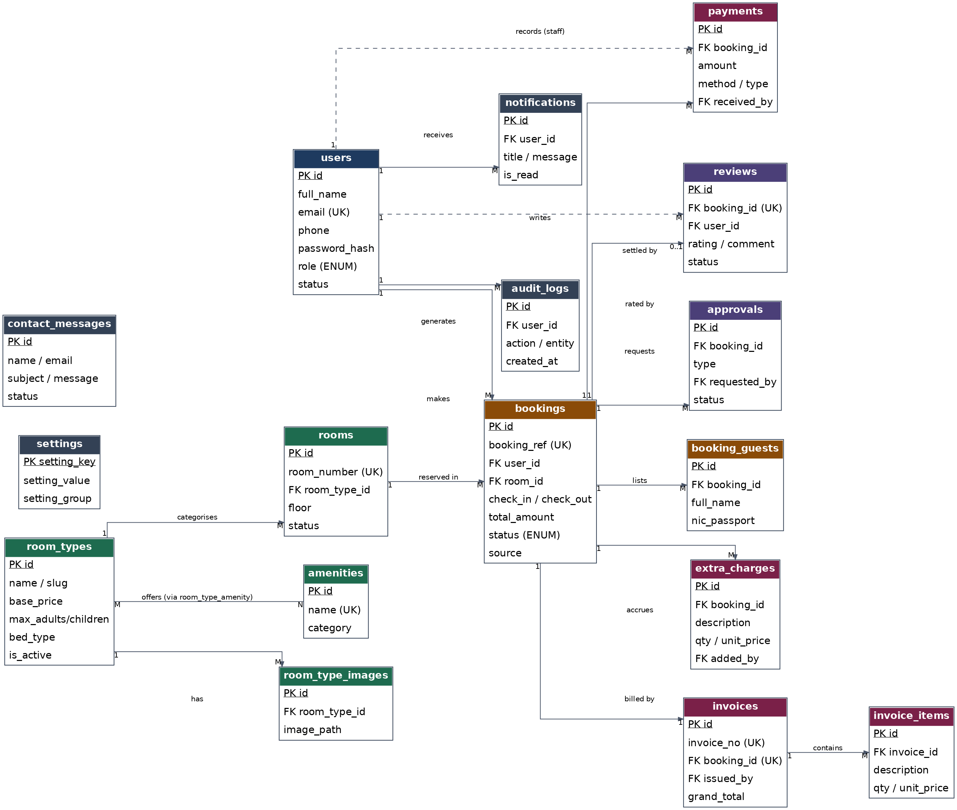
Figure 1 — Entity-Relationship Diagram of the hotel_reservation_db schema

7.1 Key relationships
- users → bookings (1:M) — a guest can make many bookings; staff members are recorded as the creator of walk-in bookings.
- room_types → rooms (1:M) — each room type (e.g. Deluxe Ocean View Double) can have many physical rooms.
- room_types ↔ amenities (M:N) — via the room_type_amenity pivot table.
- rooms → bookings (1:M) — a room accumulates many bookings over time; a composite index on (room_id, check_in, check_out, status) makes the overlap-availability query fast.
- bookings → invoices (1:1, enforced by a UNIQUE key) → invoice_items (1:M).
- bookings → payments (1:M) — supports partial payments and refunds (stored as negative amounts).
- bookings → reviews (1:0..1) and bookings → approvals (1:M) for the cancellation/refund/discount approval workflow.
- users → audit_logs (1:M) — every state-changing action across every module is recorded here.

8. Screenshots
The screens below were captured from the running application (Apache + MySQL via XAMPP, http://localhost/serandib_grand/), covering the public site, the guest-facing information display page, and the admin/staff/manager modules that implement the assignment’s add/update/delete requirement.
8.1 Home Page
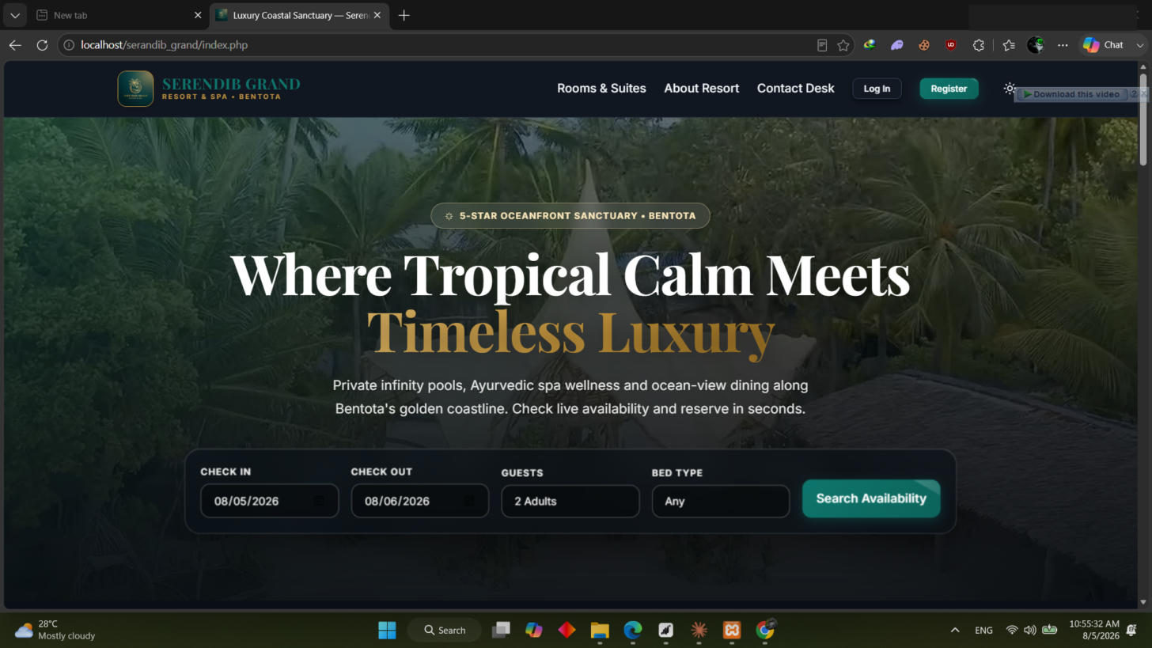
Figure 2 — Public home page with the inline availability search widget
8.2 Rooms & Availability (Information Display Page)
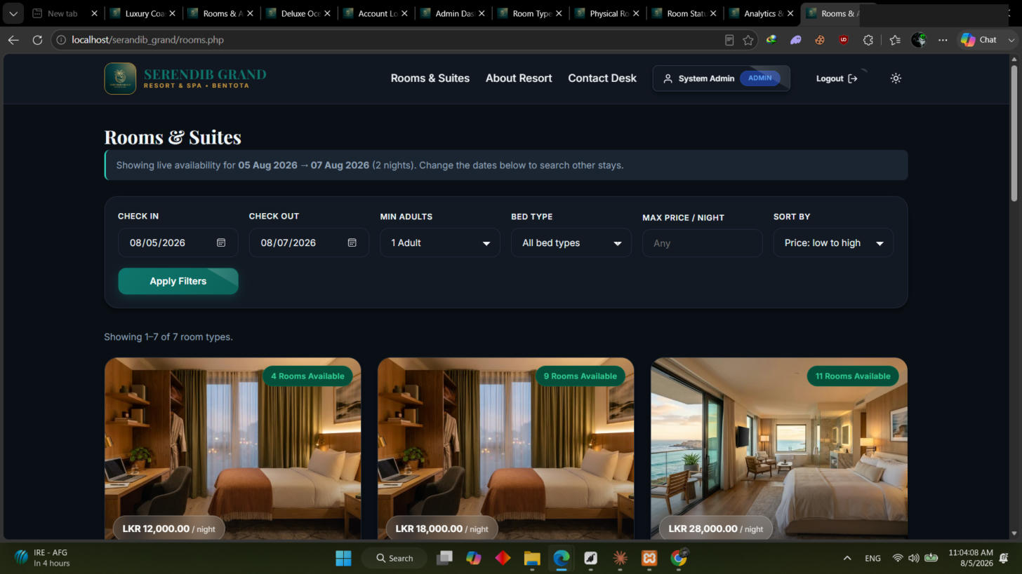
Figure 3 — Live room availability listing with filters, sorting, and pagination
8.3 Room Details
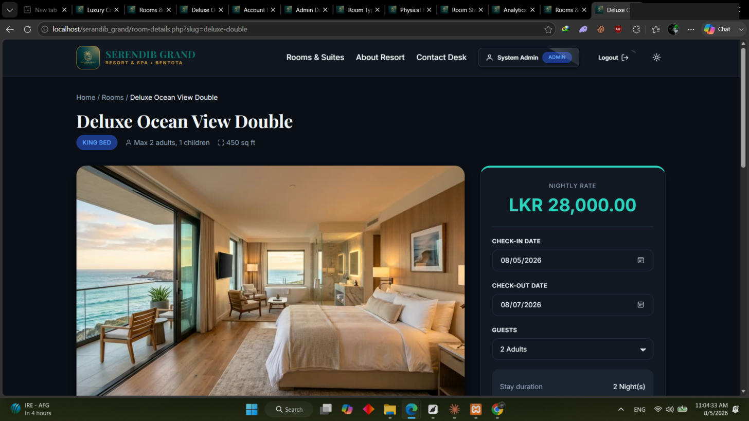
Figure 4 — Room details page with gallery, pricing, and a live price calculator
8.4 Admin — Room Types CRUD
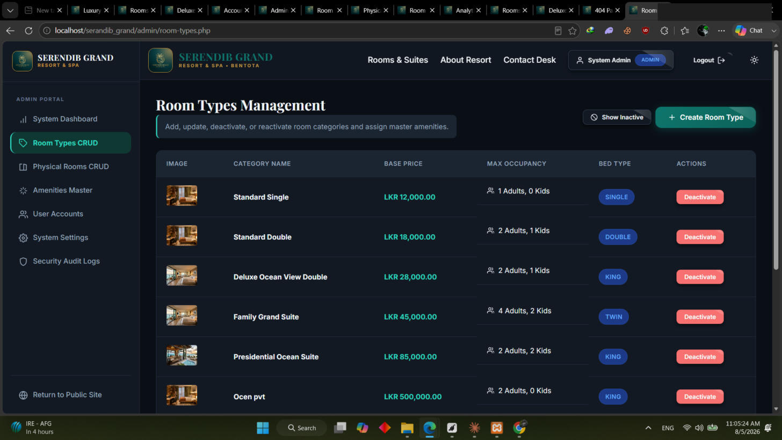
Figure 5 — Room Types management: create, edit, and deactivate room categories
8.5 Admin — Physical Rooms CRUD
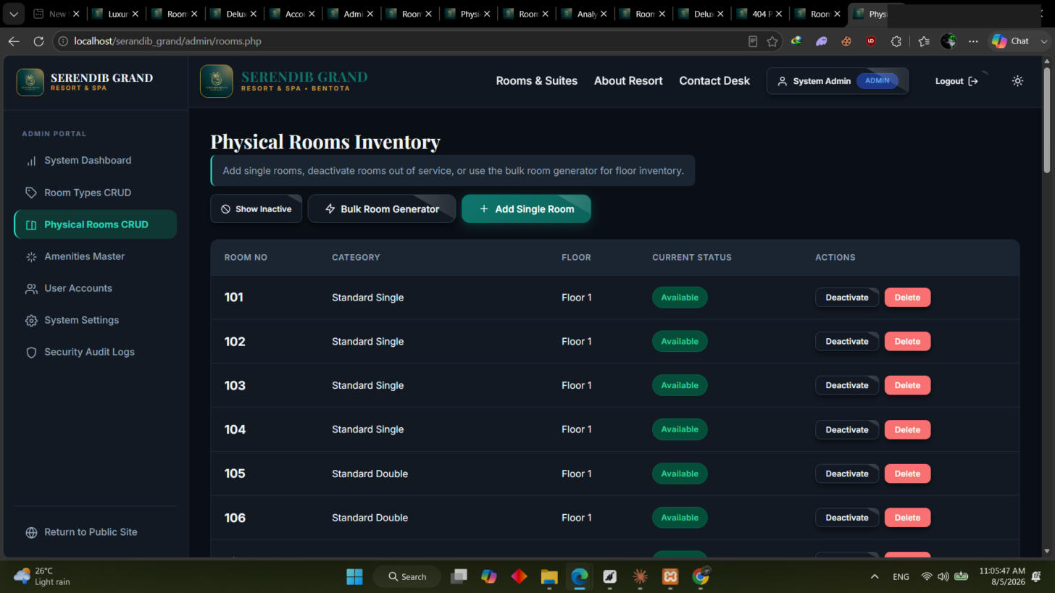
Figure 6 — Physical room inventory with Add, Deactivate, and Delete actions
8.6 Admin Dashboard
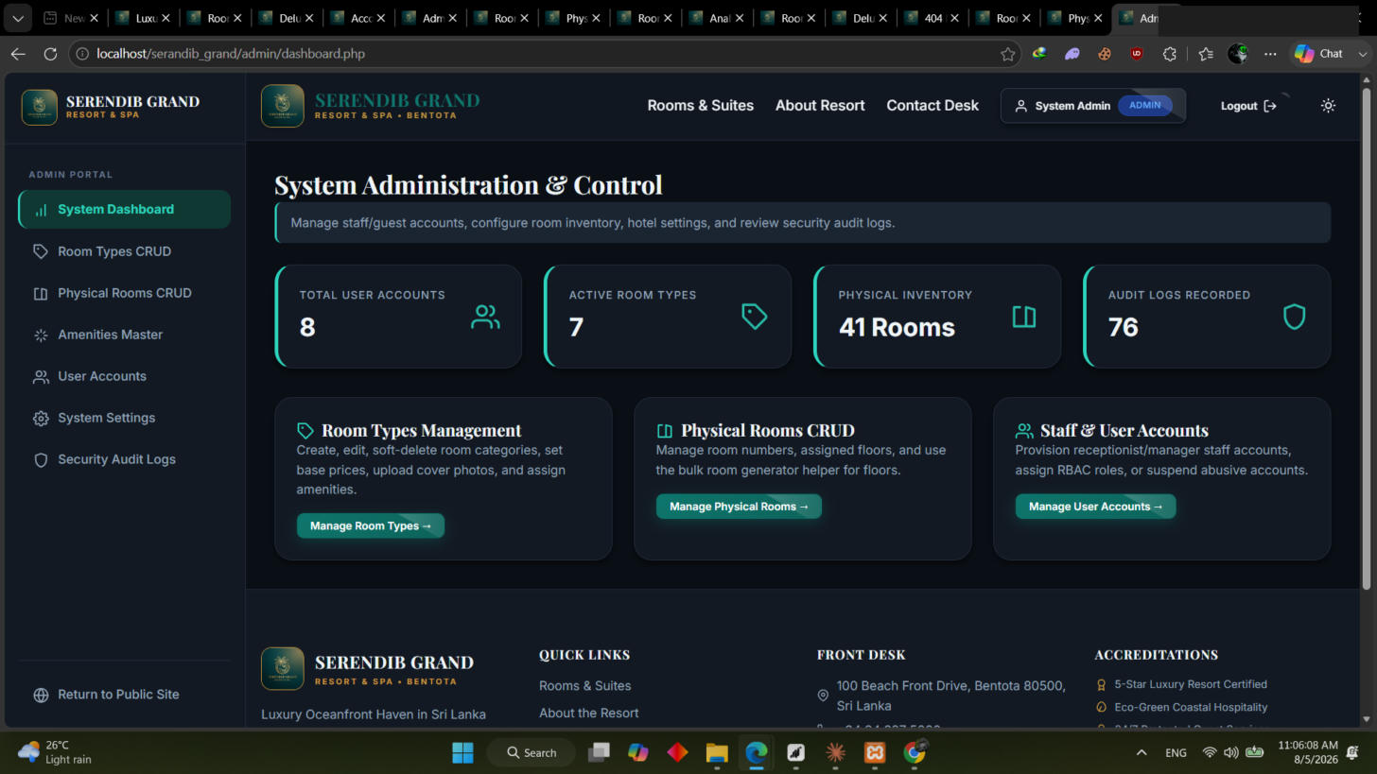
Figure 7 — System administration overview (users, room types, rooms, audit logs)
8.7 Front Desk — Room Status Board
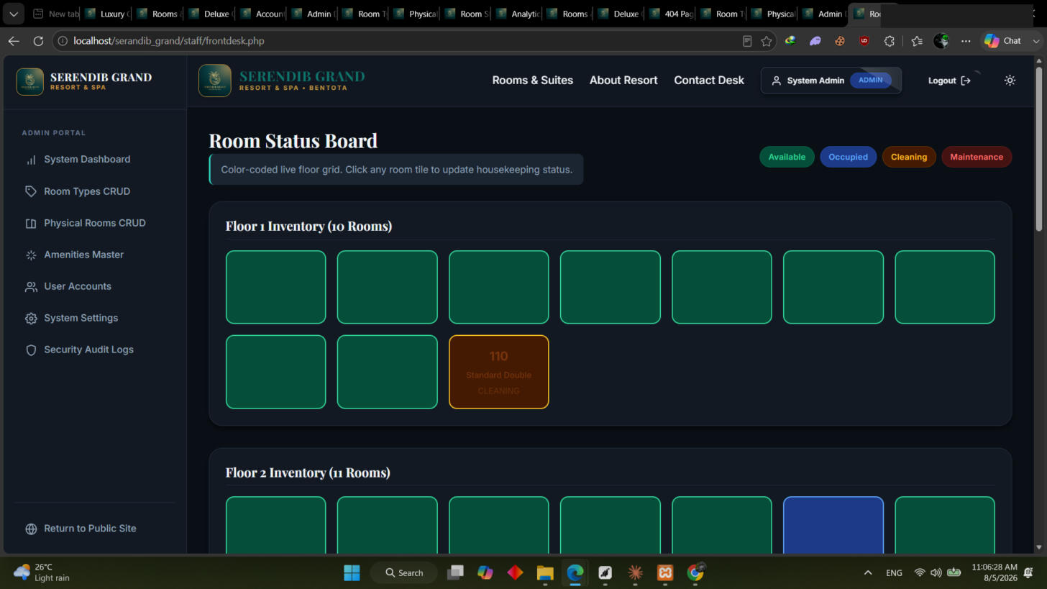
Figure 8 — Colour-coded, floor-by-floor room status board for receptionists
8.8 Manager — Executive Hotel Analytics
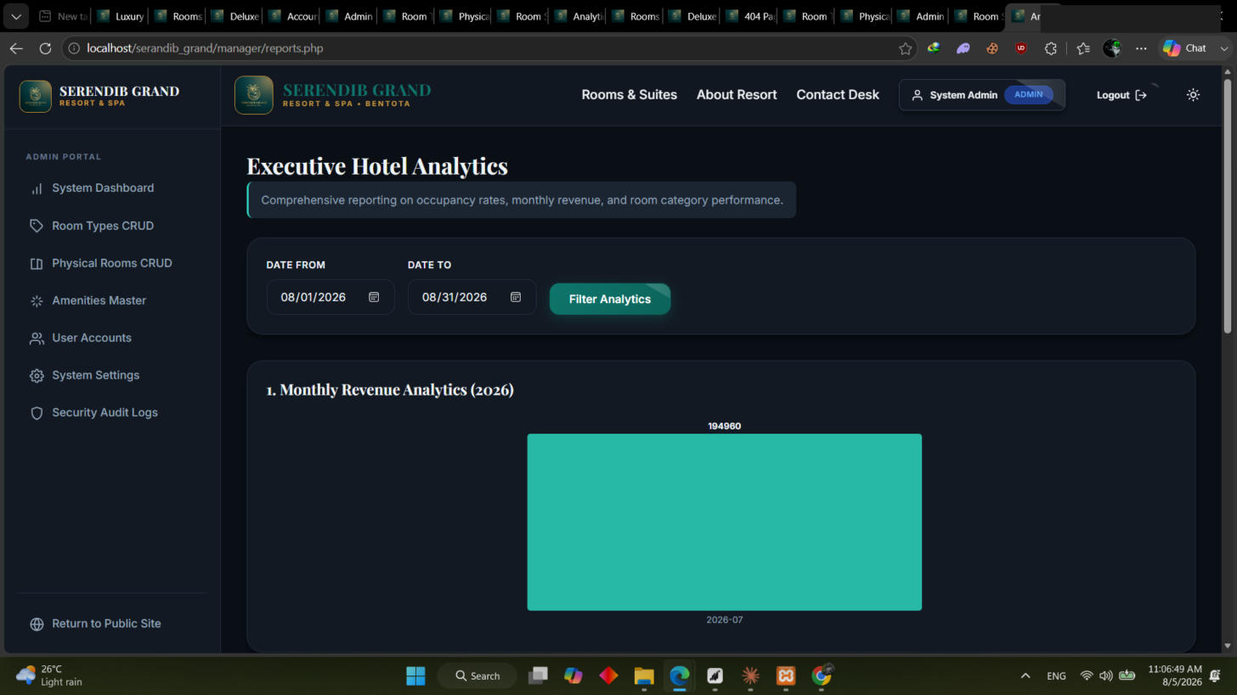
Figure 9 — Revenue and occupancy analytics with a date-range filter

9. Individual Contribution
Each of the 7 group members owned one module end-to-end — database design, model/service classes, page(s), styling, and testing for that module — which is reflected below and traceable through the project’s GitHub commit history.

M1 — W. Hirusha Suhan (UWU/IIT/23/011)
Module: Authentication & Account Security
Files owned: src/Core/Auth.php, Session.php, Csrf.php, RateLimiter.php · src/Models/User.php · auth/* · guest/profile.php
- Built the guest self-registration flow with a live server-side password-strength policy (min 8 chars, upper/lower/digit/symbol).
- Implemented login with Argon2id password verification, role-based redirect, and a generic "Invalid email or password" message to prevent account enumeration.
- Added login throttling (RateLimiter) that soft-locks an account for 15 minutes after 5 failed attempts from the same email/IP.
- Hardened sessions: fingerprinting, 30-minute idle timeout, 8-hour absolute timeout, and session ID regeneration on login/password change.
- Implemented CSRF token generation and verification (Csrf::field() / Csrf::verify()) used on every state-changing form.
- Built the profile page (update name/phone/NIC/address, change password) and the admin suspend/reactivate account workflow.

M2 — G. C. Sandeep (UWU/IIT/23/020)
Module: Room Type & Room Management (CRUD)
Files owned: src/Models/Room.php, RoomType.php, Amenity.php · admin/rooms.php · admin/room-types.php · src/Core/Uploader.php
- Built the Room Types CRUD screen — create, edit, and soft-delete (deactivate/reactivate) categories with base price, capacity, bed type, and size.
- Built the Physical Rooms CRUD screen — add single rooms, bulk-generate rooms across a floor range, edit, deactivate, and hard-delete (blocked automatically if the room has active bookings).
- Implemented the image uploader with MIME-sniffing, a 2 MB size limit, and randomly generated filenames to prevent path or filename attacks.
- Built the amenities master list (lookup table) and the many-to-many assignment of amenities to room types.
- Wired housekeeping status transitions (available / occupied / cleaning / maintenance) into the rooms table.

M3 — D. L. Chathuranga (UWU/IIT/23/030)
Module: Public Site & Availability Search
Files owned: index.php · rooms.php · room-details.php · about.php · contact.php · src/Services/AvailabilityService.php · api/availability.php
- Built the home page: hero section with an inline availability search widget, featured room types, and a facilities strip.
- Built the Rooms & Suites page (the information display page) with live "X rooms available" badges, filters (price, capacity, bed type), sorting, and pagination.
- Built the room details page with an image gallery, amenity list, and a price calculator that recalculates via AJAX as dates change.
- Implemented the core overlap-detection SQL in AvailabilityService that prevents a room from being shown as available if it already has a pending/confirmed/checked-in booking for the requested dates.
- Built the About and Contact pages, including the contact-form message store.

M4 — L. A. S. Dilshi (UWU/IIT/23/015)
Module: Guest Booking Module
Files owned: src/Models/Booking.php · src/Services/BookingService.php, PricingService.php · guest/booking-form.php · guest/my-bookings.php
- Built the 3-step booking form (dates & occupancy → guest details → review & confirm) with server-side re-validation on every step.
- Implemented PricingService — automatic calculation of nights × room rate, seasonal surcharge, service charge, and tax, all pulled from the settings table.
- Implemented BookingService::create() inside a database transaction with a row lock (FOR UPDATE) and a second in-transaction availability check to prevent double-booking under concurrent requests.
- Built "My Bookings" (the second information display page) — tabbed Upcoming / Past / Cancelled views with update and cancel actions.
- Implemented the booking-reference generator (e.g. HRS-20260805-4F7A) with collision retry logic.

M5 — W. A. M. S. Wickramarachchi (UWU/IIT/23/014)
Module: Front Desk Operations
Files owned: staff/frontdesk.php, checkin.php, checkout.php, bookings.php · src/Services/FrontDeskService.php
- Built the Room Status Board — a floor-by-floor colour-coded grid for updating housekeeping status with a single click.
- Built the receptionist's Today's Arrivals / Departures / In-House lists.
- Implemented the walk-in booking flow (search an existing guest or create one inline, then book directly as confirmed).
- Implemented check-in (validates the booking is confirmed and the date has arrived, sets the room to occupied) and check-out (shows the folio, blocks checkout while balance > 0).
- Built the confirm/reject workflow for pending online bookings.

M6 — M. A. T. Emalsha (UWU/IIT/23/016)
Module: Payments, Extra Charges & Invoicing
Files owned: src/Models/Payment.php, Invoice.php, ExtraCharge.php · src/Services/InvoiceService.php · staff/payments.php, invoice.php · assets/css/print.css
- Built the payment recording screen supporting partial payments, multiple methods (cash, card-at-hotel, bank transfer), and automatic unpaid/partial/paid status derivation.
- Built the extra charges ledger (minibar, laundry, late checkout) with running totals.
- Implemented InvoiceService — sequential invoice numbering generated inside a transaction, with line items snapshotted so later price changes never alter an already-issued invoice.
- Built the print-optimised invoice page using a dedicated @media print stylesheet (hides navigation, hotel letterhead, black-on-white).
- Implemented the refund workflow (stored as a negative payment row with a required reason).

M7 — M. R. A. D. Abeyrathne (UWU/IIT/23/047)
Module: Manager Dashboard, Reports & Moderation
Files owned: src/Services/ReportService.php · manager/dashboard.php, approvals.php, reports.php, reviews.php · admin/audit-logs.php
- Built the manager dashboard KPI cards: occupancy %, arrivals, departures, in-house guests, daily and month-to-date revenue, ADR, and pending approvals count.
- Built the Executive Hotel Analytics page — monthly revenue, revenue by room type, bookings by status, and cancellation-rate reports with a date-range filter and chart rendering.
- Built the approval queue for cancellation, refund, and discount requests raised by front-desk/guest actions.
- Built the review moderation screen (approve / hide / delete with a logged reason).
- Built the audit log viewer with filters by user, action, entity, and date range, backed by the AuditLog::record() calls made from every other module.

9.1 Shared Foundation
The database schema (schema.sql, seed.sql), the bootstrap/autoload chain, the shared layout partials (includes/header.php, nav.php, sidebar.php, footer.php), and the base CSS design-token system were built collaboratively by the whole group in the first week before module work was split, and changes to these shared files afterwards were reviewed by at least two members before merging.

