1. Run

docker-compose up –build

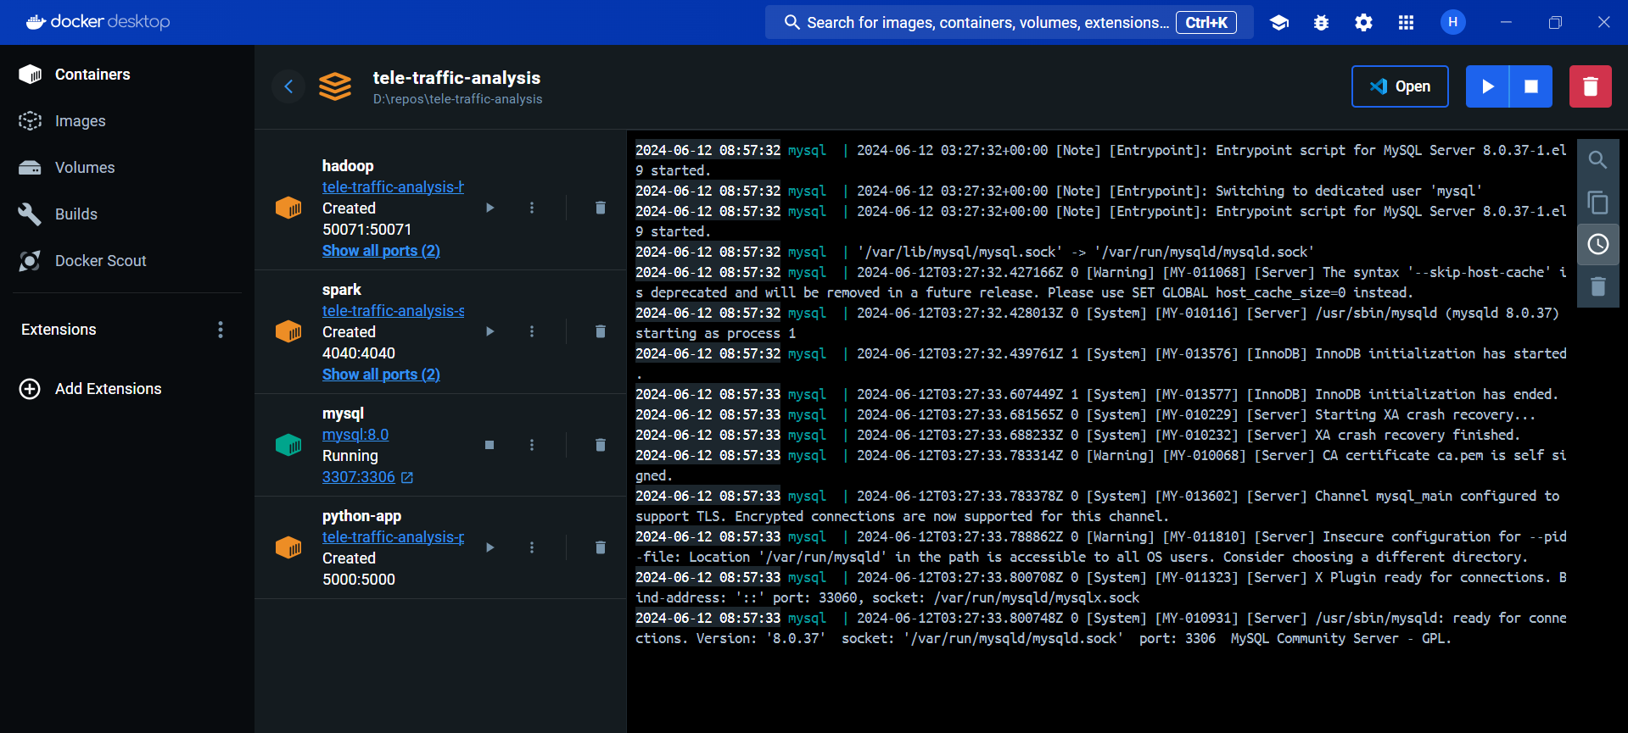

1. Inside mysql, the db was not created. So ran the sql script manually from the mysql cmd
   1. Connect mysql

mysql -u root -p

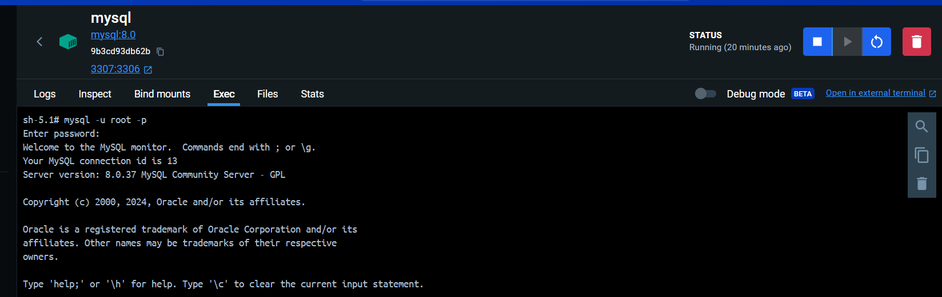

* 1. Run db scripts

source /docker-entrypoint-initdb.d/1_init_db.sql

source /docker-entrypoint-initdb.d/2_create_views.sql



* 1. DB was created

SHOW DATABASES;

1. Connect mysql Docker with MySQL Workbench
   1. IP address of your MySQL container

docker inspect -f '{{range.NetworkSettings.Networks}}{{.IPAddress}}{{end}}' <container_name_or_id>

* 1. Using the IP address & password create a new connection in Workbench

