# Azure DevOps – Theoretical Assignment

## Project: TeamPulse – Project Management Dashboard

The TeamPulse project is a web-based project management dashboard designed to help organizations track productivity, project milestones, and collaboration efficiency. This document outlines the theoretical Azure DevOps structure for managing and planning this project using Agile methodology.

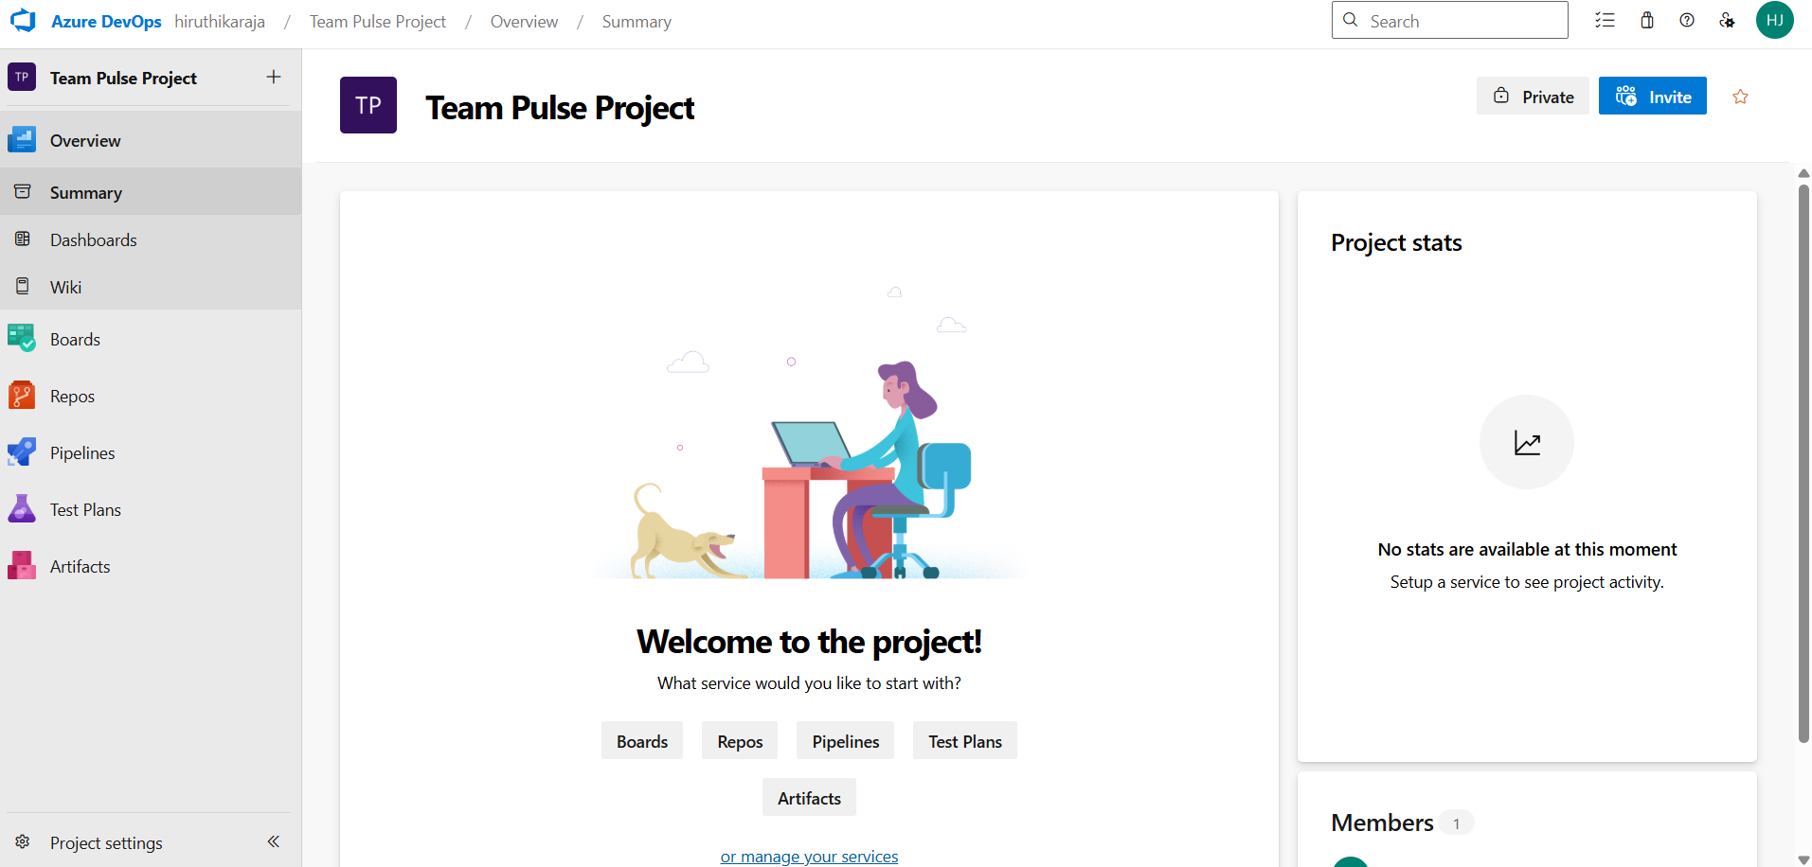

## Epic

TeamPulse – Project Management Dashboard

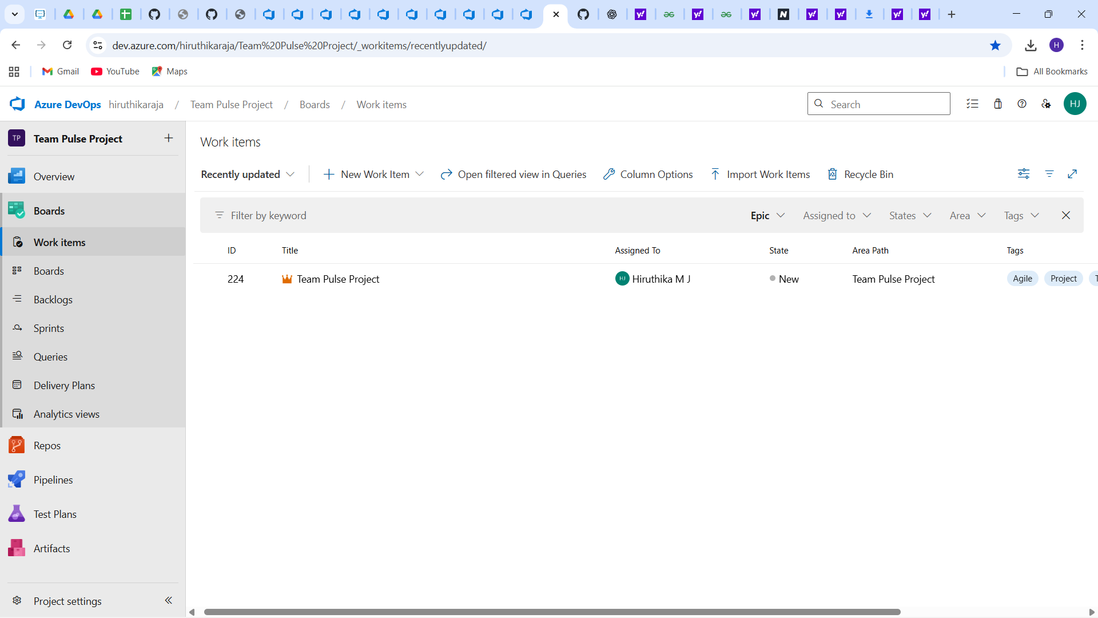

## Features

* 1. User Authentication & Role Management
* 2. Dashboard Analytics & KPIs
* 3. Task & Sprint Management
* 4. Team Chat & Notifications

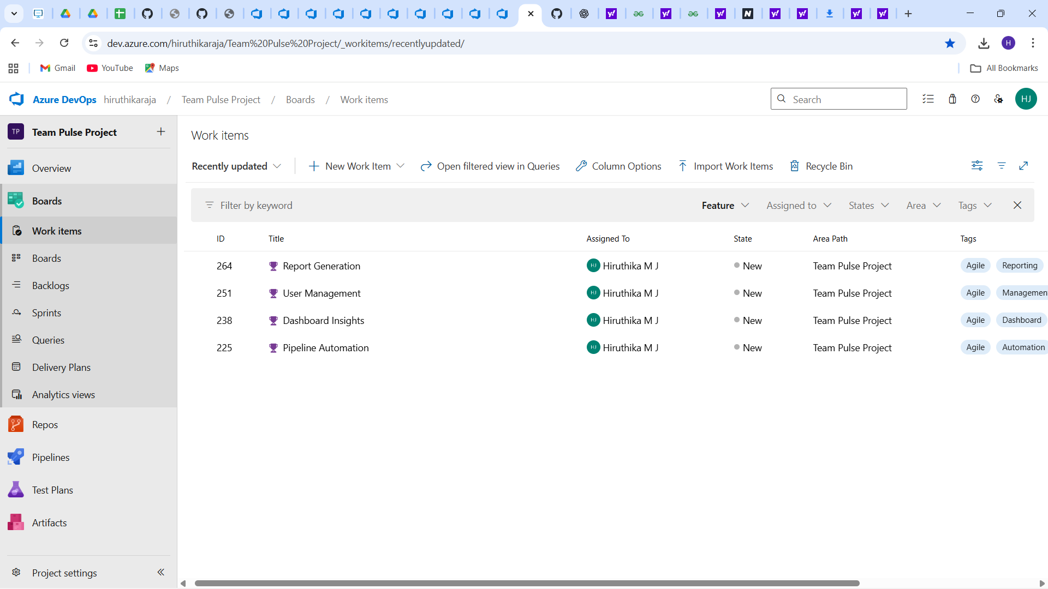

## User Stories Example (for Feature 1: User Authentication & Role Management)

* As an Admin, I want to create user accounts so that I can manage access.
* As a Manager, I want to assign roles to users for access control.
* As a User, I want to log in using my credentials to view assigned tasks.

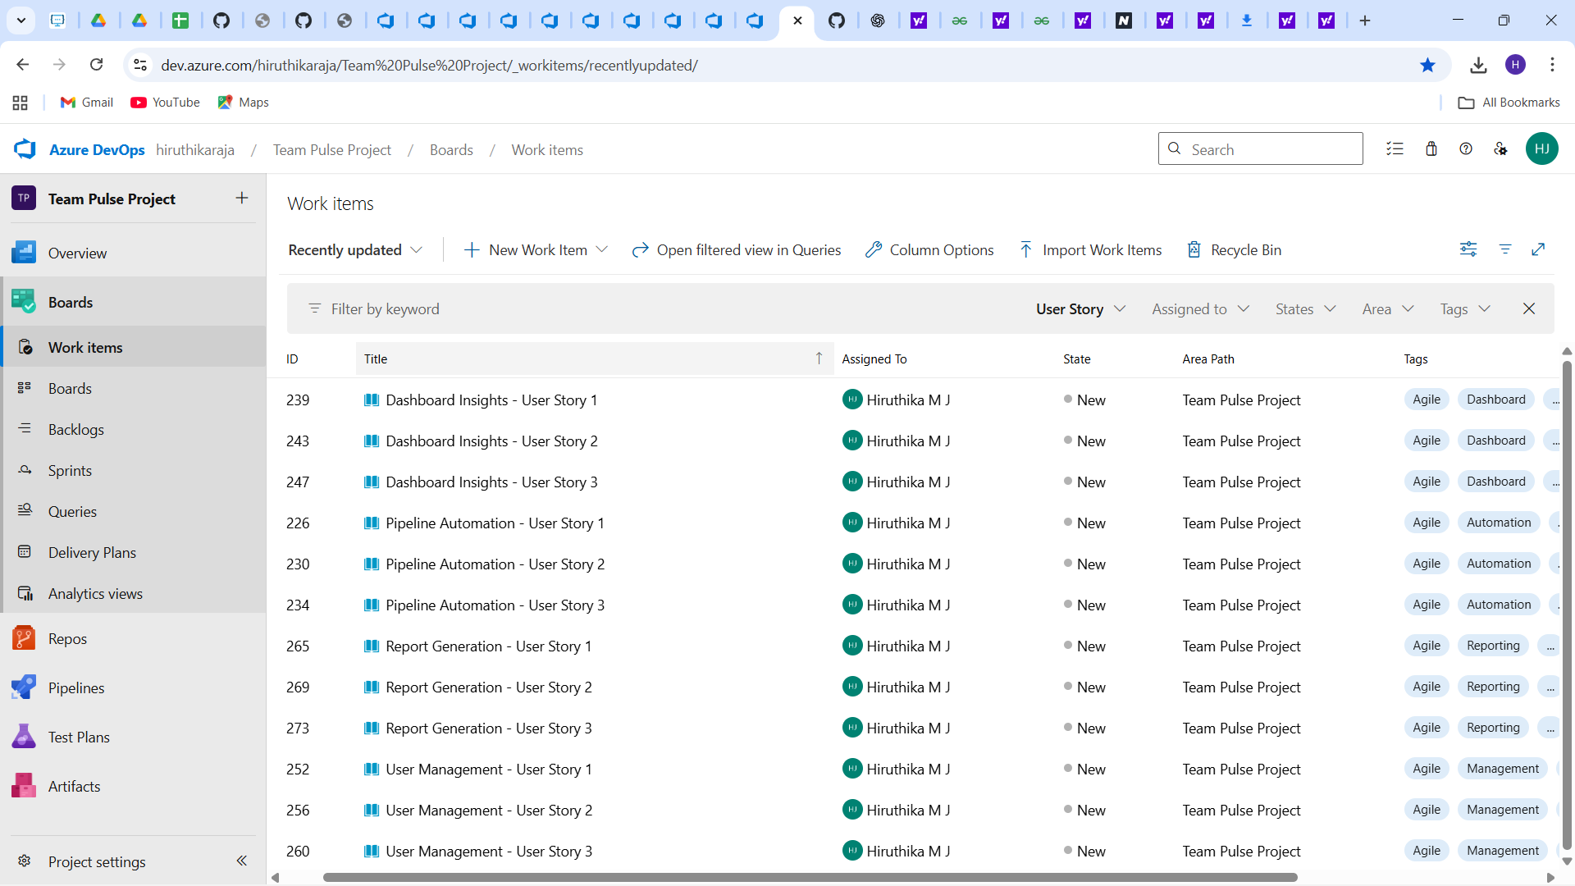

## Tasks Example (for User Story 1)

* Define user roles and permissions.
* Design the login and registration form.
* Create theoretical data flow diagrams.
* Document password reset logic. 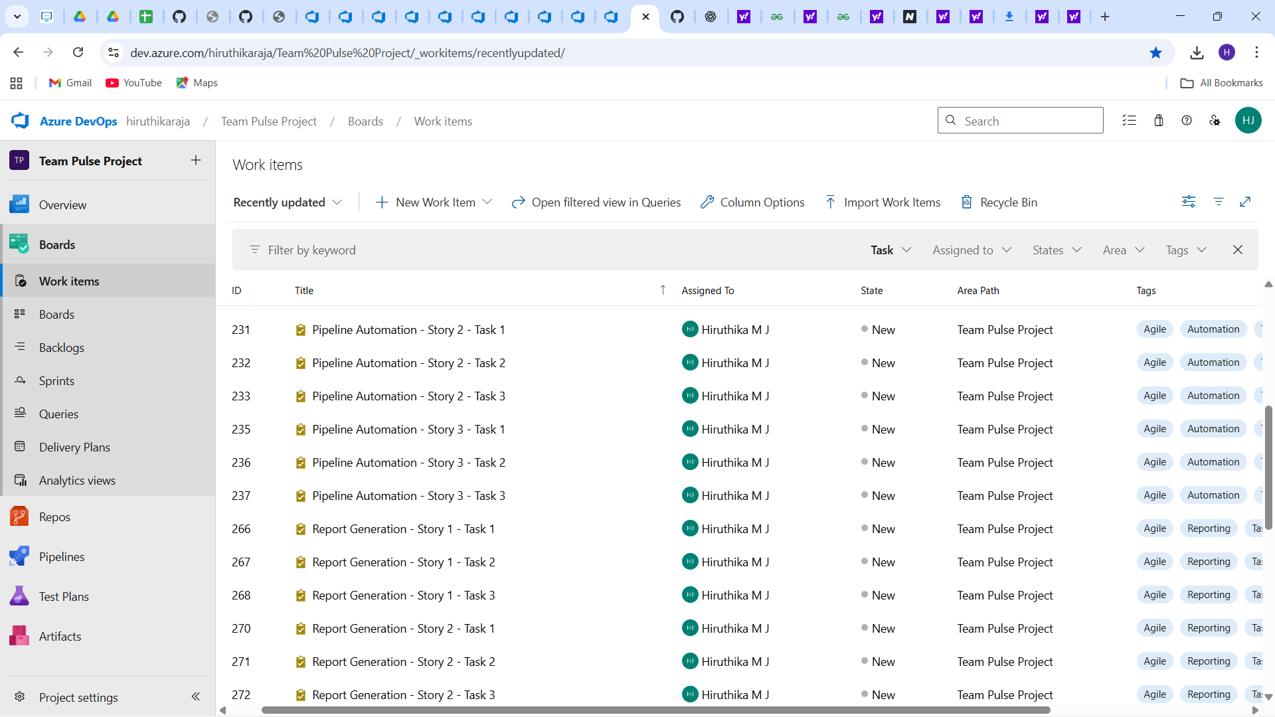

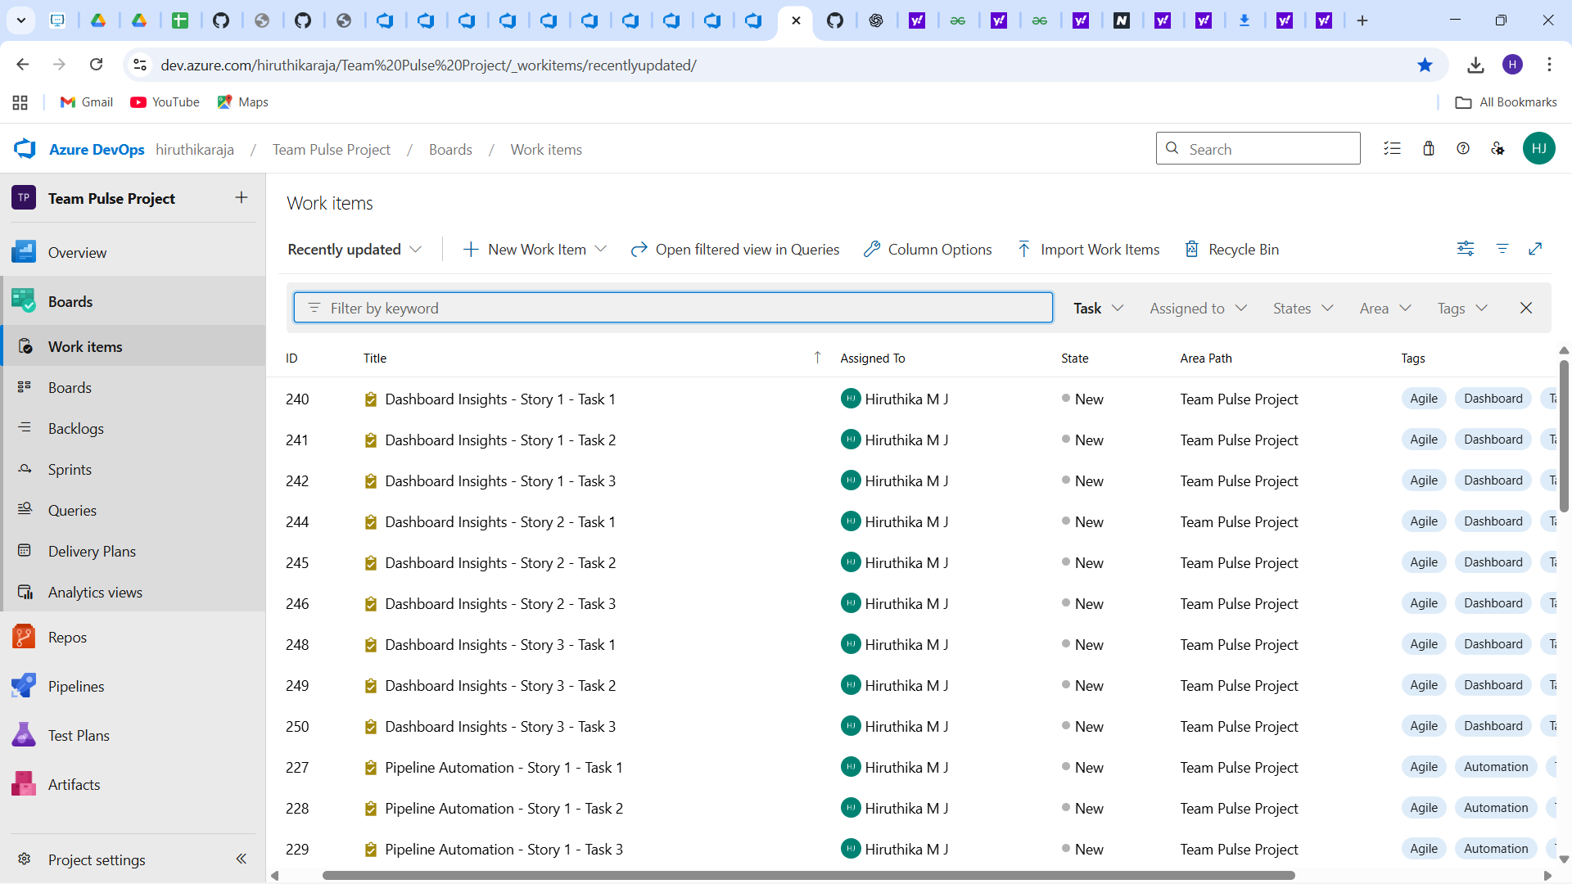

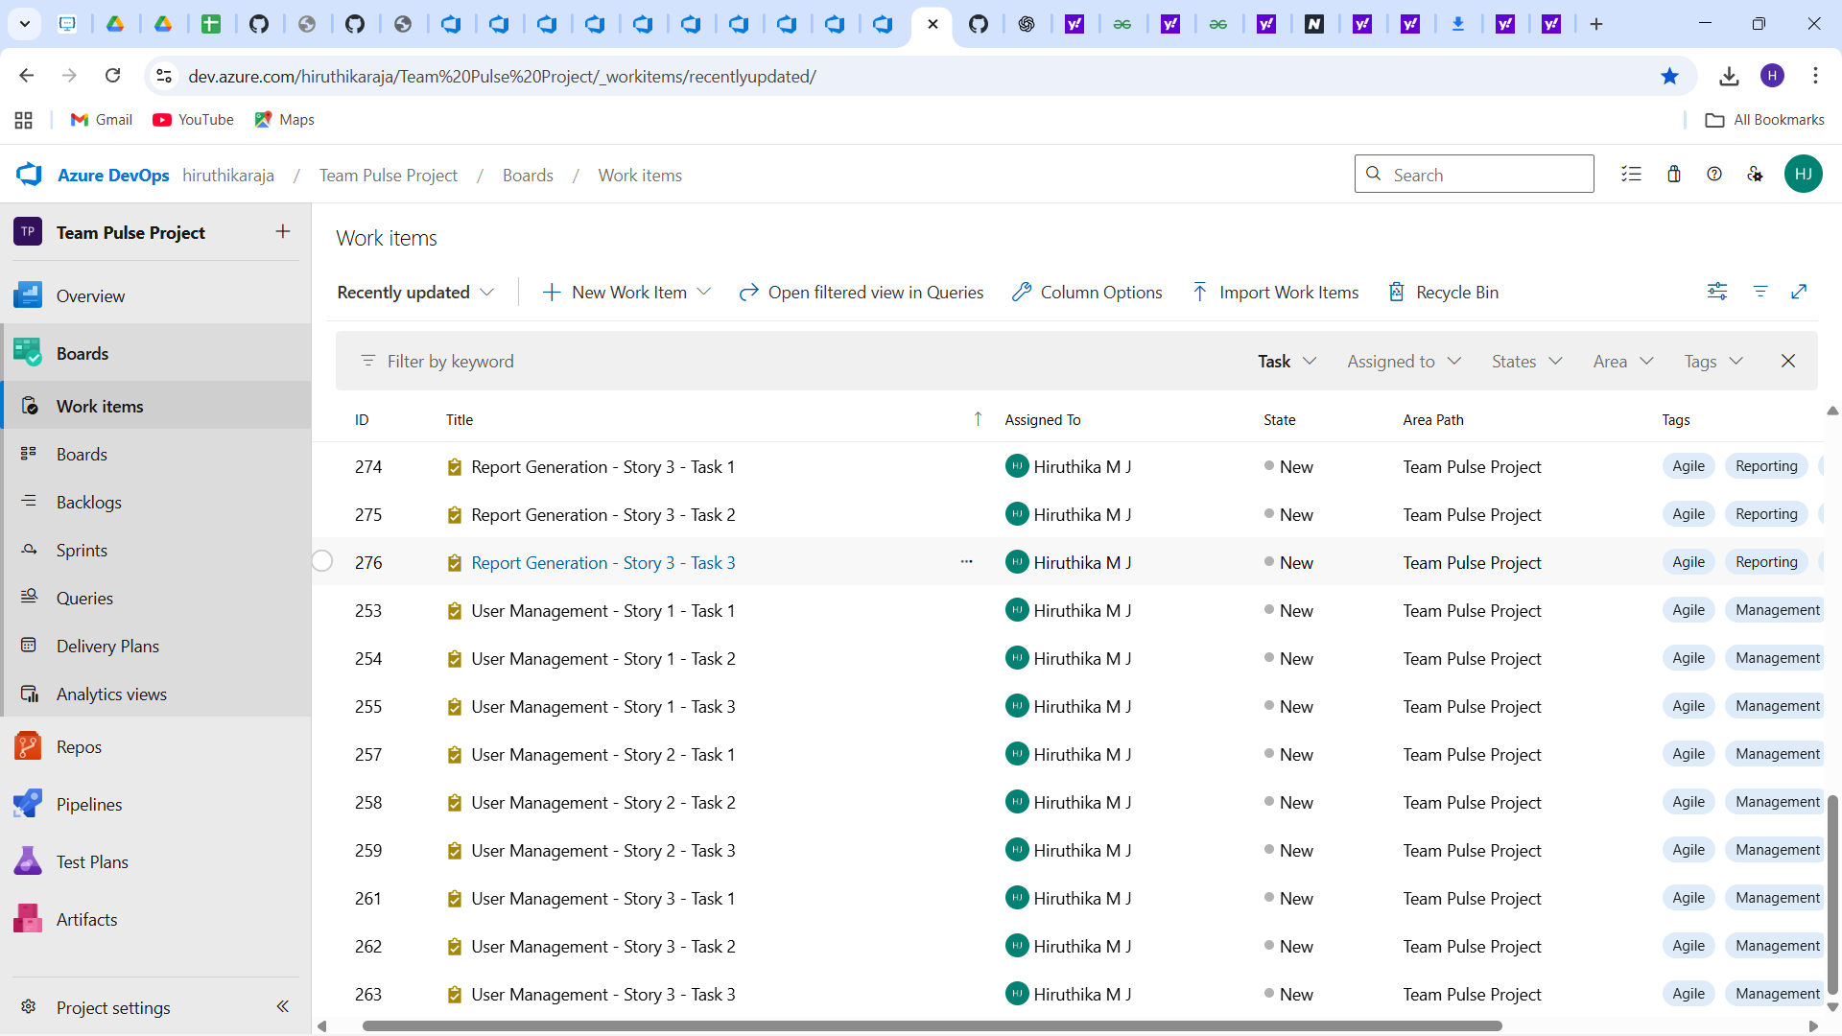

## How Azure DevOps Supports Agile Methodology

Azure DevOps supports Agile methodology by providing a structured framework to manage work items, sprints, and team collaboration. It allows teams to plan, track, and discuss work across the entire development lifecycle. Features such as Boards, Backlogs, and Sprints enable smooth sprint planning and progress tracking. Real-time updates, dashboards, and burndown charts enhance visibility and accountability within the team.

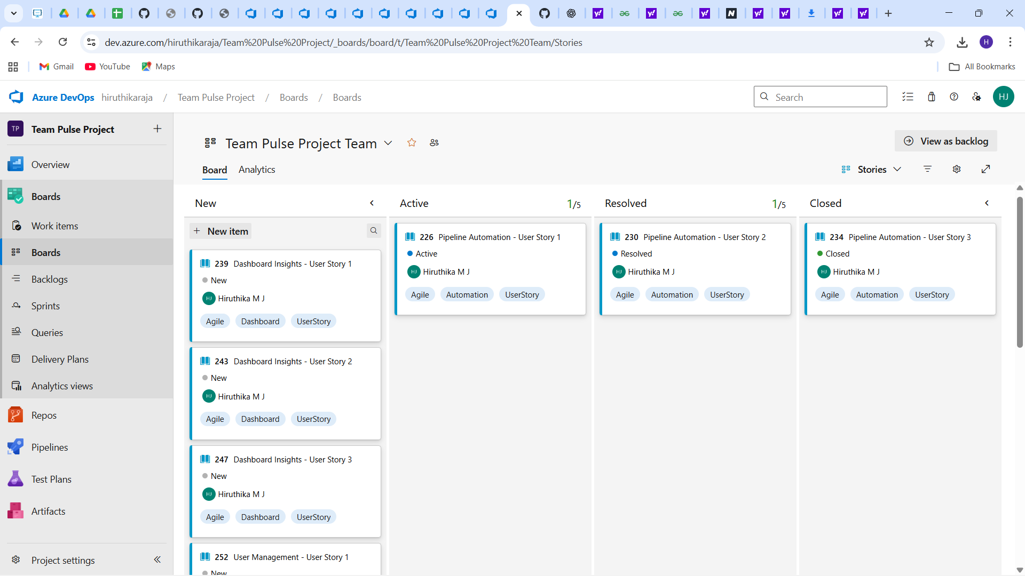

## Benefits of Breaking Large Projects into Smaller Work Items

Breaking large projects into smaller work items ensures better clarity, task ownership, and measurable progress. It helps teams identify dependencies early, manage workload efficiently, and prioritize deliverables. This approach reduces risks and improves overall project predictability and quality.

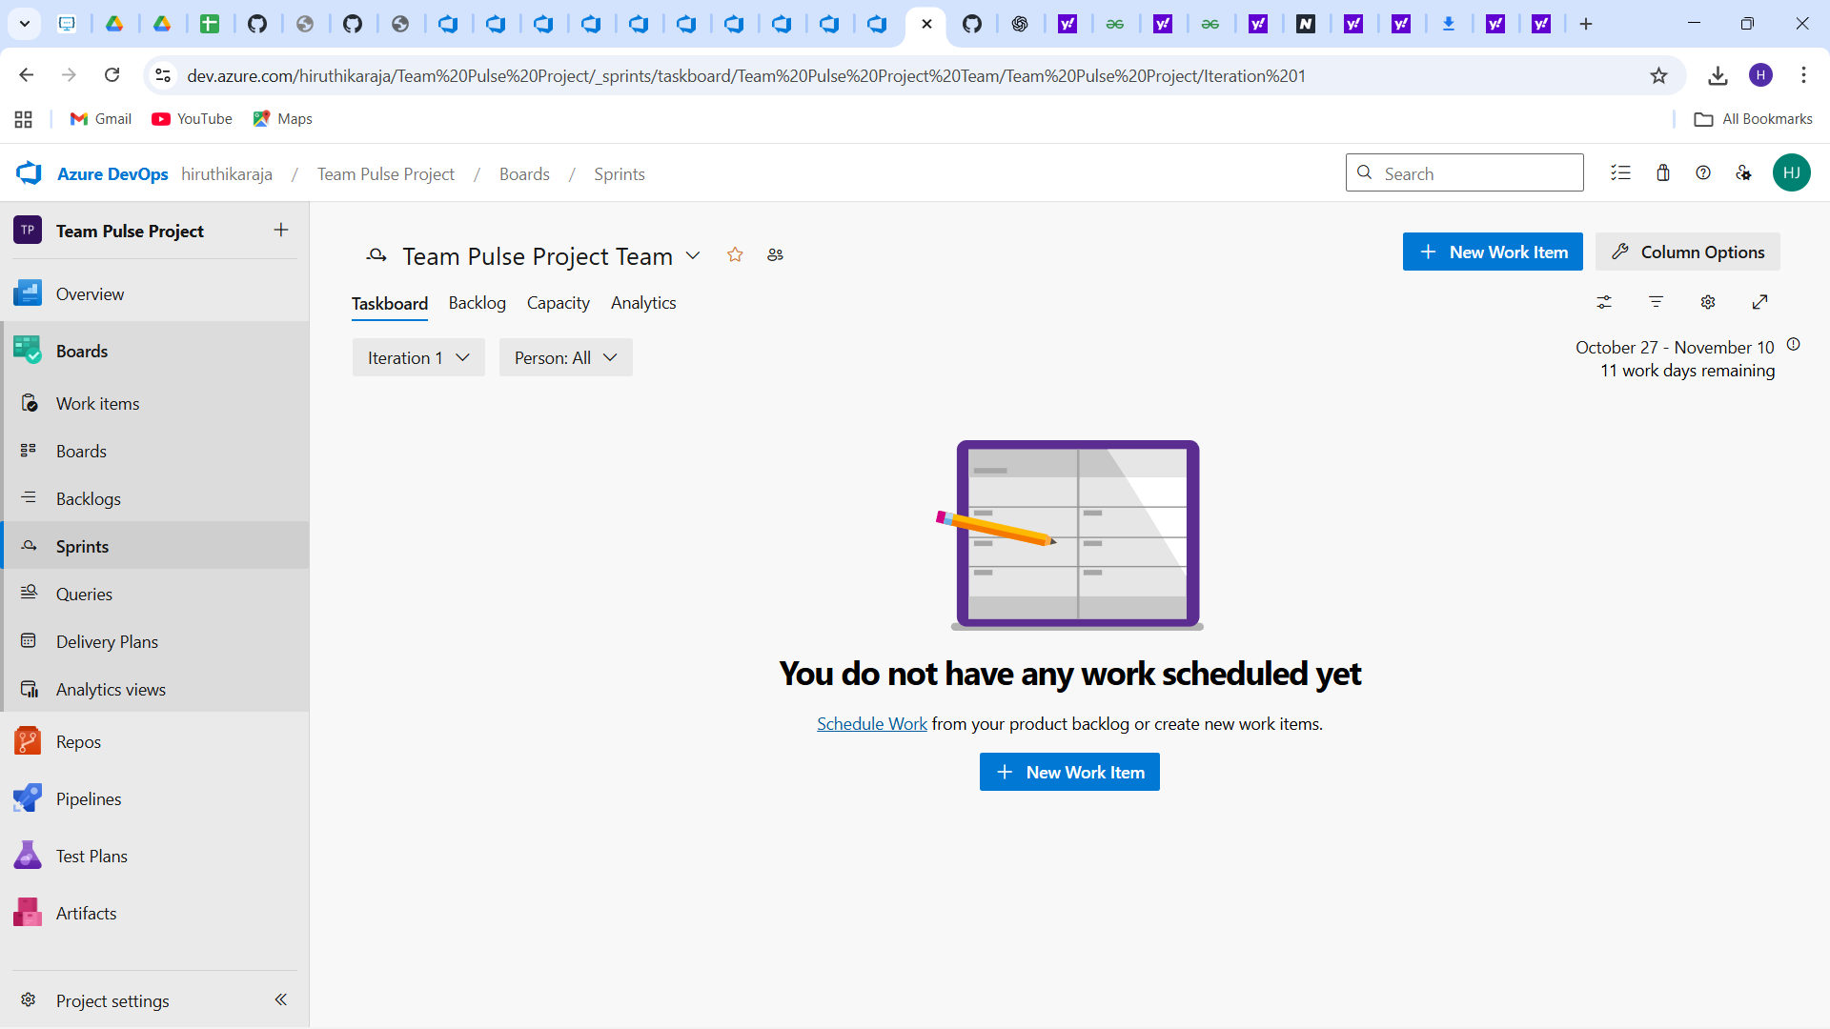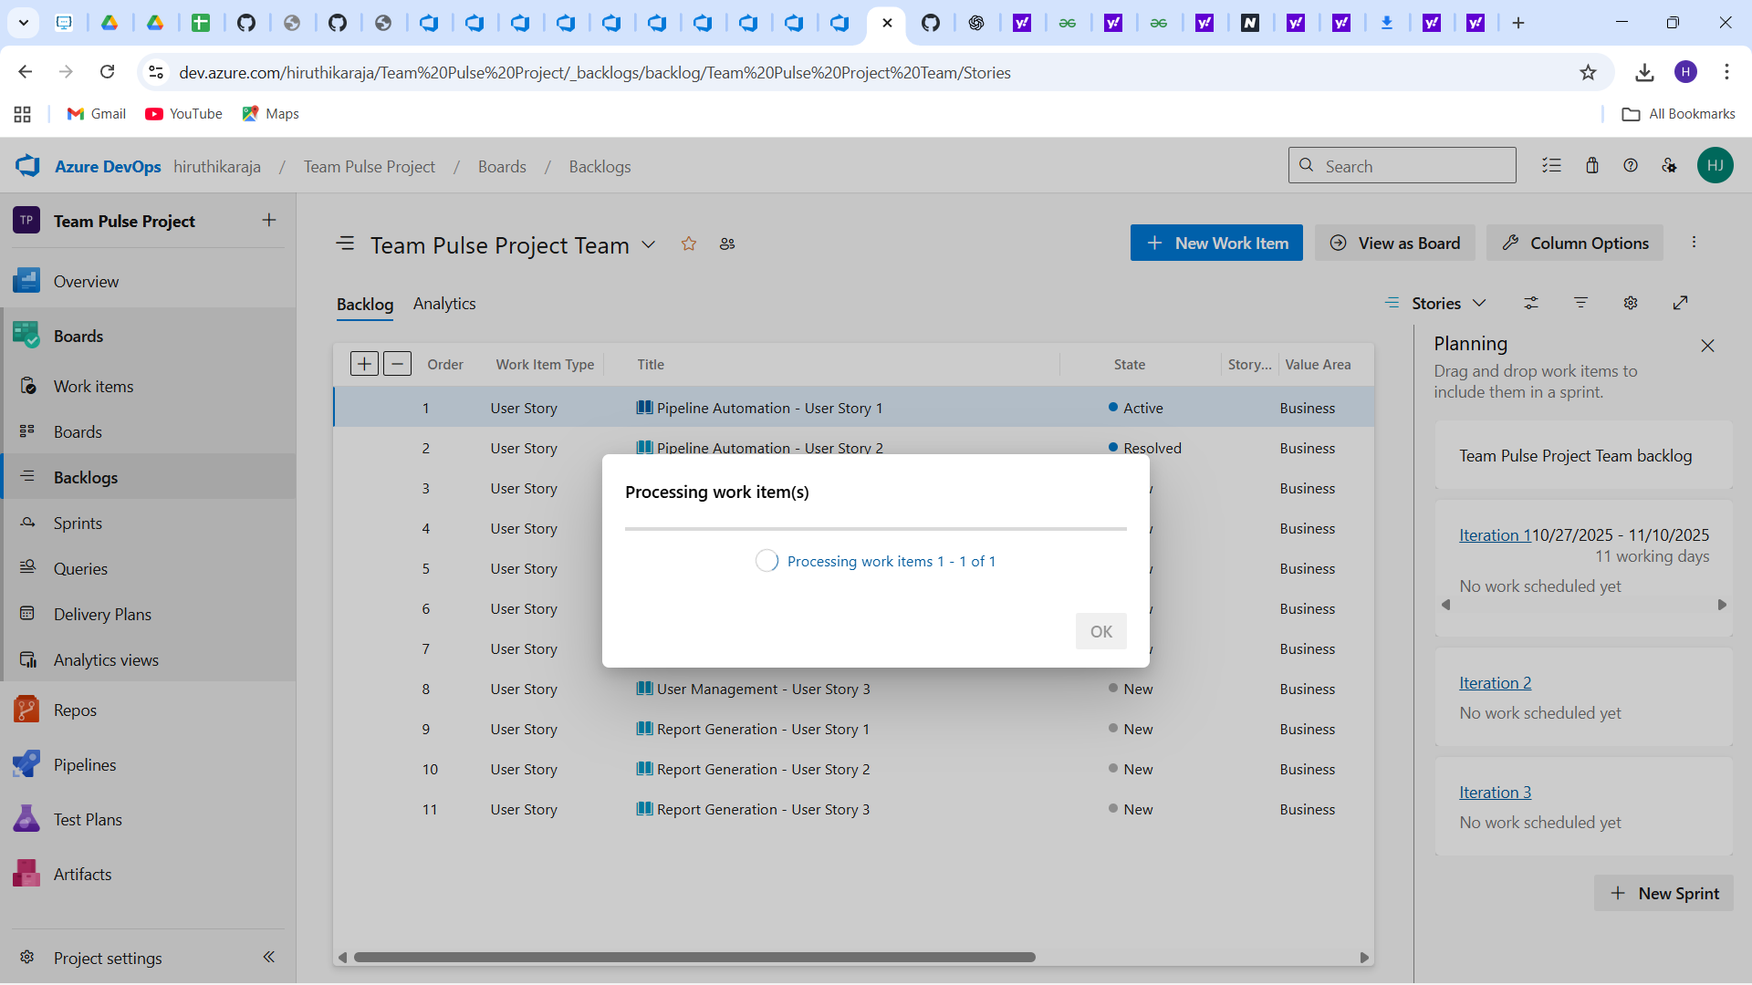

## Iteration / Sprint Planning

Sprint 1 has been created in Azure DevOps and includes selected user stories from the 'User Authentication & Role Management' feature. Each story has been assigned tasks to be completed within the sprint duration. The sprint view helps visualize ongoing work, track progress, and ensure sprint goals are met.

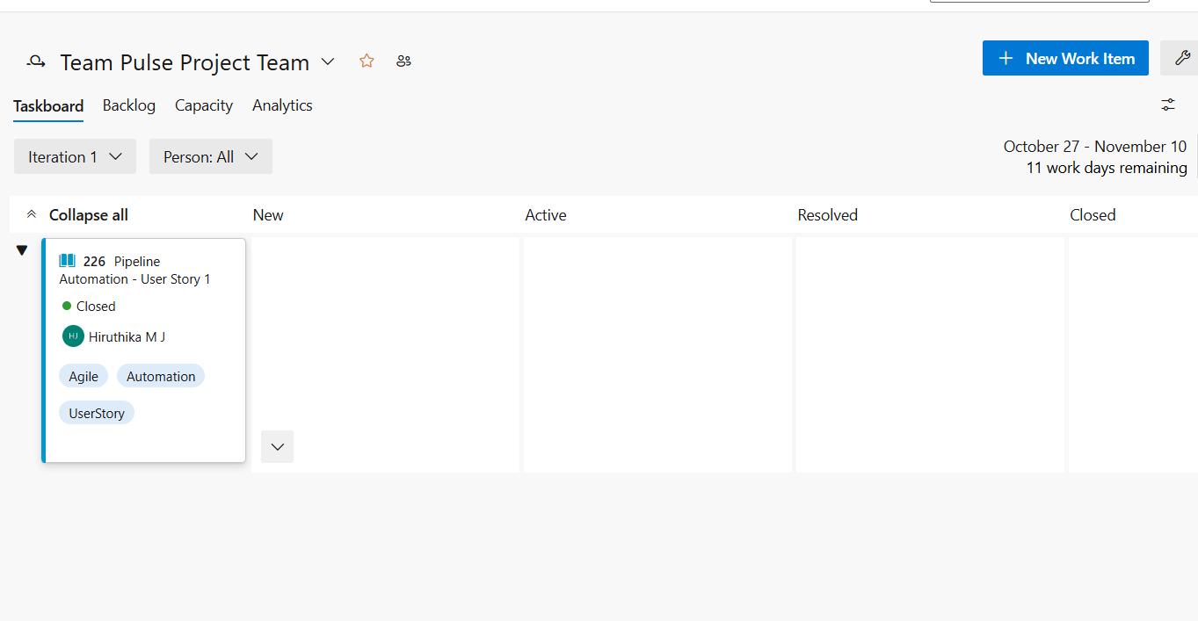

## Tags and Priorities

Tags have been used to categorize user stories based on components such as Frontend, Backend, and Database. Priority levels have been assigned to ensure focus on high-impact tasks:  
• P1 – High Priority  
• P2 – Medium Priority  
• P3 – Low Priority

## Acceptance Criteria (for Sample User Story)

* User must receive an error message if login fails.
* Only admins can create new accounts.
* Passwords must meet minimum security requirements.

## Definition of Done (DoD)

A task is considered 'Done' when it has been developed, documented, reviewed by peers, and validated against acceptance criteria. All related documentation must be updated, and the item should be ready for integration testing and deployment.

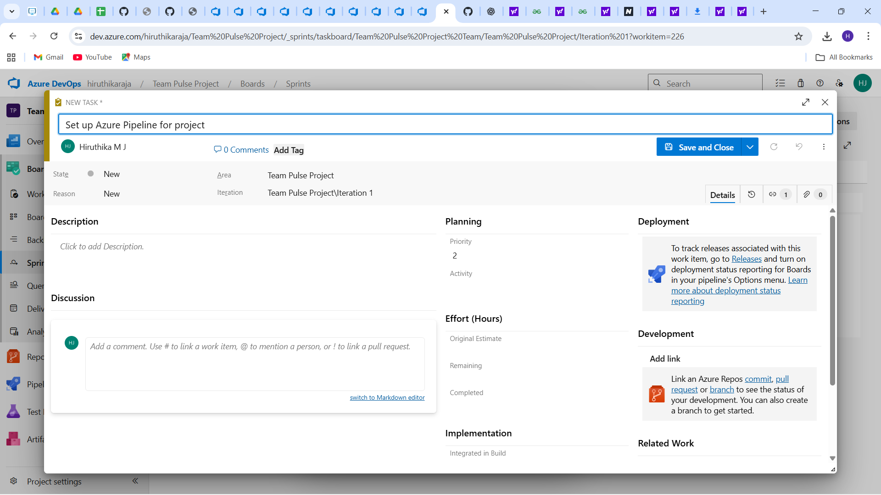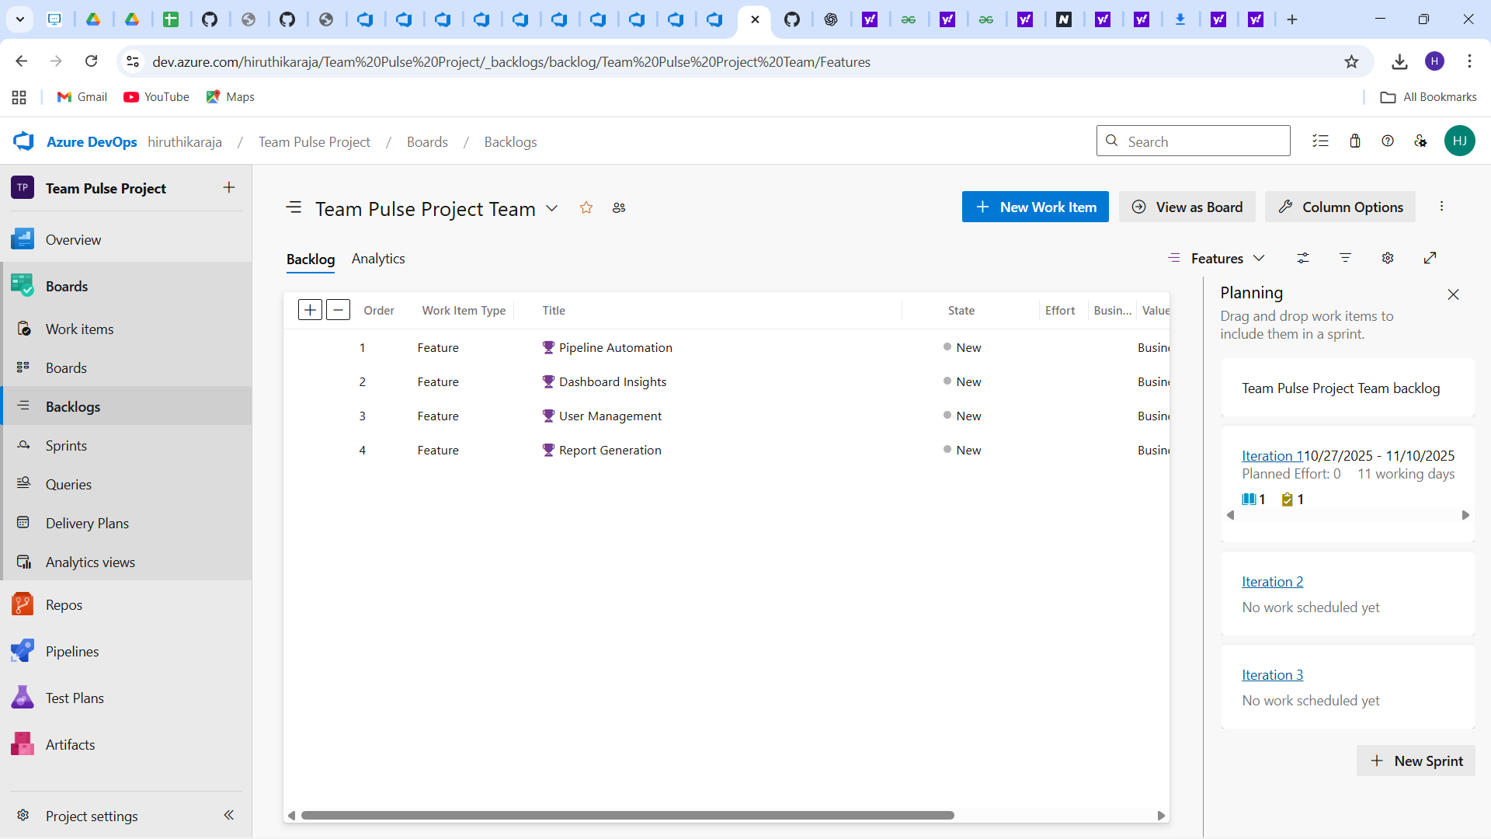

## Burndown Chart (Optional – Bonus Section)

A Burndown Chart can be viewed under the Analytics or Dashboard tab in Azure DevOps. It visually represents the remaining work in Sprint 1 and helps track sprint progress against planned efforts.

