## CP-III Project Report on

**E-commerce Website**

at

**U. V. Patel College of Engineering**



|  |  |
| --- | --- |
| **Internal Guide:** | **Prepared By:** |
| Prof. Pravesh S. Patel | Ms. Hirva Khunt  (19012011019) |
|  | Ms. Gracy Patel  (19012021052) |

### B. Tech Semester VII

**(Computer Engineering/Information Technology)**

## Nov-Dec, 2022

Submitted to,

## Department of Computer Engineering/Information Technology

U.V. Patel College of Engineering Ganpat University, Kherva - 384 012

**U.V. PATEL COLLEGE OF**

**ENGINEERING**



**28/11/22**

**CERTIFICATE**

# TO WHOM SO EVER IT MAY CONCERN

This is to certify that Ms. Hirva Khunt student of **B.Tech. Semester VII (Computer Engineering)** has completed his/her full semester on site project work titled “**E-commerce Website**” satisfactorily in partial fulfillment of the requirement of Bachelor of Technology degree of Computer Engineering of Ganpat University, Kherva, Mehsana in the year 2022-2023.

|  |  |
| --- | --- |
| **Prof. Pravesh S. Patel** | **Dr. Paresh M. Solanki** |
| **College Project Guide** | **Head, Computer Engineering** |

**U.V. PATEL COLLEGE OF**

**ENGINEERING**



**25/11/22**

**CERTIFICATE**

# TO WHOM SO EVER IT MAY CONCERN

This is to certify that Ms. Gracy Patel student of **B.Tech. Semester VII (Information Technology)** has completed his/her full semester on site project work titled “**E-commerce Website”** satisfactorily in partial fulfillment of the requirement of Bachelor of Technology degree of Information Technology of Ganpat University, Kherva, Mehsana in the year 2022-2023.

|  |  |
| --- | --- |
| **Prof. Pravesh S. Patel** | **Dr. Devang Pandya** |
| **College Project Guide** | **Head, InformationTechnology** |

**Acknowledgment**

A small website like this one has required help from many quarters. We realized this when we ventured into the area of web development. From the beginning, everyone our Project mentor Prof.Pravesh Patel, Classmates, Friends co-operated, an supported us for which we express our sincere acknowledgement.

Training is the first step in the practical field from where one learns how to apply theory principles for this the practical purposes.To develop a successful website,one needs understanding and co-ordination from all those who are directly and indirectly involved in this.We, the students of Engineering College, find ourselves to be privileged to have golden opportunity to develop website under the guidance of such people without whom designing and developing website successfully would have been just impossible for us. We are thankful to them.We would like to thank all those who have supported us. A person can be successful only when the team and organization for which they are working have unlimited goal of his perseverance. We hereby, like to show our deep gratitude towards our instructor and project in charge all faculty of college helped us very much.We are obliged to them for successful completion of our E-Commerce Project.

# Abstract

Electronic Commerce is process of doing business through computer networks. A person sitting on his chair in front of a computer can access all the facilities of the Internet to buy or sell the products.

Unlike traditional commerce that is carried out physically with effort of a person to go & get products, ecommerce has made it easier for human to reduce physical work and to save time. E-Commerce which was started in early 1990’s has taken a great leap in the world of computers, but the fact that has hindered the growth of e- commerce is security. Security is the challenge facing e-commerce today & there is still a lot of advancement made in the field of security.

The main advantage of e-commerce over traditional commerce is the user can browse online shops, compare prices and order merchandise sitting at home on their PC.

For increasing the use of e-commerce in developing countries the B2B e-commerce is implemented for improving access to gl7obal markets for firms in developing countries. For a developing country advancement in the field of e-commerce is essential. The research strategy shows the importance of the e-commerce in developing countries for business applications.

Defination of E-commerce

Electronic commerce or ecommerce is a term for any type of business, or commercial transaction, that involves the transfer of information across the Internet. It covers a range of different types of businesses, from consumer based retail sites, through auction or music sites, to business exchanges trading goods and services between corporations. It is currently one of the most important aspects of the Internet to emerge.

Working of E-COMMERCE

The consumer moves through the internet to the merchant's web site. From there, he decides that he wants to purchase something, so he is moved to the online transaction server, where all of the information he gives is encrypted. Once he has placed his order, the information moves through a private gateway to a Processing Network, where the issuing and acquiring banks complete or deny the transaction. This generally takes place in no more than 5-7seconds..

There are many different payment systems available to accommodate the varied processing needs of merchants, from those who have a few orders a day to those who process thousands of transactions daily.With the addition of Secure Layer Technology,E-Commerce is also a very safe way to complete transactions

**Index**

1. Introduction 3
   1. Purpose 3
   2. Motivation 3
   3. Objective 4
   4. Tools & Technology 5
2. Project Scope 6
   1. Problem Solution 6
   2. Aims and Objectives 6
      1. Customer Side 7
      2. Admin Side 7
3. Feasibility Study 9

3.1. Literature Survey 9

3.2 Weakness of Existing System 9

* 1. Legal Feasibility 10
  2. Economical Feasibility 10

1. Software and hardware Requirements 11
   1. Functional Requirement 11
   2. Non-functional Requirements 12
   3. Hardware and Software Requirements 13
2. System Module 14
   1. Admin Module 15
   2. Seller Module 15
   3. Customer Module 16
3. Project Plan 17
   1. Implementation Planning 17
4. System Design 18
   1. Flowchart Diagram 18
   2. Data Flow Diagram 19
   3. E-R Diagram 20
   4. Use case Diagram 21
   5. Class Diagram 22
   6. Activity Diagram 23
   7. DFD 24

7.8 Data Design Diagram 24

1. Implementation Details 25
   1. UI (User Interface ) Implementation Details 25
      1. Home Page ( Default Page of website ) 25
   2. Backend Implementation 28

1

* + 1. **Admin GUI** 28
    2. **Seller GUI** 28

### List Of Figures

Figure 1 Admin Module 33

Figure 2 Seller Module 33

Figure 3 Customer Module 34

Figure 4 Flow Chart Diagram 36

Figure 5 Data Flow Diagram 37

Figure 6 E-R Diagram 38

Figure 7 Use Case Diagram 39

Figure 8 Class Diagram 20

Figure 9 Acitivity Diagram 21

Figure 10 DFD Level 1 Diagram 22

Figure 11 Data Design Diagram 22

2

### Introduction

E-Commerce, also known as electronic commerce or internet commerce, is an activity of buying and selling goods or services over the internet or open networks. So, any kind of transaction (whether money, funds, or data) is considered E- commerce. So, E-commerce can be defined in many ways, some define E- Commerce as buying and selling goods and services over the Internet, others define E-Commerce as retail sales to consumers for which the transaction takes place on open networks. The buying and selling of products, services, and digital products through the Internet all fall under the umbrella of e-commerce.

#### Purpose

In today’s internet era almost everything has come to us on tips of our fingers ,we have online education system, online healthcare systems etc.

Price – Products prices are mostly low in online shops compared to traditional shops. Convenience – E-commerce websites are much more convenient.

Variety – Numerous varieties of products are available. Timid to buy from a store in the presence of people.

Furthermore, the spread of the Covid-19 pandemic has caused a lot of changes in our lifestyle, people fearing to get outside their homes, transportation almost shut down and social distancing becoming all the more important. Big to small scale business that relied on the traditional incur a lot of consequence due to the lockdown issues. Some tend to more towards using social media platforms like Facebook to sell their product. However, the social media platforms have been beneficial for marketing purposes alone but leaves the whole task of customer and massive order management via direct messaging (DM), which takes a lot of time to respond to all customers.

In addition, everyone tends to use social media, posing a great challenge to differentiate between scammers (fraudsters) and legit sellers.

#### Motivation

* **Opportunity to win new and potential customers:** Right course of action ensures your brand marketing is heading the right direction. For attracting the quality traffic, we can always optimize your website to make sure the search engine optimization is helping in fetching the right user-traffic for your site that improves the conversion rate.

Often user tends to use web search to look for the relevant information and right site ranking will improve your chance of getting the limelight. For ranking in

3

search engines you need to have a website which is rightly optimized and has the quality information and relevant keywords and for that you need to invest in ecommerce website first.

* **Higher chance of converting user into a buyer:** One of the prime purposes behind building a website is most likely going to be chance to improve sales. Your commercial website will open new doors to connect and network with potential and interested clients who would want to invest in your products and services. Besides having a physical store, the online store or ecommerce will give you the liberty to connect with your user at any time of the day. That’s a good reason to get that ecommerce site ready for your business!
* **Make it convenient for your customers:** The prime reason behind establishing your ecommerce website should be adding comfort to your buyers’ life by making it little easier for them to learn more about your services and how they can reach out to you with least effort or hassle. A custom designed website will have the specific features and functionalities that will not just help the site to stand out but also add great user experience and that factor is essential for improving sale boost. Your online store is available 24*7 and that gives your buyer the freedom to visit and purchase services whenever they feel like.
* **Increase business activity with 24*7 web presence:** Once you have an ecommerce website, all your customer requires to reach out to you is an internet connection. Having ecommerce website will make it easier for your business to update your online store on available stocks and addition of any new product, which will keep your buyer updated and aware of your services.
* **Expanding brand reach:** This generation of click and share has the potential to skyrocket any business sale overnight by sharing and talking about it over internet. Sharing on social media and attractive web presence are some of the ways to improve your business reach and increase the clientele.

#### Objective

**Provide a Unique Customer Experience**

Your eCommerce store offers the same level of service to customers as you do to consumers visiting your physical store. However, by using Builderfly, you can customize a unique experience for your customers and stand out from the crowd. As a seller with Builderfly, you must enhance your customer’s experience by appealing to their tastes and preferences. Round-the-clock customer service, immediate response to your customer’s queries, and providing engaging content to your customers win the deal for you. Builderfly can help you do all this and more!

4

#### Tools & Technology

**Back-end:**

Python Django Framework - Django is a high-level Python web framework that encourages rapid development and clean, pragmatic design.

**Front-end:** HTML , CSS

5

### Project Scope

Traditionally, customers are used to buying the products at the real, in other words, factual shops or supermarkets. It needs the customers to show up in the shops in person, and walk around different shopping shelves, and it also needs the owners of shops to stock, exhibit, and transfer the products required by customers. It takes labour, time and space to process these operations.

Furthermore, the spread of the Covid-19 pandemic has caused a lot of changes in our lifestyle, people fearing to get outside their homes, transportation almost shut down and social distancing becoming all the more important. Big to small-scale business that relied on the traditional incurred a lot of consequences due to the lockdown issues. Some tend to move towards using social media platforms like Facebook to sell their product. However, social media platforms have been beneficial for marketing purposes alone but leave the whole task of customer and massive order management via direct messaging (DM), which takes a lot of time to respond to all customers.

In addition, everyone tends to use social media, posing a great challenge to differentiate between scammers (fraudsters) and legit sellers.

* 1. **Problem Solution**

Our E-com site is an Online shopping system provides a solution to reduce and optimize these expenses. Authorized Customers do not need to go to the factual shops to choose, and bring the products they need by hands. They simply browse their Personal computers or cell phones to access shops, and evaluate the products description, pictures on the screen to choose products. In addition, the owners of the shop do not need to arrange or exhibit their stocks products. They just input the description, prices of products, and upload their pictures. Simply, both customers and shop owners do not need to touch the real products in the whole process of shopping, and management. In the end the logistic centre will distribute the products required by customers, or products ordered by shop owners to their locations. The customers are able to track the status of their orders until delivery, after which they can leave a review of the type of service they received. The payment and products’ quantity will be saved in database through the data flow. These shopping, management and distribution processes greatly simplify and optimize the retail business.

#### Aims and Objectives

* + - The main objective of the study is to develop an online fashion brochure system. The system aims to achieve the following objectives:

6

* + - To design an online fashion system.
    - To provides a solution to reduce and optimize the expenses of customer order management
    - To create an avenue where people can shop for fashion products online.
    - To develop a database to store information on fashion products and services.

#### The proposed project would cover:

#### Customer Side

* + - * Customer can view/search products without login.
      * Customer can also add/remove product to cart without login (if customer try to add same product in cart. It will add only one)
      * When customer try to purchase product, then he/she must login to system.
      * After creating account and login to system, he/she can place order.
      * If customer click on pay button, then their payment will be successful and their order will be placed.
      * Customer can check their ordered details by clicking on orders button.
      * Customer can see the order status (Pending, Confirmed, Delivered) for each order
      * Customer can Download their order invoice for each order
      * Customer can send feedback to admin (without login)

#### Admin Side

* + - * Admin can provide username, email, password and your admin account will be created.
      * After login, there is a dashboard where admin can see how many customers is registered, how many products are there for sale, how many orders placed.
      * Admin can add/delete/view/edit the products.
      * Admin can view/edit/delete customer details.
      * Admin can view/delete orders.

7

* + - * Admin can change status of order (order is pending, confirmed, out for delivery, delivered)
      * Admin can view the feedbacks sent by customers

8

**3.1. Literature Survey**

### Feasibility Study

A literature review is an expressive study based on the detailed review of earlier pertinent studies related to the various concepts of online shopping to discover the concept of online shopping. It highlights the status of online shopping, importance and problems of online shopping, factors affecting online shopping and a critical review of the privacy and security issues in online shopping.

Online buying behaviour is affected by various factors like, economic factors, demographic factors, technical factors, social factors, cultural factors, psychological factors, marketing factors and legislative factors. Customers choose an online-shop mainly based on references, clarity terms of delivery, graphic design and additional services. Problematical customers read discussions on the Internet before they spend their money on-line and when customers are incapable to purchase the product fast and with no trouble they leave online-shop. Kotler, (2003) described Consumer buying method as learning, information-processing and decision-making activity divided in several consequent steps: Problem identification, Information search, Alternatives evaluation, Purchasing decision, Post-purchase behaviour. Euthymia identified the main constituent of the online shopping experience as follows: the functionality of the Web site that includes the elements trade with the site’s usability. the emotional elements planned for lowering the customer’s hesitation by communicating trust and credibility of the online seller and Web site and the content elements including the aesthetic aspects of the online presentation and the marketing mix. Usability and trust are the issues more regularly found to influence the online consumer’s behaviour. Karayiannis, (2 examined that discriminating of potential determinants between web- shoppers and non-shoppers. Free shipping is a great motivator to purchase the products and customers are willing to pay nominal.

#### Weakness of Existing System

Online shopping problems are great barrier to the online purchase aim of customers. General problems include prospect of having credit card. The obscurity to confirm the reliability of the provide goods and the risk to buy a product that it would not value as much as customer pay for it. Aftersales problems, involved difficulty to change not working product with a new one and products warranty are not assured. Online shopping has various disadvantages:

* + - The customers can not touch and fell of the products when they want to Purchase.
    - Some time delivery time is so much late

9

* + - Some time they will pay the shipping charges so why the cost of the product may increase.
    - Lack of personal attention by the sellers. More chance to fraud.
    - Security of internet banking password and credit card password
    - Lack of quality

#### Legal Feasibility

Adoptability and scalability of your business model won’t be of any use if it isn’t legal. For instance, buying/selling alcohol online is legal some US states, but restrictive in others. Moreover, in India, it is simply not possible, given the current state of law.

So,in our website we have to have some rules and regulations on things like what products are legal to sell online and after customer buys that product if he/she don’t receive the product how admin will take ahead steps.

#### Economical Feasibility

Economic Feasibility is about total cost incurred for the system. The software resource requirement of the proposed system is Django and SQLite for functional and backend development and HTML, CSS for the frontend UI.

#### Technical Feasibility

Technical feasibility corresponds to determination of whether it is technically feasible to develop the software. Here those tools are considered, which will be required for developing the project. The tools, which are available, and tools, which will be required, are taken into account. Considering all above points and aspects it is observed that the cost incurred in developing this project from a technical perspective would not be too high. Thus, it is feasible for company as well as for us to develop this system.

#### Operational Feasibility

Operational feasibility corresponds to whether users are aware of interface environment and sufficient resources are available or not.

10

### Software and hardware Requirements

* 1. **Functional Requirement**

The following is the desired functionality of the new system. The proposed project wouldcover:

### Customer Module

* Customer can view/search products without login.
* Customer can also add/remove product to cart without login (if customer try to add same product in cart. It will add only one)
* When customer try to purchase product, then he/she must login to system.
* After creating account and login to system, he/she can place order.
* If customer click on pay button, then their payment will be successful and their order will be placed.
* Customer can check their ordered details by clicking on orders button.
* Customer can see the order status (Pending, Confirmed, Delivered) for each order
* Customer can Download their order invoice for each order
* Customer can send feedback to admin (without login)

### Admin Module

* Admin can provide username, email, password and your admin account will be created.
* After login, there is a dashboard where admin can see how many customers is registered, how many products are there for sale, how many orders placed.
* Admin can delete/view/edit the products.
* Admin can view/delete customer details.
* Admin can view/delete orders.
* Admin can change status of order (order is pending, confirmed, out for delivery, delivered)

11

### Seller Module

* Seller can provide username, password ,that are given by the admin and can login to there account.
* After that,In the dashboard seller can add/delete/view/edit the products.
* Seller can view/delete orders.
* Admin can change status of order (order is pending, confirmed, out for delivery, delivered)

### Non-functional Requirements

It specifies the quality attribute of a software system. They judge the software system based on Responsiveness, Usability, Security, Portability and other non-functional standards that are critical to the success of the software system.

* Availability: The system should remain operational in any day and any place.
* Accuracy: There is a need to optimize the system to ensure more accurate results and calculations.
* Usability: The system should provide a User-friendly user interface and tooltips to enhance itself and be effectively responsive.
* Secure: The system must be able to provide security against any external injections by using a layered security system. Implementation of user login functionalities also ensures the system is secure from unauthorized persons.
* Performance of the system: Response time is very good for given piece of work. The system will support multi user environment.
* Reliability of the system: The system will be highly reliable and it generates all the updates information in correct order. Data validation and verification is done at every stage of activity. System recovery will also be speed.

12

### Hardware and Software Requirements Hardware Requirments

|  |  |  |
| --- | --- | --- |
| **SL** | **Hardware** | **Minimum System Requirement** |
| 01 | Processor | 2.4 GHz Processor speed |
| 02 | Memory | 2 GB RA |
| 03 | Disk Space | 500 GB |

**Software Requirments**

|  |  |  |
| --- | --- | --- |
| **SL** | **Software** | **Minimum System Requirement** |
| 01 | Operating System | Windows 8, Windows 10 or MAC Ox 10.8,10.9, or 10.11, LINUX |
| 02 | Database Management System | SQL Lite 3 |
| 03 | Runtime Environment | PyCharm or Visual Studio Code |

13

# System Module

|  |  |  |
| --- | --- | --- |
| **Admin** | **Seller** | **Customer** |
| **login** | **Login/Sign Up** | **Login/Sign Up** |
| **Add seller or customer** | - | - |
| **Remove seller or**  **customer** | - | - |
| **Restrict seller or**  **customer** | - | - |
| **-** | **Add products** | **-** |
| **Delete products** | **Delete Product** | **-** |
|  | **View products** | **View products** |
| **-** | **-** | **Purchase product** |
| **-** | **Product Data Analysis** | **-** |
| **-** | **-** | **Add comment** |
| **Delete comment** | **-** | **Delete comment** |
| **-** | **-** | **Bill payment** |
| **Sign Out** | **Sign out** | **Sign out** |

14

#### Admin Module

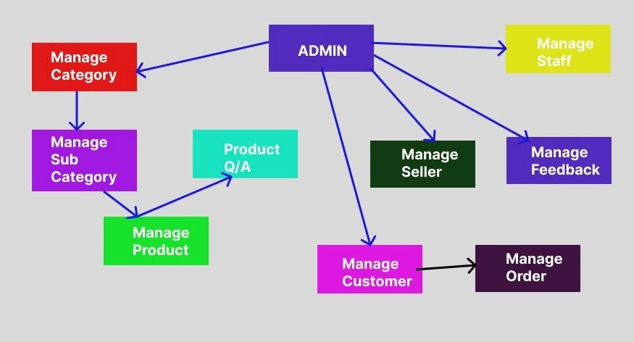

Figure 1 Admin Module

#### Seller Module

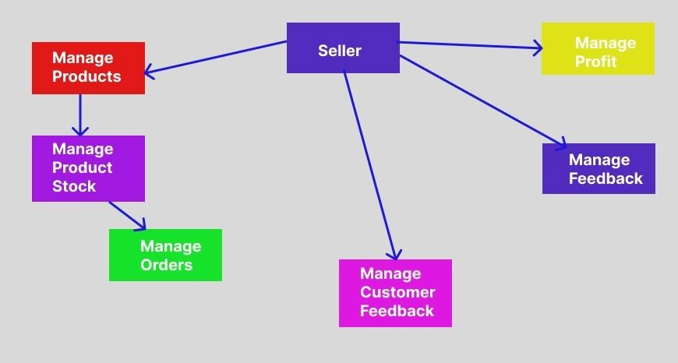

Figure 2 Seller Module

15

#### Customer Module

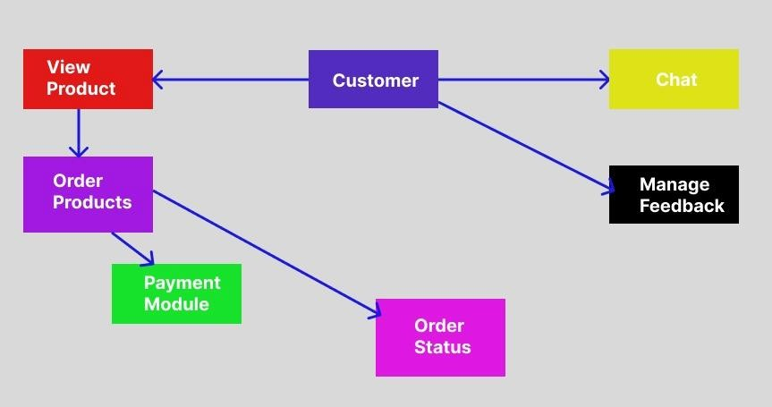

Figure 3 Customer Module

16

# Project Plan

**6.1 Implementation Planning**

System analysis/planning – Gathering information System design – UI of the website

System building - Implementation of UI Testing – Testing of the website Implementation of service

17

#### Flowchart Diagram

# System Design

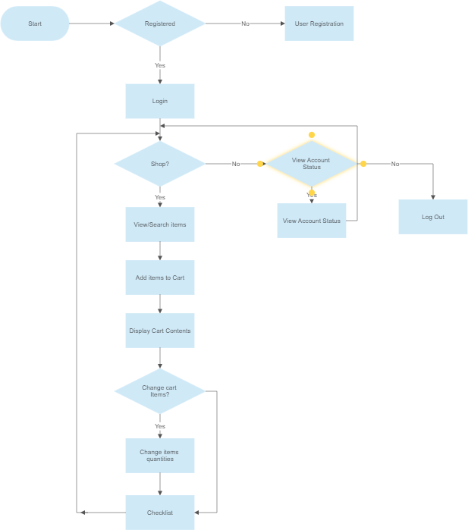

Figure 4 Flowchart Diagram

18

#### Data Flow Diagram

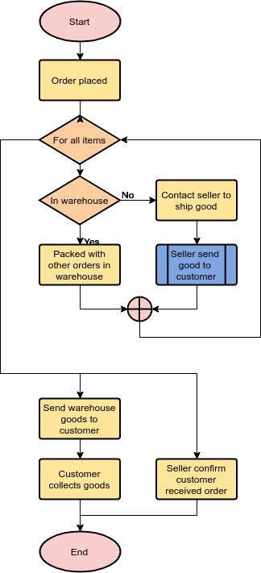

Figure 5 Data Flow Diagram

19

#### E-R Diagram

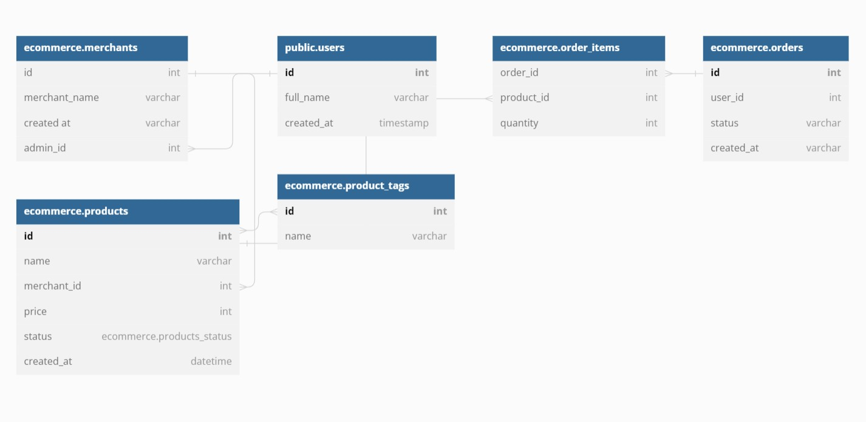

Figure 6 E-R Diagram

20

#### Use case Diagram

Figure 7 Use Case Diagram

21

#### Class Diagram

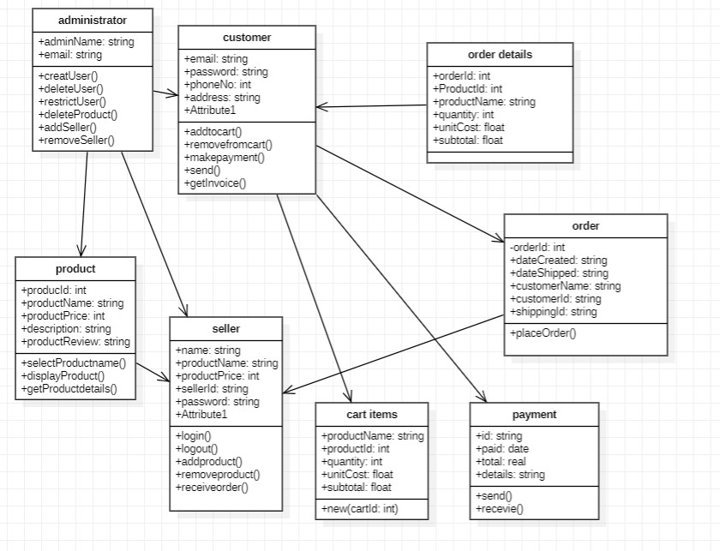

Figure 8 Class Diagram

22

#### Activity Diagram

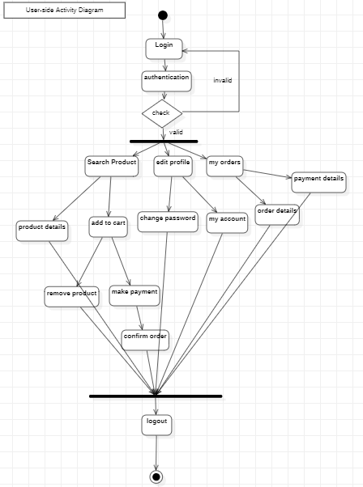

Figure 9 Activity Diagram

23

#### DFD

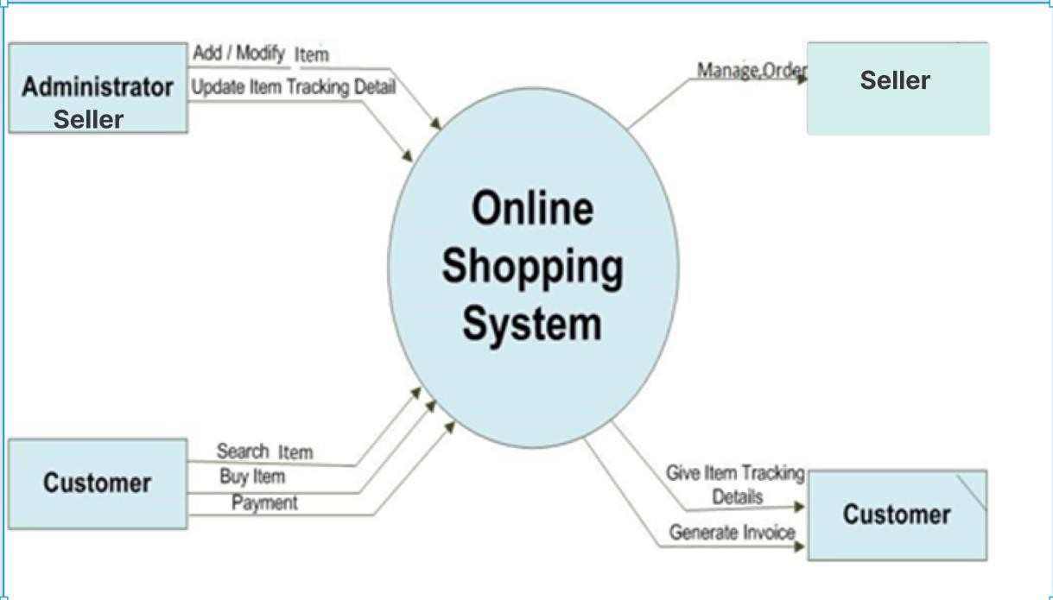

Figure 10 DFD level 1 Diagram

#### 7.8 Data Design Diagram

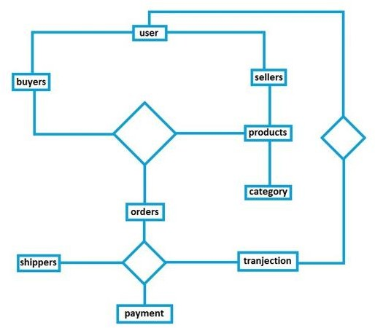

Figure 11 Data Design Diagram

24

# Implementation Details

#### UI (User Interface ) Implementation Details

* + 1. Home Page ( Default Page of website )

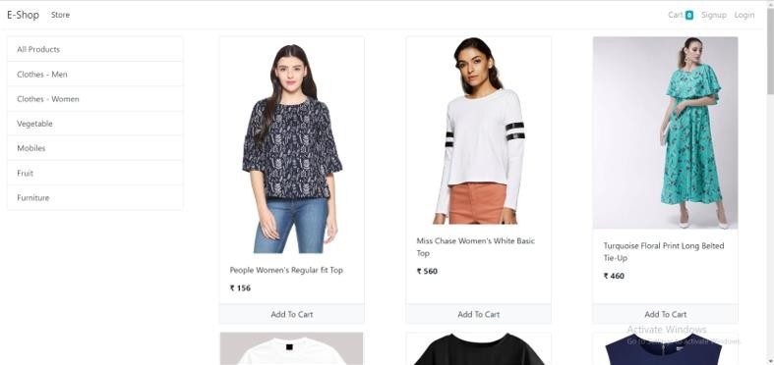

* + 1. Sign Up Page

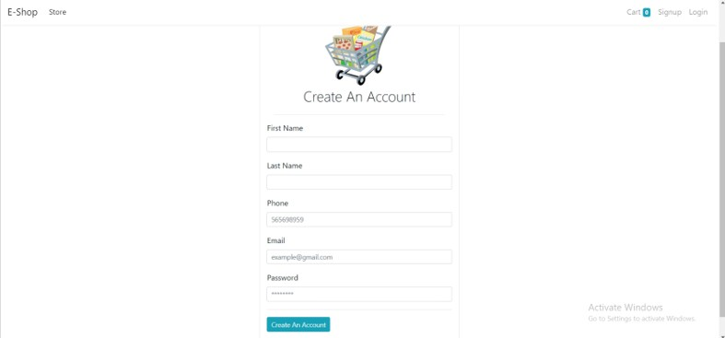

25

* + 1. Login Page

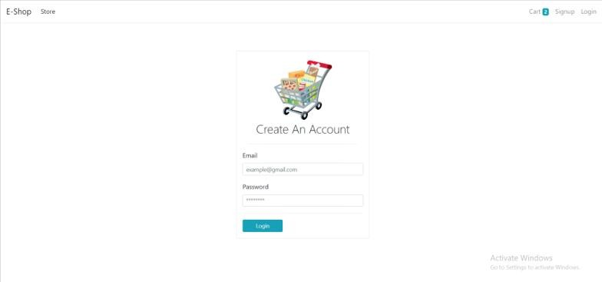

* + 1. Cart

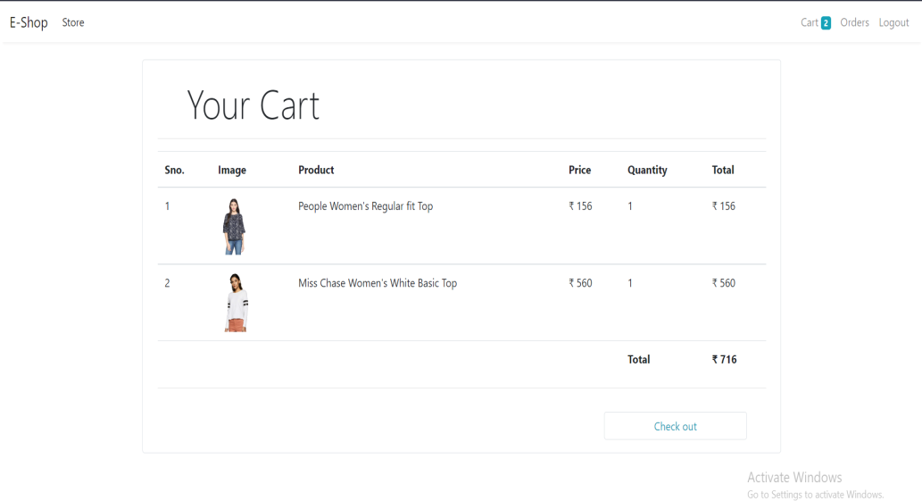

26

* + 1. Checkout form Page



8.1.6 Orders Page

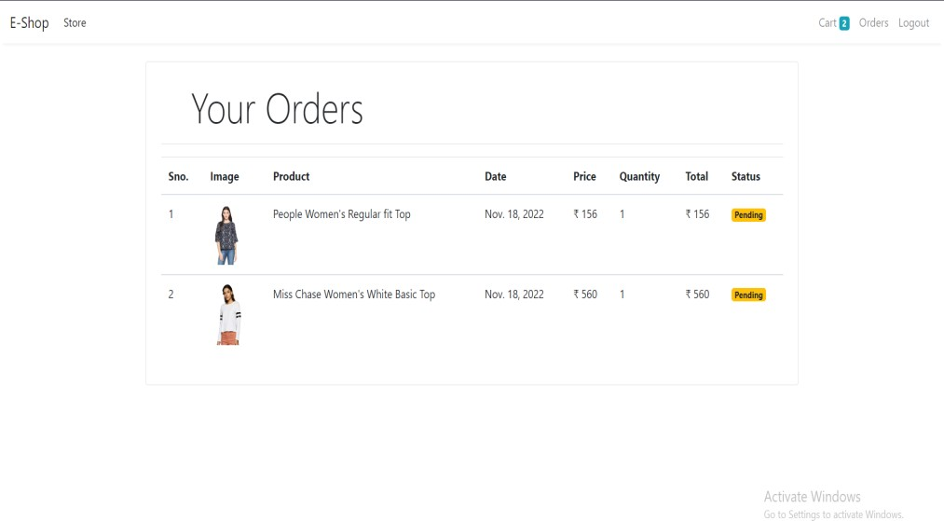

27

#### Backend Implementation

* + 1. Admin GUI

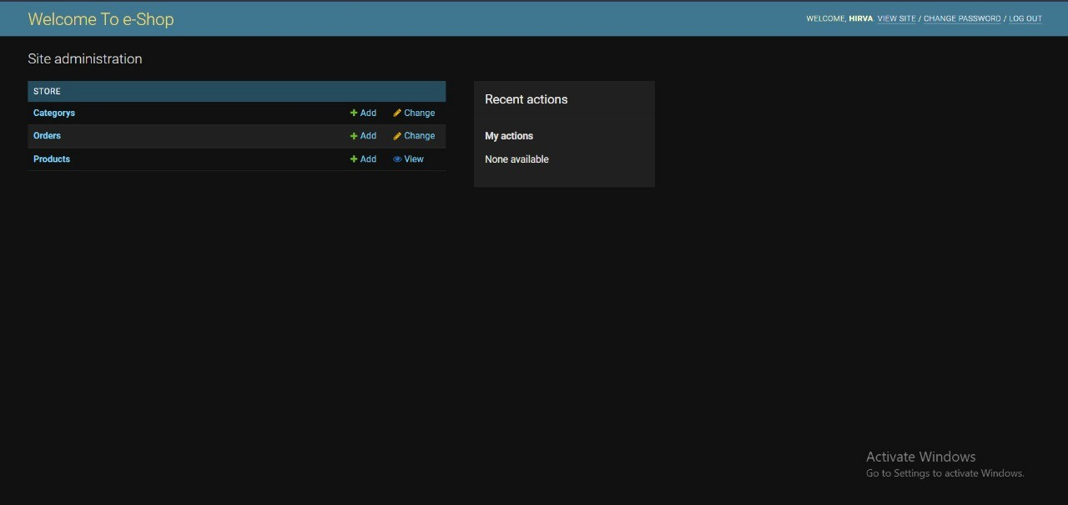

* + 1. Seller GUI



28

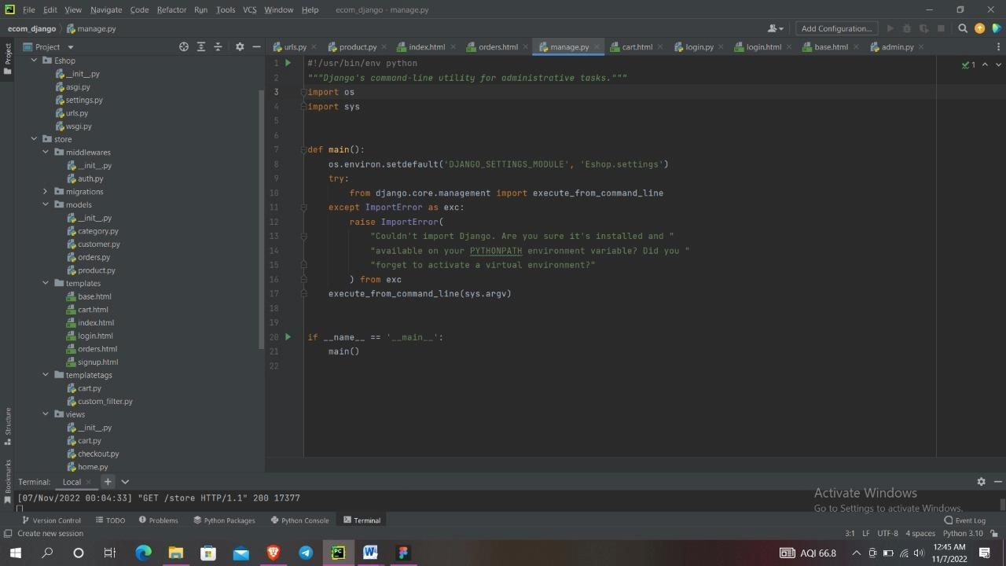

29

Django is a Model View Control (MVC) framework

* **Mange.py** -This file is used basically as a command-line utility and for deploying, debugging, or running our web application. It contains code for run-server, or make migrations or migrations, etc. that we use in the shell. Anyway, we do not need to make any changes to the file.

•

#!/usr/bin/env python

*"""Django's command-line utility for administrative tasks."""*

import os import sys

def main():

os.environ.setdefault('DJANGO_SETTINGS_MODULE', 'Eshop.settings') try:

from django.core.management import execute_from_command_line except ImportError as exc:

raise ImportError(

"Couldn't import Django. Are you sure it's installed and

"

"available on your PYTHONPATH environment variable? Did

you "

"forget to activate a virtual environment?"

) from exc execute_from_command_line(sys.argv)

if name == ' main ': main()

* **Db.sqlite3** is the database file.
* **Static** folder contains all the static files like CSS and images.
* **Env** folder is the project specific development environment. Its created through a command

‘virtualenev Env’

* Eshop folder is the Django projects consisting of init, admin, models, views, apps and forms.

30

Models are basically the blueprints of the database we are using and hence contain the information regarding attributes and the fields etc of the database.

* Views is a crucial one, it contains all the Views (usually as classes). Views.py can be considered as a file that interacts with the client. Views are a user interface for what we see when we render a Django Web application.
* URLs Just like the project urls.py file, this file handles all the URLs of our web application.

31

**URLS.py**

•

from django.contrib import admin from django.urls import path

from .views.home import Index , store from .views.signup import Signup

from .views.login import Login , logout from .views.cart import Cart

from .views.checkout import CheckOut from .views.orders import OrderView

from .middlewares.auth import auth_middleware

urlpatterns = [

path('', Index.as_view(), name='homepage'), path('store', store , name='store'),

path('signup', Signup.as_view(), name='signup'), path('login', Login.as_view(), name='login'), path('logout', logout , name='logout'),

path('cart', auth_middleware(Cart.as_view()) , name='cart'), path('check-out', CheckOut.as_view() , name='checkout'), path('orders', auth_middleware(OrderView.as_view()),

name='orders'),

]

Ecommerce folder is the Django application directory consisting of the following essential files.

* Init.py This file remains empty and is present them only to tell that this particular directory is a package.
* Settings.py This file is present for adding all the applications and the middleware application present. Also, it has information about templates and databases. Overall, this is the main file of our Django web application.
* Urls.py This file handles all the URLs of our web application. This file has the lists of all the endpoints that we will have for our website.
* Wsgi.py This file mainly concerns with the WSGI server and is used for deploying our applications on to servers like Apache etc.
* Asgi.py In the newer versions of Django, you will also find a file named as asgi.py apart from wsgi.py. ASGI can be considered as a succeeded interface to the WSGI. ASGI, short for Asynchronous Server Gateway interface.

32

### Admin.py:

* from django.contrib import admin from .models.product import Product

from .models.category import Category from .models.customer import Customer from .models.orders import Order

class AdminProduct(admin.ModelAdmin):

list_display = ['name', 'price', 'category', 'description']

class AdminCategory(admin.ModelAdmin): list_display = ['name']

class CustomerAdmin(admin.ModelAdmin):

list_display = ['first_name', 'last_name', 'email']

class OrderAdmin(admin.ModelAdmin):

list_display = ['product', 'customer', 'quantity',

'price', 'address', 'phone']

admin.site.site_header = "Welcome To e-Shop" admin.site.site_title = "e-Shop" admin.site.register(Product, AdminProduct) admin.site.register(Category, AdminCategory) admin.site.register(Customer, CustomerAdmin) admin.site.register(Order, OrderAdmin)

### Views.py

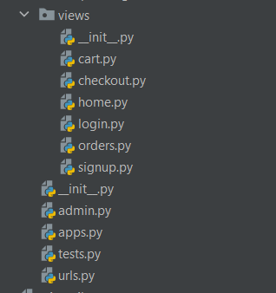

33

### Models.py

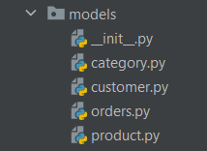

34

# Conclusion

In general, today’s businesses must always strive to create the next best thing that consumers will want because consumers continue to desire their products, services etc. to continuously be better, faster, and cheaper. In this world of new technology, businesses need to accommodate to the new types of consumer needs and trends because it will prove to be vital to their business’ success and survival. E-commerce is continuously progressing and is becoming more and more important to businesses as technology continues to advance and is something that should be taken advantage of and implemented.

From the inception of the Internet and e-commerce, the possibilities have become endless for both businesses and consumers. Creating more opportunities for profit and advancements for businesses, while creating more options for consumers. However, just like anything else, e-commerce has its disadvantages including consumer uncertainties, but nothing that can not be resolved or avoided by good decision-making and business practices.

There are several factors and variables that need to be considered and decided upon when starting an e-commerce business. Some of these include: types of e-commerce, marketing strategies, and countless more. If the correct methods and practices are followed, a business will prosper in an e-commerce setting with much success and profitability.

35

# References

* + <https://www.youtube.com/>
  + <http://google.com/>
  + <https://www.academia.edu/>
  + <https://www.amazon.in/>

36

## ANNEXURE - ABOUT COLLEGE (UVPCE)

U. V. Patel College of Engineering

U. V. Patel College of Engineering (GUNI-UVPCE) is situated in Ganpat Vidyanagar campus. It was established in September 1997 with the aim of providing educational opportunities to students. The College is named after Shri Ugarchandbhai Varanasibhai Patel, a leading industrialist of Gujarat, for his generous support. It is a self-financed institute approved by All India Council for Technical Education (AICTE), New Delhi and the Commissionerate of Technical Education, Government of Gujarat.

The College is spread over 25 acres of land and is a part of Ganpat Vidyanagar Campus. It has six ultra-modern buildings of architectural splendor, class rooms, tutorial rooms, seminar halls, offices, drawing hall, workshop, library, well equipped departmental laboratories and several computer laboratories with internet connectivity through 1 Gbps Fiber link, satellite link education center with two-way audio and one-way video link. The Institute offers various undergraduate programs, postgraduate programs, and Ph.D. programs.

Placement plays a key role in shaping the future of the students, and keeping this in mind; the institute has forged healthy relations with the prominent industries. These tie-ups are mutually beneficial. In turn they extend every possible help to the institute especially with regard to providing hands-on training to the students. As part of this initiative, Incubation Centre/Start- up activities have also been developed.

37